Match and write.

The film is about a boy.
This story is about a creative girl.
I know the girl.
The book is about a man.

The man travels around the world helping poor people.
The girl is good at playing the piano.
The girl works very hard to become a fashion designer.
The boy likes cats very much.

who

1 | The film is about  . | 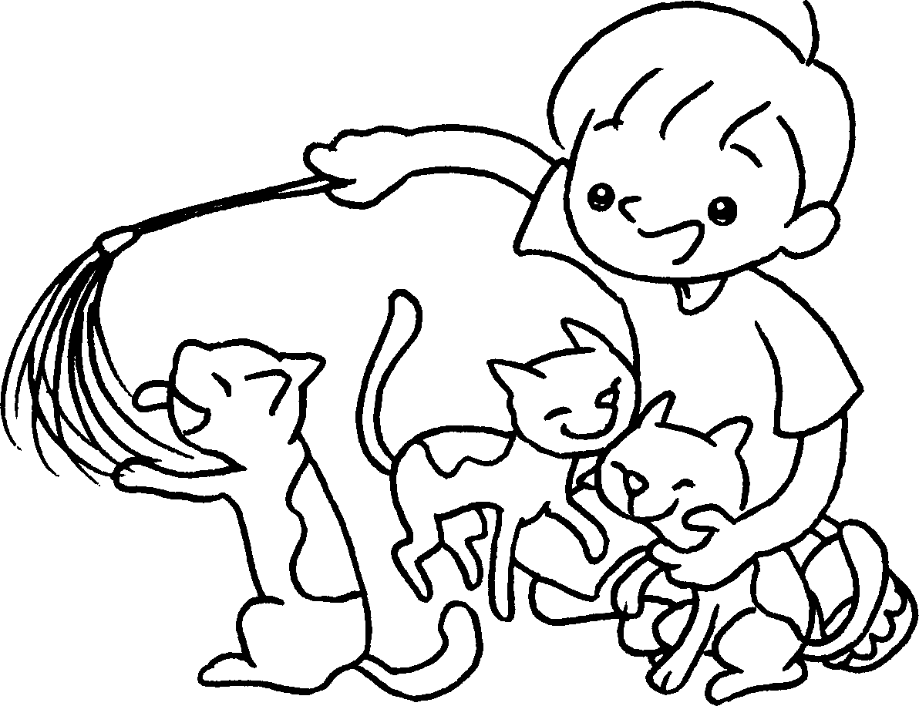
2 |  | 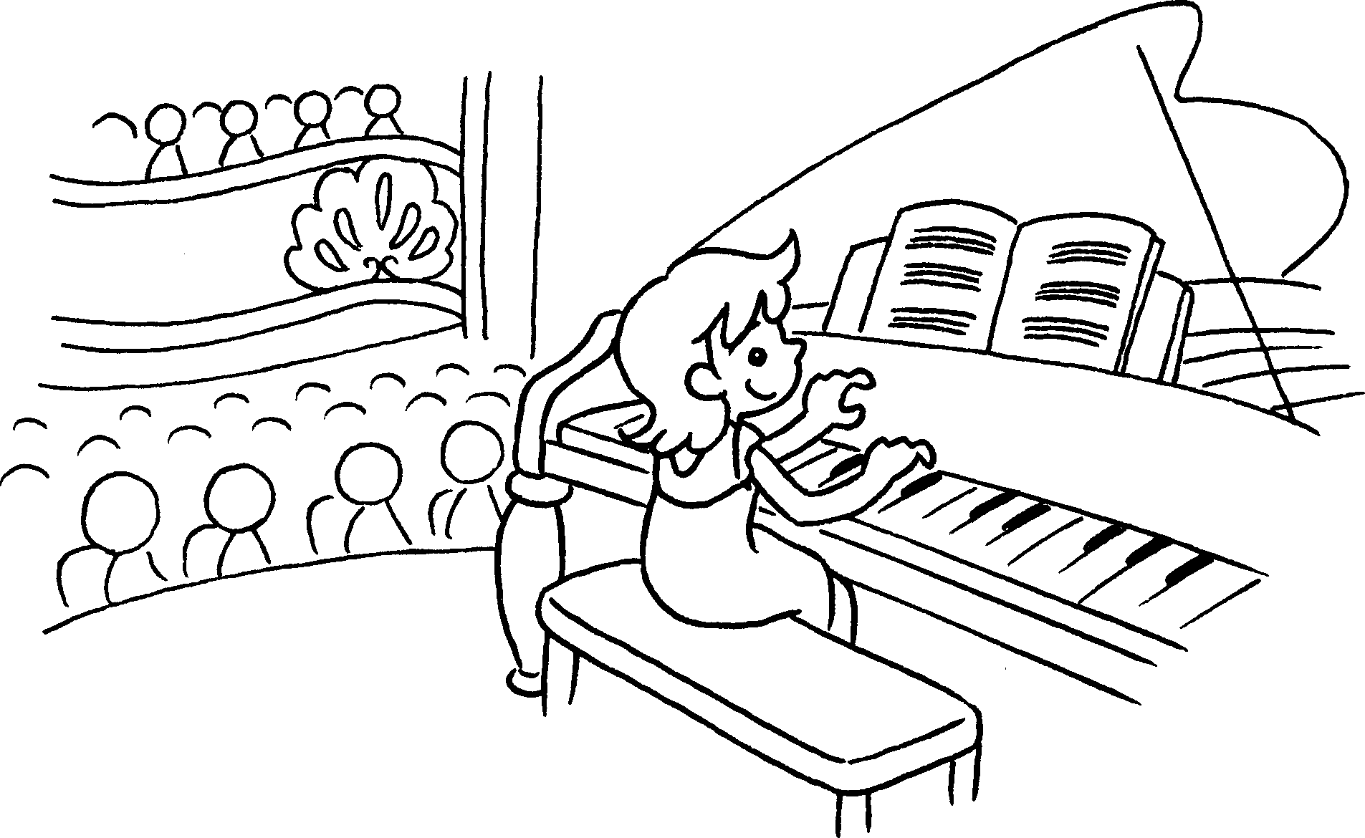
3 |  | 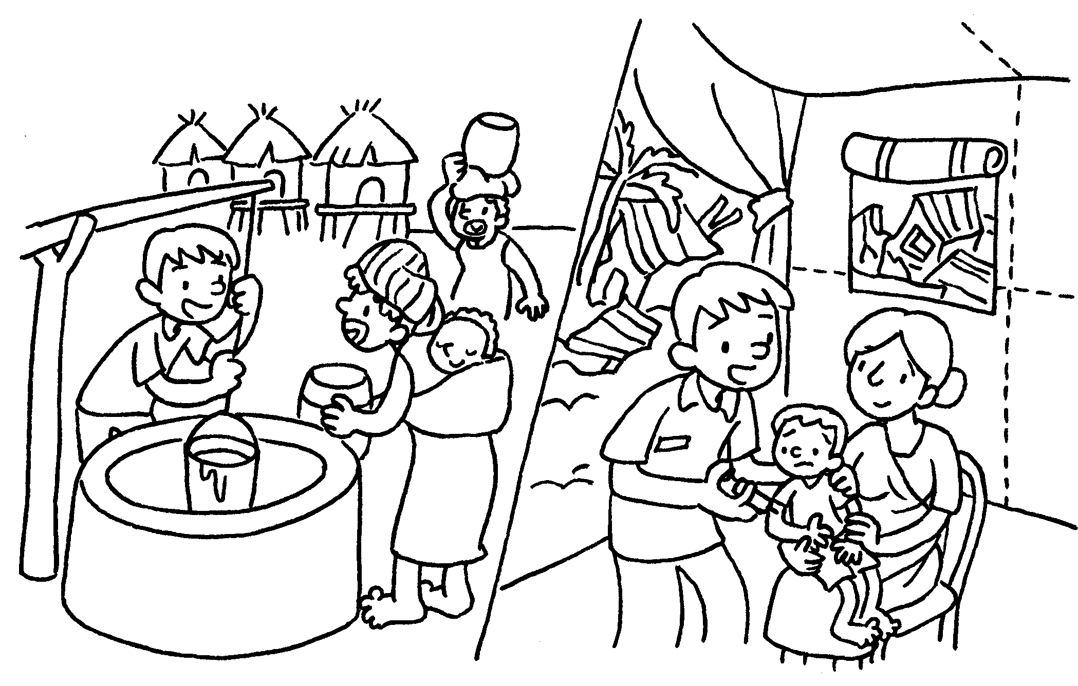
4 |  | 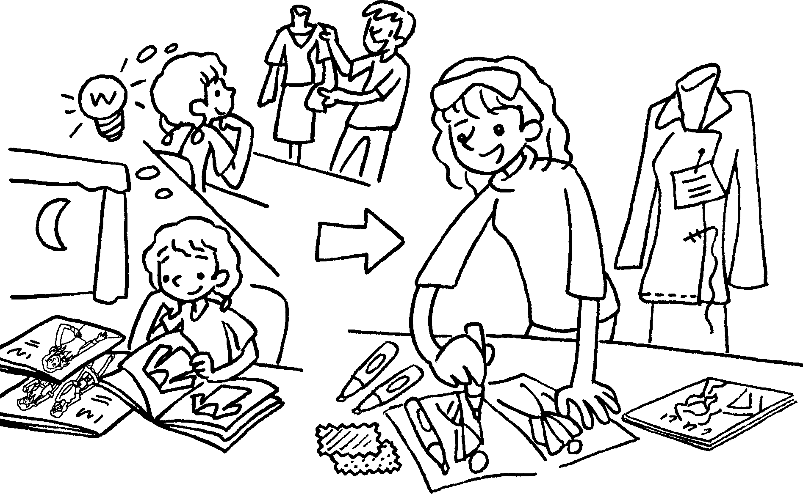


Book 6A Chapter 6 Graded Worksheets
Worksheet 2⬇⬇⬇
- a boy who likes cats very much
- I know the girl who is good at playing the piano.
- The book is about a man who travels around the world helping poor people.
- This story is about a creative girl who works very hard to become a fashion designer.

