Choose and write.

which | who

1 | They have a dog has big eyes. | 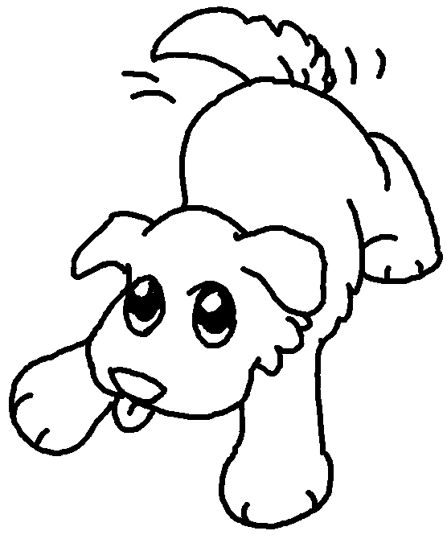
2 | The film is about a man likes Kung Fu very much. | 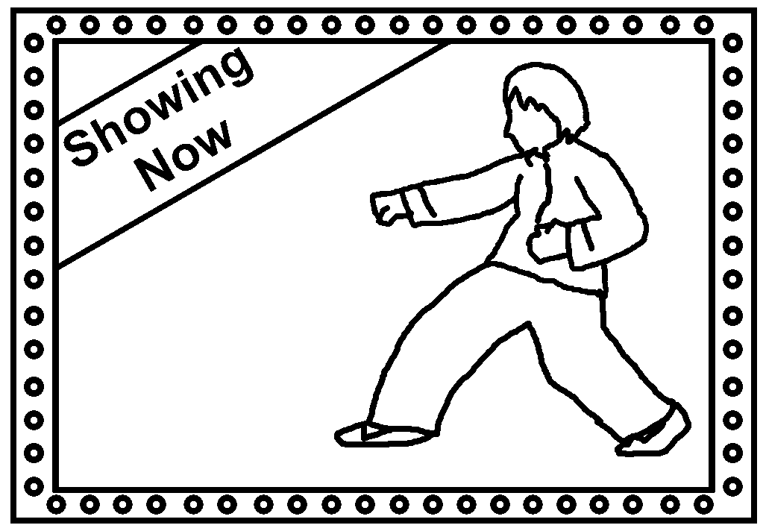
3 | My friend gave me a cake was very delicious. | 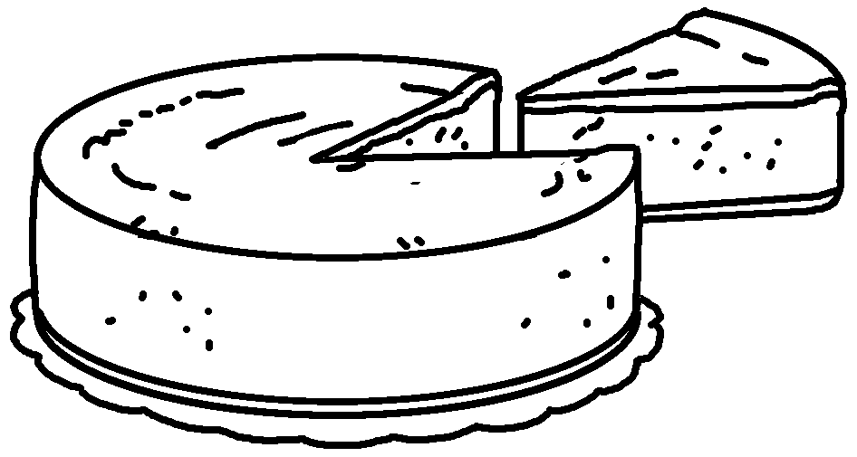
4 | This is the picture is very famous around the world. | 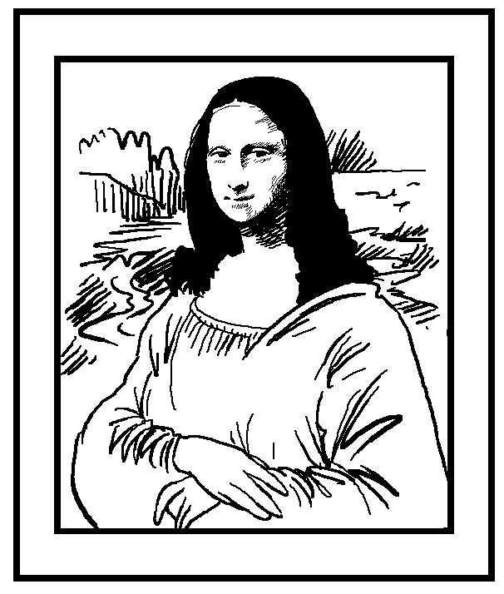
5 | The story is about a girl meets the prince in the palace. | 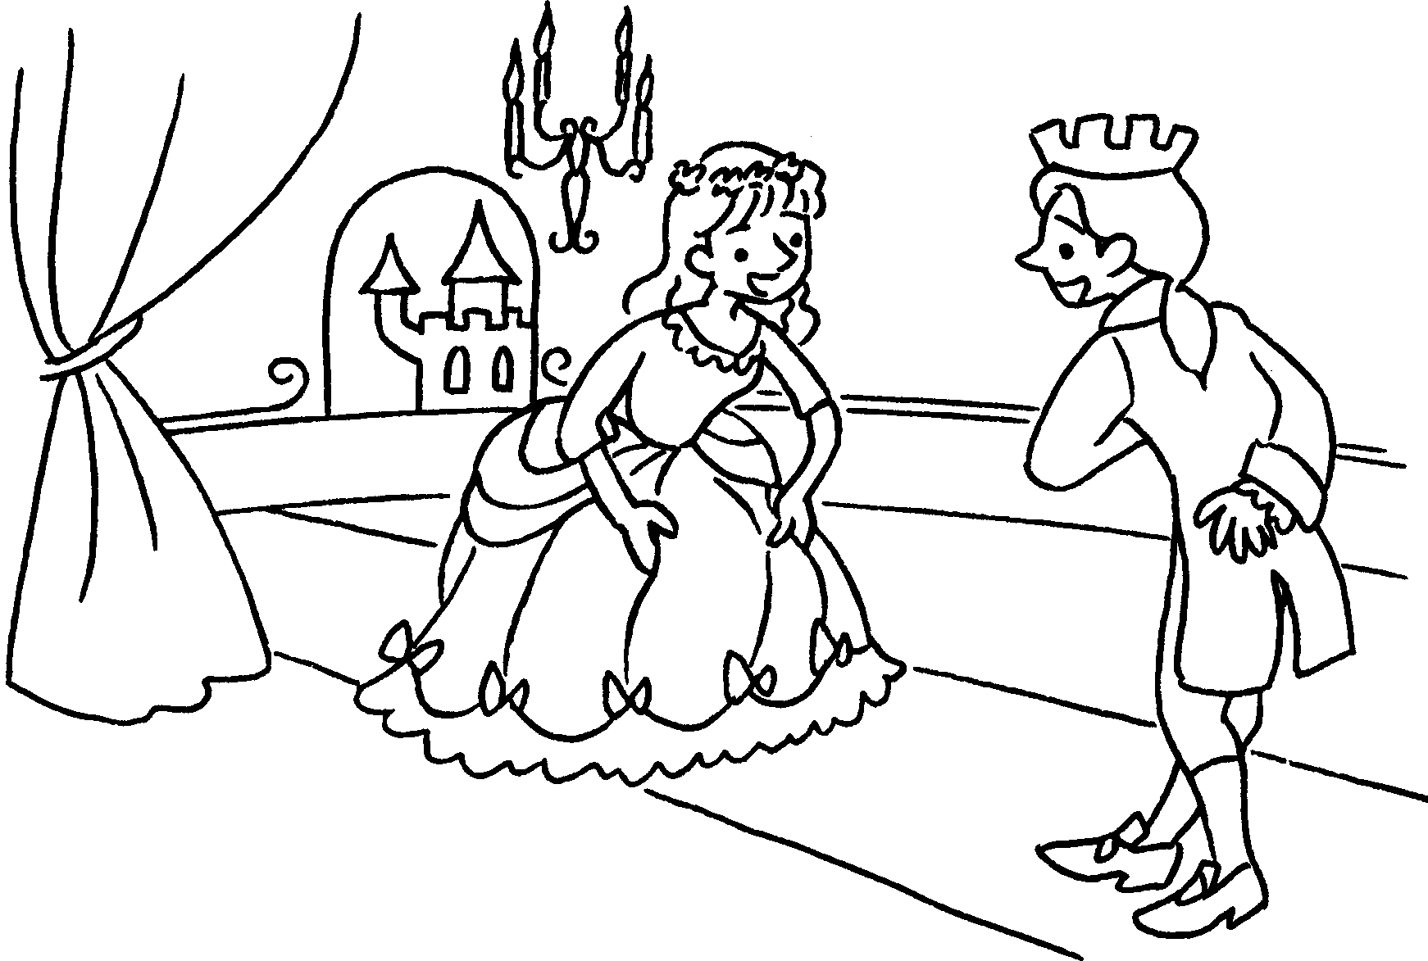
6 | The book is about a woman turns into a witch at night. | 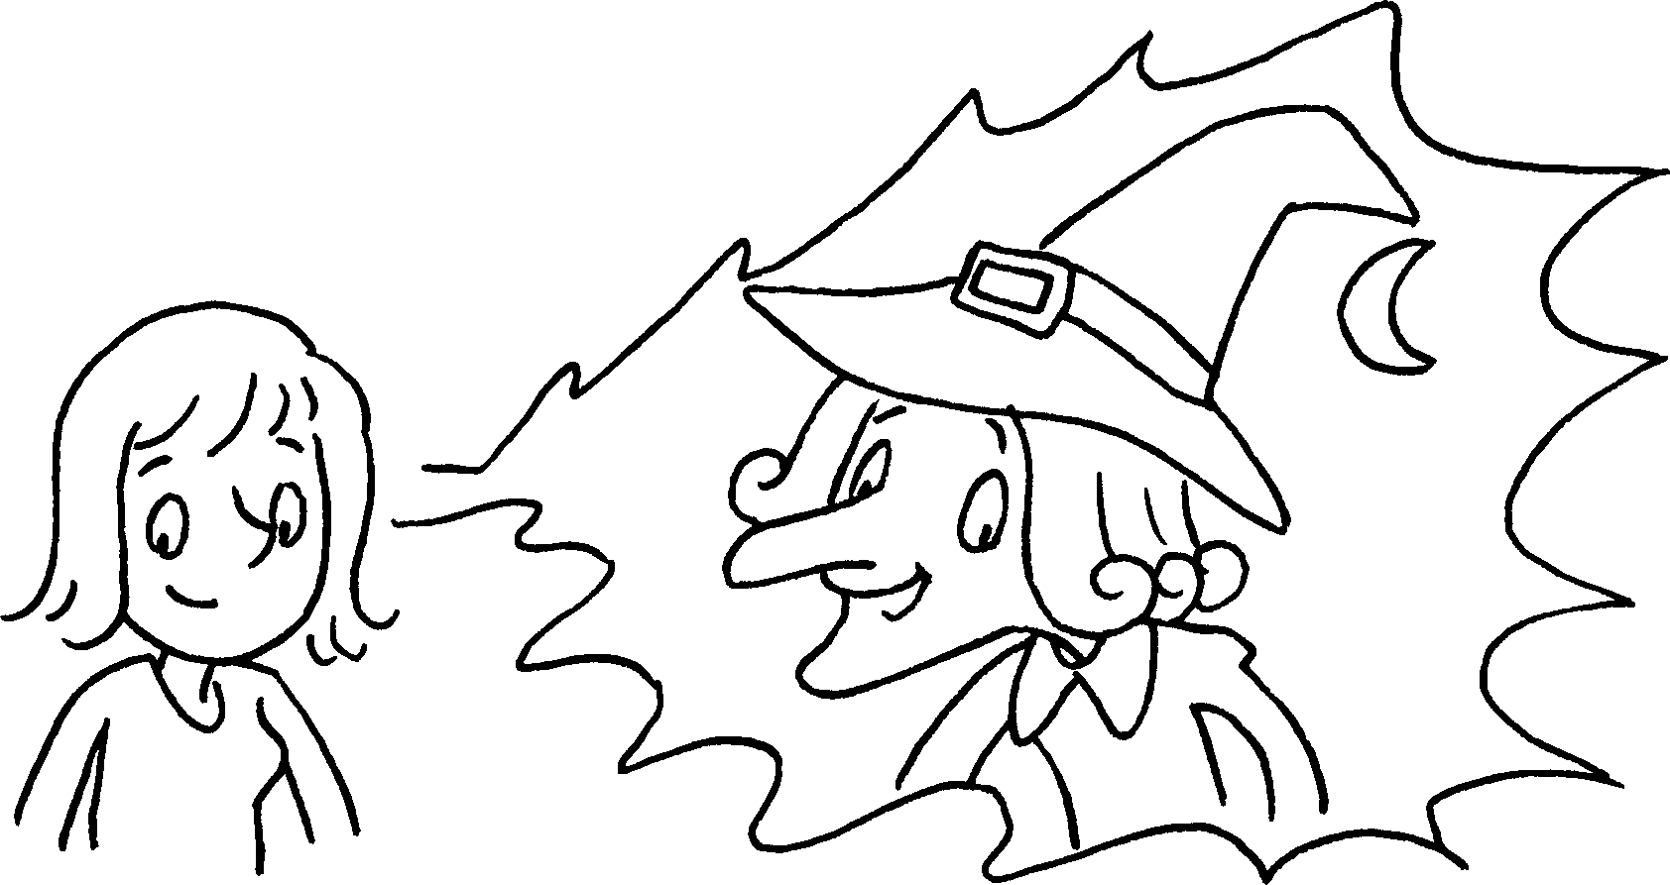


Book 6A Chapter 6 Graded Worksheets
Worksheet 3⬇
- which
- who
- which
- which
- who
- who

