Look at the pictures and finish the sentences using ‘who’ or ‘which’.

was very delicious turns into a witch at night likes Kung Fu very much
meets the prince in the palace is very famous around the world

1 | They have a dog has big eyes. | 
2 | The film is about a man  . | 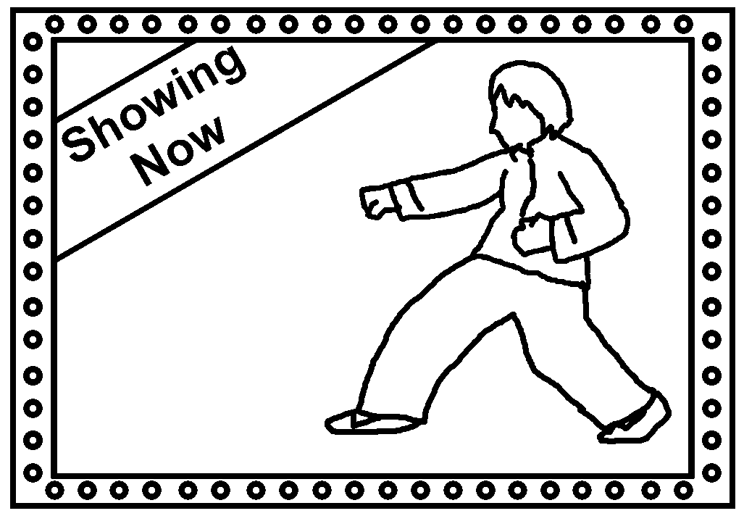
3 | My friend gave me a cake  . | 
4 | This is the picture  . | 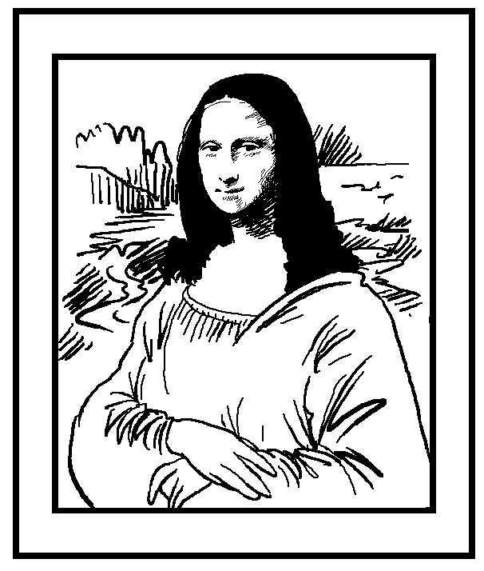
5 | The story is about a girl  . | 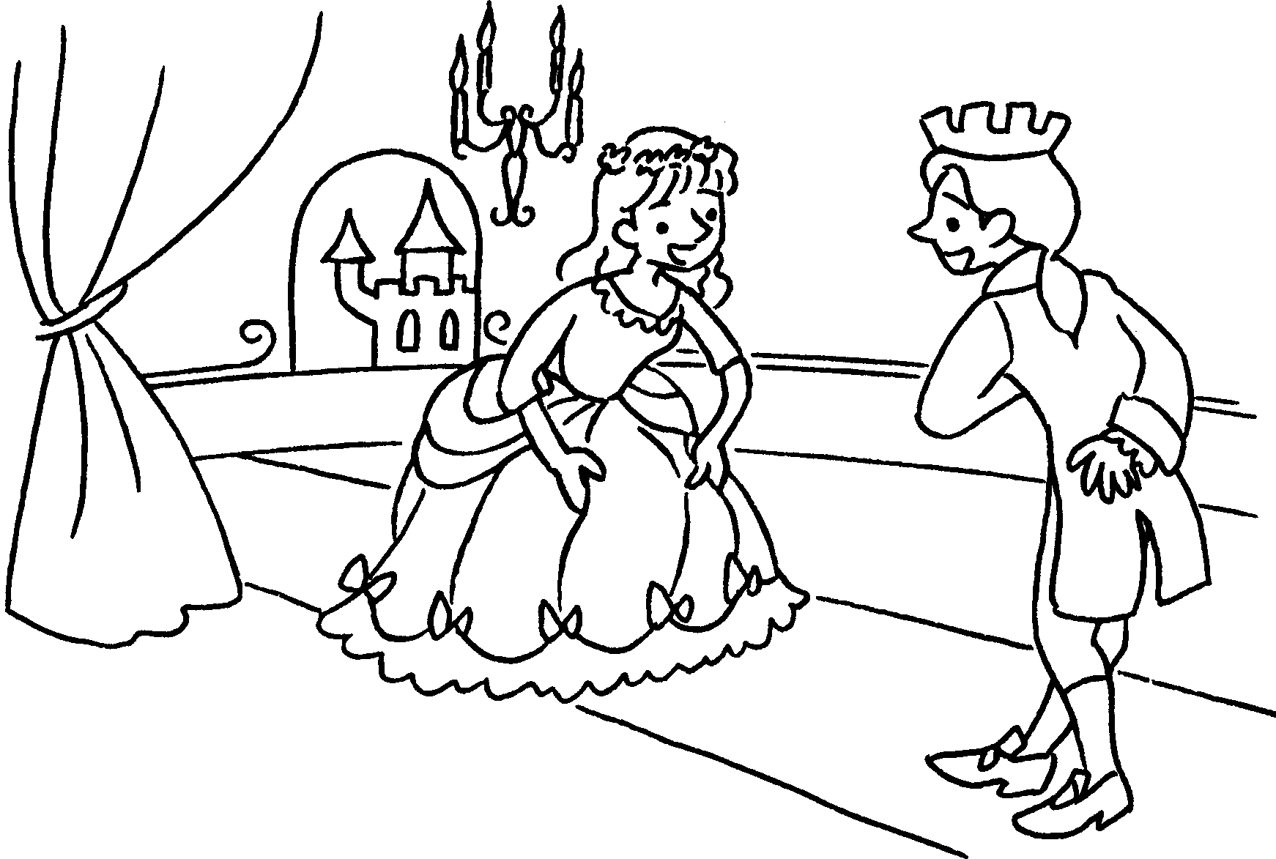
6 | The book is about a woman  . | 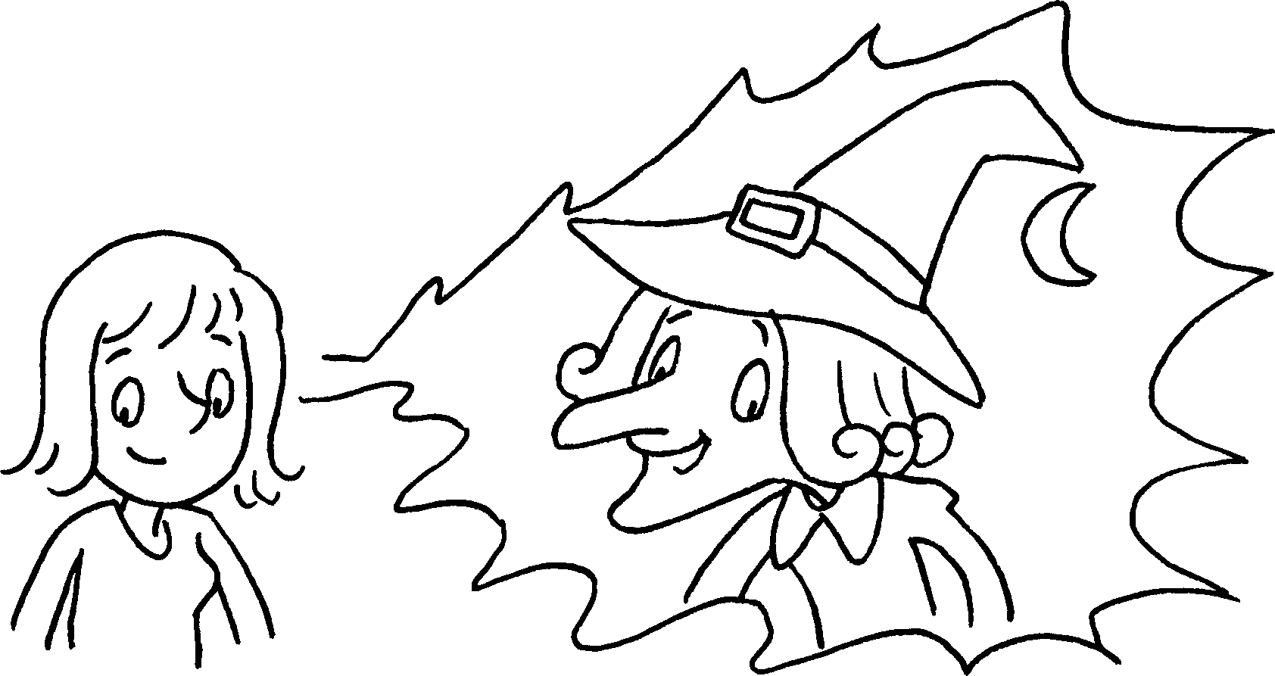


Book 6A Chapter 6 Graded Worksheets
Worksheet 3⬇⬇
- which
- who likes Kung Fu very much
- which was very delicious
- which is very famous around the world
- who meets the prince in the palace
- who turns into a witch at night

