Use ‘who’ or ‘which’ to combine the two sentences.

1 | They have a dog. The dog has big eyes.  They have a dog has big eyes. | 
2 | The film is about a man. The man likes Kung Fu very much.  _________________________________________________  _________________________________________________ | 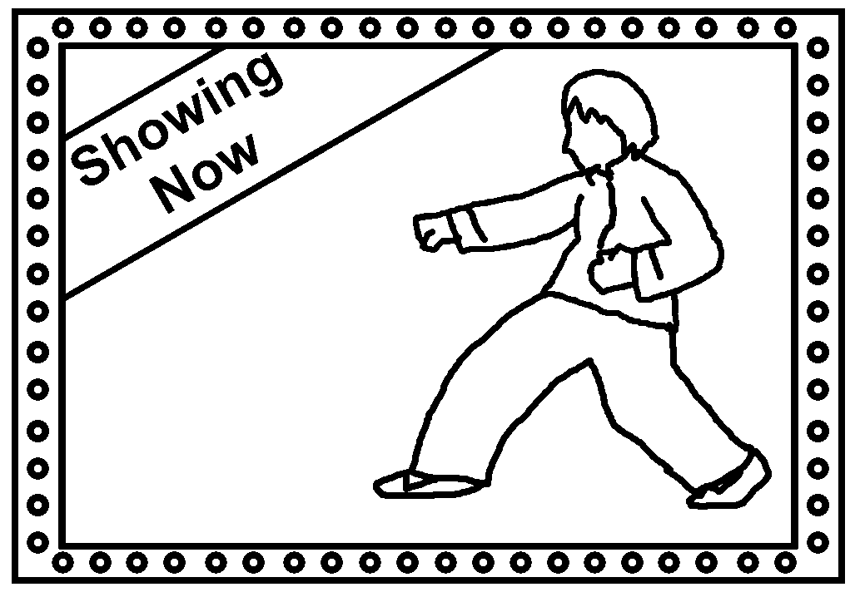
3 | My friend gave me a cake. The cake was very delicious.  _________________________________________________  _________________________________________________ | 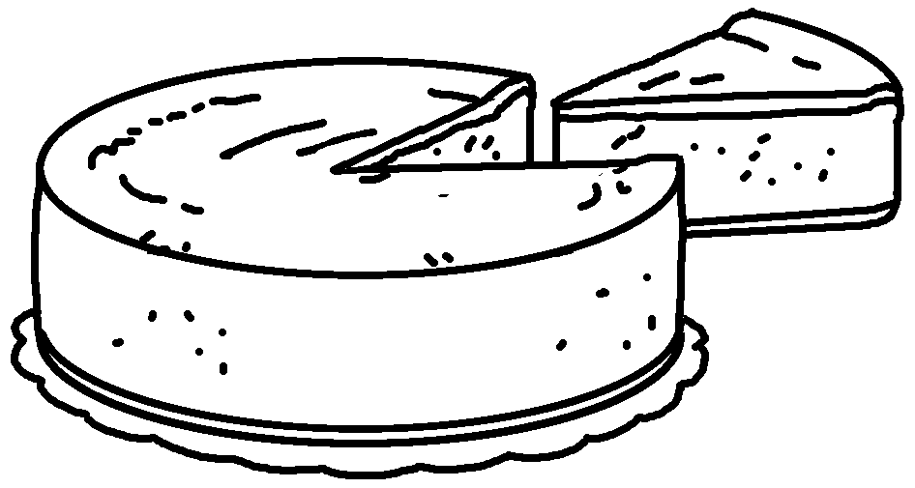
4 | Leonardo da Vinci painted many pictures. His pictures are very famous.  _________________________________________________  _________________________________________________ | 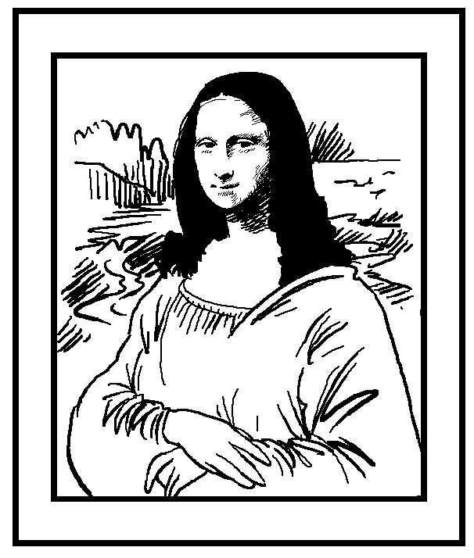
5 | The story is about a girl. The girl meets the prince in the palace.  _________________________________________________  _________________________________________________ | 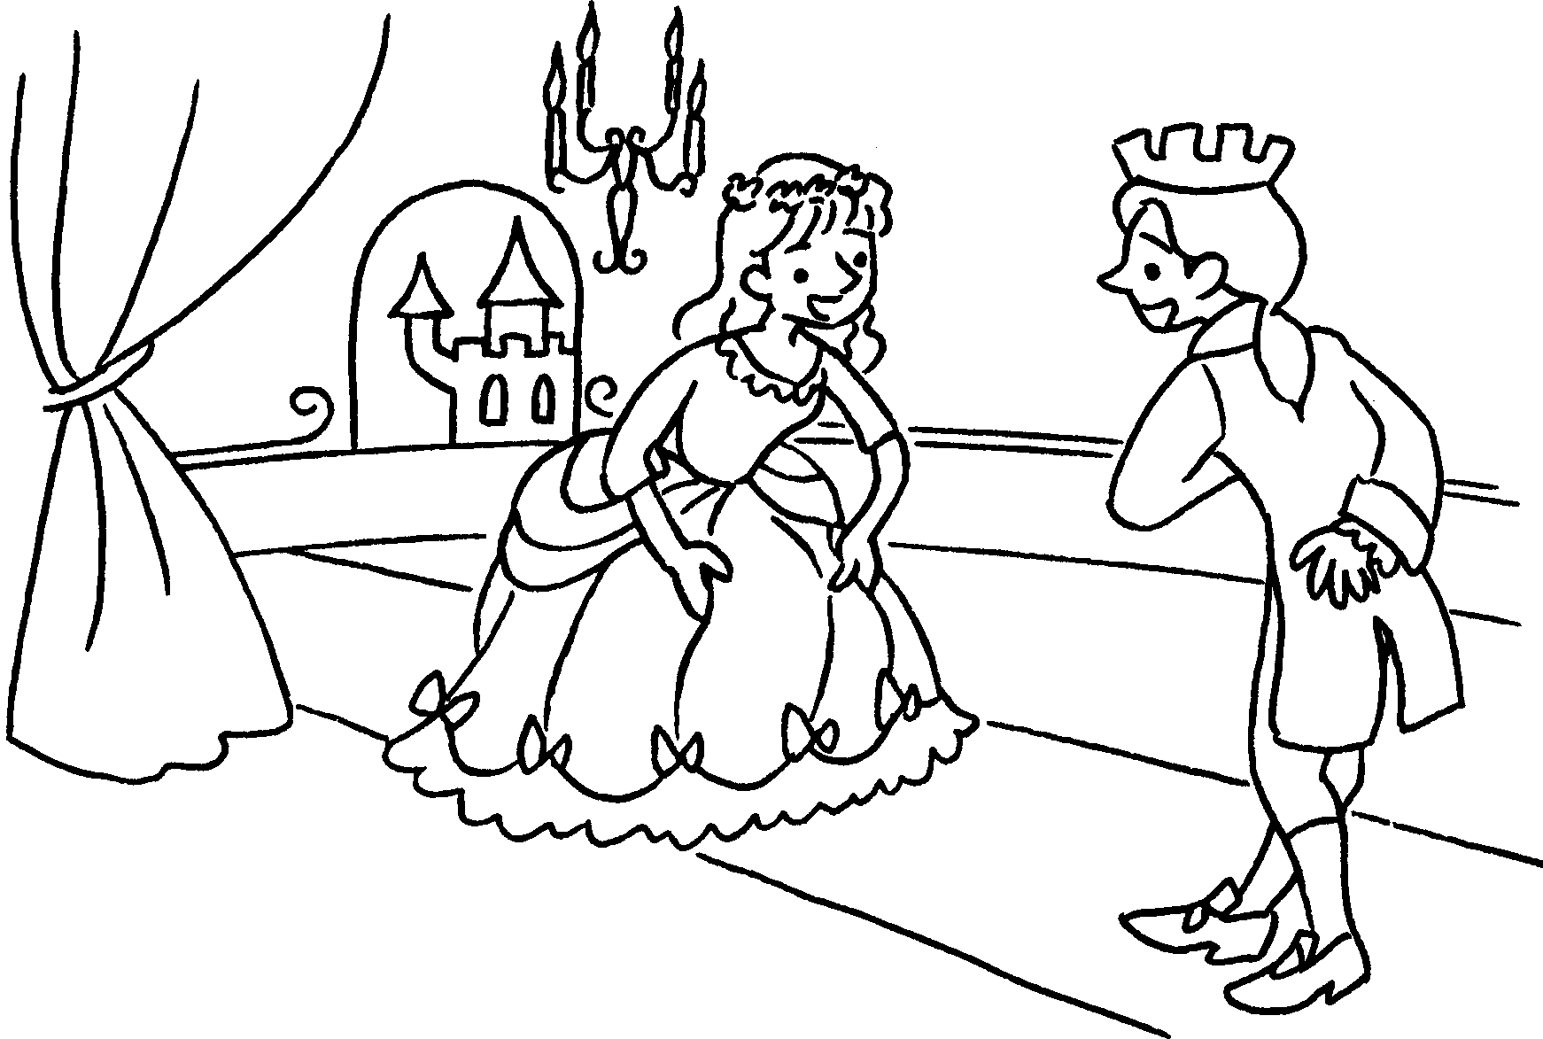
6 | The book is about a woman. The woman turns into a witch at night.  _________________________________________________  _________________________________________________ | 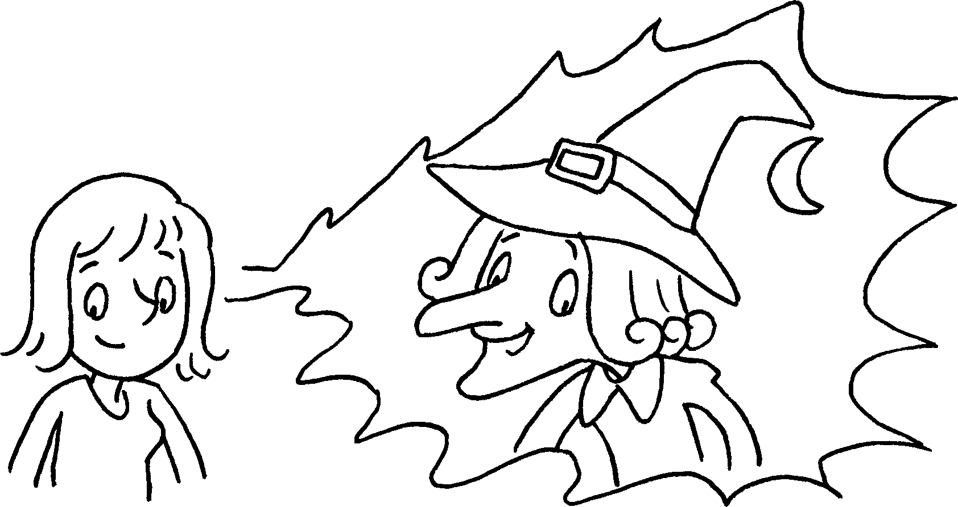


Book 6A Chapter 6 Graded Worksheets
Worksheet 3⬇⬇⬇
- which
- The film is about a man who likes Kung Fu very much.
- My friend gave me a cake which was very delicious.
- Leonardo da Vinci painted many pictures which are very famous.
- The story is about a girl who meets the prince in the palace.
- The book is about a woman who turns into a witch at night.

