- Reading is fun
Have you ever read or seen Charlie and the Chocolate Factory? What is it about? Did you like it? Read the book report and find out what Jason thinks.
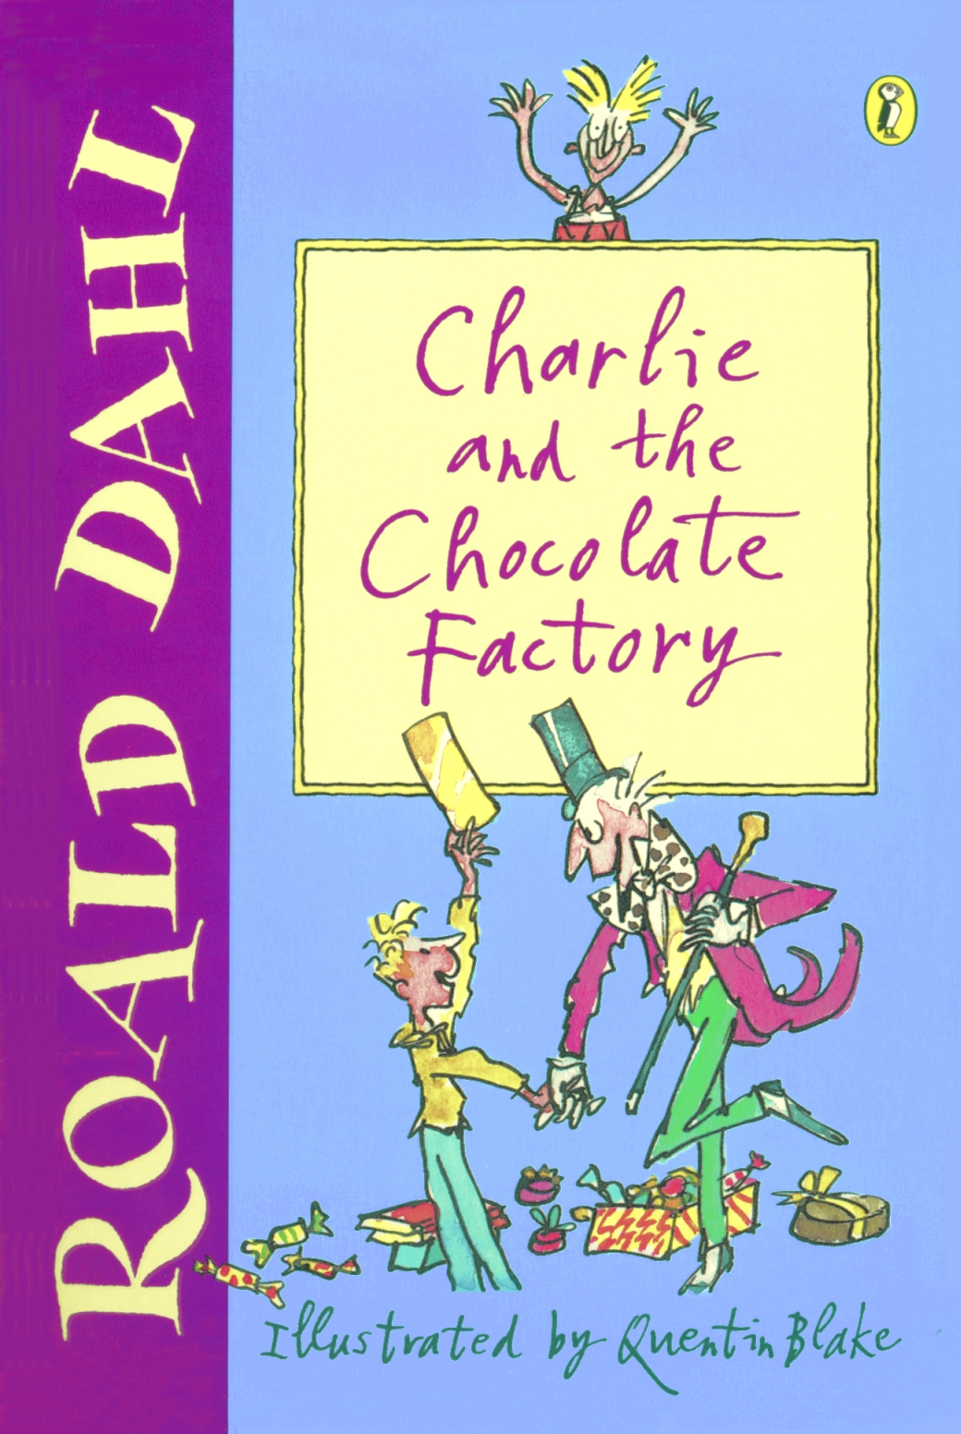
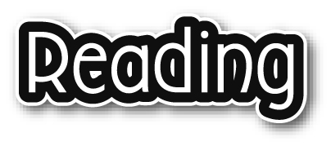
Book reportBy Jason Smith (6A)
Title: Charlie and the Chocolate Factory
Author: Roald Dahl
Why did you choose this book?
Because I love Roald Dahl’s stories.
What is the book about?
The book is about a boy who loves eating chocolate bars. His name is Charlie. Charlie and four other lucky children win a tour of the chocolate factory which belongs to Willy Wonka. However some strange things happen to the children during their adventure.
Augustus is the first child who has an ‘accident’. In the chocolate room, he drinks from the chocolate river. He falls into the river and disappears.
The next one is Violet. She is a proud girl. In the inventing room, she does not listen to Mr Wonka and eats the latest chewing gum. She turns into a blueberry balloon!

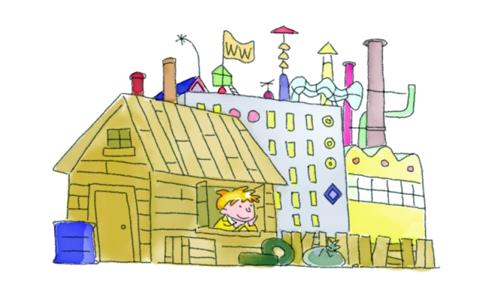

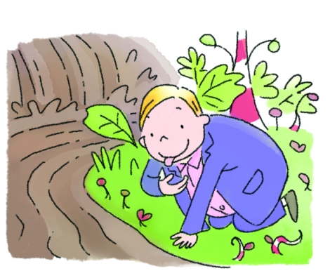

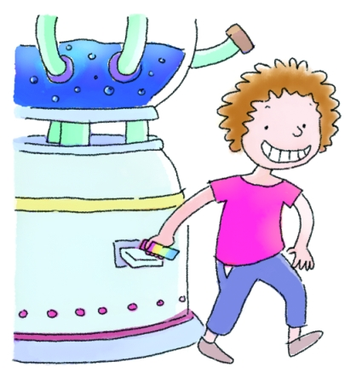

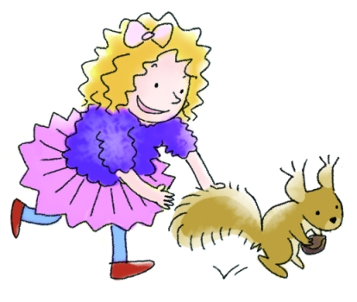
Veruca is a spoilt girl who does not listen to Mr Wonka either. In the nut room, she tries to take one of the squirrels but they take her away instead.
Finally, the children go to the television-chocolate room which has a big camera and a special TV. Mr Wonka tells
them not to go near the camera but Mike is naughty. He shrinks until he is only 15 centimetres tall.
In the end, Mr Wonka gives a very special prize to Charlie – the keys to the chocolate factory.

What did you like / dislike about the book?
The plot was very exciting. I was amused because the characters were funny. My favourite character was Mr Wonka because his inventions were very interesting.
What would you do if you were the characters?
If I were Charlie, I would invite other children to visit the factory.
If I were Mr Wonka, I would make an ice cream which tastes of popcorn.

