Choose and write.

firework displays |  | good luck flowers |  | red paper
lion dance | parades |  | rice cakes and turnip cakes

Chinese New Year  1  2  3  4  5  6  7  8  9  10  11  12 |  |  | 1 | perform the
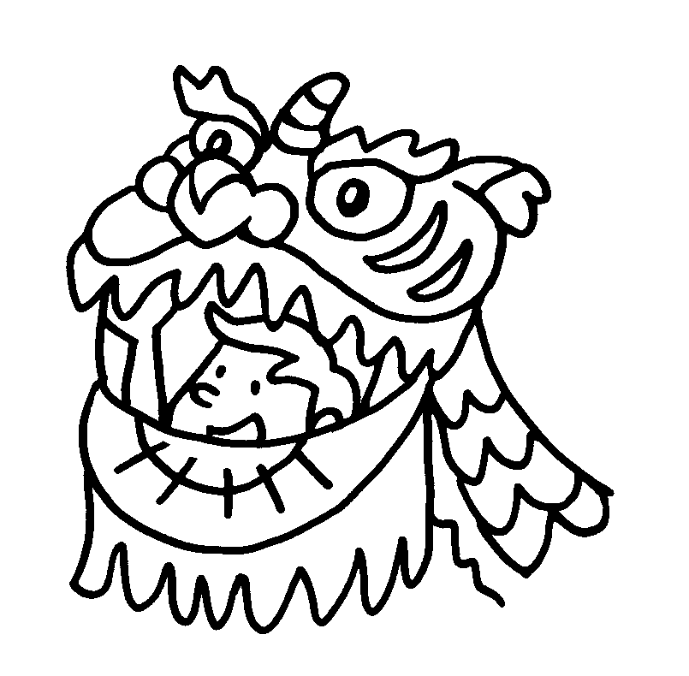 | 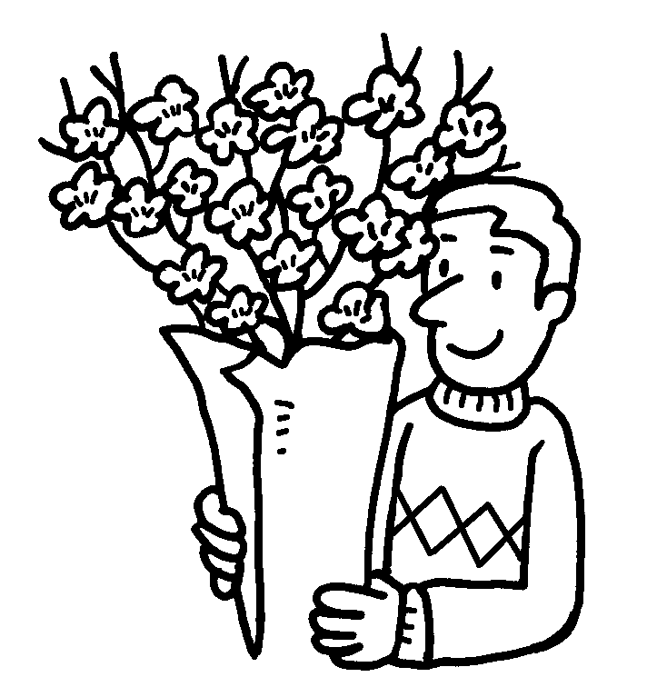 | 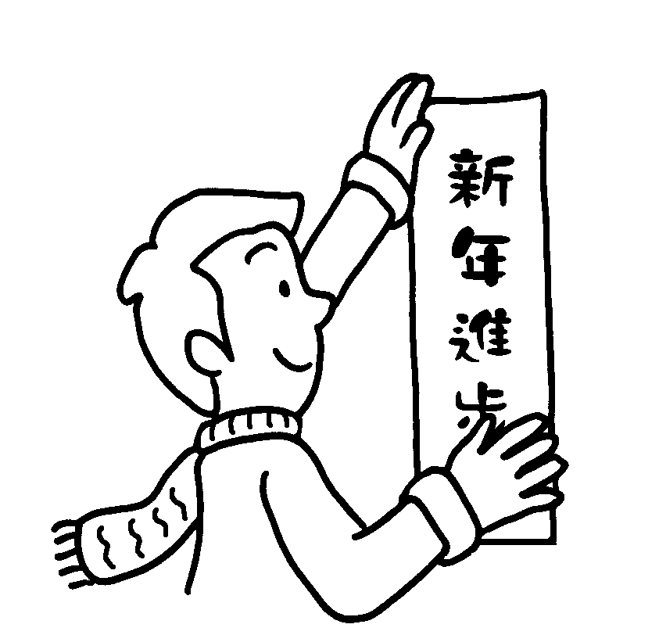 | 2 | buy
 |  |  | 3 | decorate home with
 |  |  | 4 | eat
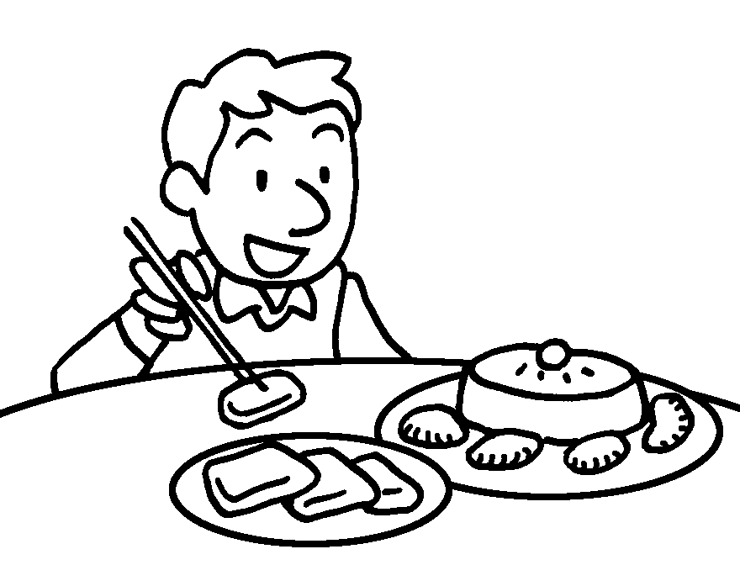 | 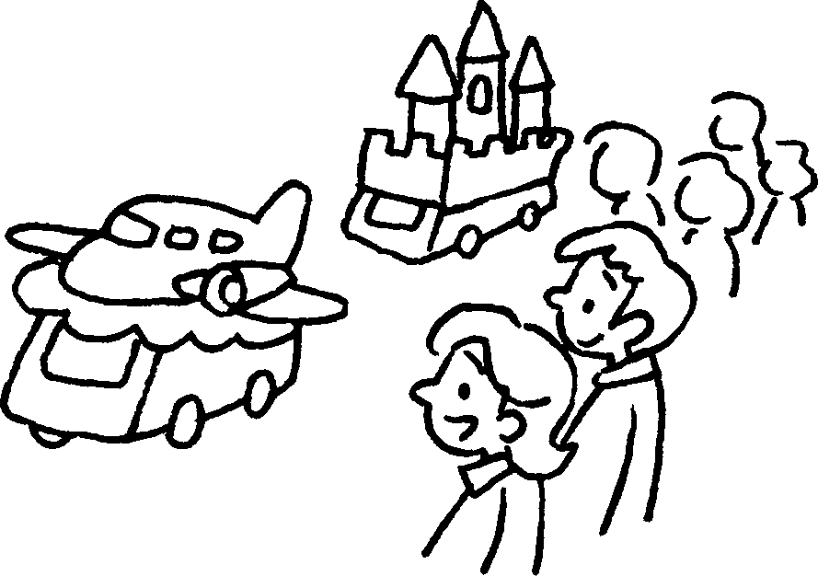 | 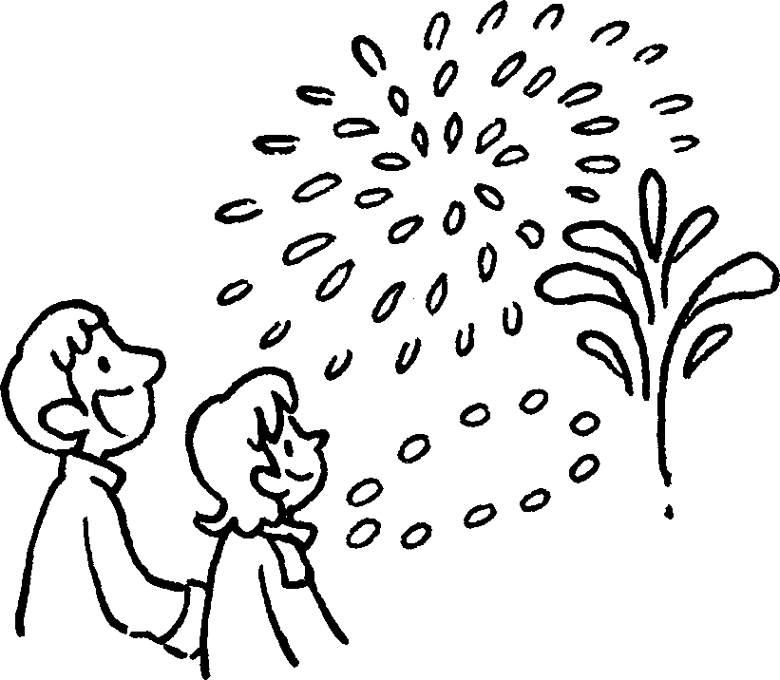 | 4 | eat
 |  |  | 5 | watch
 |  |  | 6 | watch

graves | special food

Ching Ming Festival |  | 7  8 | give to  dead relatives  sweep
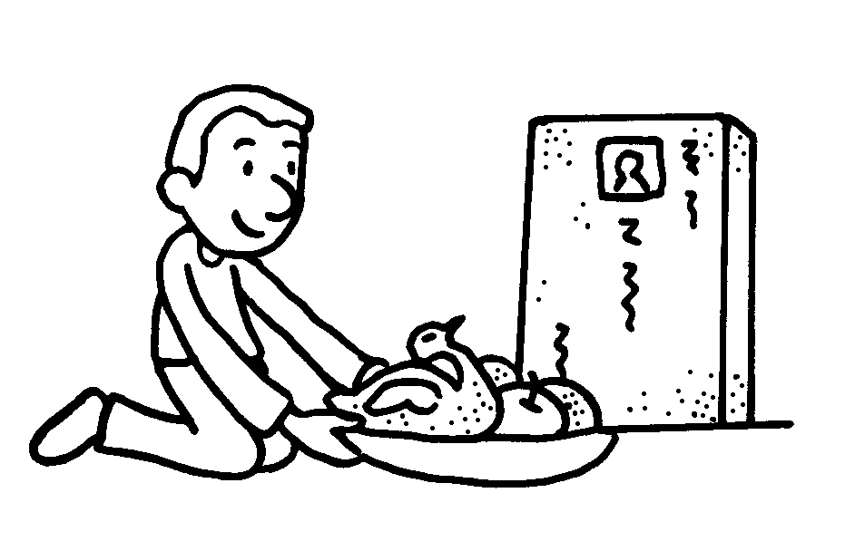 | 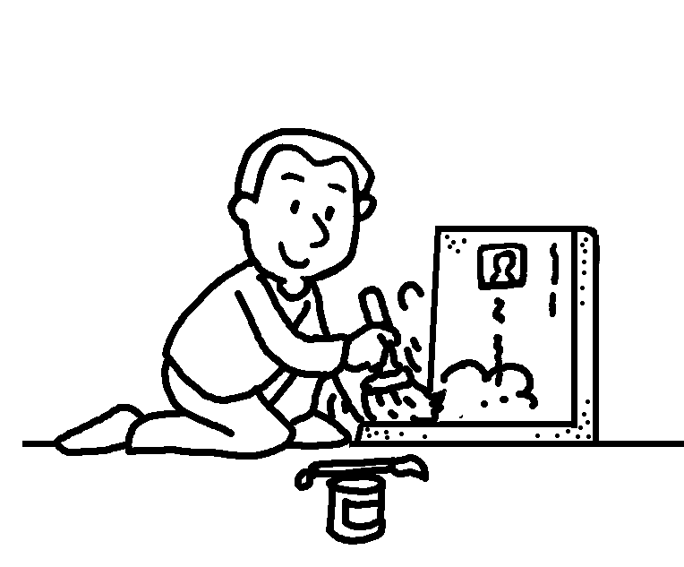 | 7  8 | give to  dead relatives  sweep

lanterns | moon cakes | riddles | starfruit

Mid-Autumn Festival |  | 9  10  11  12 | buy  eat  tie to lanterns  light
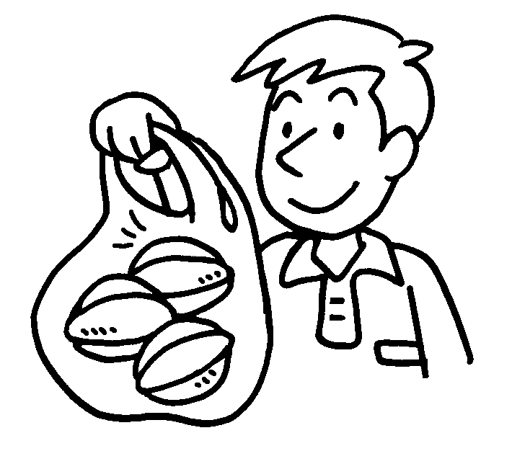 | 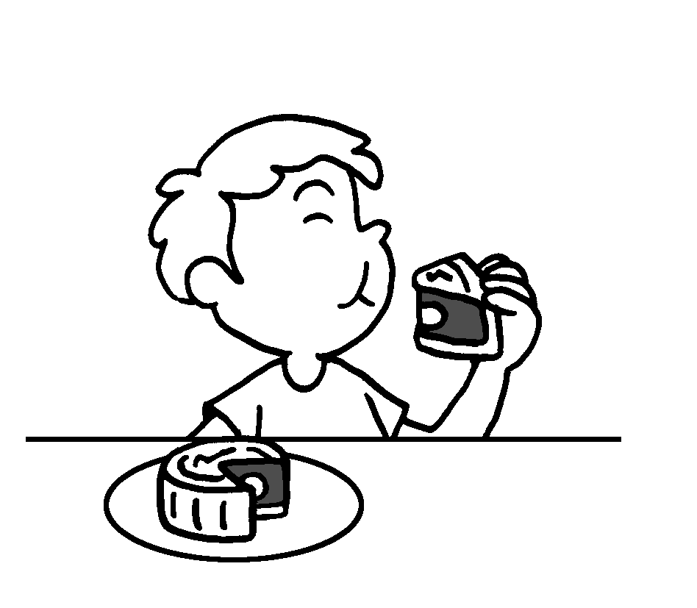 | 9  10  11  12 | buy  eat  tie to lanterns  light
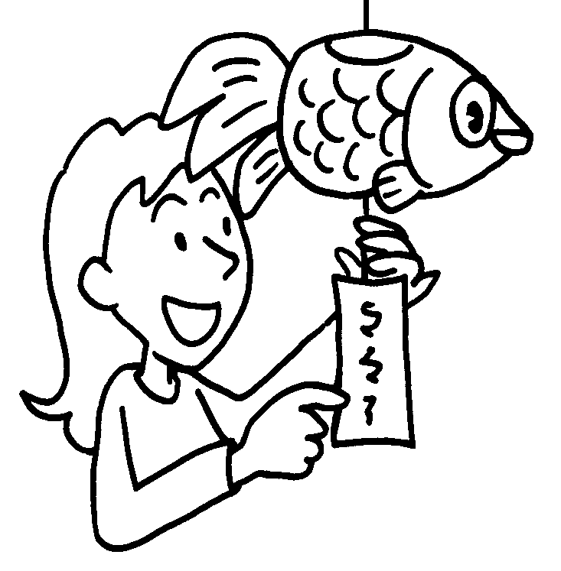 | 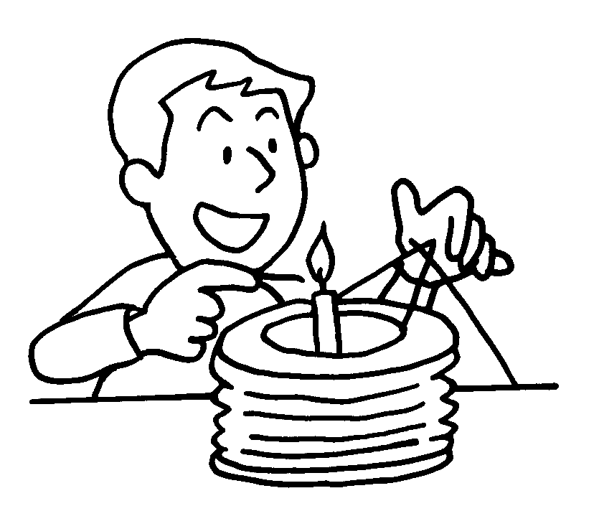 | 9  10  11  12 | buy  eat  tie to lanterns  light


Book 6A Chapter 7 Graded Worksheets
Worksheet 1⬇
- lion dance
- good luck flowers
- red paper
- rice cakes and turnip cakes
- parades
- firework displays
- special food
- graves
- starfruit
- moon cakes
- riddles
- lanterns

