What do people do at different festivals? Write.

Chinese New Year  1  2  3  4  5  6  7  8  9  10  11  12 |  |  | 1 | perform the l  d
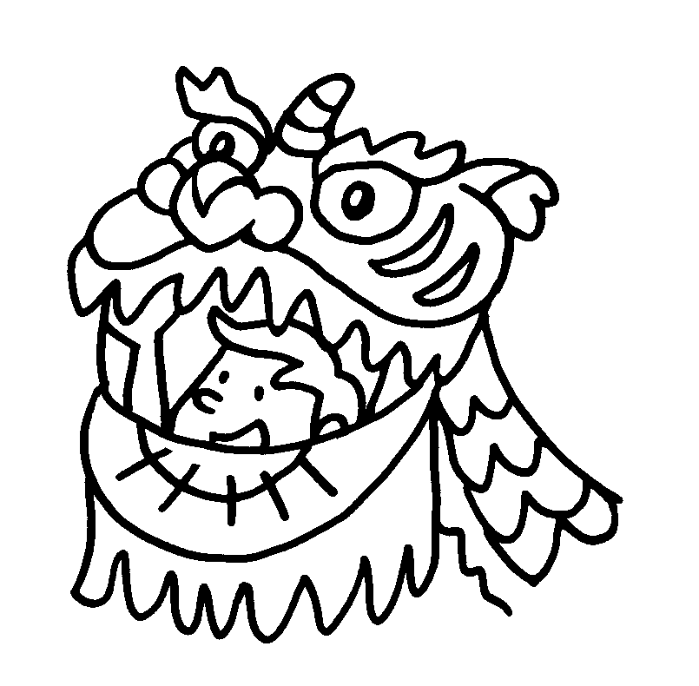 | 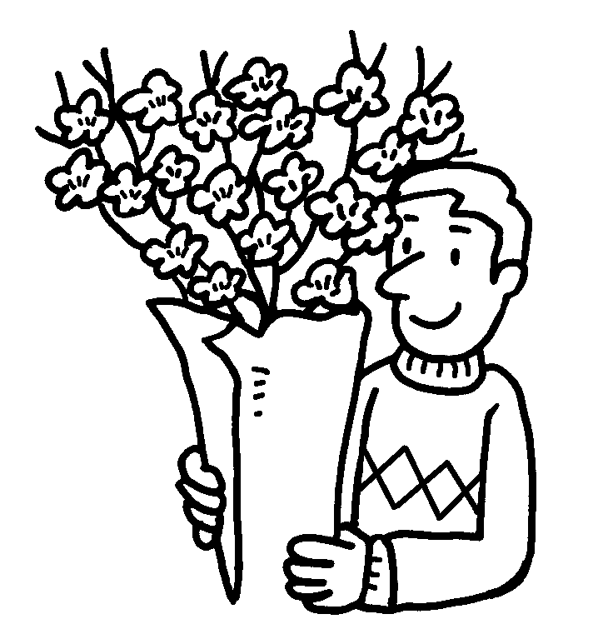 | 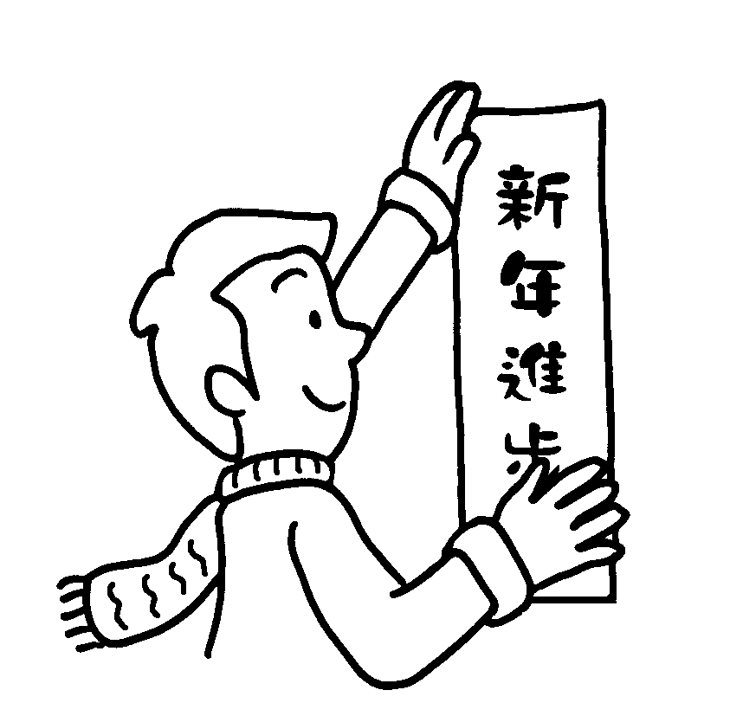 | 2 | buy g l  f
 |  |  | 3 | decorate home with r  p
 |  |  | 4 | eat r c  and t c
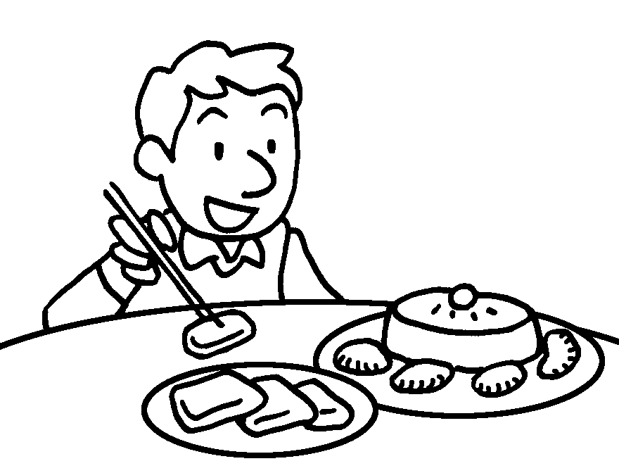 | 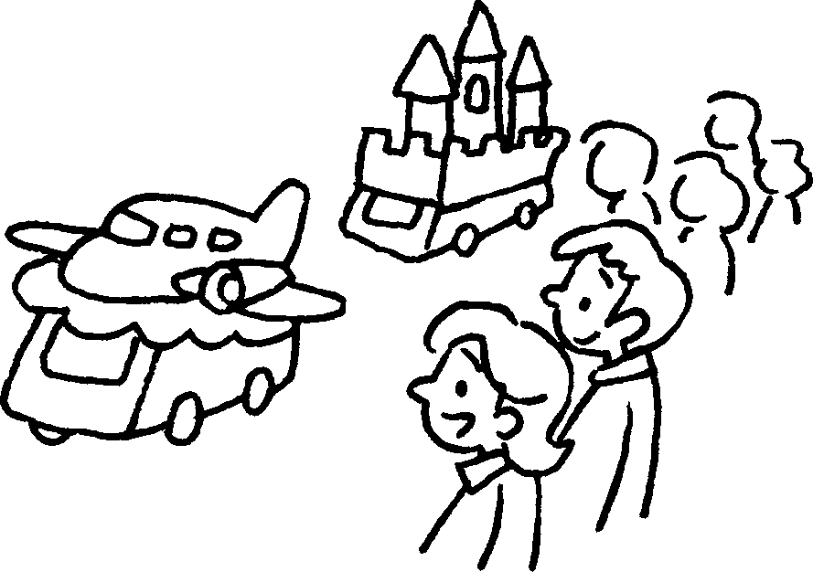 | 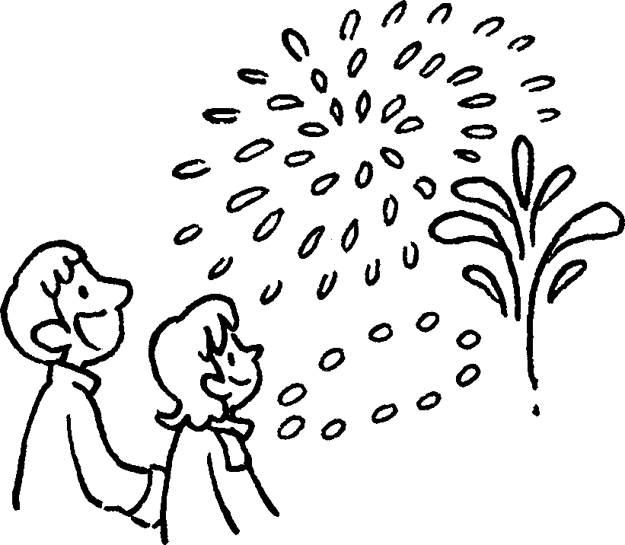 | 4 | eat r c  and t c
 |  |  | 5 | watch p
 |  |  | 6 | watch f  d

Ching Ming Festival |  |  | 7  8 |  | give s f to dead relatives  sweep g
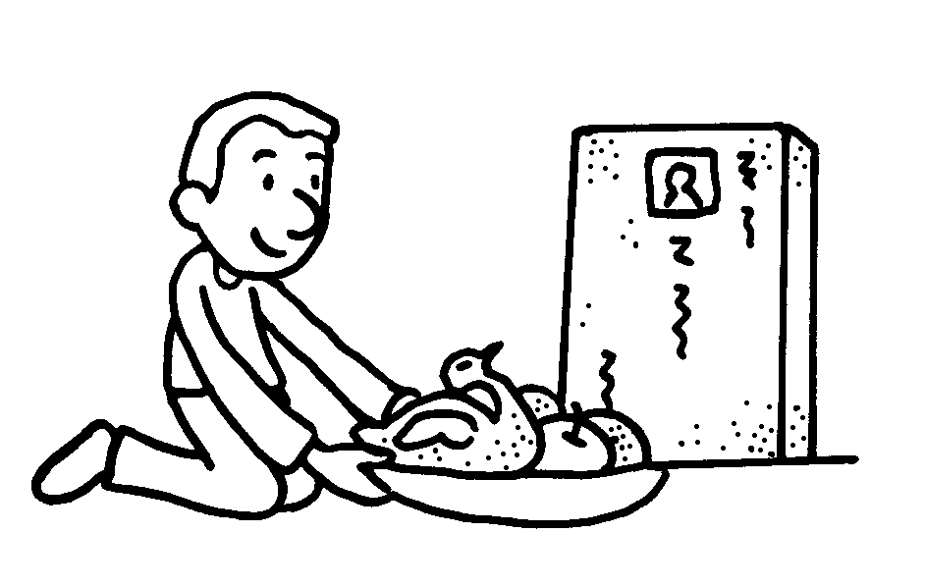 | 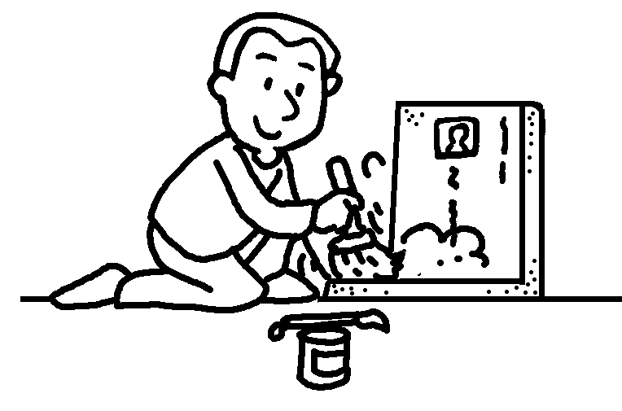

Mid-Autumn Festival |  | 9  10  11  12 | buy s  eat m c  tie r to lanterns  light l
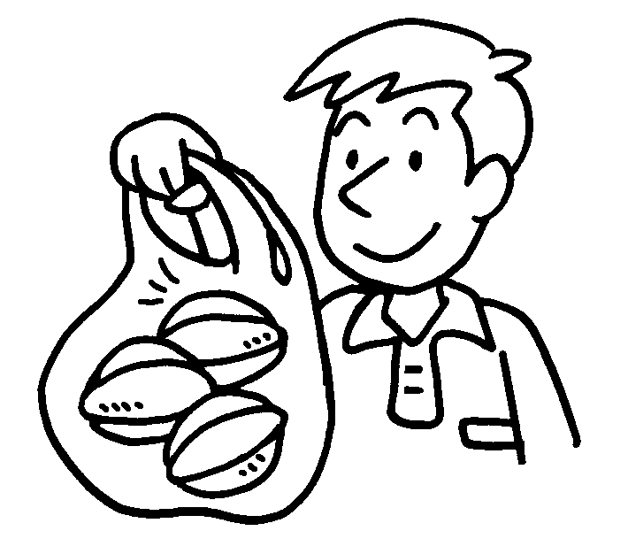 | 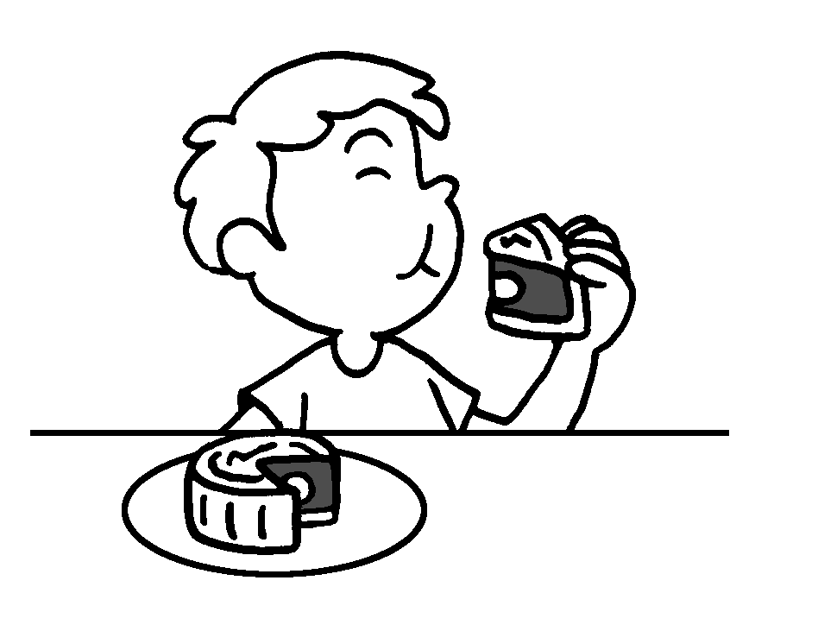 | 9  10  11  12 | buy s  eat m c  tie r to lanterns  light l
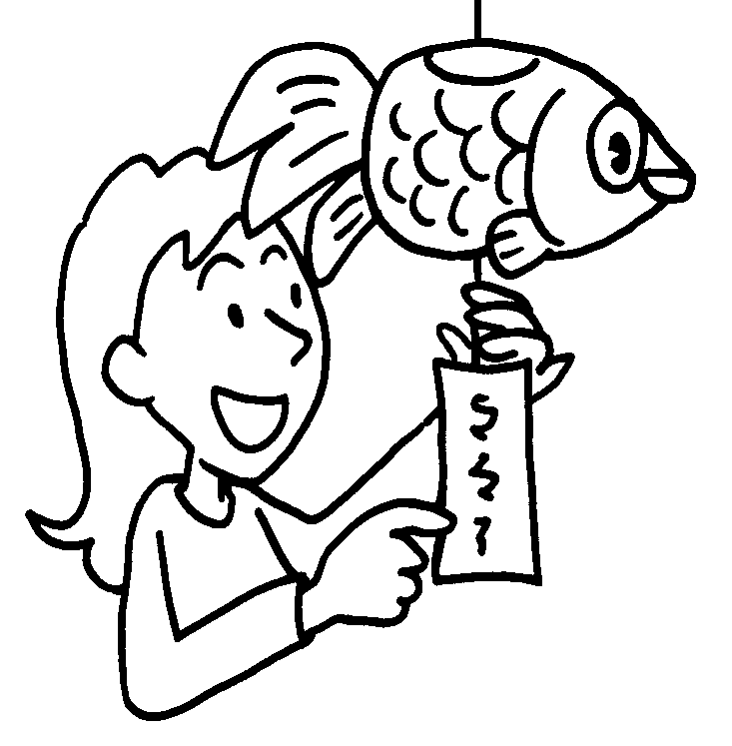 | 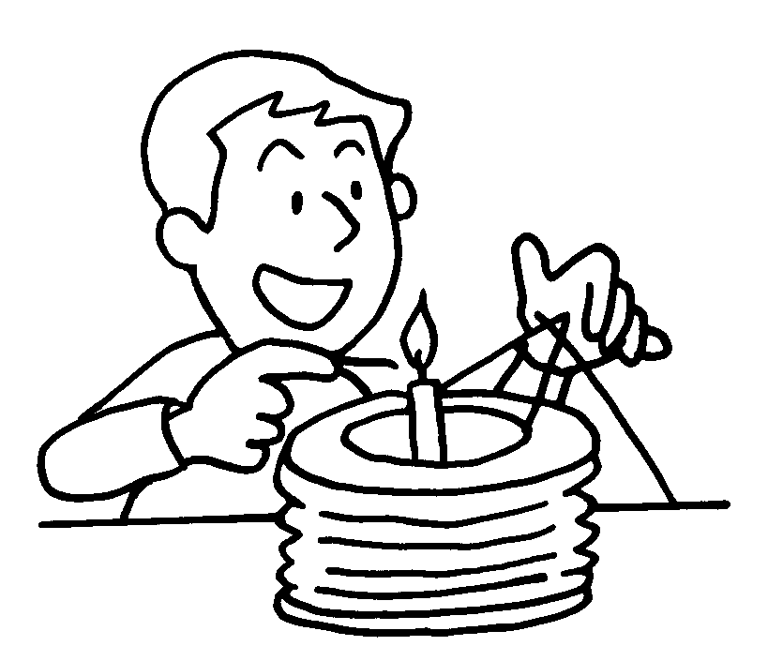 | 9  10  11  12 | buy s  eat m c  tie r to lanterns  light l


Book 6A Chapter 7 Graded Worksheets
Worksheet 1⬇⬇
- lion dance
- good luck flowers
- red paper
- rice cakes turnip cakes
- parades
- firework displays
- special food
- graves
- starfruit
- moon cakes
- riddles
- lanterns

