What do people do at different festivals? Write.

Chinese New Year  1  2  3  4  5  6  7  8  9  10  11  12 |  |  | 1 | perform the
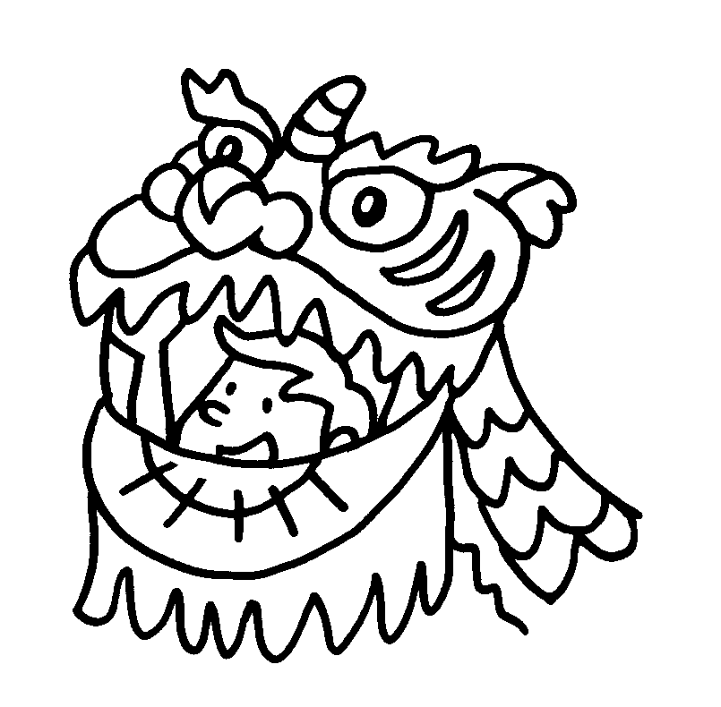 | 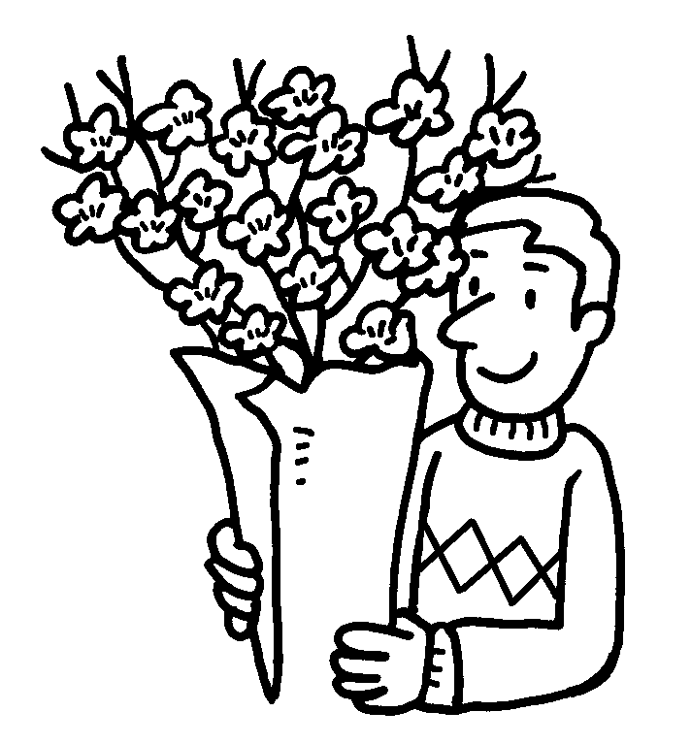 | 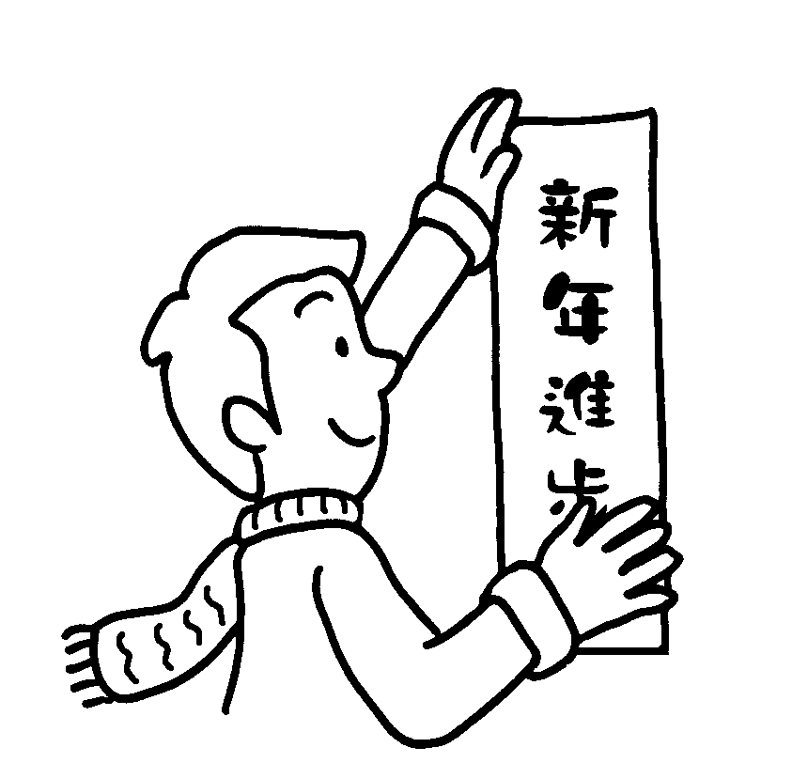 | 2 | buy
 |  |  | 3 | decorate home with
 |  |  | 4 | eat  and
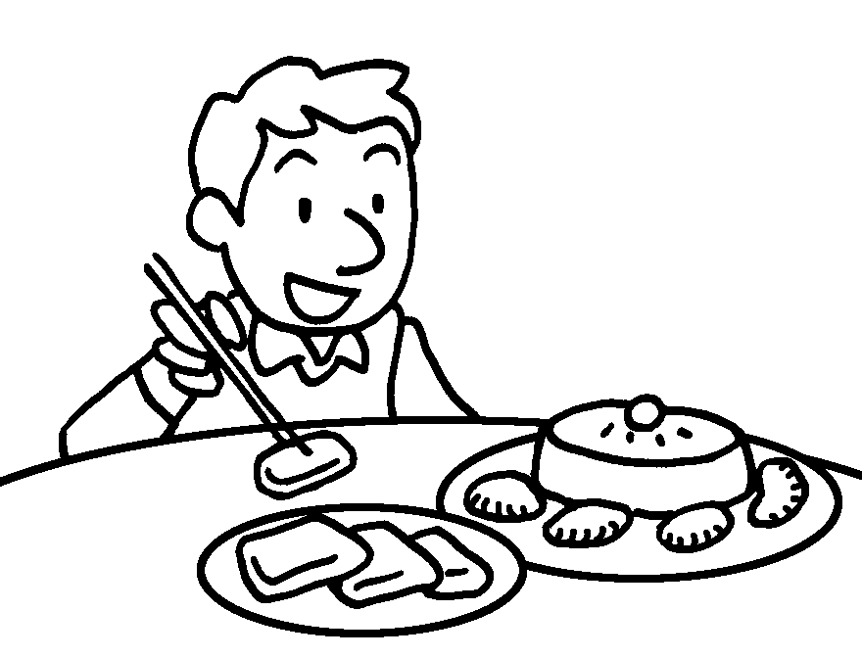 | 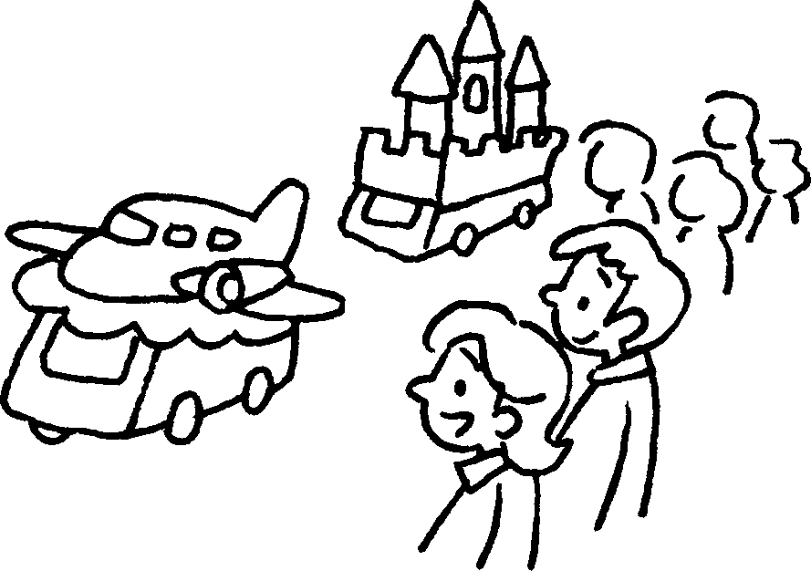 | 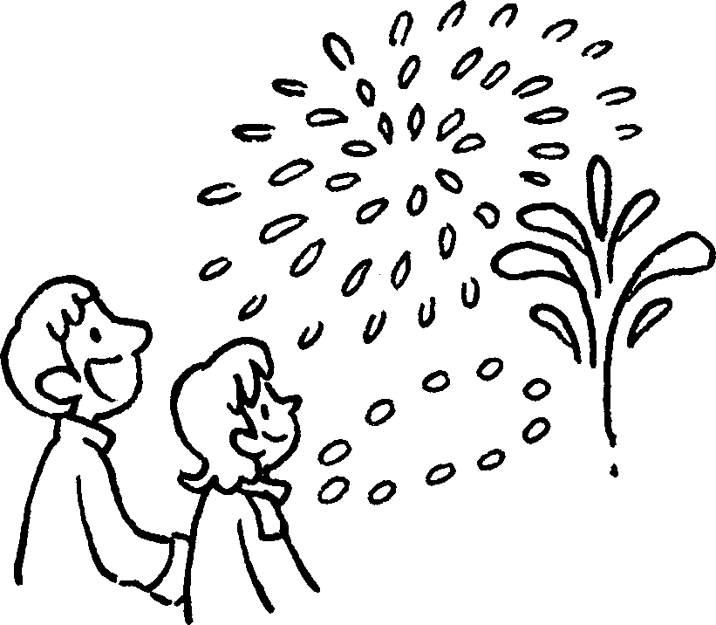 | 4 | eat  and
 |  |  | 5 | watch
 |  |  | 6 | watch

Ching Ming Festival |  |  | 7  8 |  | give to dead relatives  sweep
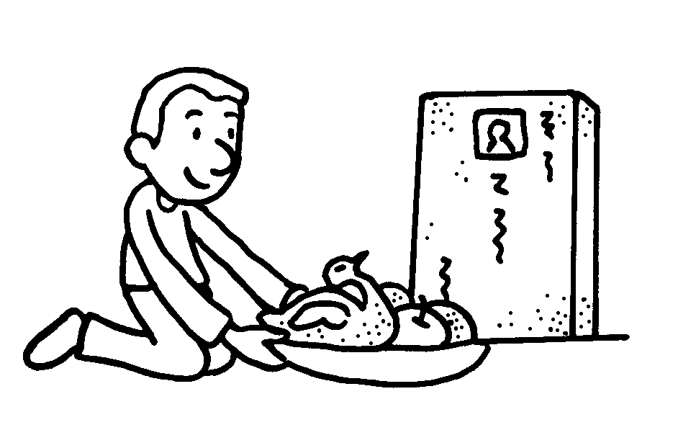 | 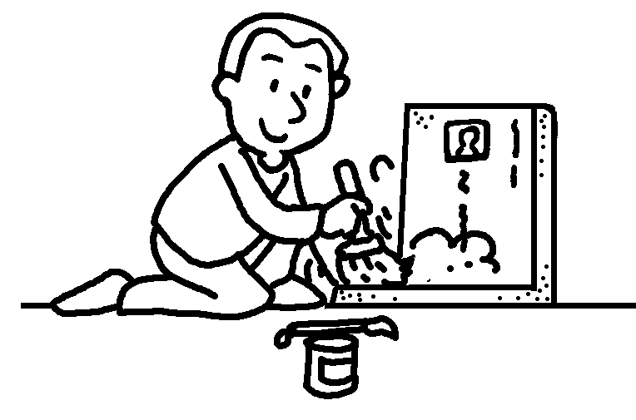

Mid-Autumn Festival |  | 9  10  11  12 | buy  eat  tie to lanterns  light
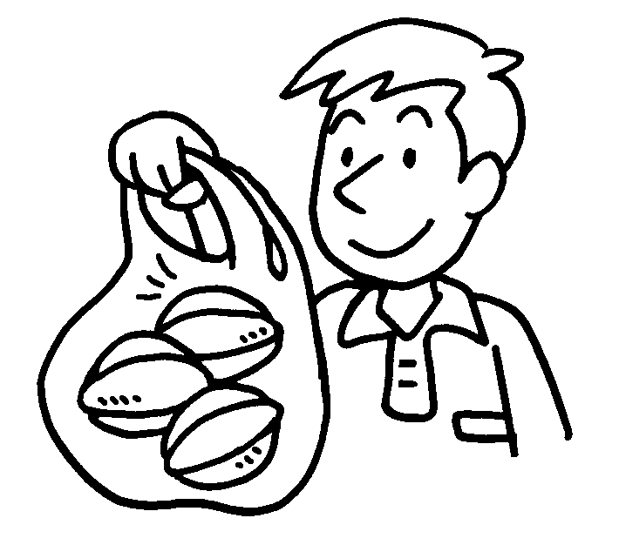 | 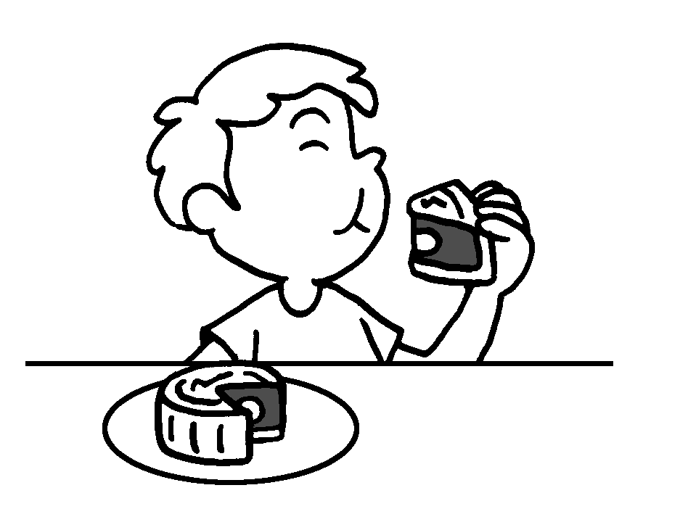 | 9  10  11  12 | buy  eat  tie to lanterns  light
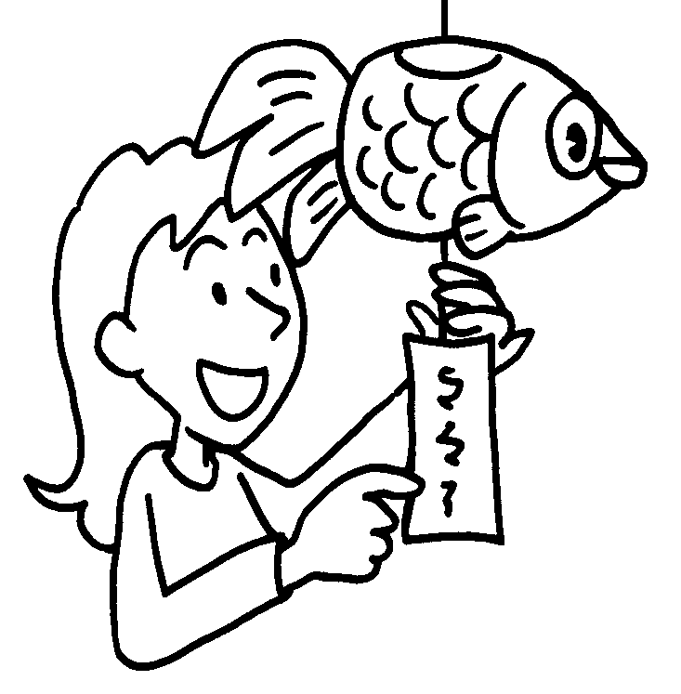 | 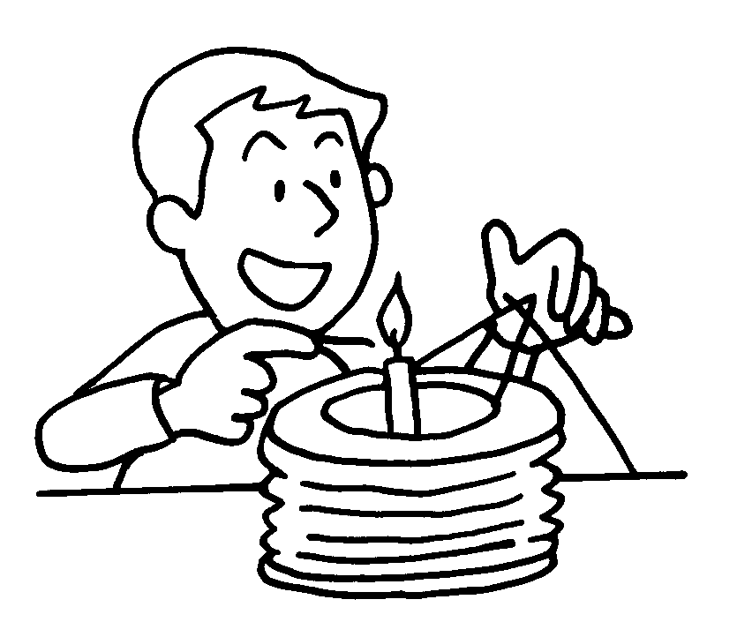 | 9  10  11  12 | buy  eat  tie to lanterns  light


Book 6A Chapter 7 Graded Worksheets
Worksheet 1⬇⬇⬇
- lion dance
- good luck flowers
- red paper
- rice cakes / turnip cakes
turnip cakes / rice cakes
- parades
- firework displays
- special food
- graves
- starfruit
- moon cakes
- riddles
- lanterns
(Accept any reasonable answers.)

