Finish the sentences. Use the passive voice.

is | are

1 | Rice dumplings ( eat ) at Dragon Boat Festival. | 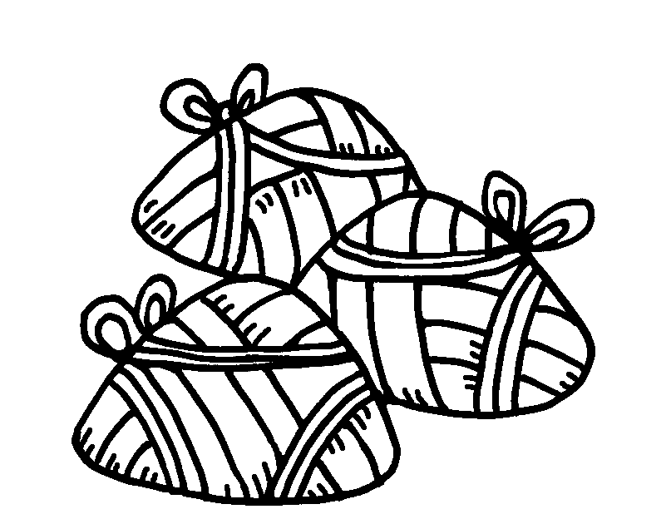
2 | Trees ( decorate ) at Christmas. | 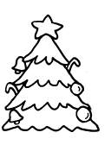
3 | Good luck flowers ( buy ) at Chinese New Year. | 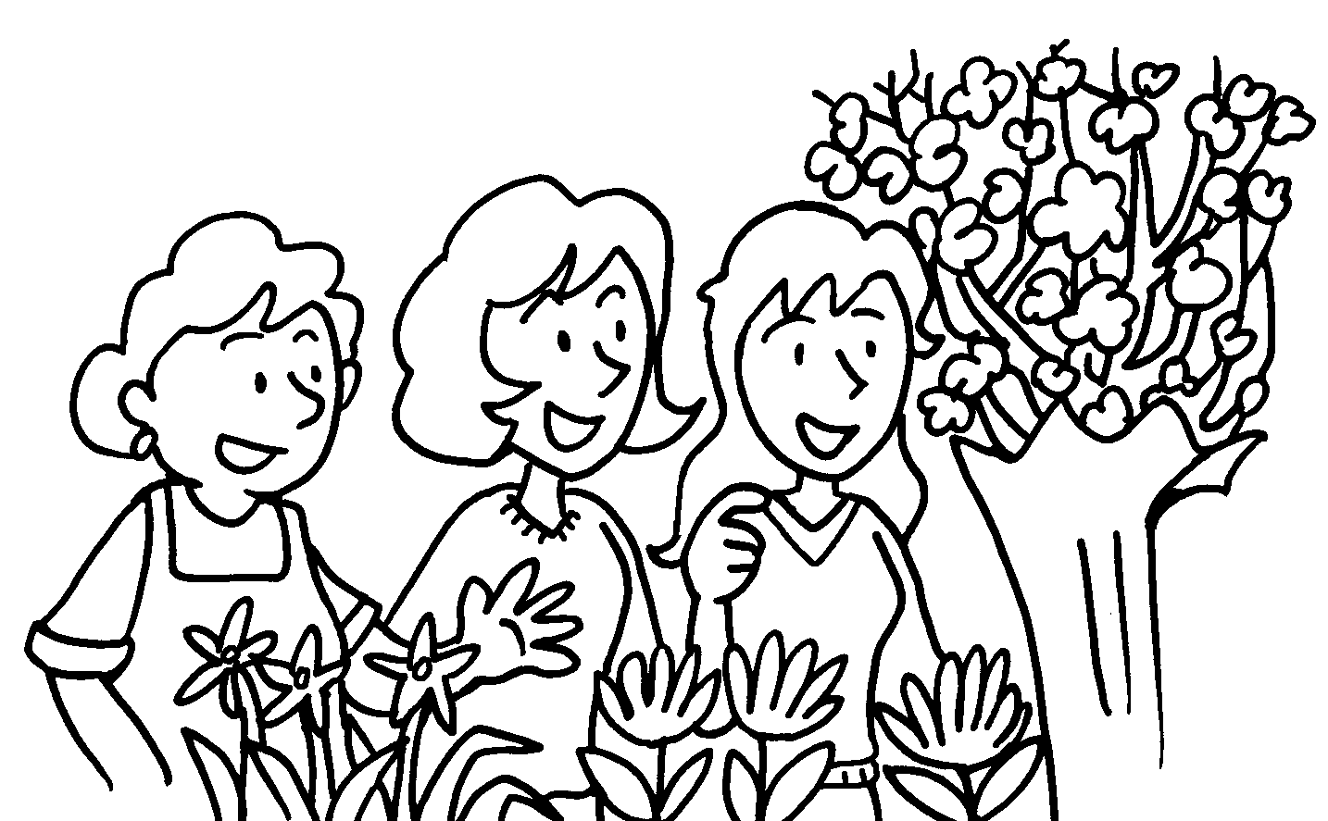
4 | Red paper ( use ) to decorate homes at Chinese New Year. | 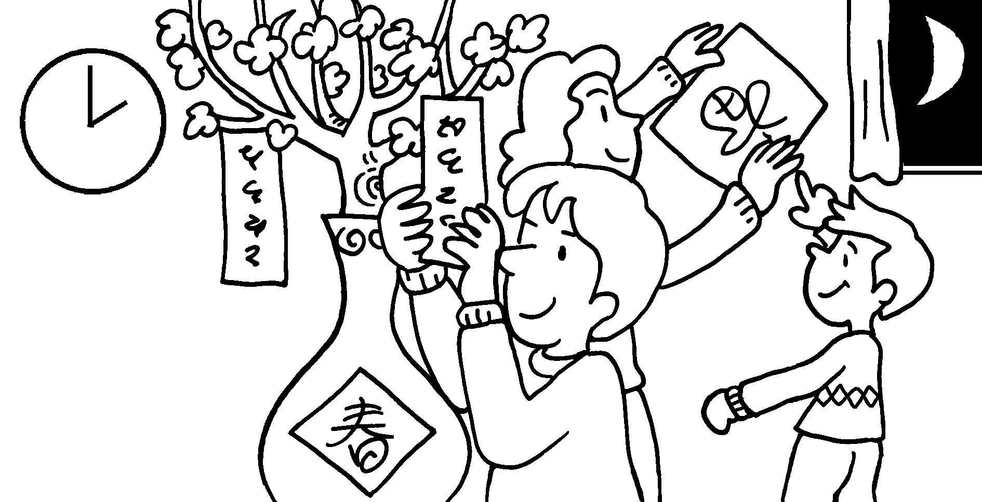
5 | Chocolate eggs ( give ) to children at Easter. | 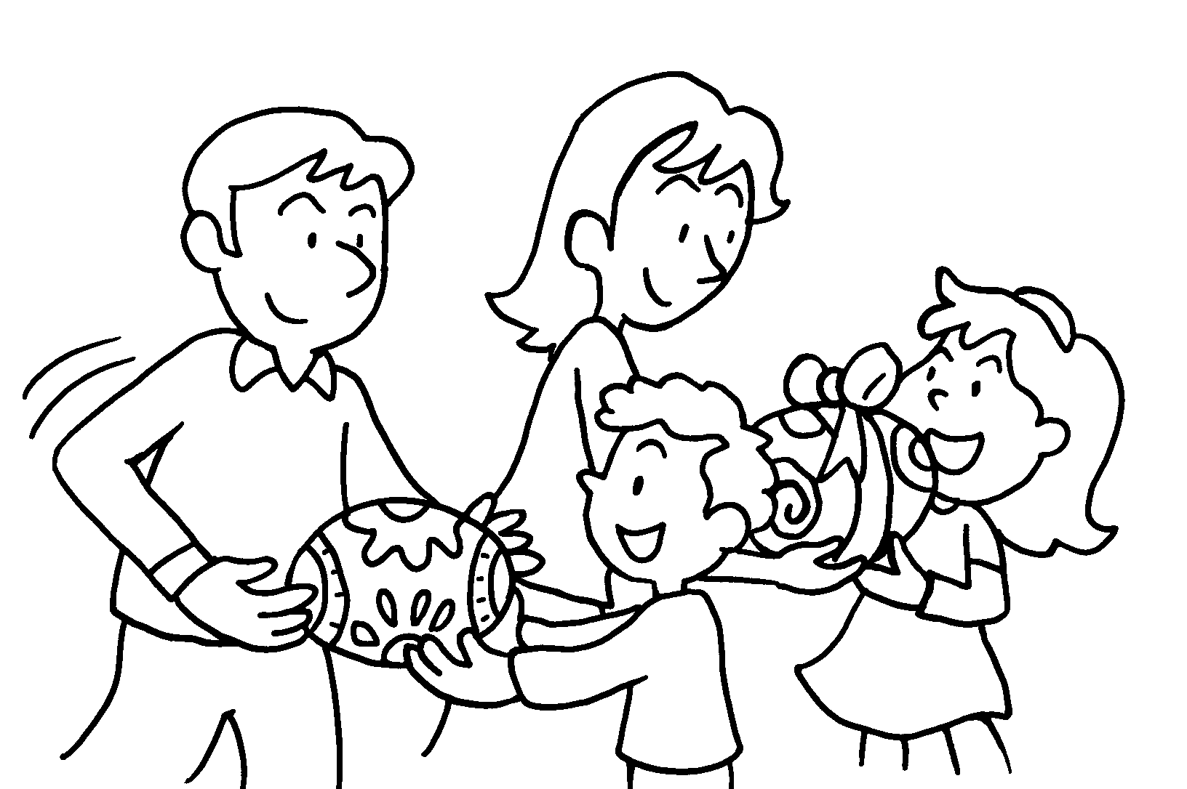
6 | Lucky money ( give ) to children at Chinese New Year. | 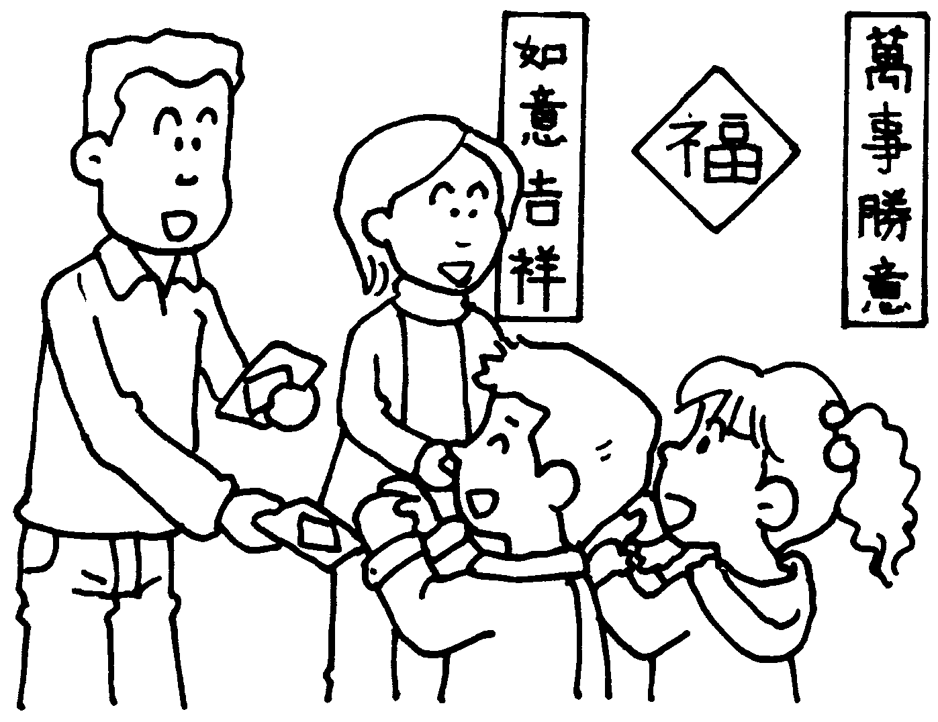


Book 6A Chapter 7 Graded Worksheets
Worksheet 2⬇
- are eaten
- are decorated
- are bought
- is used
- are given
- is given

