Finish the sentences. Use the passive voice.

is / are buy decorate eat give use

1 | Rice dumplings at Dragon Boat Festival. | 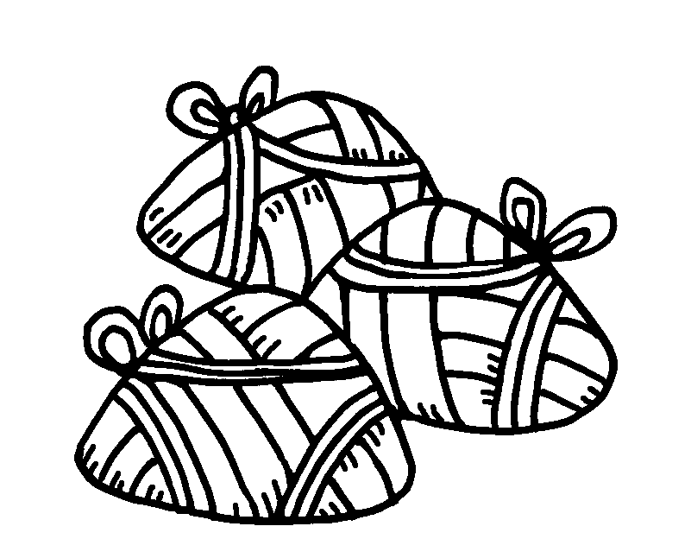
2 | Trees at Christmas. | 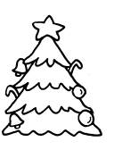
3 | Good luck flowers at Chinese New Year. | 
4 | Red paper to decorate homes at Chinese New Year. | 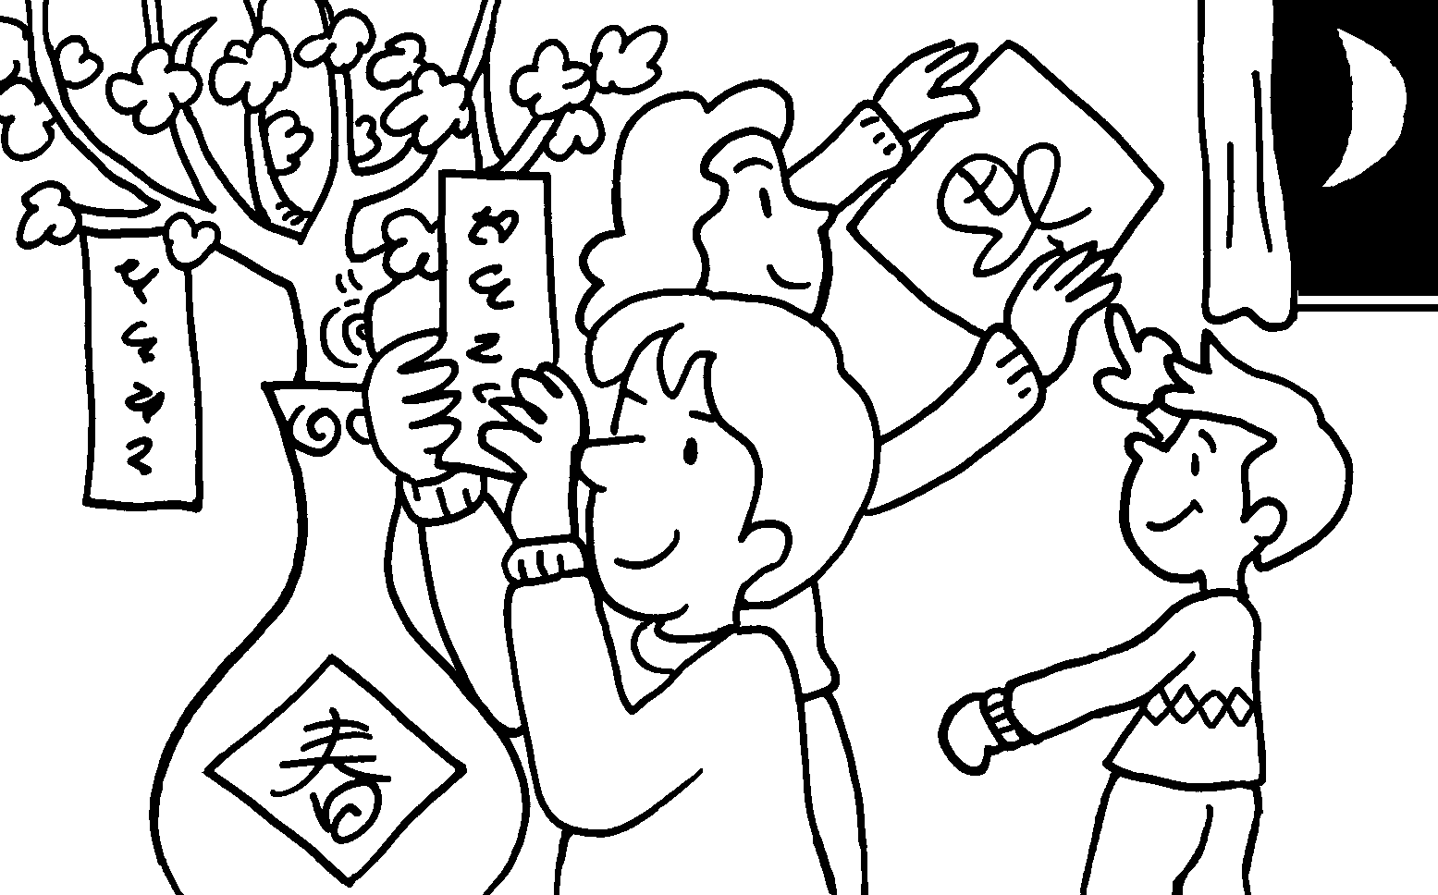
5 | Chocolate eggs to children at Easter. | 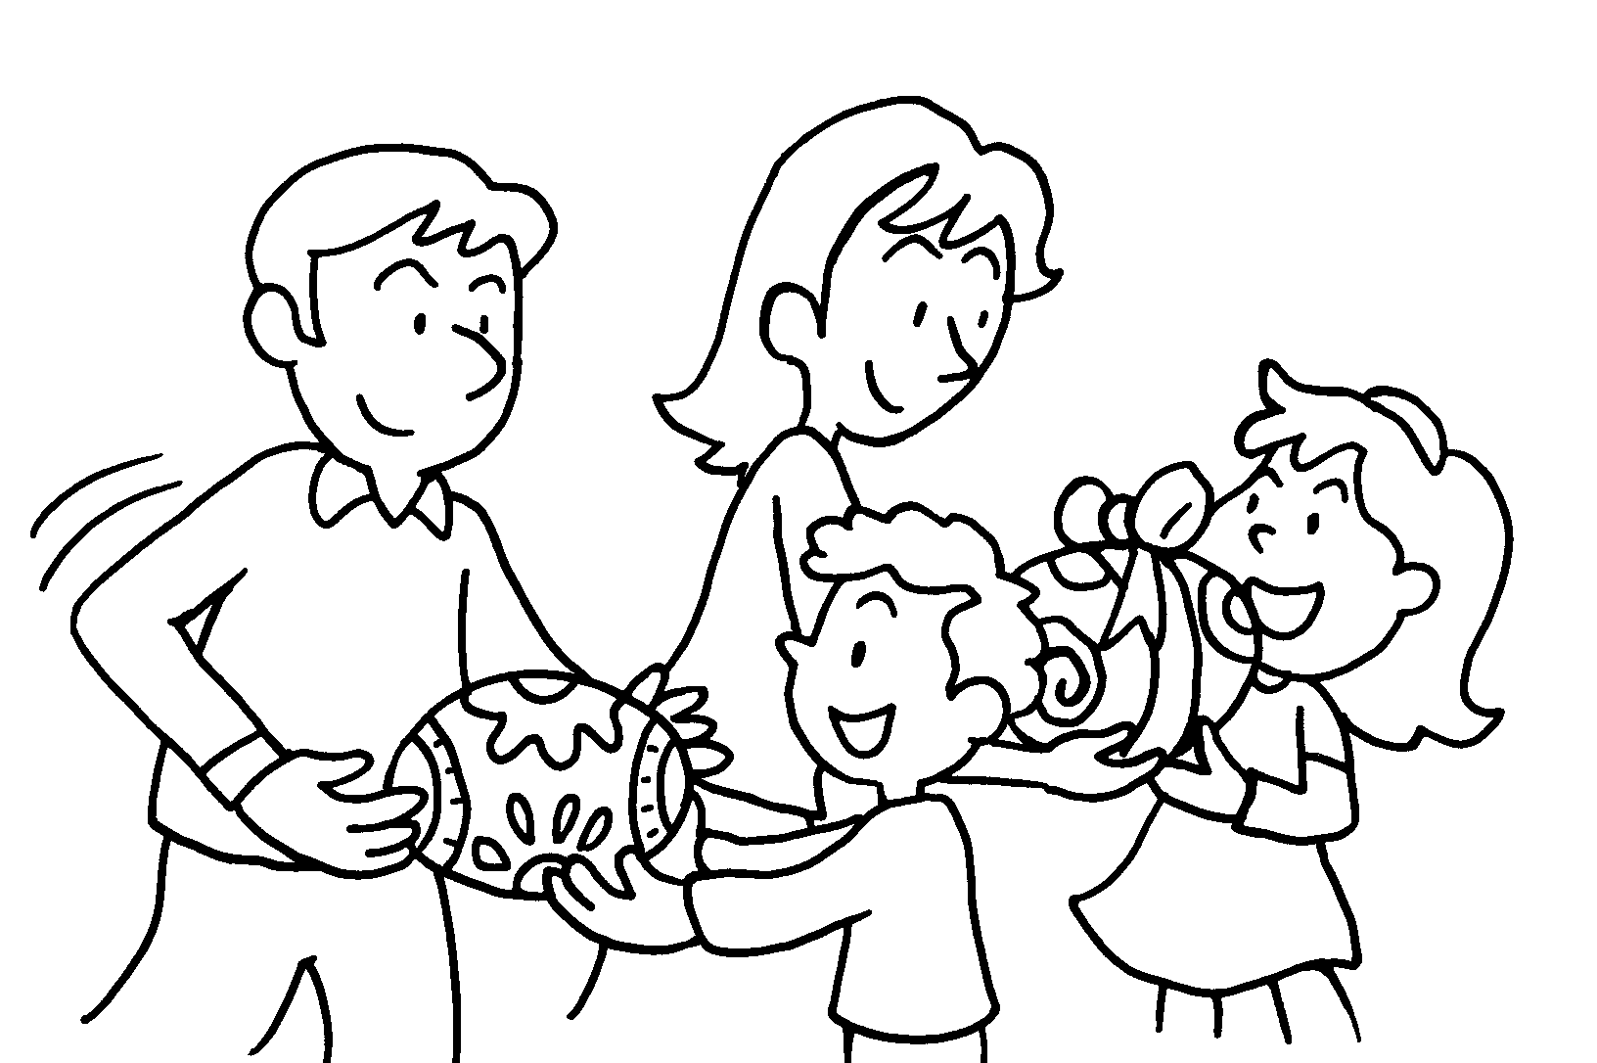
6 | Lucky money to children at Chinese New Year. | 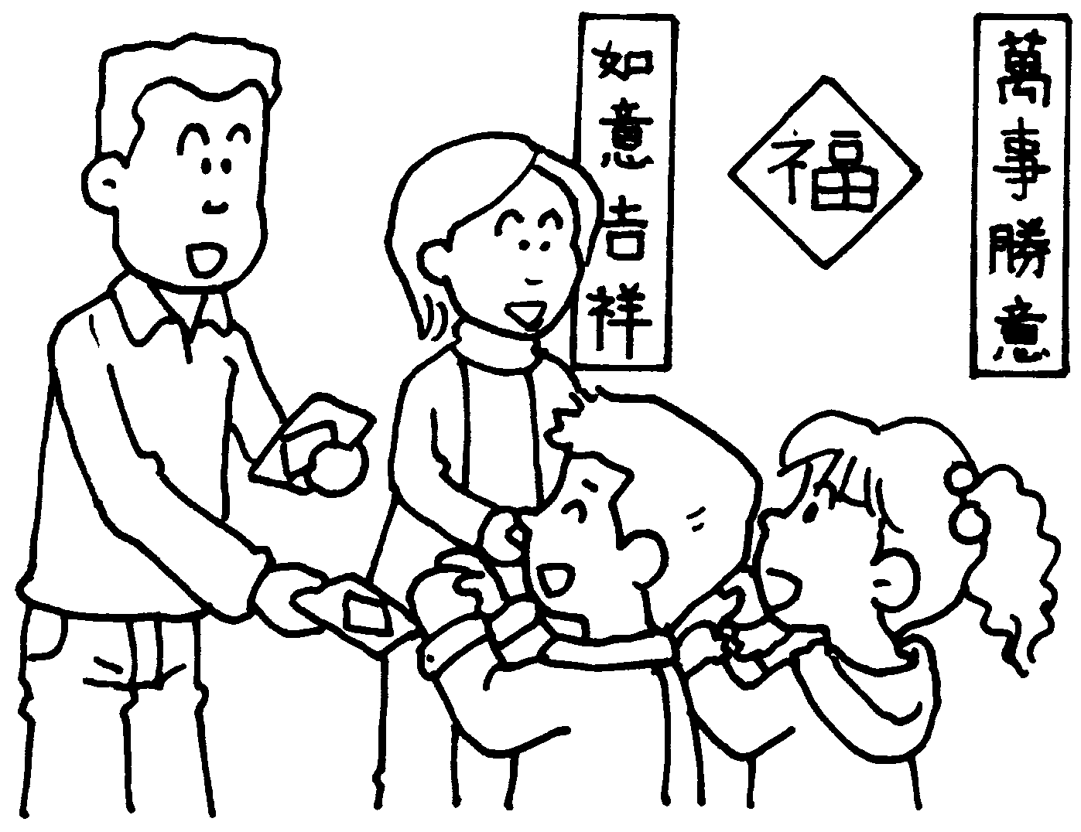


Book 6A Chapter 7 Graded Worksheets
Worksheet 2⬇⬇
- are eaten
- are decorated
- are bought
- is used
- are given
- is given

