Finish the sentences. Use the passive voice.

red paper rice dumplings lucky money buy decorate eat
good luck flowers chocolate eggs trees give use

1 | at Dragon Boat Festival.  Rice dumplings | 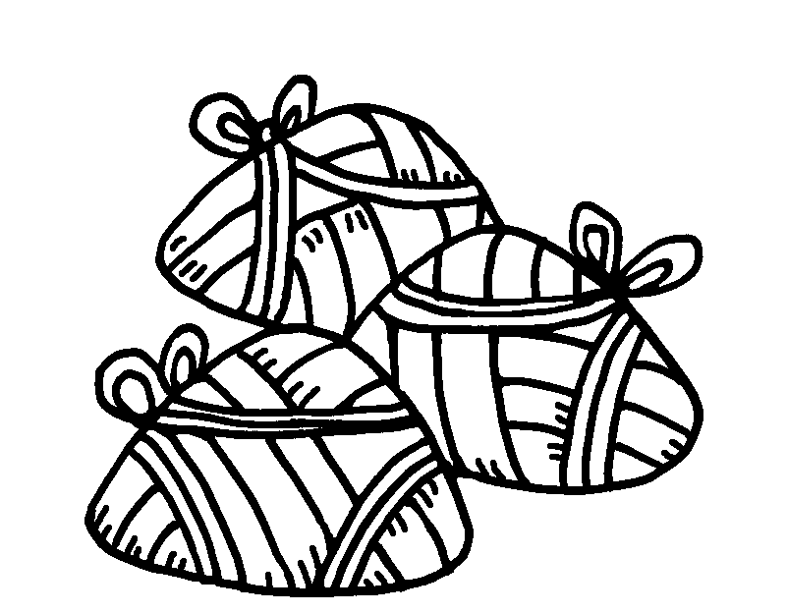
2 | at Christmas. | 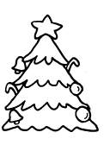
3 | at Chinese New Year. | 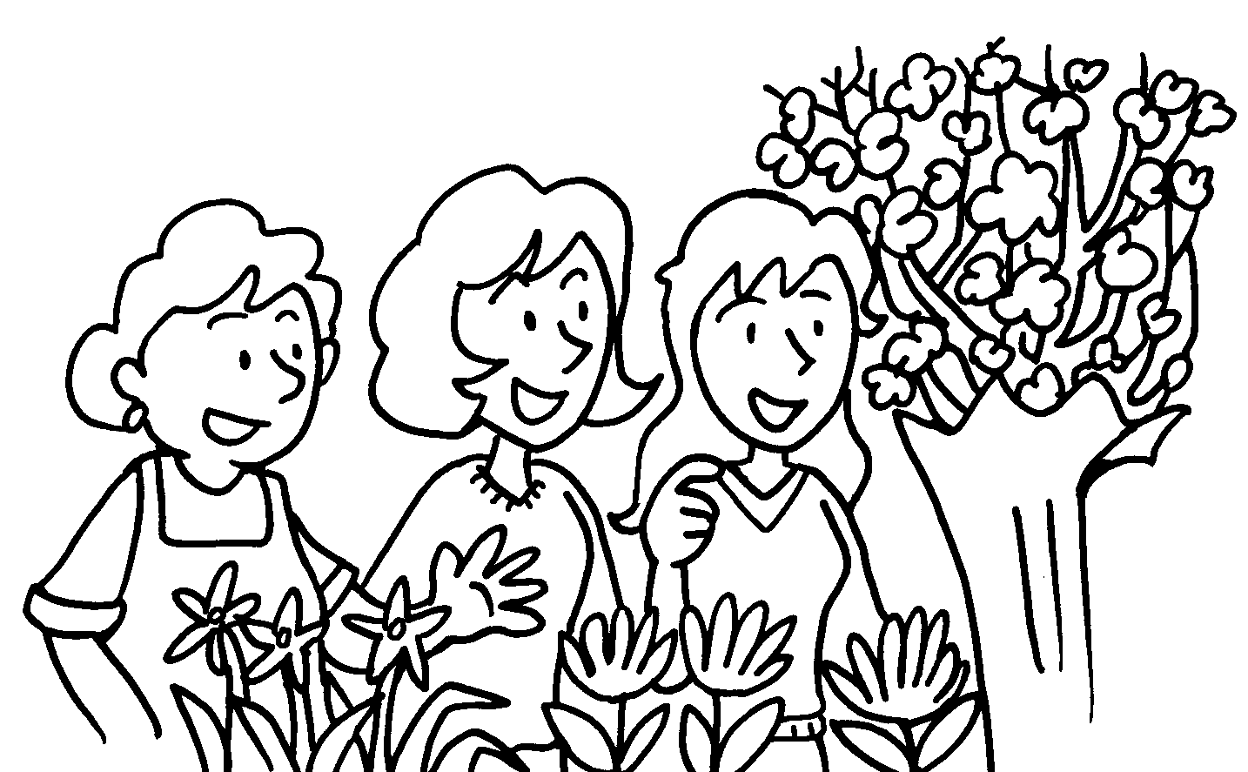
4 | to decorate homes at Chinese New Year. | 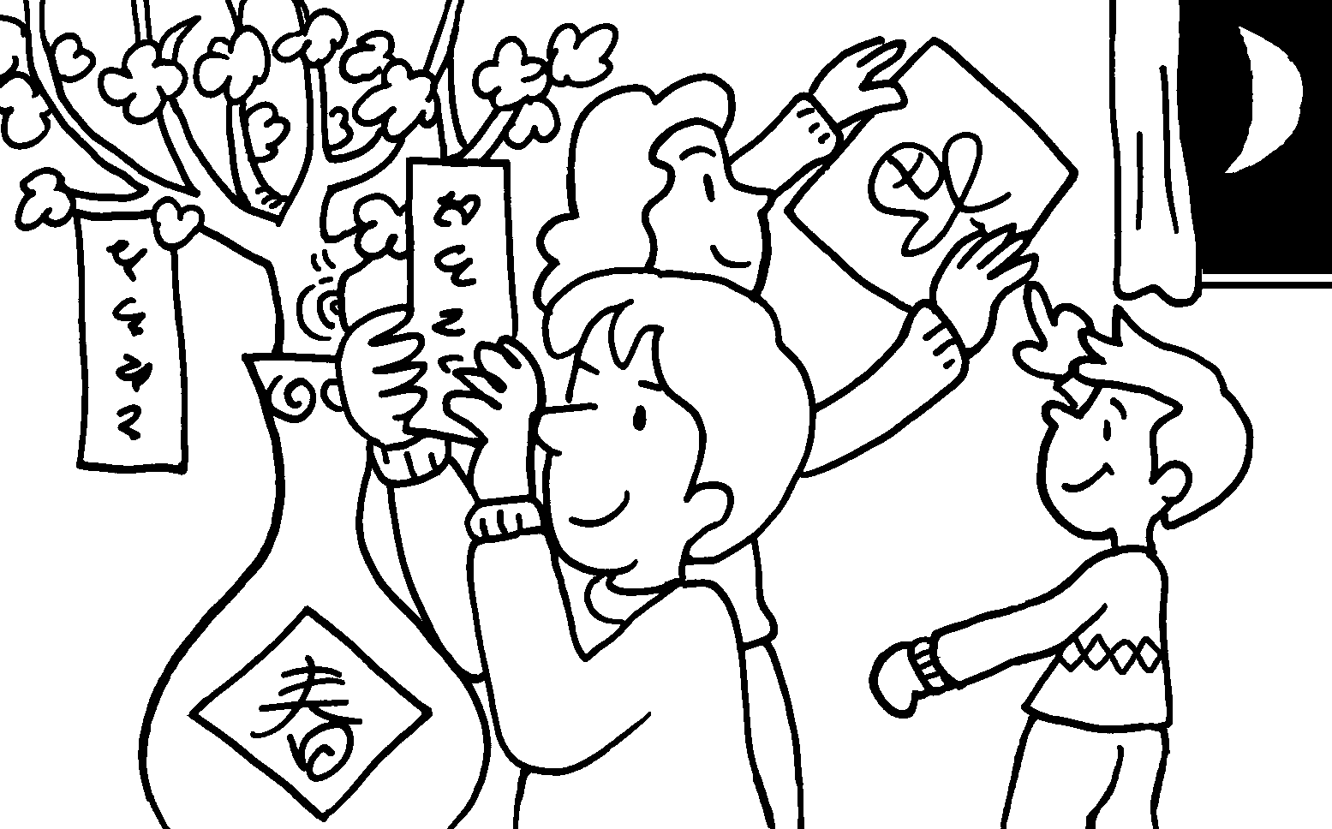
5 | to children at Easter. | 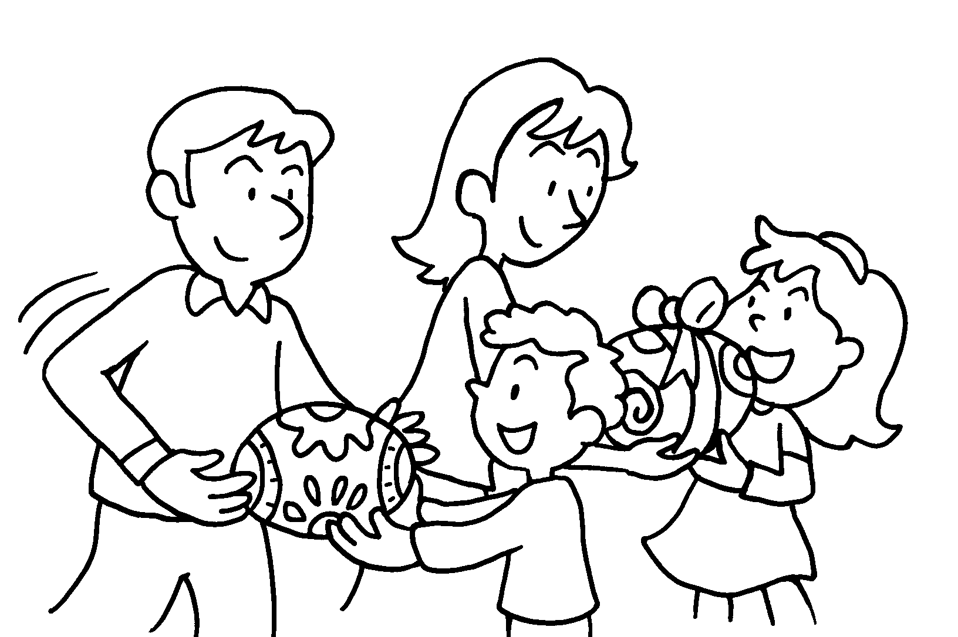
6 | to children at Chinese New Year. | 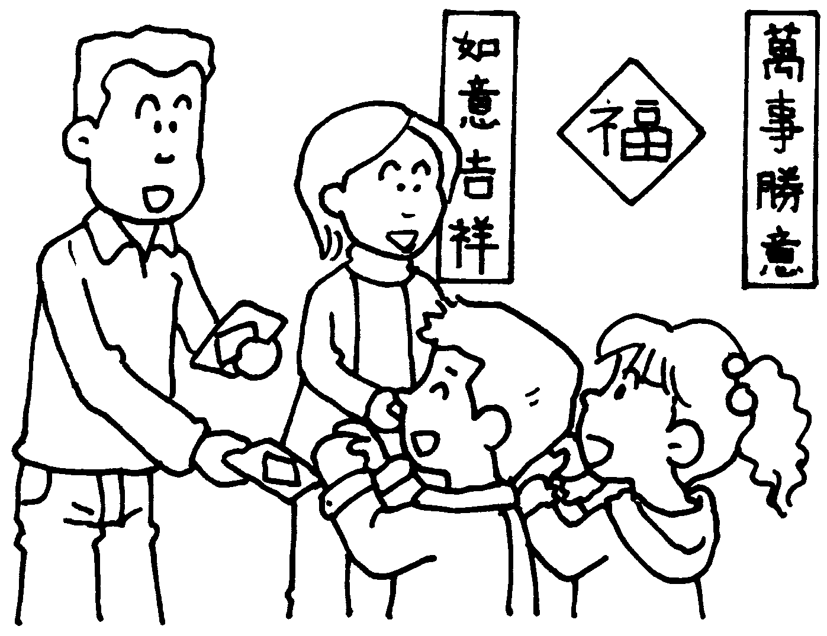


Book 6A Chapter 7 Graded Worksheets
Worksheet 2⬇⬇⬇
- are eaten
- Trees are decorated
- Good luck flowers are bought
- Red paper is used
- Chocolate eggs are given
6 Lucky money is given

