Finish the sentences. Use the passive voice.

riddles presents and cards graves eat give tie
moon cakes the board sweep decorate

1 | to friends at Christmas.  Presents and cards | 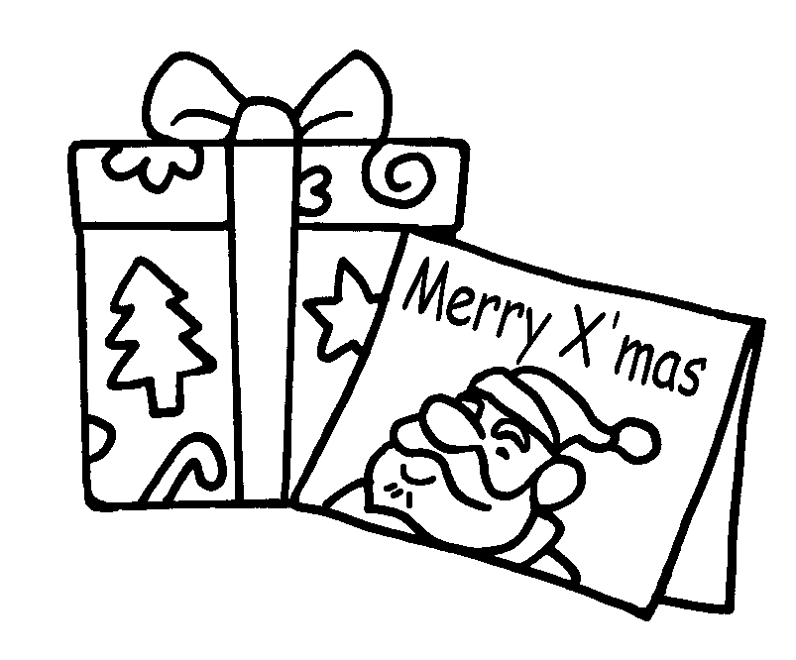
2 | at Mid-Autumn Festival. | 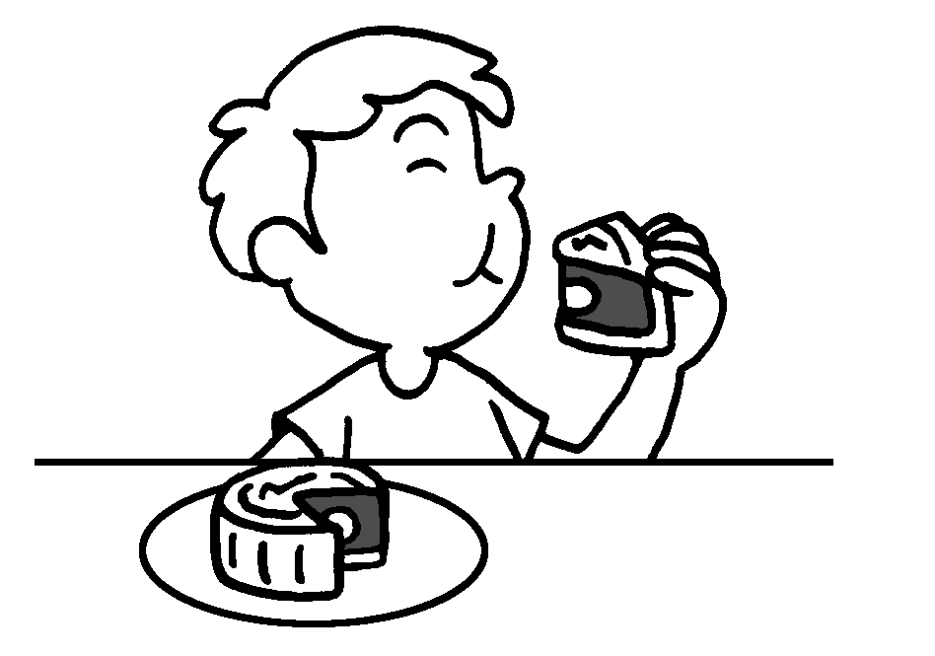
3 | with cards at Christmas. | 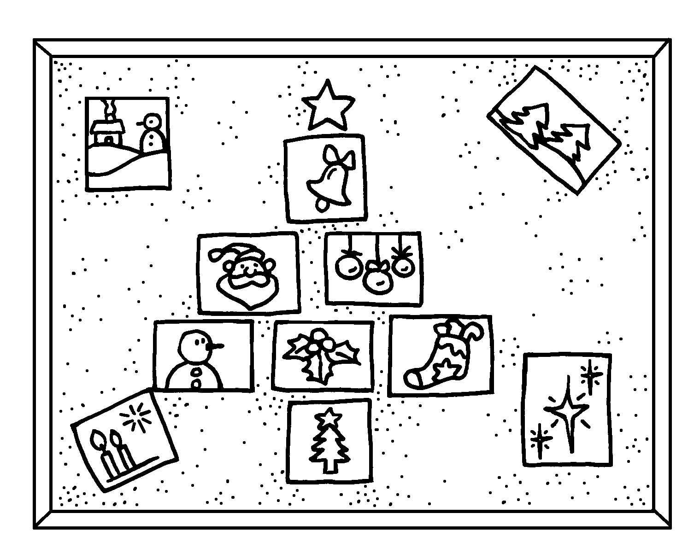
4 | to lanterns at Mid-Autumn Festival. | 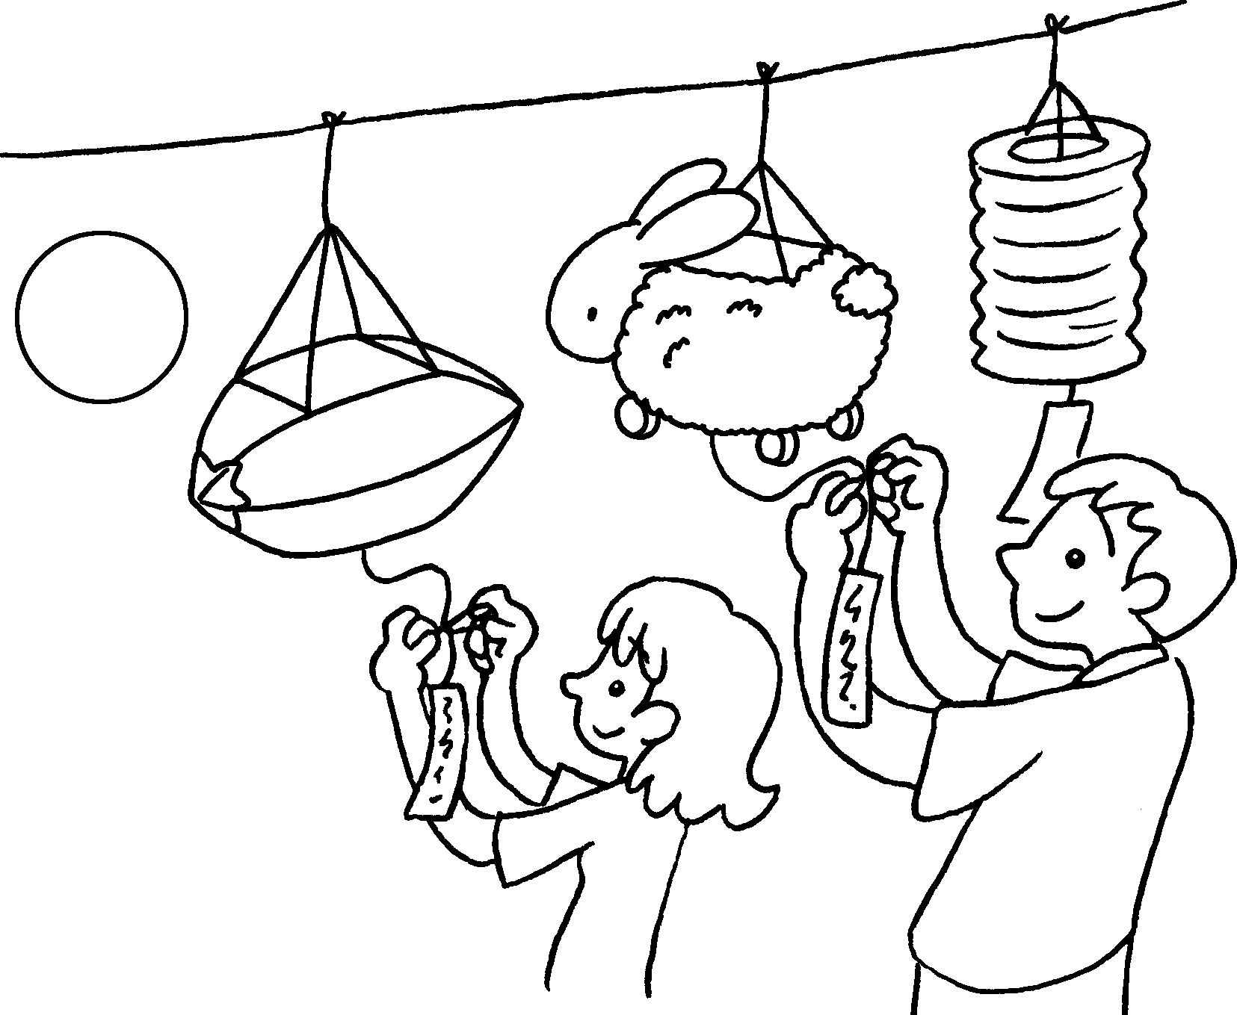
5 | at Ching Ming Festival. | 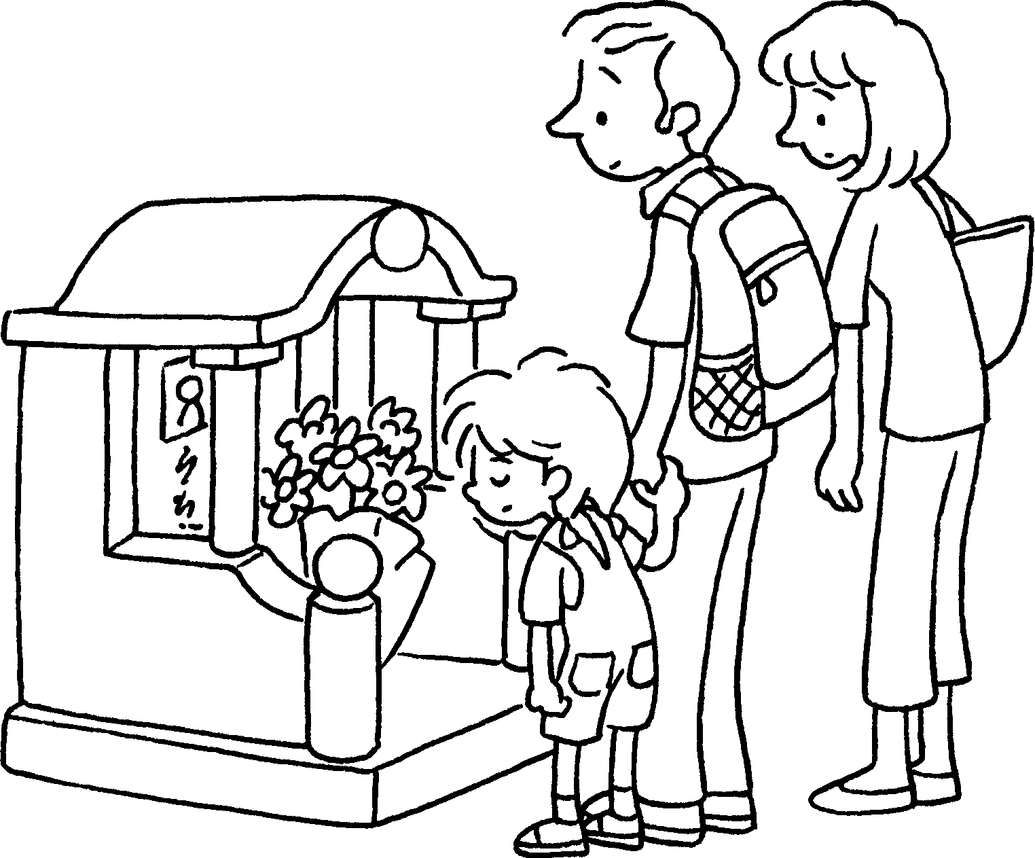


Book 6A Chapter 7 Graded Worksheets
Worksheet 3⬇
- are given
- Moon cakes are eaten
- The board is decorated
- Riddles are tied
- Graves are swept

