Rewrite the sentences using the passive voice.
1 | People give presents and cards to friends at Christmas.  Presents and cards to friends at Christmas. | 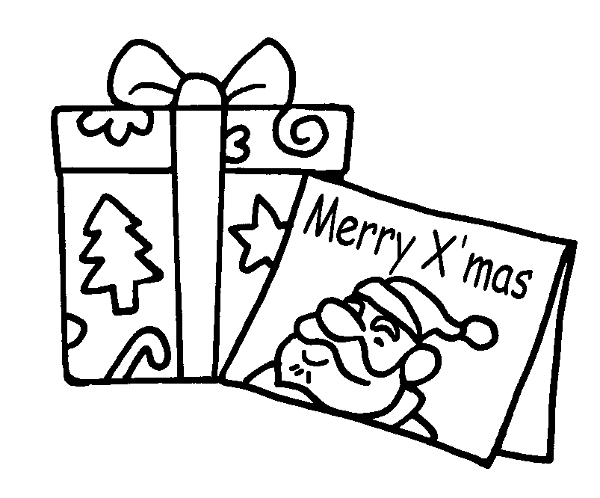
2 | People eat moon cakes at Mid-Autumn Festival.  at Mid-Autumn Festival. | 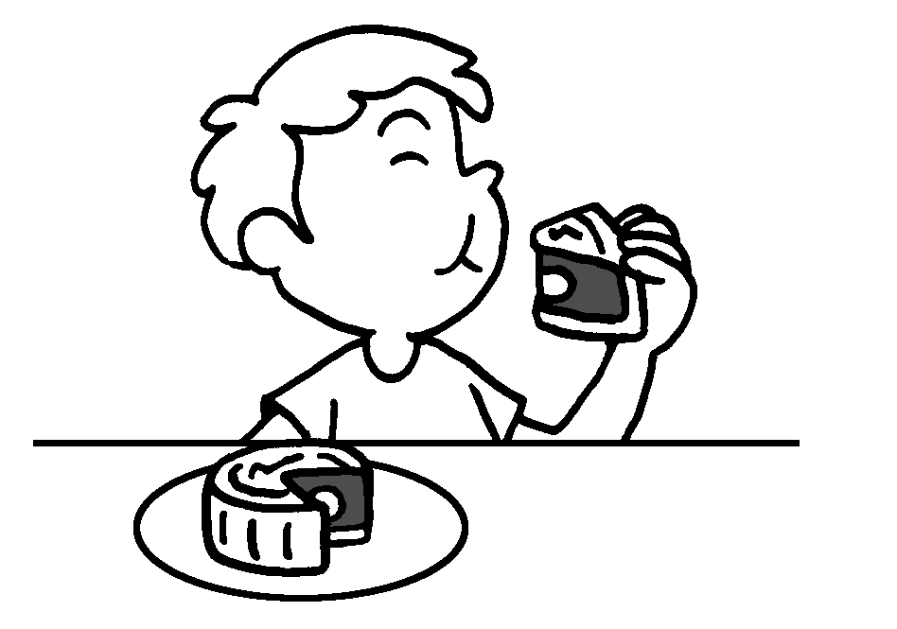
3 | We decorate the board with cards at Christmas.  at Christmas. | 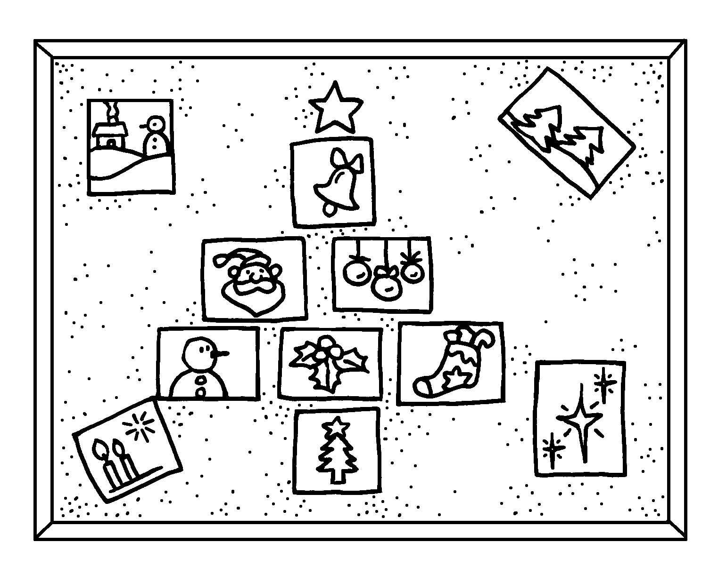
4 | People tie riddles to lanterns at Mid-Autumn Festival. | 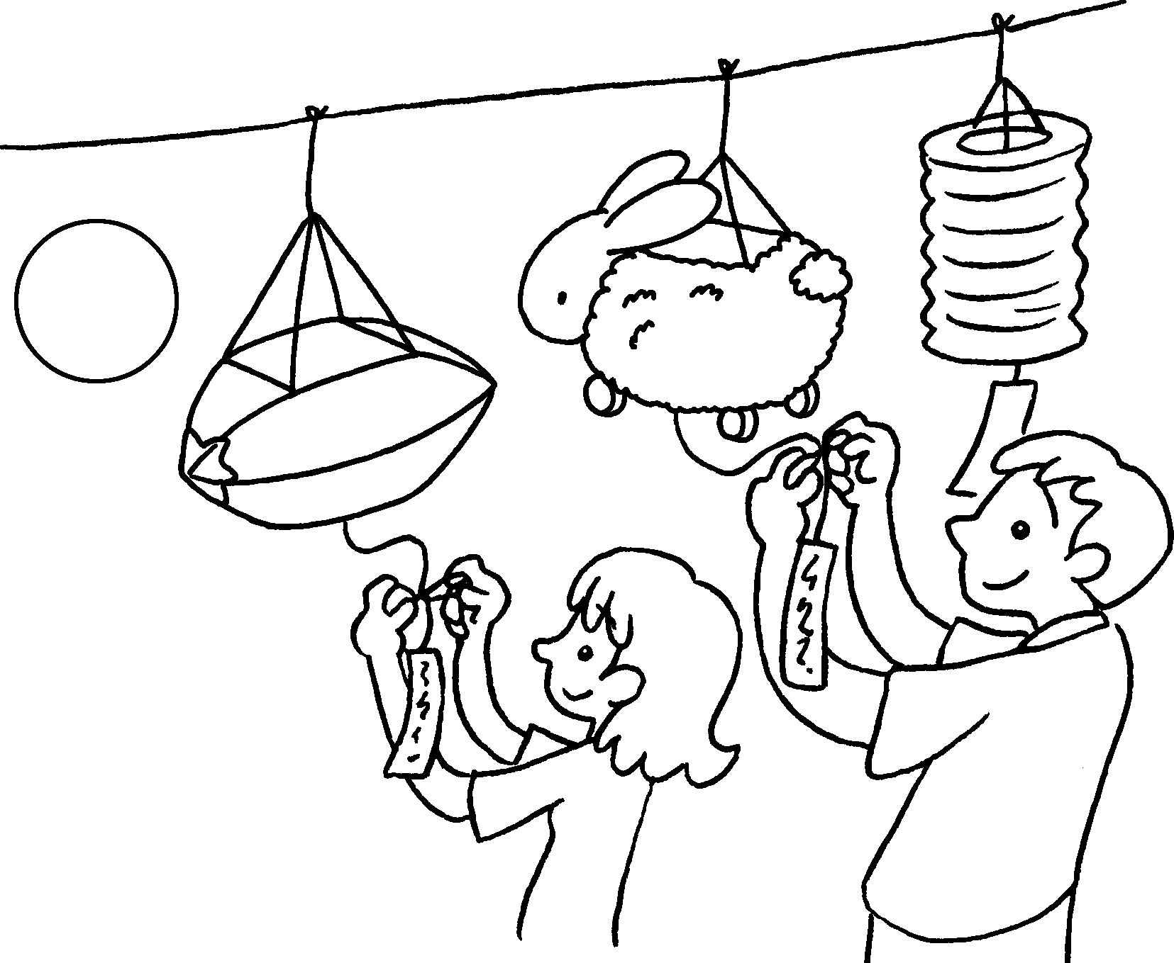
5 | People sweep graves at Ching Ming Festival. | 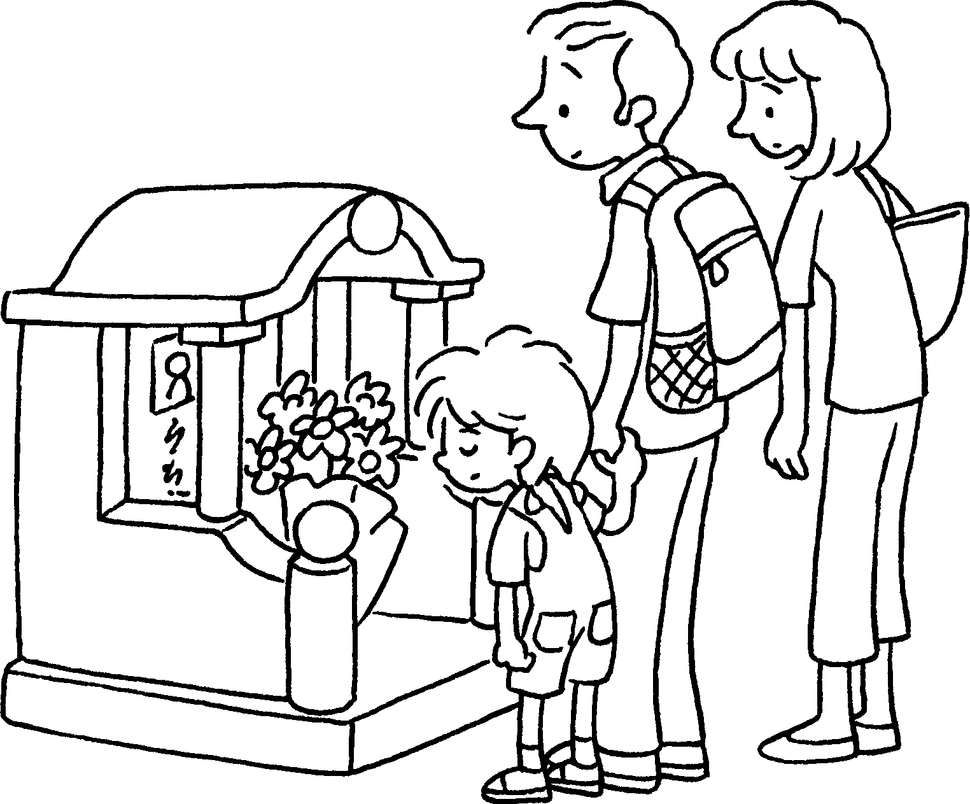


Book 6A Chapter 7 Graded Worksheets
Worksheet 3⬇⬇⬇
- are given
- Moon cakes are eaten
- The board is decorated with cards
- Riddles are tied to lanterns at Mid-Autumn Festival.
- Graves are swept at Ching Ming Festival.

