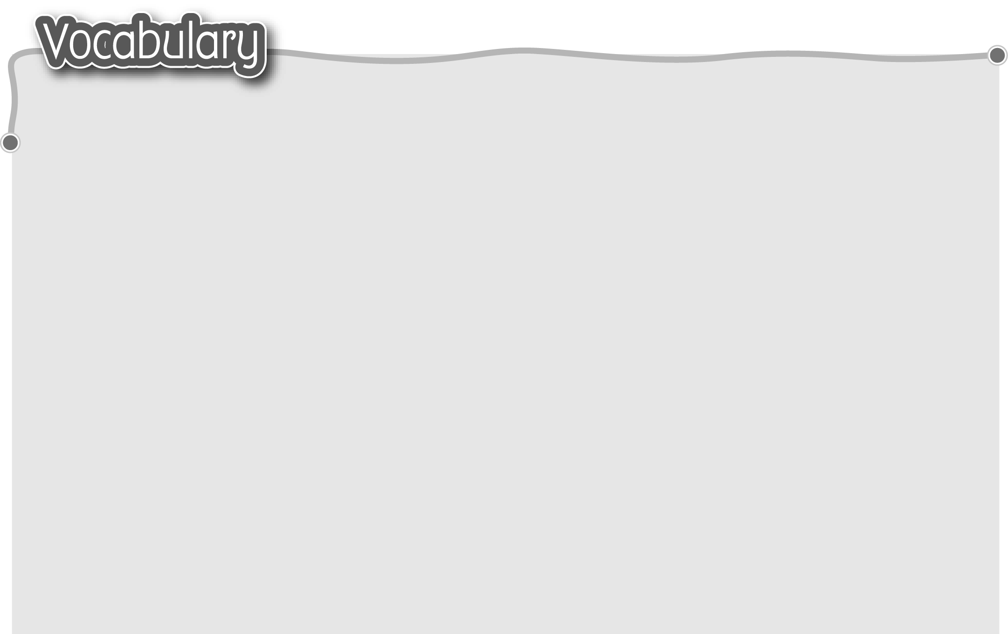
1 festival tradition 節日傳統習俗 9 Ching Ming Festival 清明節
2 Chinese New Year 農曆新年 10 sweep graves 掃墓
3 decorate home with red paper 11 give special food to dead relatives
用揮春佈置家居 給先人供奉特別食品
4 buy good luck flowers 買年花 12 Mid-Autumn Festival 中秋節
5 eat rice cakes / turnip cakes 13 buy / eat moon cakes / starfruit
吃年糕/蘿蔔糕 買/吃月餅/楊桃
6 perform the lion dance 表演舞獅 14 light lanterns 點燈籠
7 watch firework displays 15 tie riddles to lanterns
觀看煙花匯演 把燈謎繫於燈籠上
8 watch parades 觀看巡遊
The words marked with * have different meanings in other
contexts. You can look up those meanings in a dictionary.
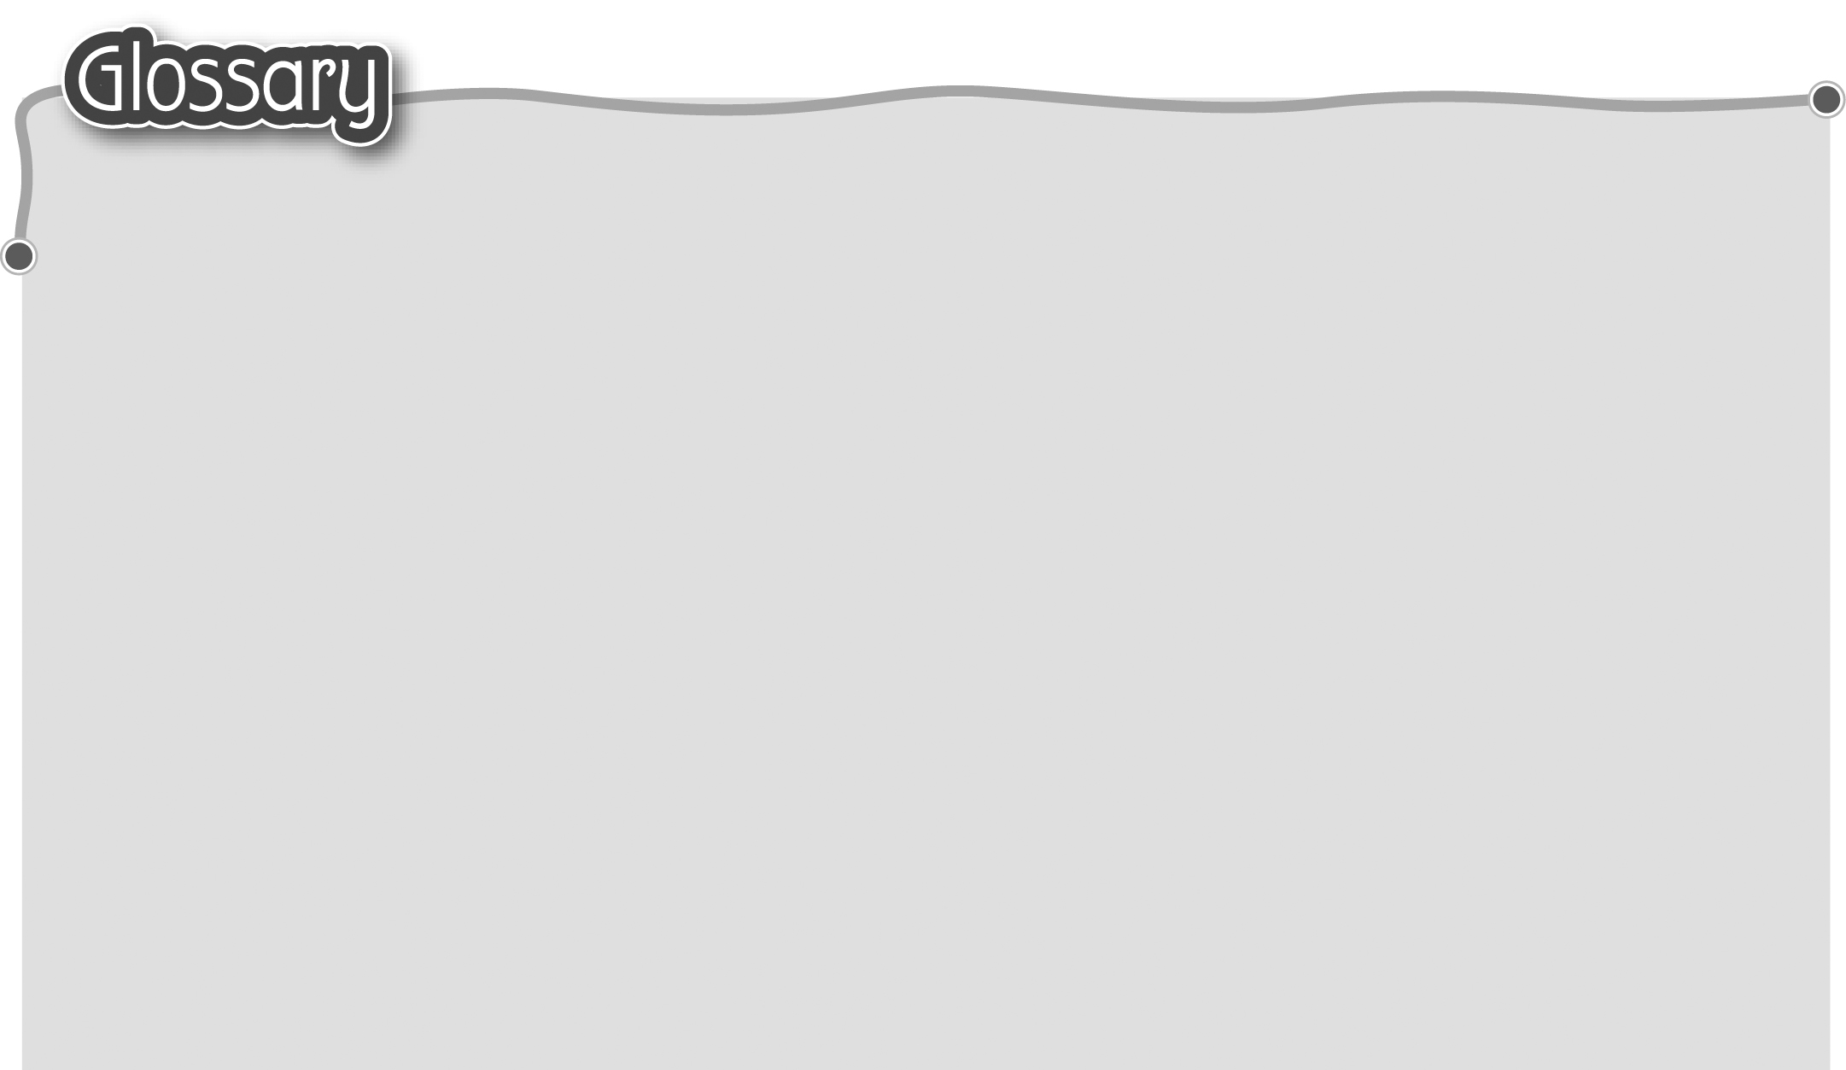
1 joy (p.56) 歡樂 11 set … free (p.57) 把……放生
2 lucky money (p.56) 利是 12 throw water (p.57) 潑水
3 each (p.56) 每一 13 bold* (p.57) 鮮艷
4 draw near (p.56) 來臨 14 display* (p.57) 展示（動詞）
5 pumpkin (p.56) 南瓜 15 scary (p.60) 恐怖
6 ghost (p.56) 鬼魂 16 mask (p.60) 面具
7 spooky (p.56) 陰森恐怖 17 long life (p.61) 長壽
8 run short (p.57) 愈來愈少 18 wealth (p.61) 財富
9 live* (p.57) 活生生（形容詞） 19 underwear (p.61) 內衣褲
10 place … in (p.57) 把……放在……內

