Imagine that you have an overseas pen friend. Write a letter to tell him / her how people usually celebrate Chinese New Year in Hong Kong.

Hint: The letter should be informal, e.g. using Dear (first name), to start the letter and Best Wishes, / Yours, etc. to end the letter.

Paragraph 2 ― write about what people do at Chinese New Year. Useful words include: get lucky money / red packets, wear new clothes, visit our relatives, go to the flower market, and the words on p.59 of your textbook. You may use the passive voice, e.g. Lucky money is given to children.

Last paragraph ― ask what special festivals your pen friend celebrates in his / her country. Ask him / her to write back to tell you.

Dear ________________ ,
How are you? I am excited because Chinese New Year is coming. Do you know how we celebrate Chinese New Year in Hong Kong? Let me tell you.
_____________________________________________________
_________________________________________________________________
_________________________________________________________________
_________________________________________________________________
_________________________________________________________________
_________________________________________________________________
_________________________________________________________________
_____________________________________________________
_________________________________________________________________
_________________________________________________________________
____________________
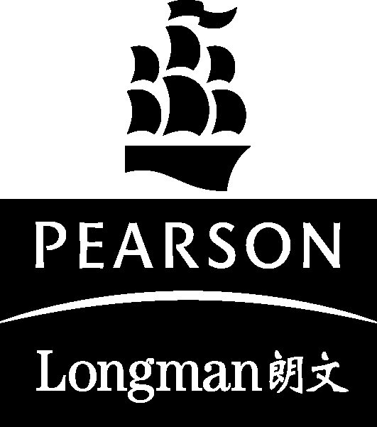 Primary Longman Elect 6A © Pearson Education Asia Limited 2009
____________________
Primary Longman Elect 6A © Pearson Education Asia Limited 2009
Primary Longman Elect 6A © Pearson Education Asia Limited 2009

