RP no: Century Gothic 15pt
(所有圈號用15pt)
Choose and write.
1
2
3
4
5
smooth | wise | gentle | hard | brave
rough | silly | fierce | soft | timid

 | 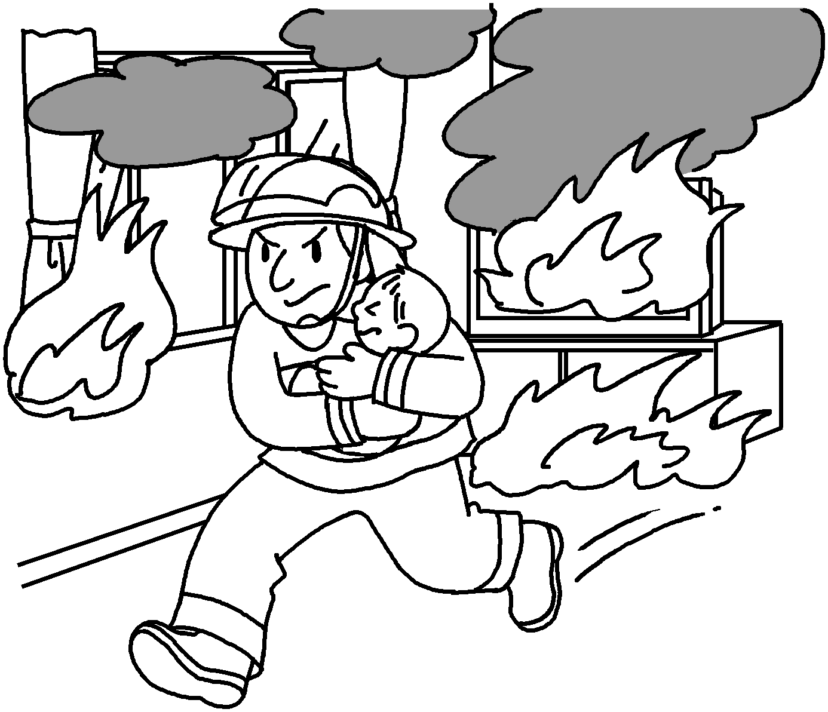 | 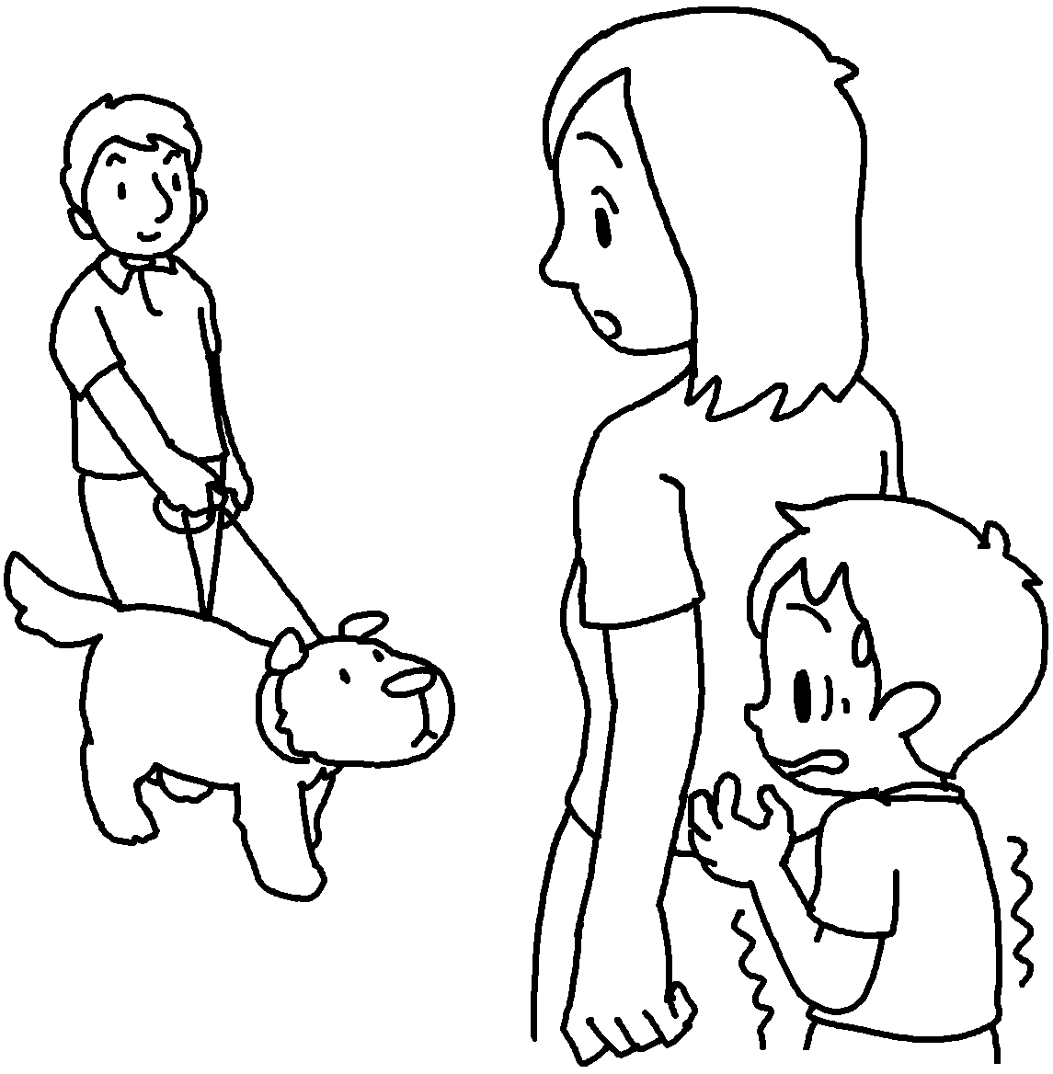 |  |  | 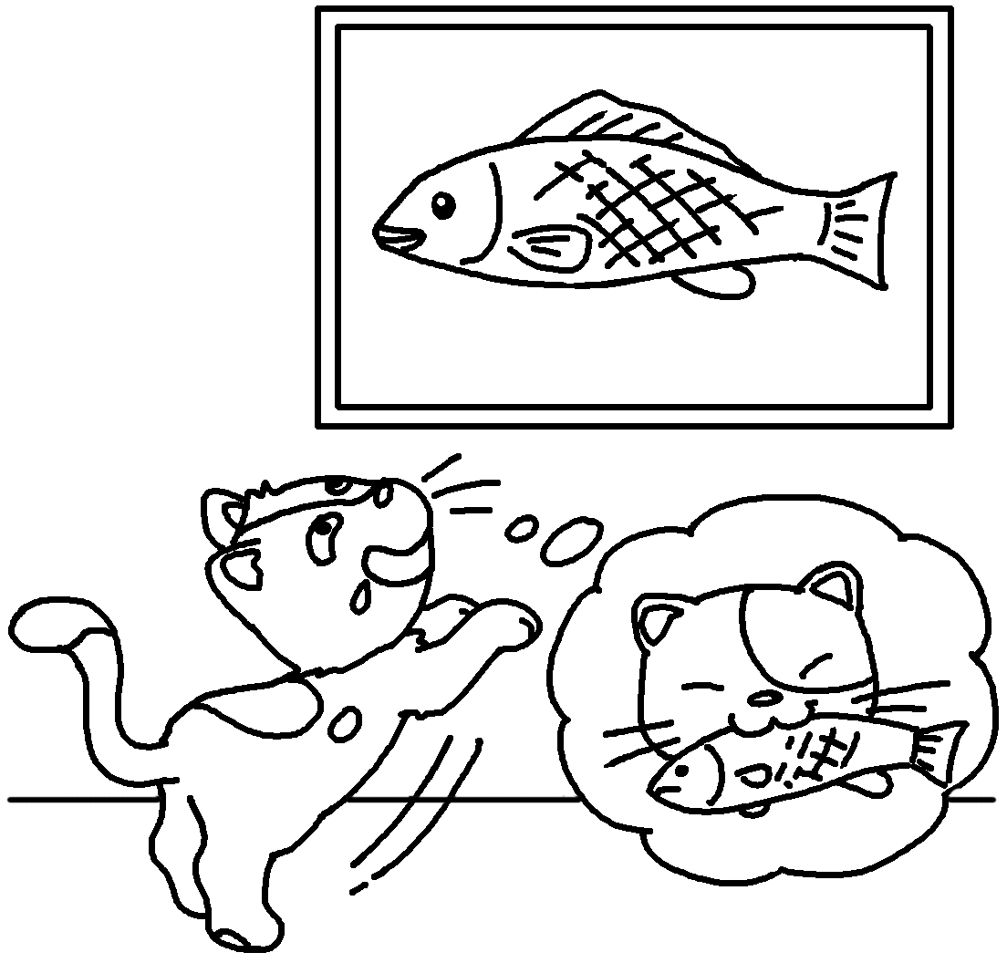 |   Look before you leap.
 | 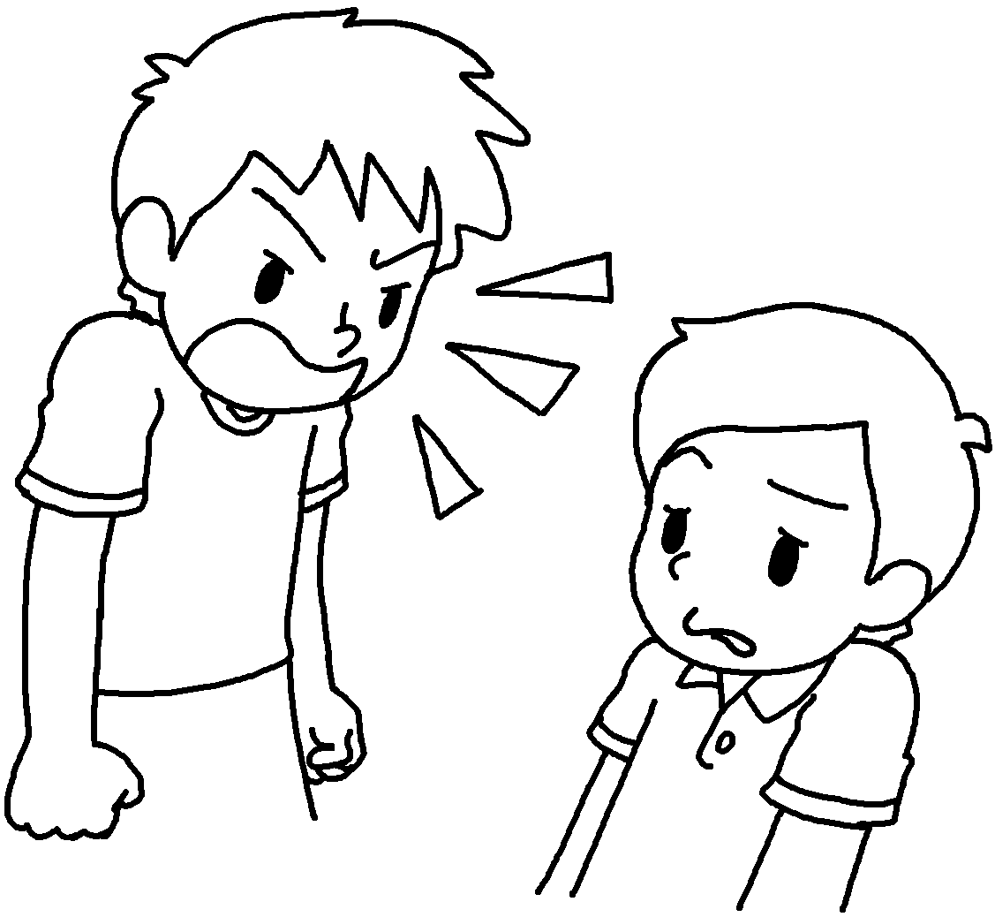 |  |  |  |  | 
 |  |  |  | 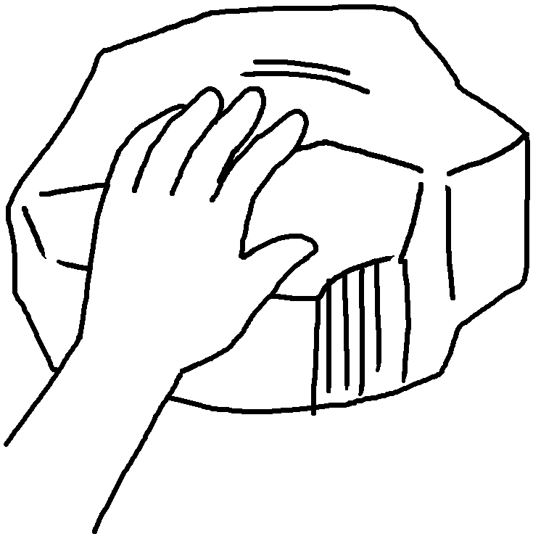
RP no: Century Gothic 15pt
(所有圈號用15pt)


Book 6B Chapter 1 Graded Worksheets
Worksheet 1⬇
1 brave timid 2 silly wise
3 fierce gentle 4 smooth rough
5 soft hard

