RP no: Century Gothic 15pt
(所有圈號用15pt)
Write the correct adjectives. Fill in the missing letters.
1
2
3
4
5

 | 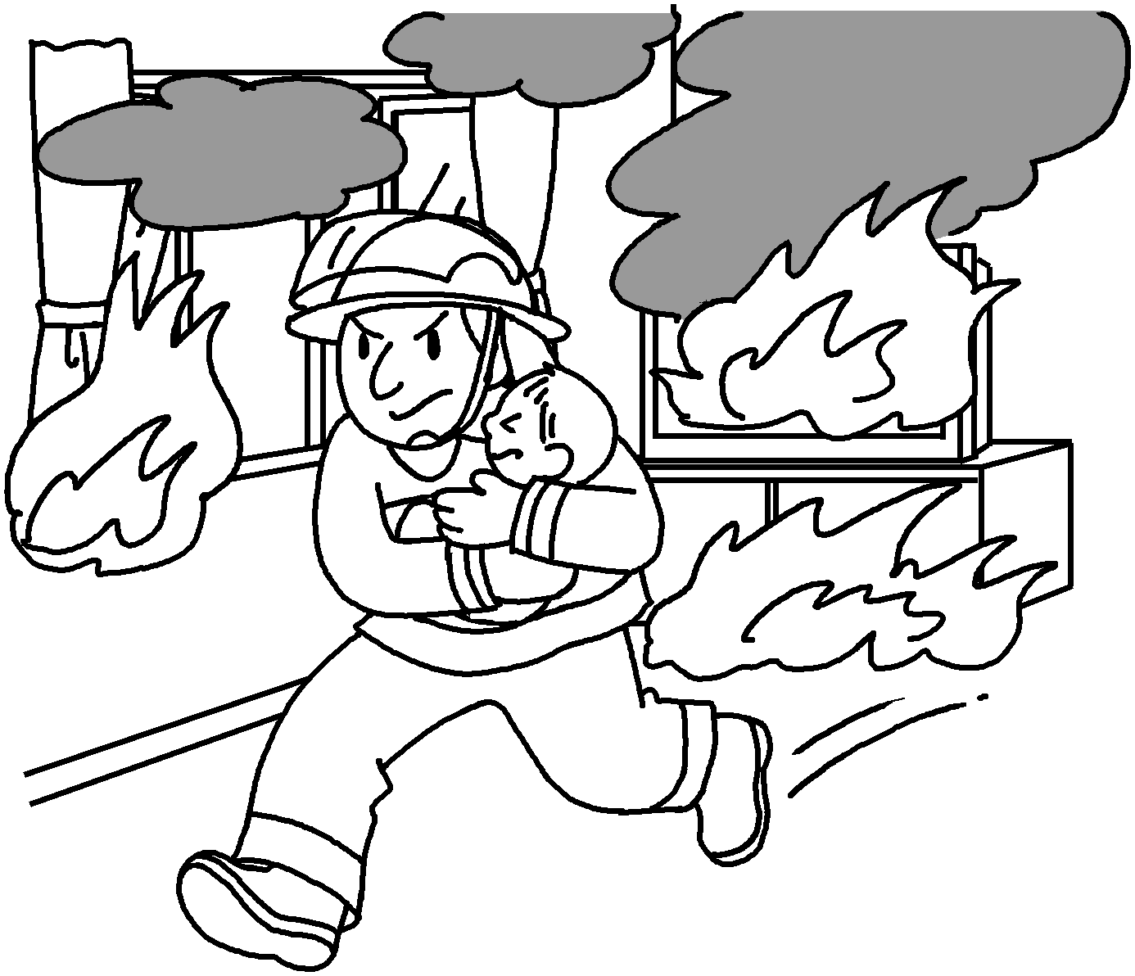 | 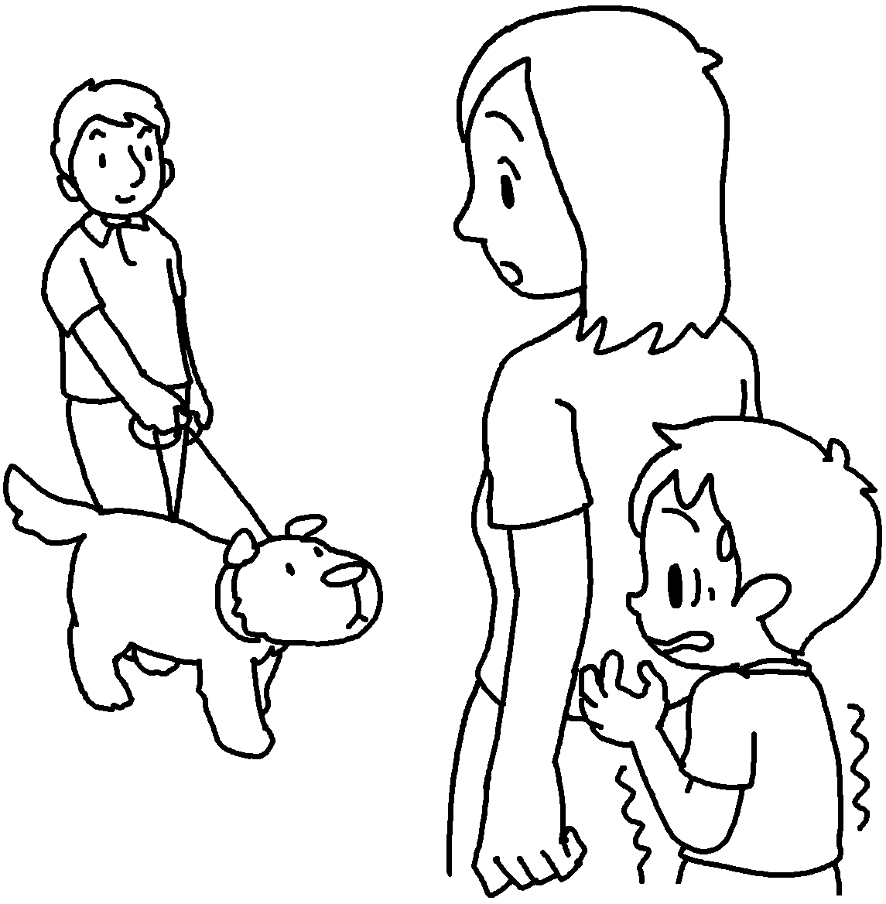 |  | 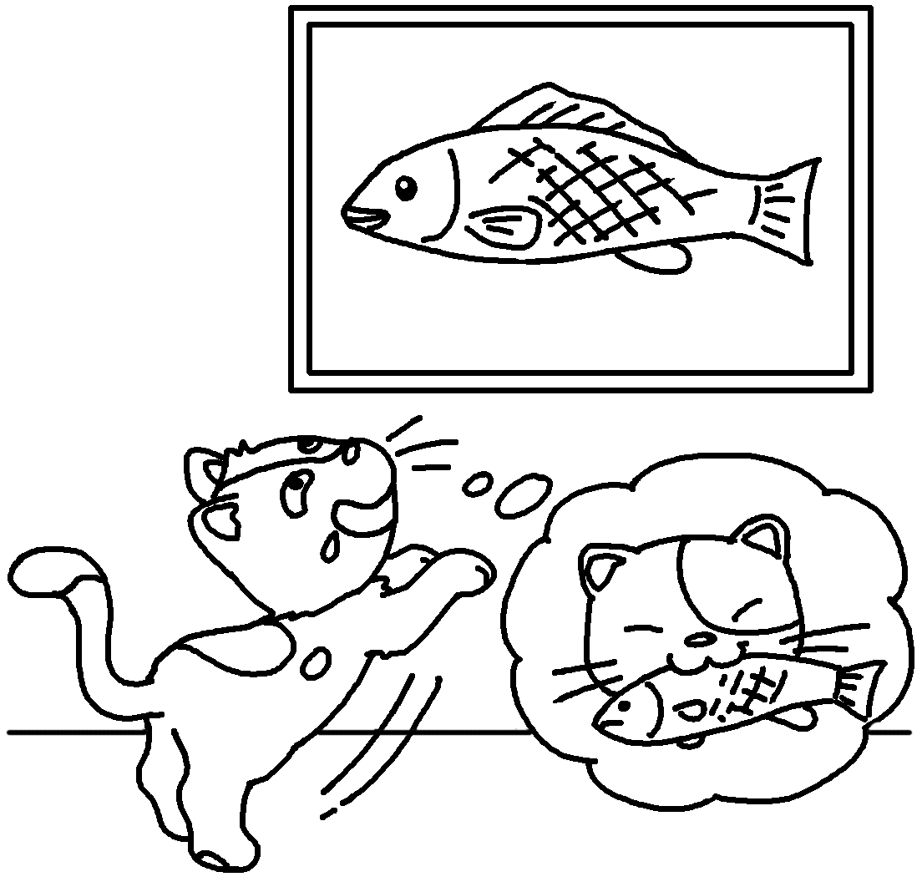 | 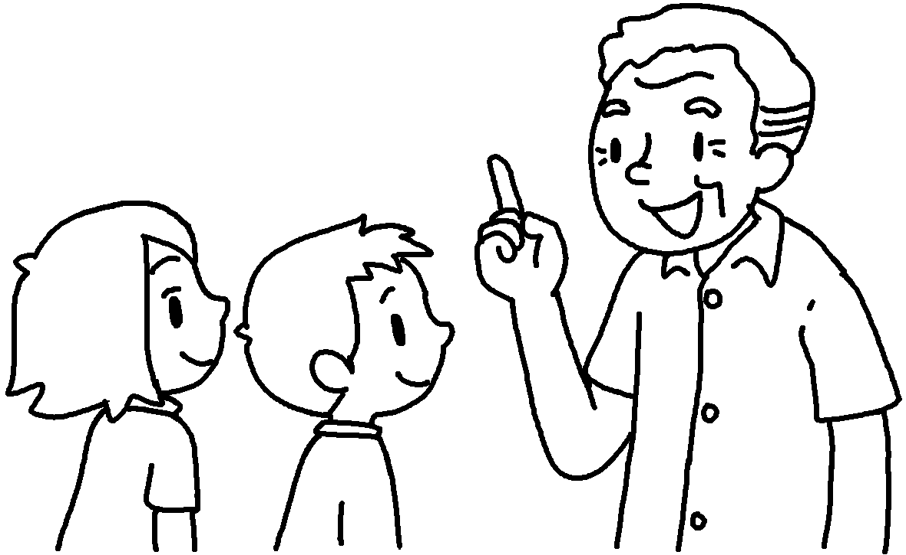  Look before you leap.
 | b __ __ __ __ | t __ __ __ __ |  | s __ __ __ __ | w __ __ __

 |  | 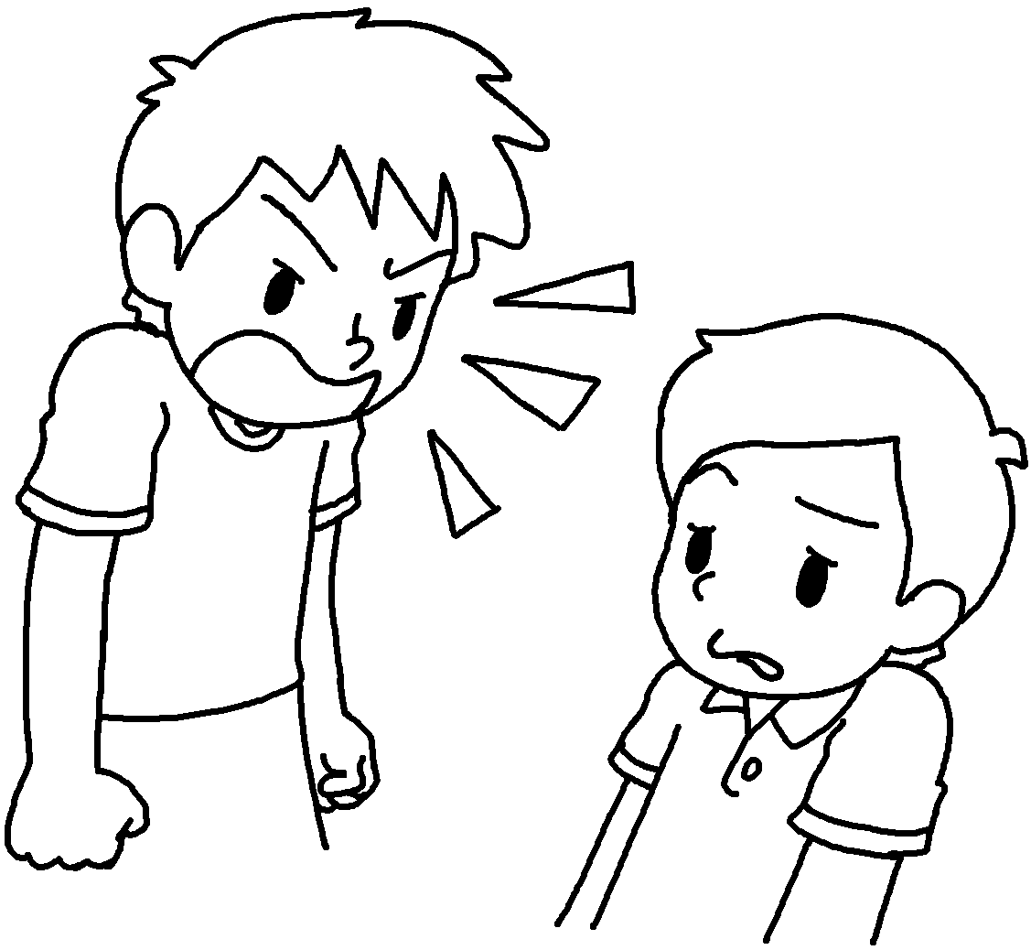 | 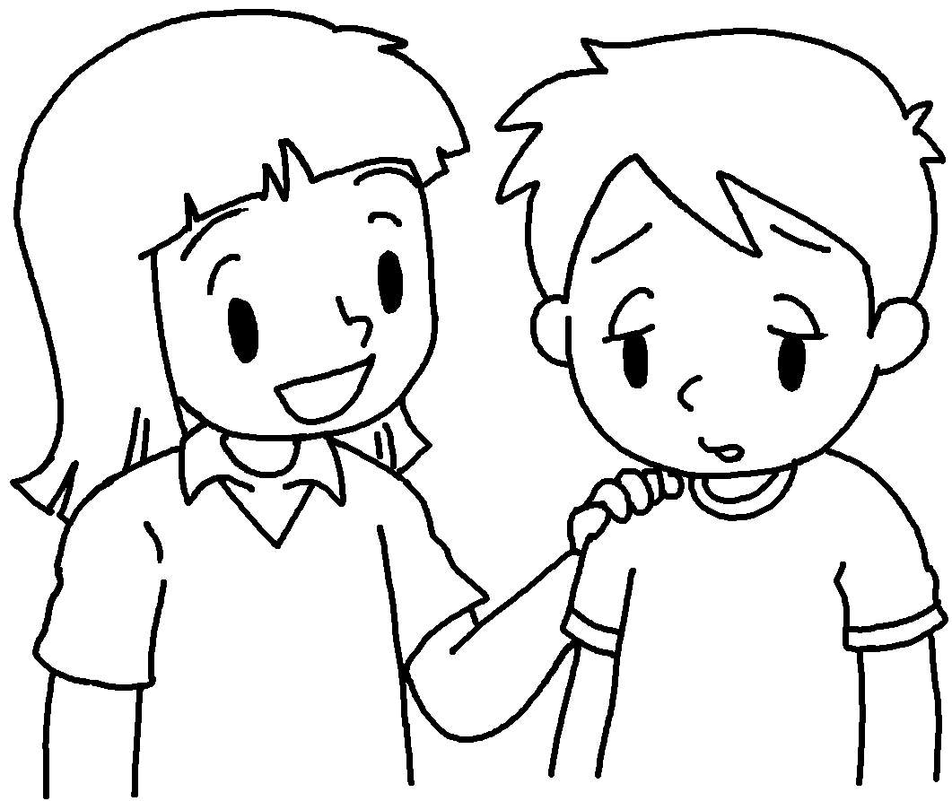 |  |  | 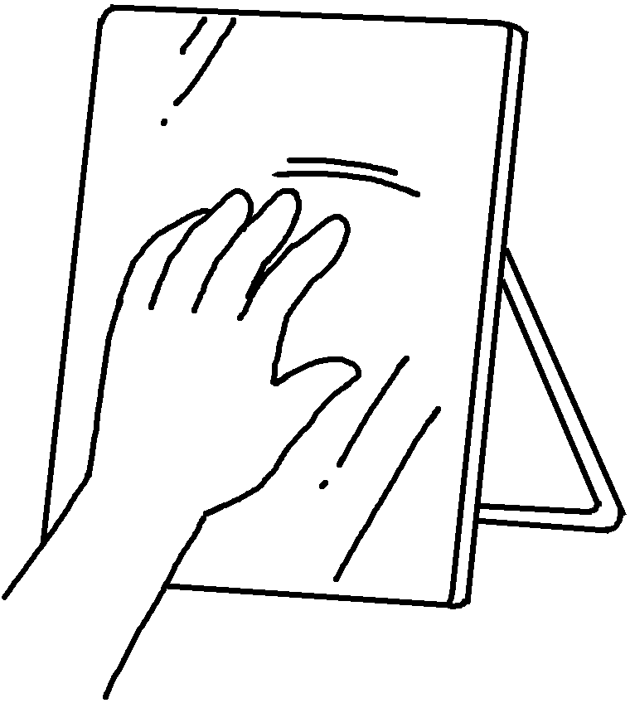 |  | 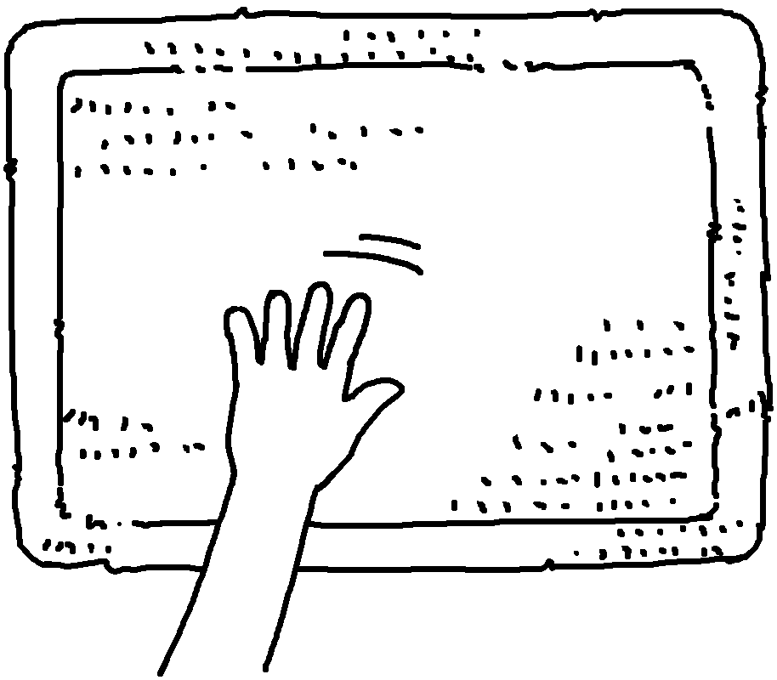
 | f __ __ __ __ __ |  | g __ __ __ __ __ |  |  |  | s __ __ __ __ __ |  | r __ __ __ __

 |  | 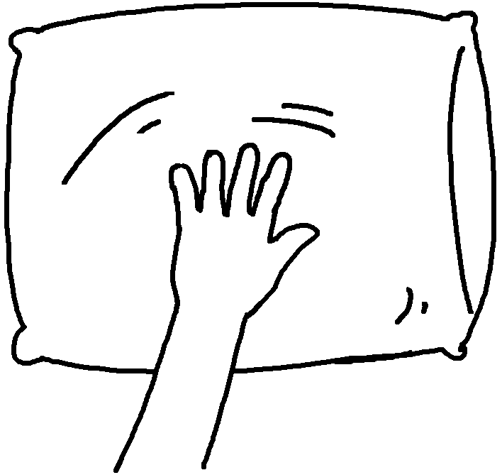 | 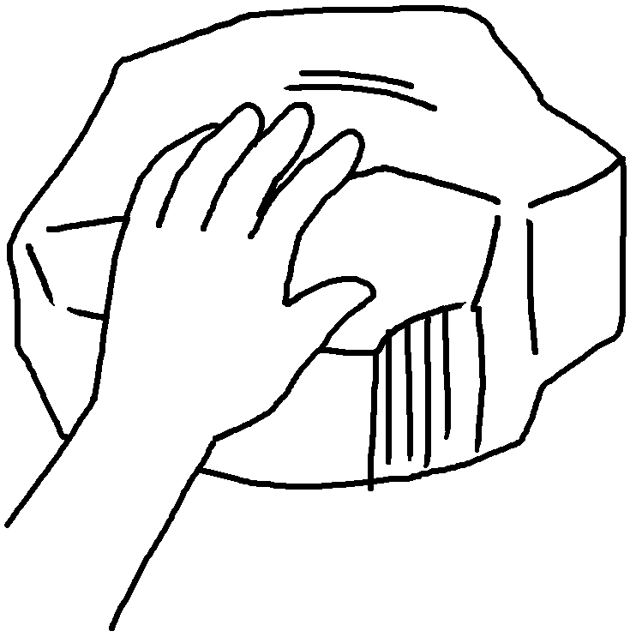
 |  | s __ __ __ | h __ __ __

RP no: Century Gothic 15pt
(所有圈號用15pt)


Book 6B Chapter 1 Graded Worksheets
Worksheet 1⬇⬇
1 b r a v e t i m i d 2 s i l l y w i s e
3 f i e r c e g e n t l e 4 s m o o t h r o u g h
5 s o f t h a r d

