RP no: Century Gothic 15pt
(所有圈號用15pt)
Write the opposite adjectives.
1
2
3
4
5

 | 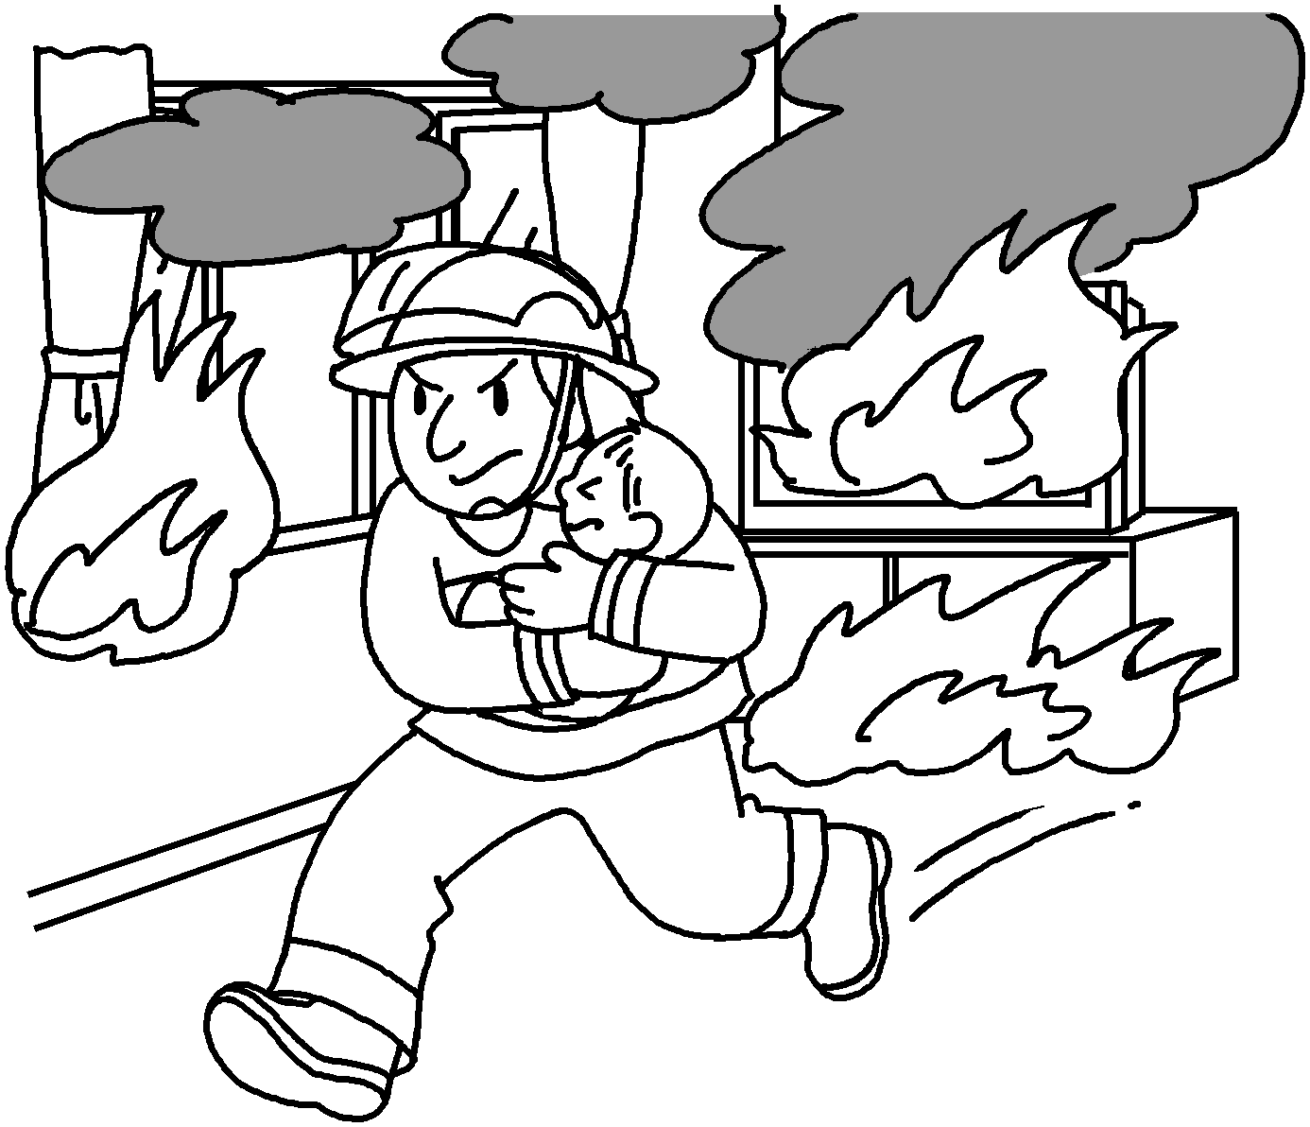 | 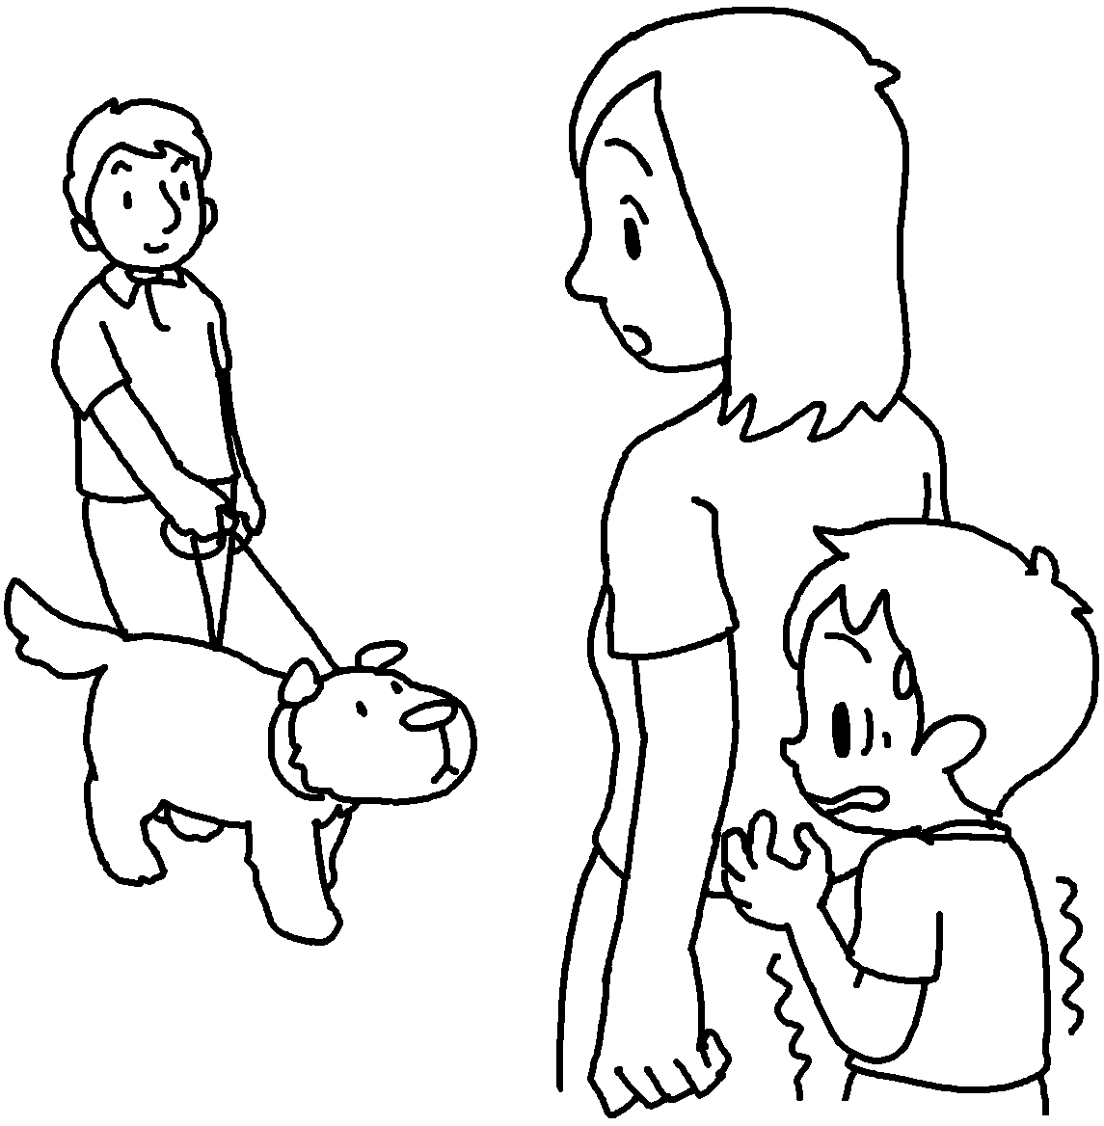 |  | 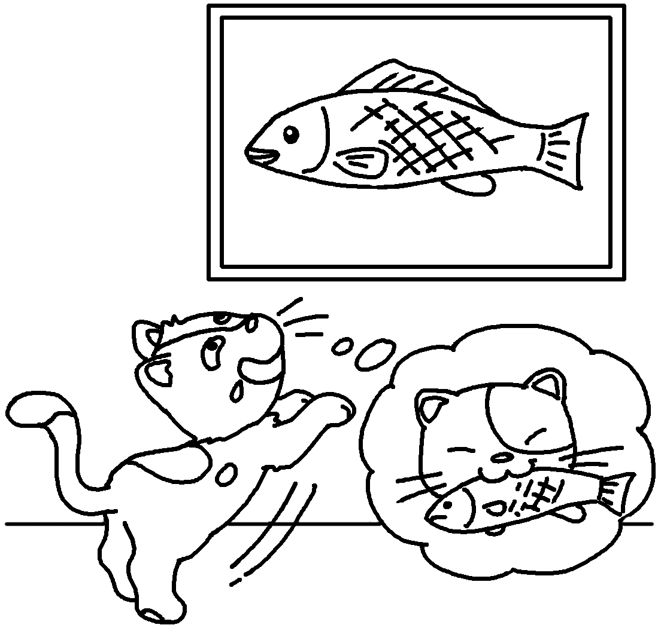 | 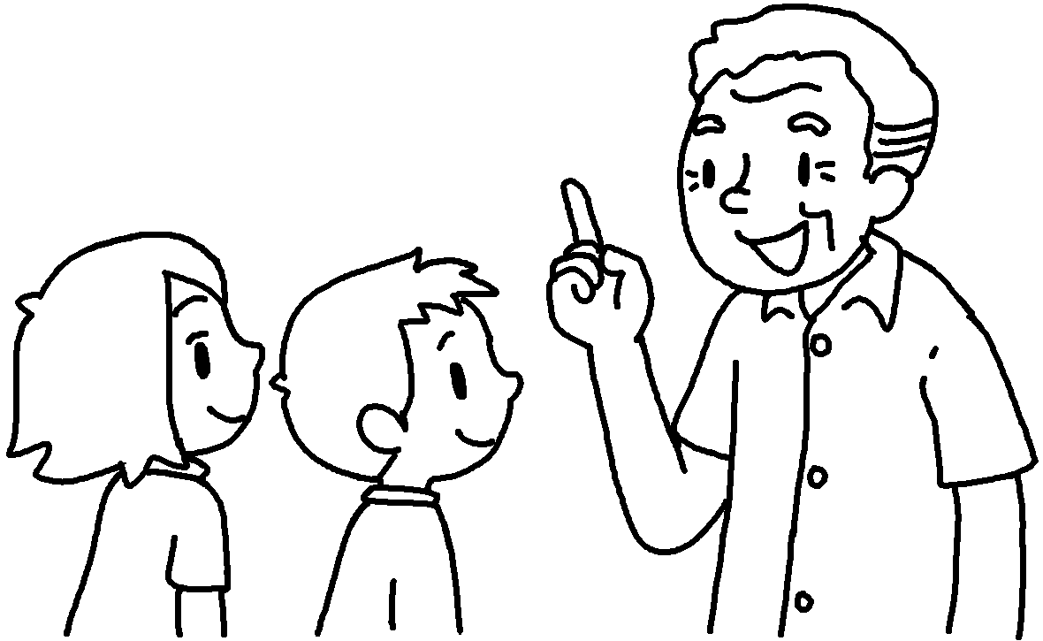  Look before you leap.
 | b | t |  | s | w

 |  | 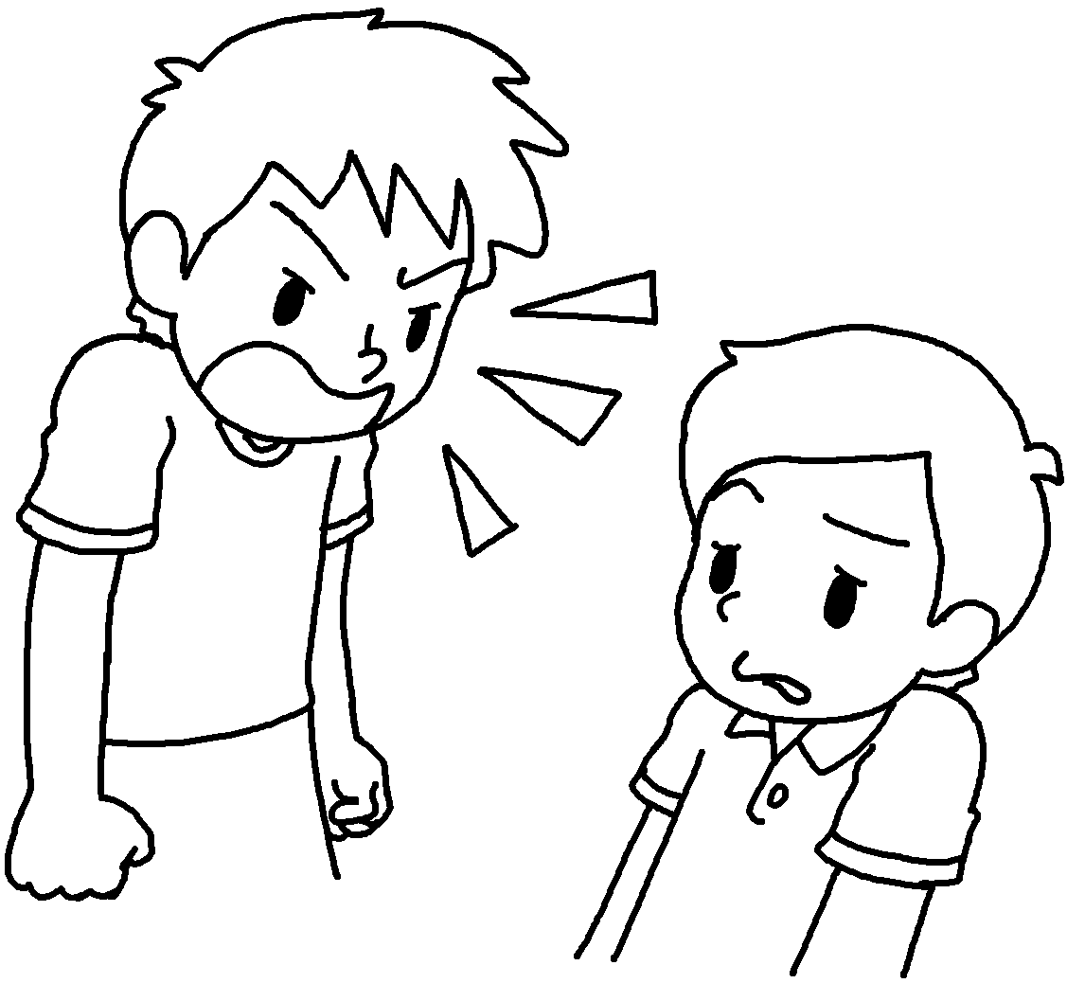 | 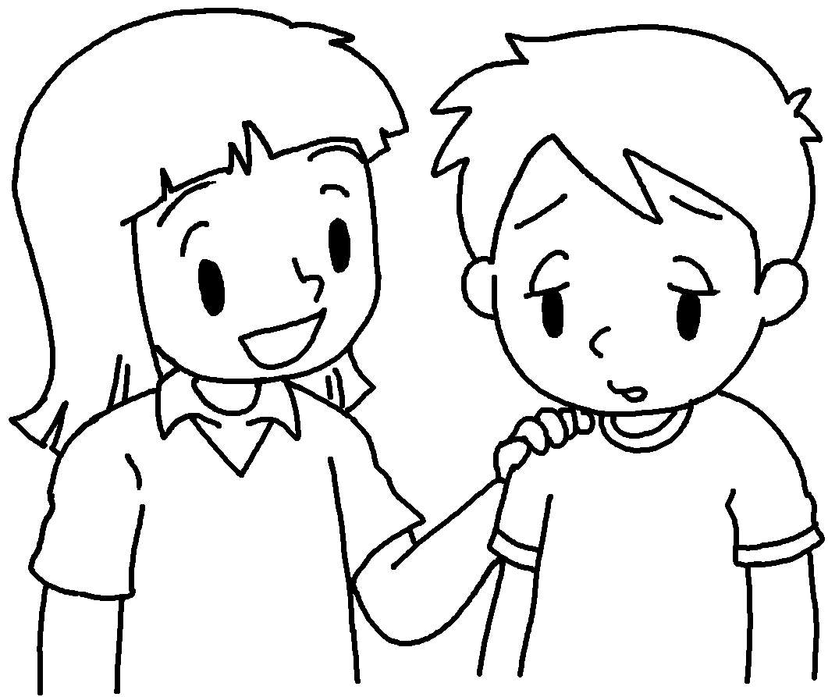 |  |  | 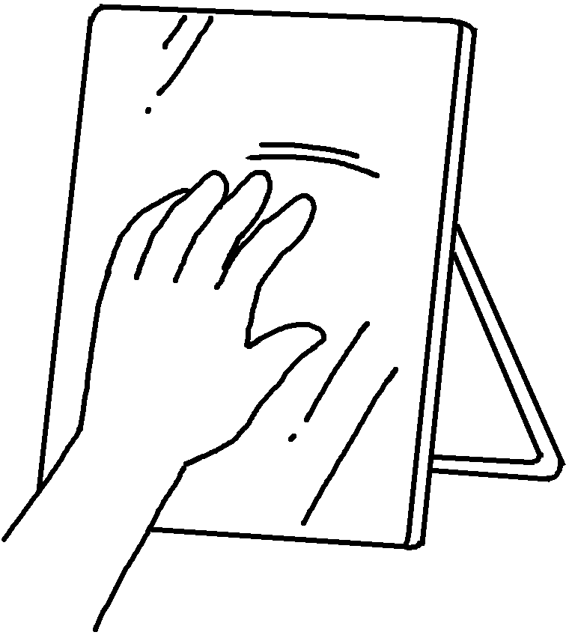 |  | 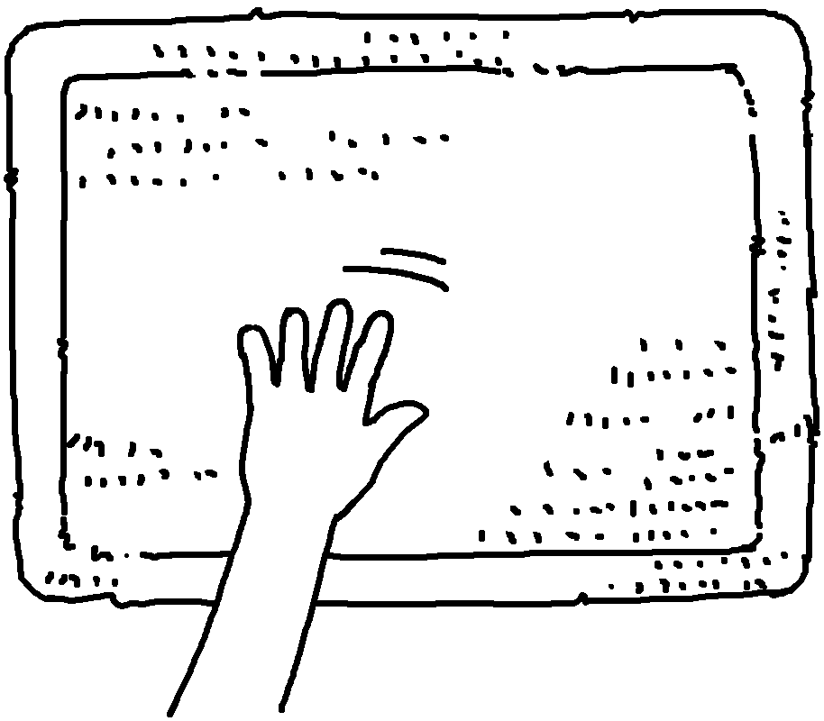
 | f |  | g |  |  |  | s |  | r

 |  | 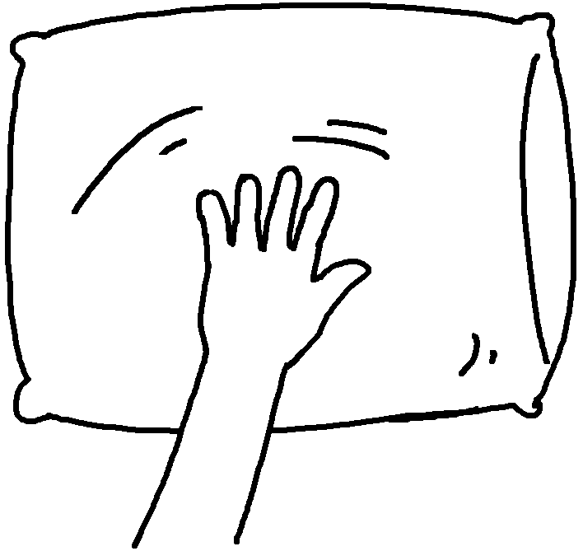 | 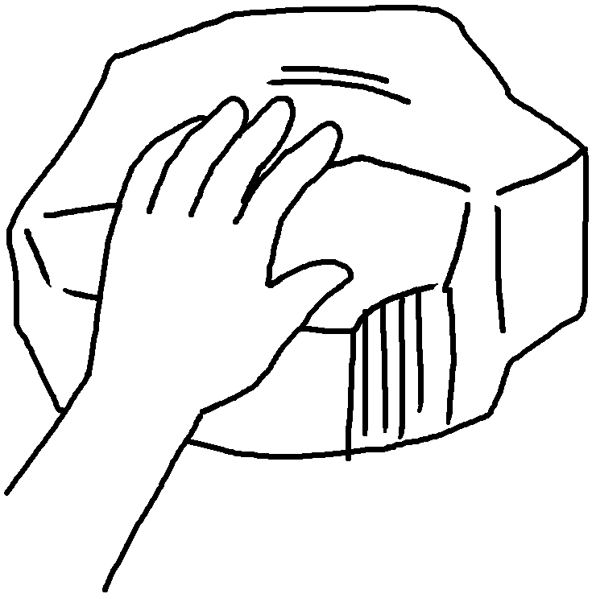
 |  | s | h


Book 6B Chapter 1 Graded Worksheets
Worksheet 1⬇⬇⬇
1 brave timid 2 silly wise
3 fierce gentle 4 smooth rough
5 soft hard

