Finish the sentences.
as ... as

1 | 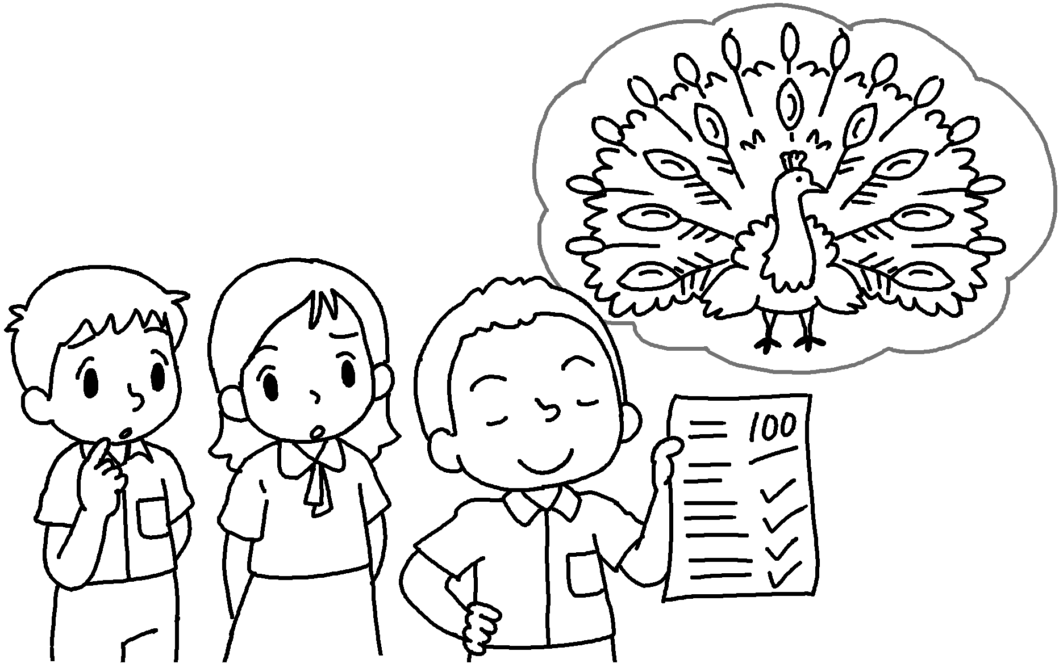 | David is proud  a peacock.
2 | 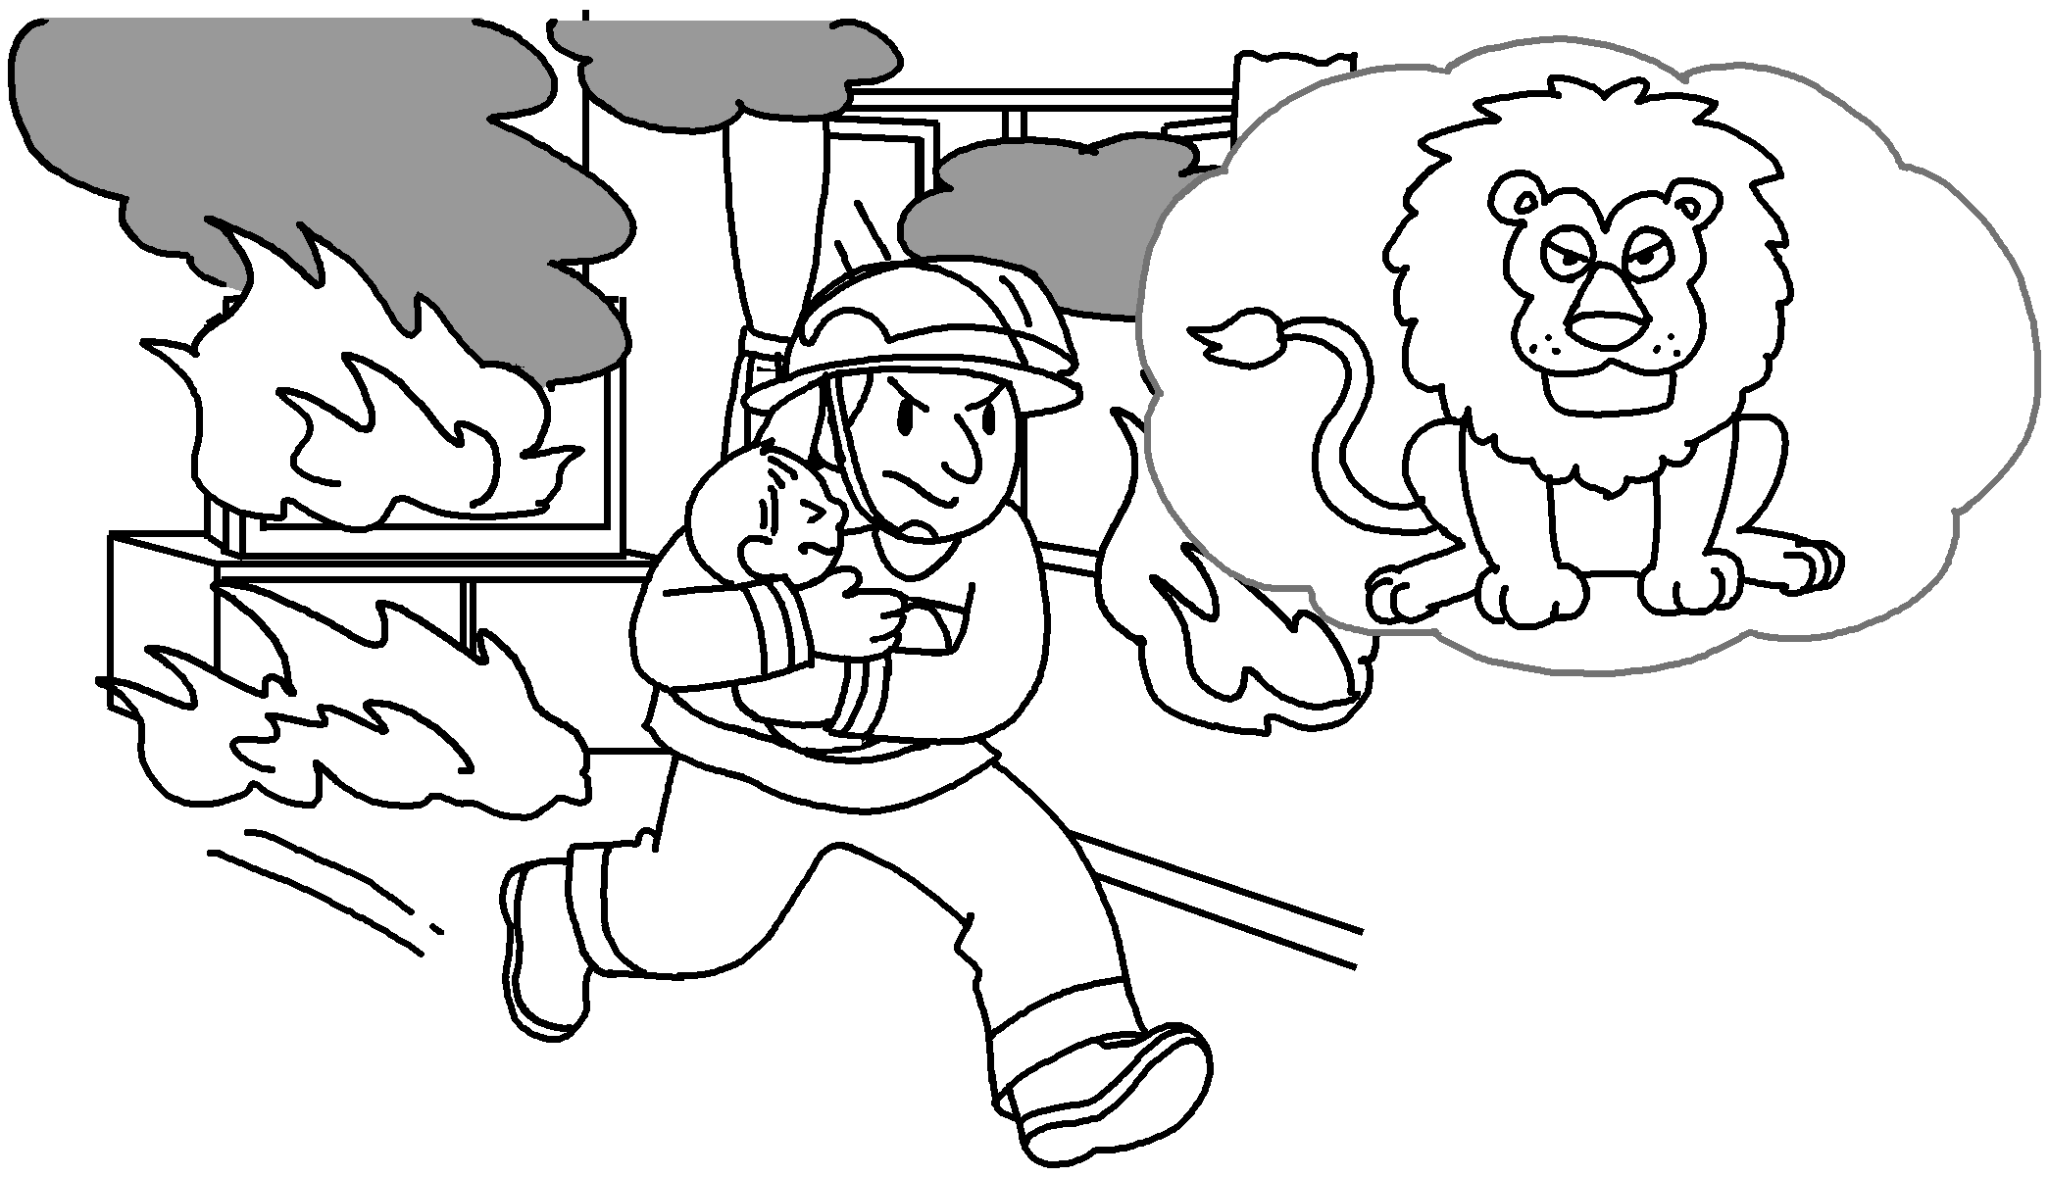 | The fireman is brave  a lion.
3 | 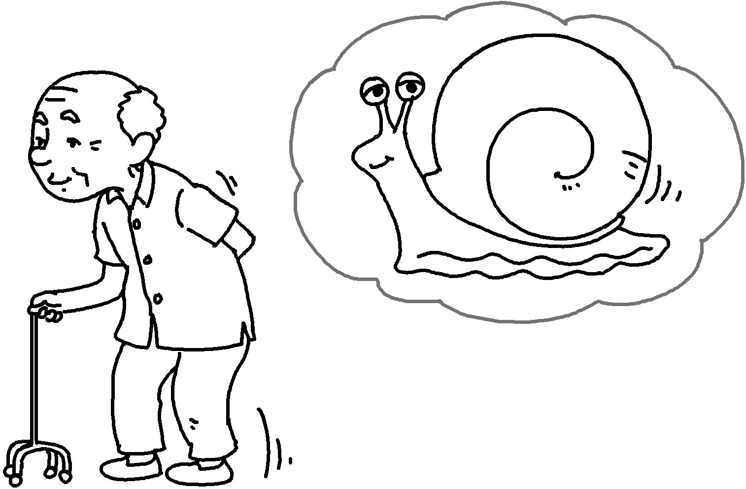  ( slow / snail ) | My grandpa is  a .
4 | 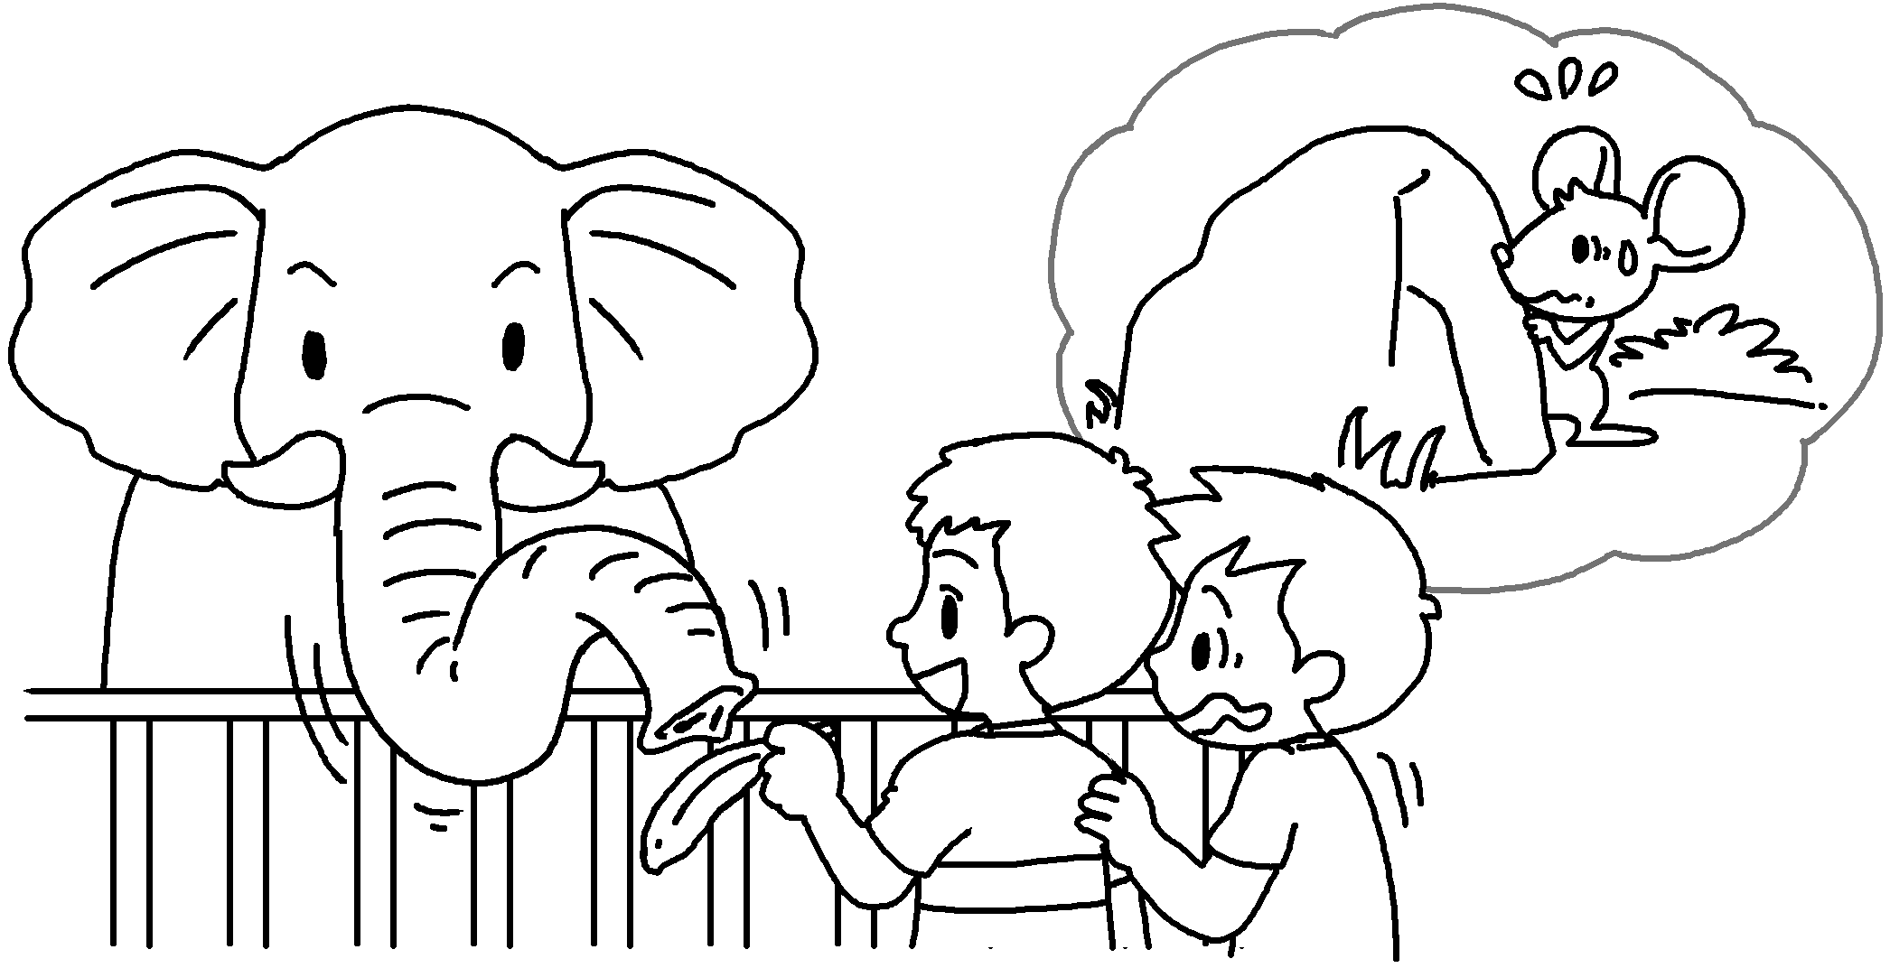  ( timid / mouse ) | Alan is  a .
5 | 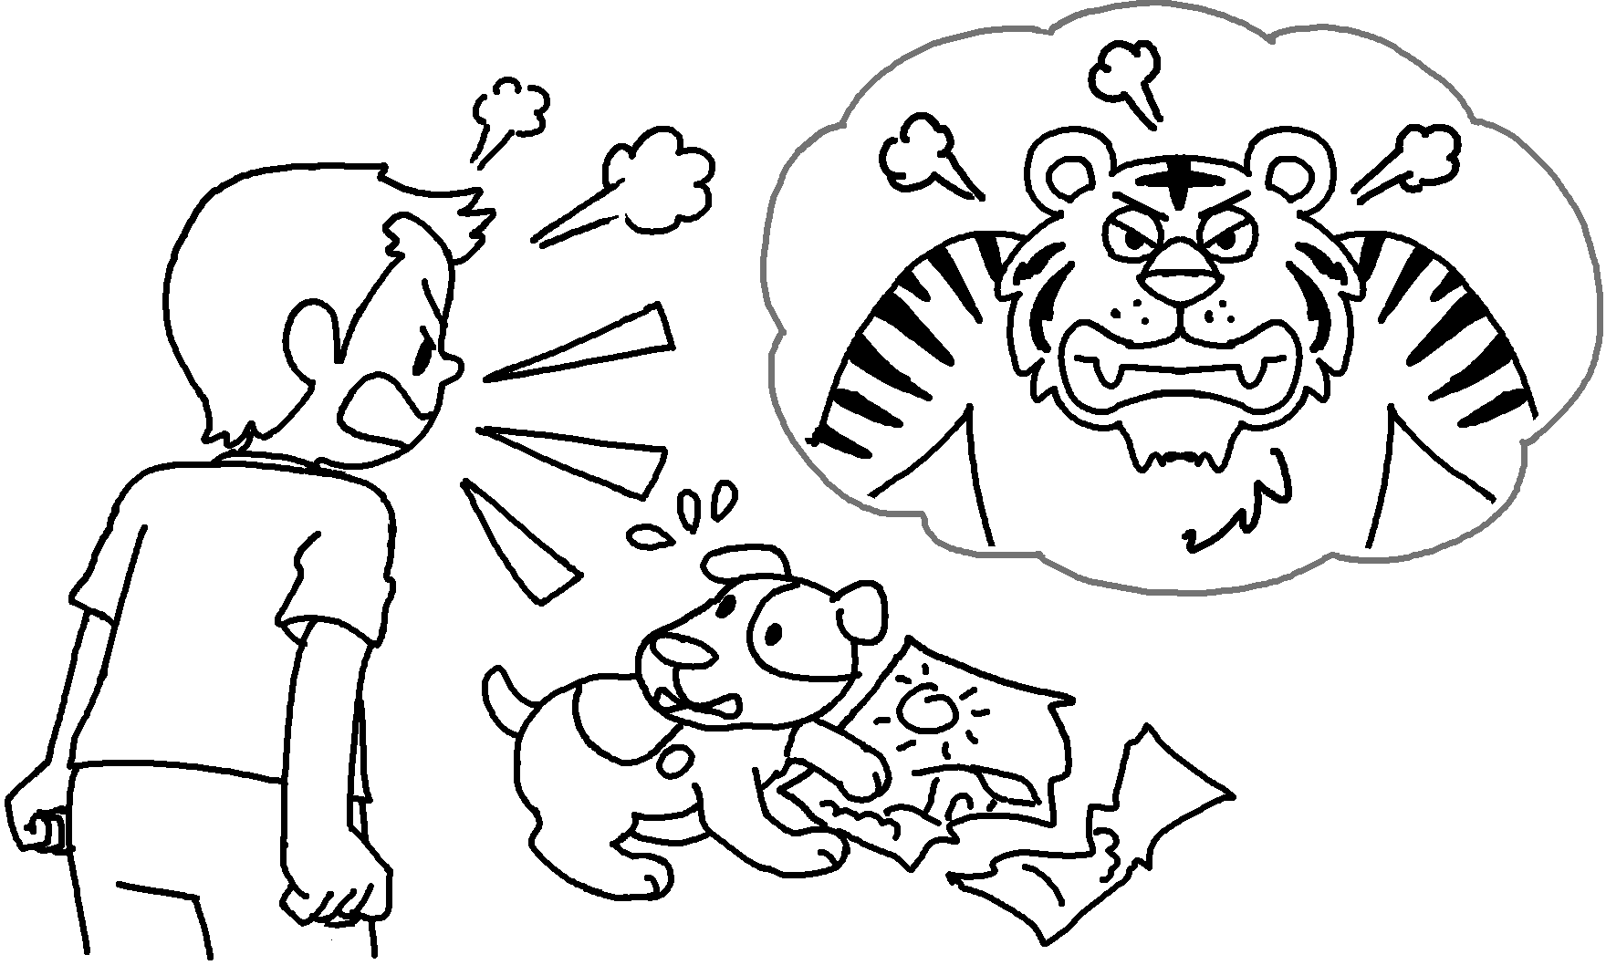  ( fierce / tiger ) | Tommy is  .
6 | 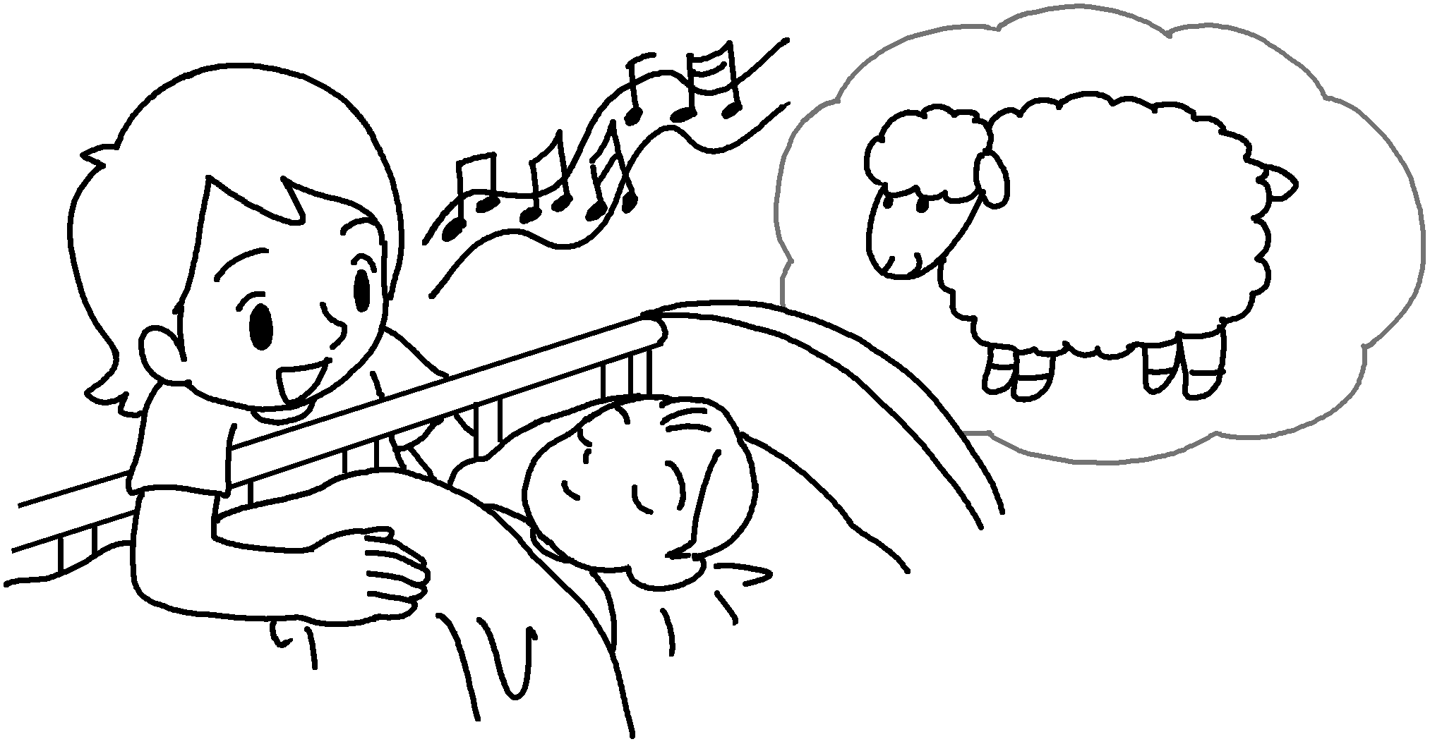  ( gentle / lamb ) | Mary is  .


Book 6B Chapter 1 Graded Worksheets
Worksheet 2⬇
1 as as
2 as as
3 as slow as snail
4 as timid as mouse
5 as fierce as a tiger
6 as gentle as a lamb

