Finish the sentences.
brave
as ... as
fierce
slow
gentle
timid

1 | 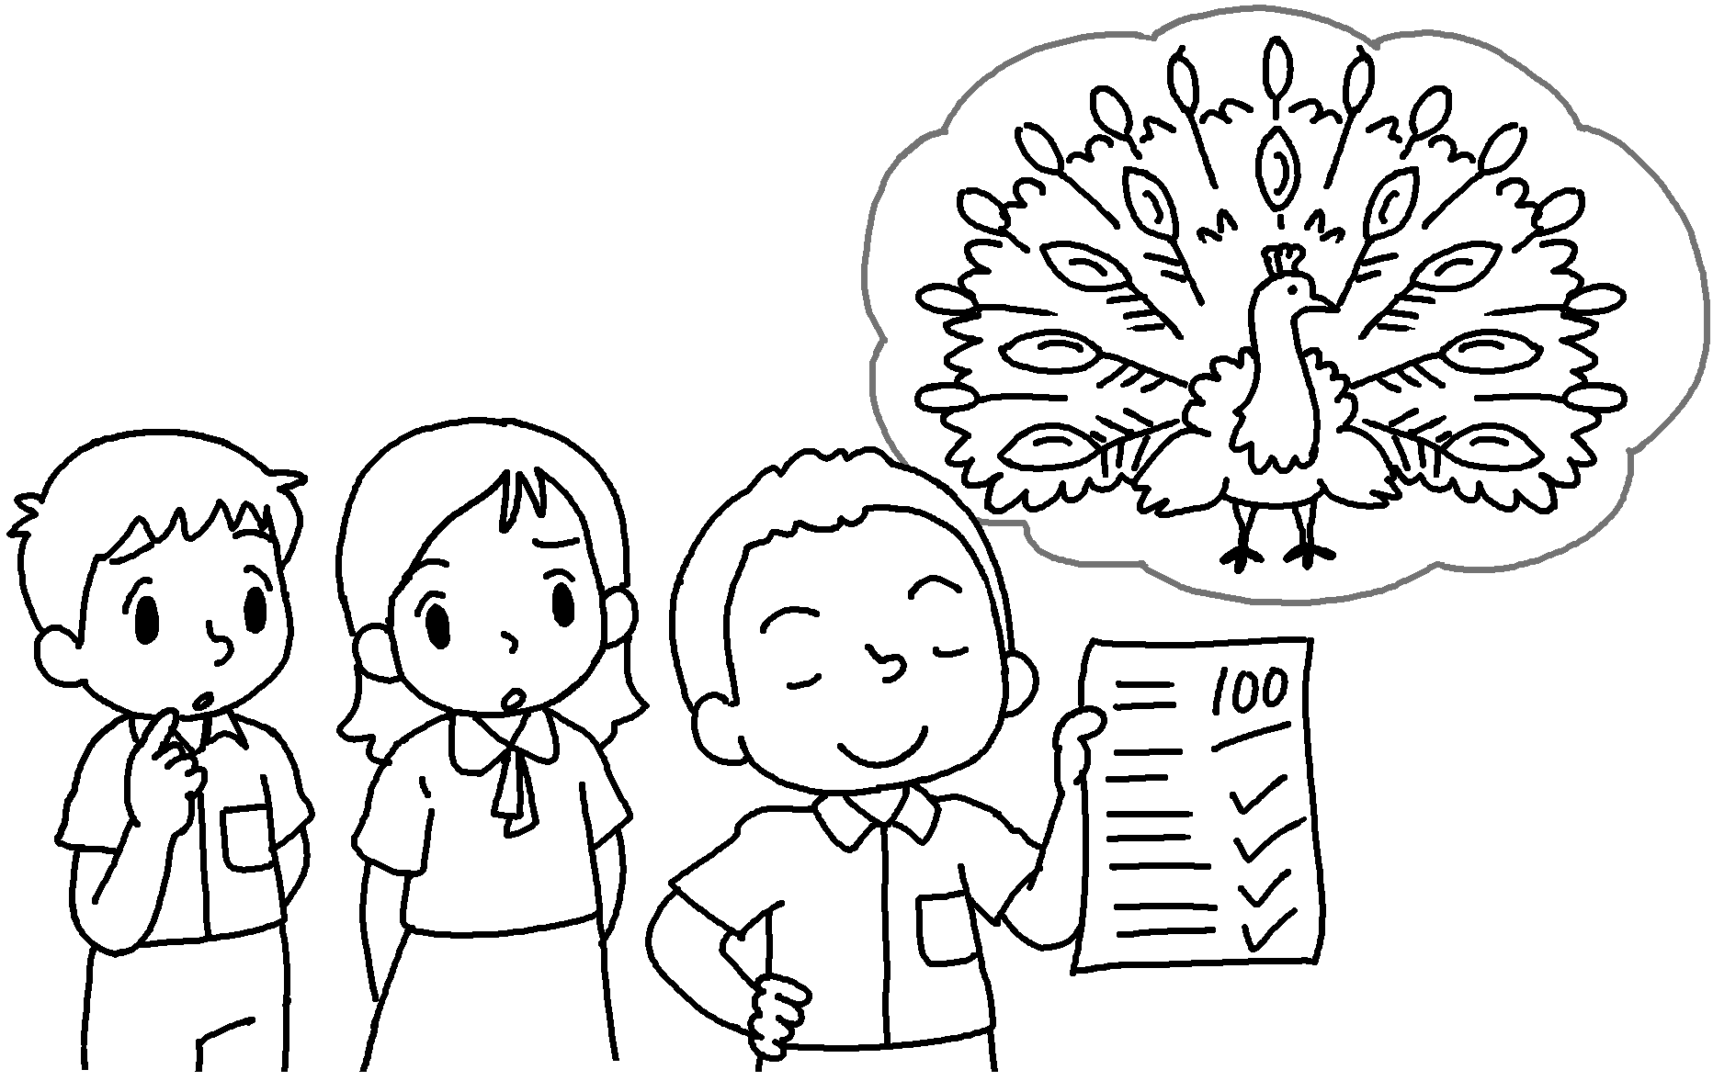 | David is proud  a peacock.
2 | 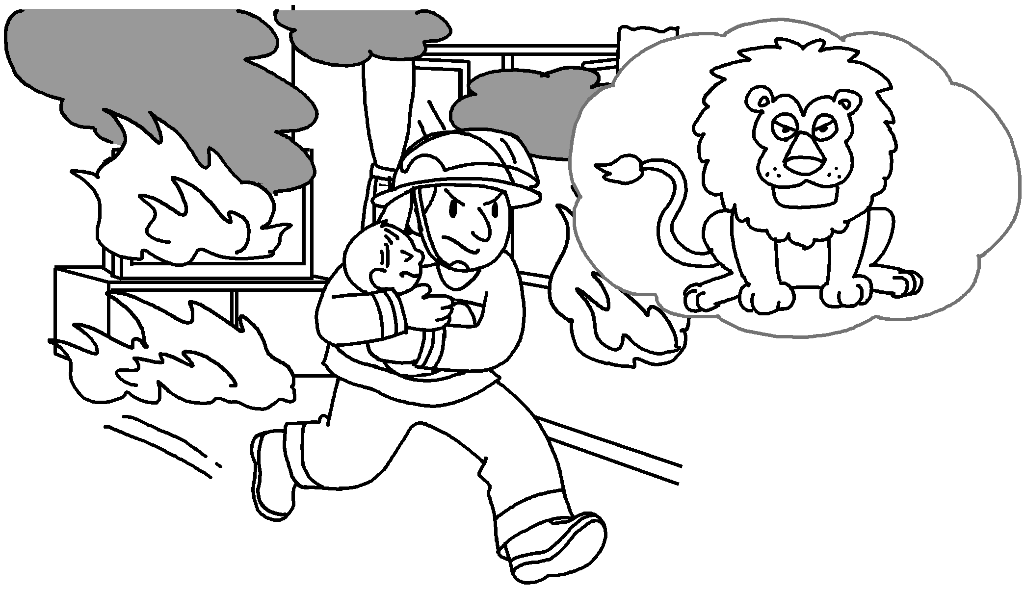 | The fireman is  a lion.
3  snail  mouse  tiger  lamb | 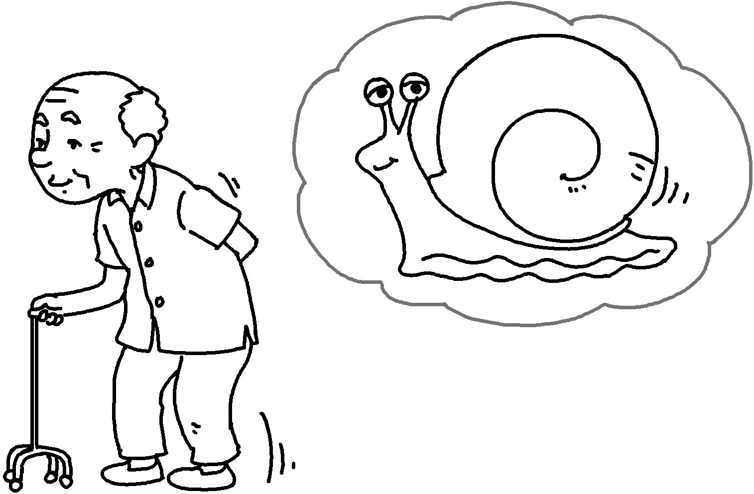 | My grandpa is  a .
4 | 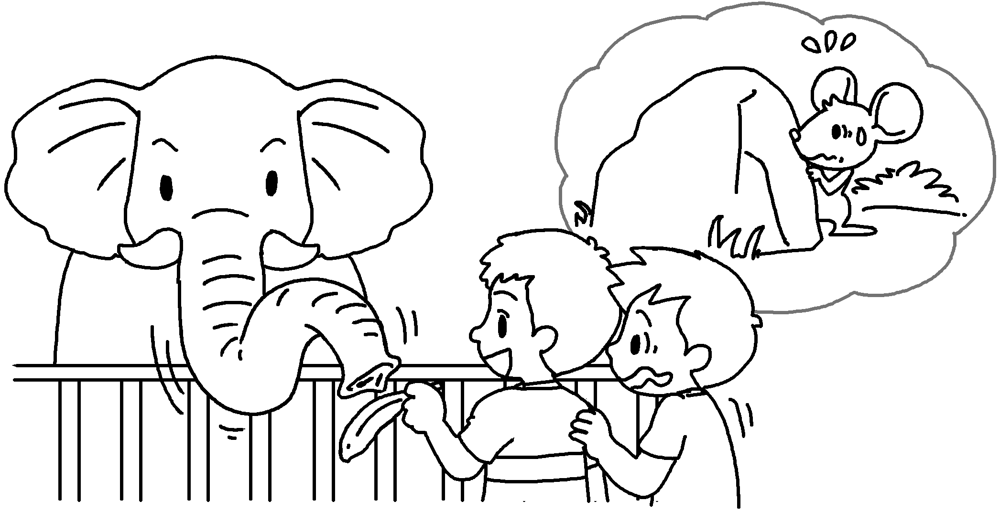 | Alan is ___________  .
5 | 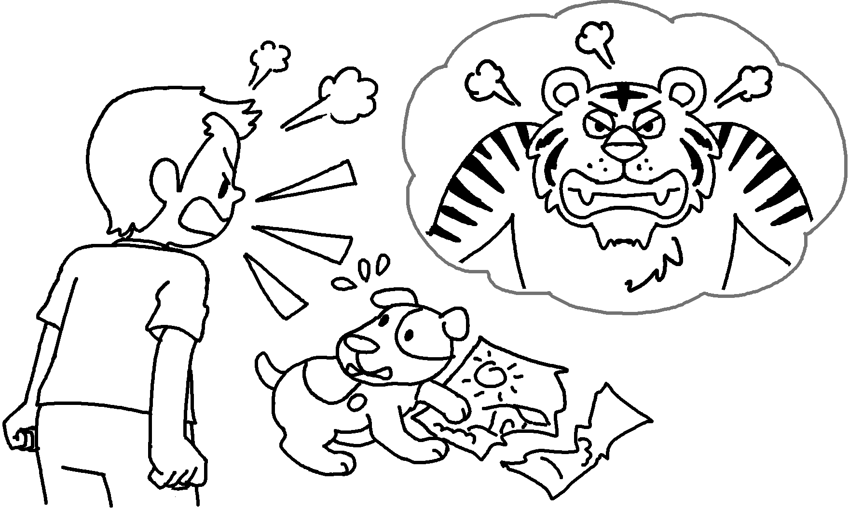 | Tommy is  .
6 | 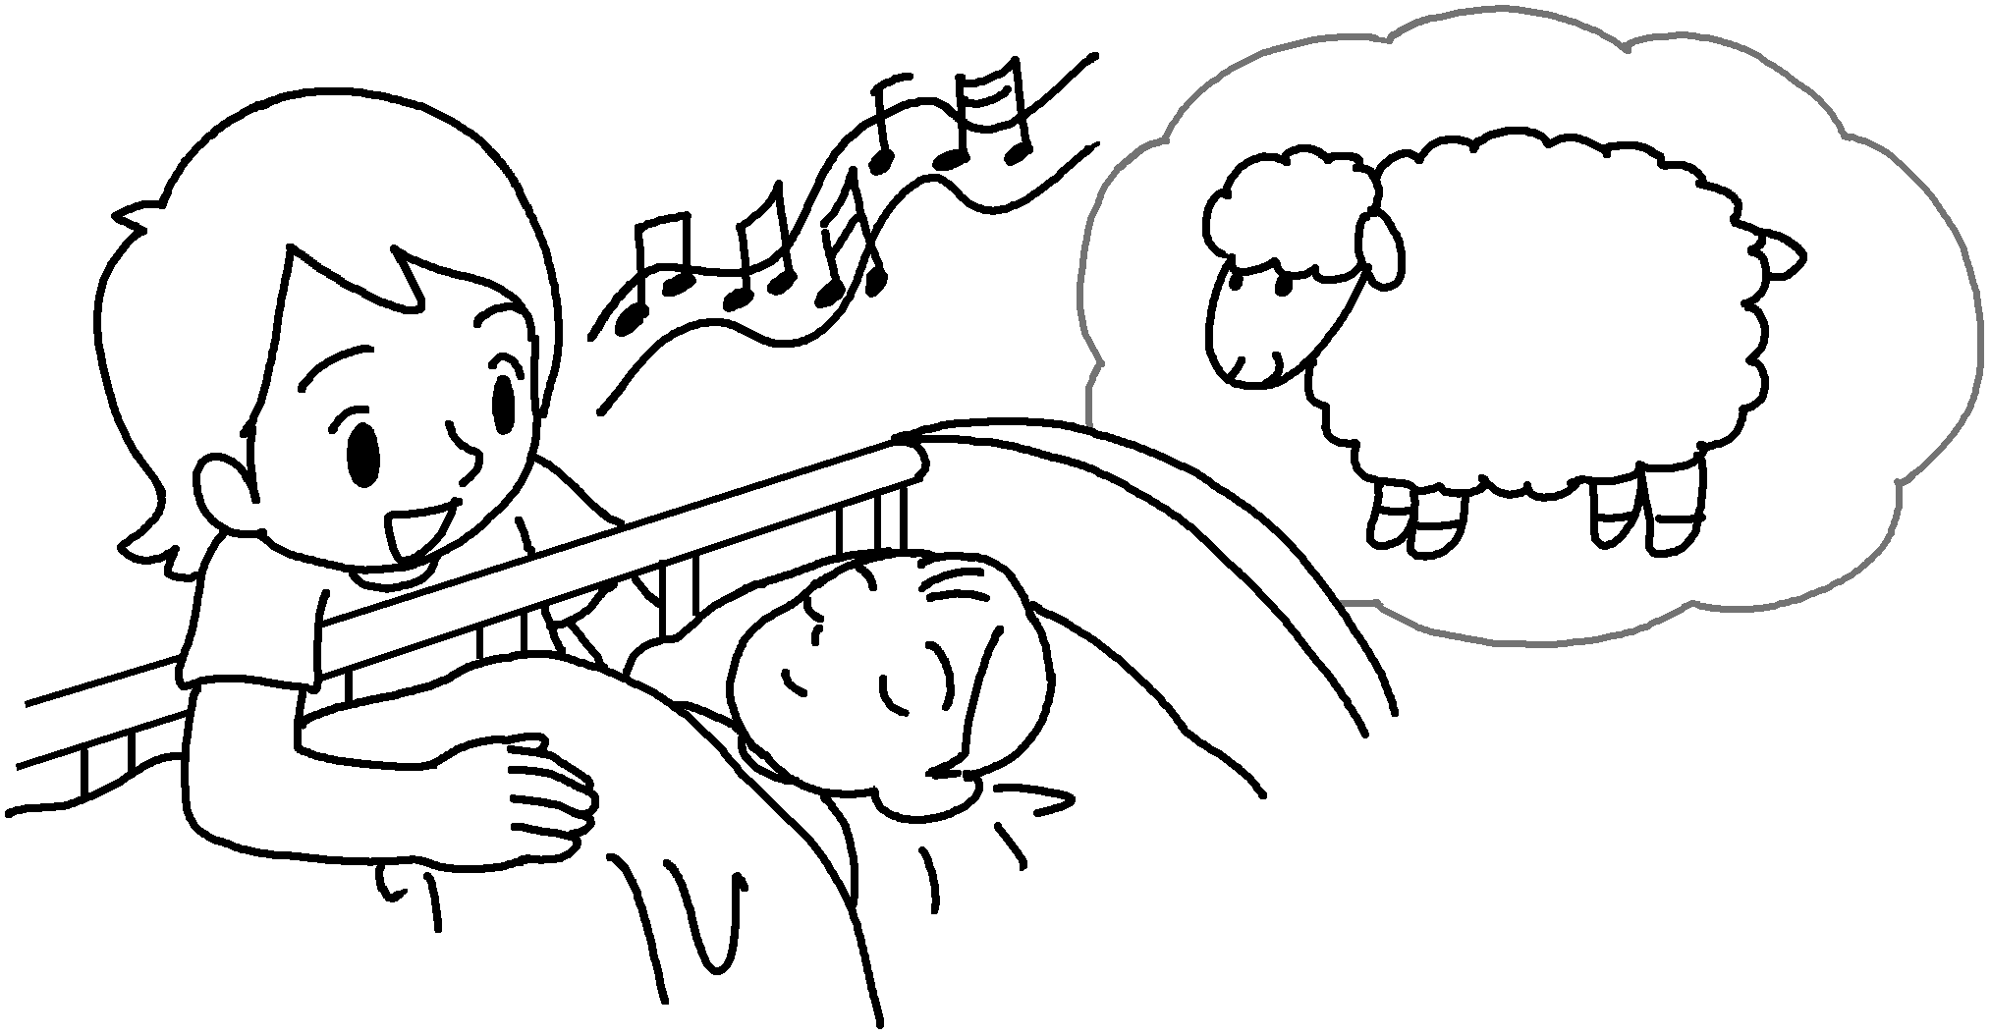 | Mary is  .


Book 6B Chapter 1 Graded Worksheets
Worksheet 2⬇⬇
1 as as
2 as brave as
3 as slow as snail
4 as timid as a mouse
5 as fierce as a tiger
6 as gentle as a lamb

