Finish the similes.

brave fierce slow lamb tiger lion
as ... as
gentle timid snail mouse

1 | 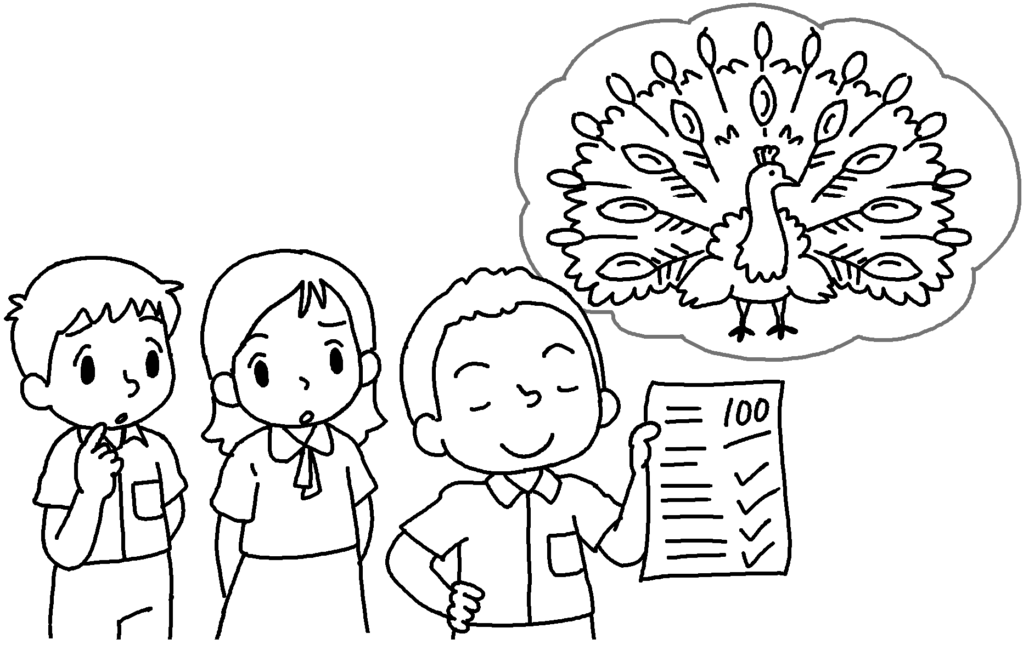 | David is proud  a peacock.
2 | 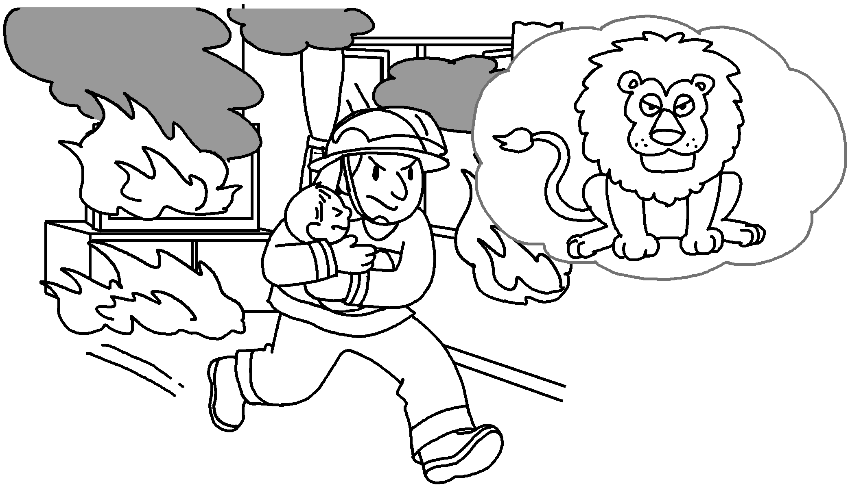 | The fireman is  a .
3 | 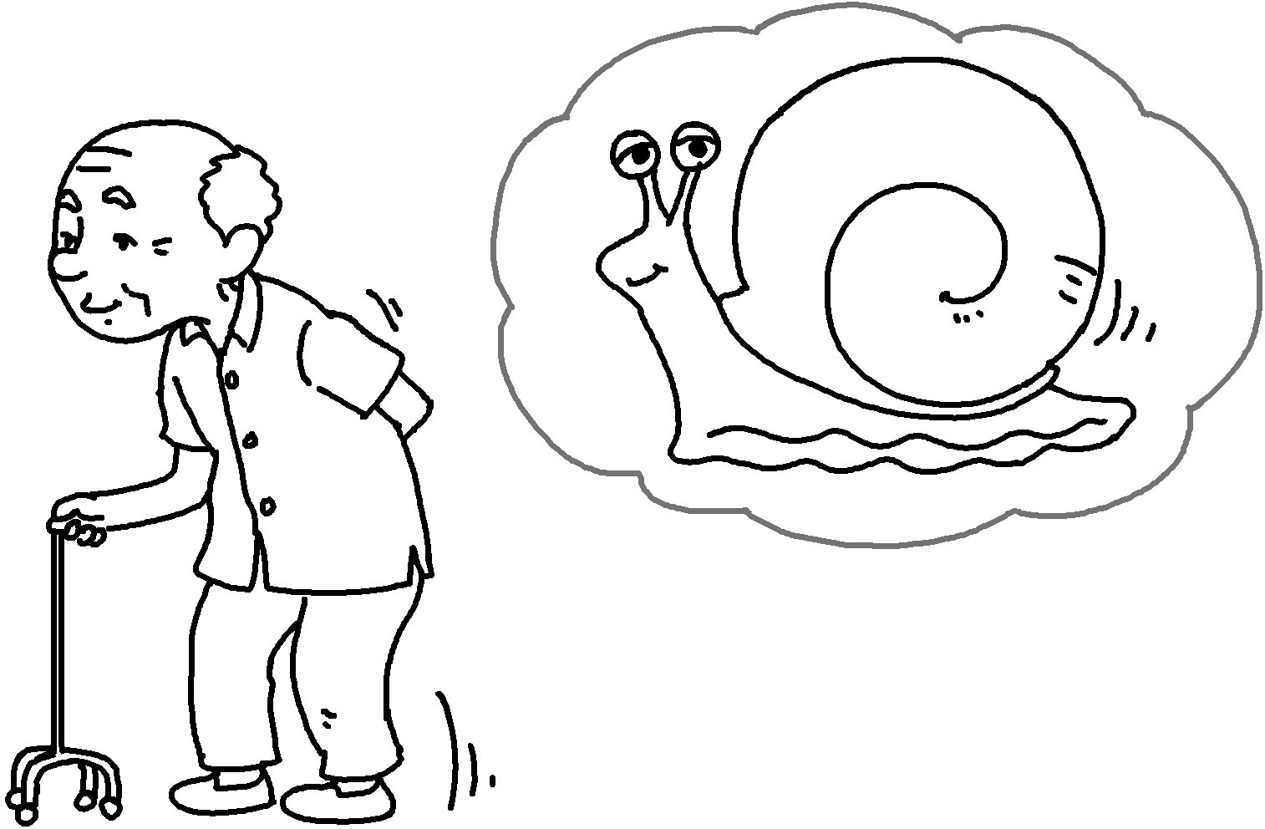 | My grandpa is  .
4 | 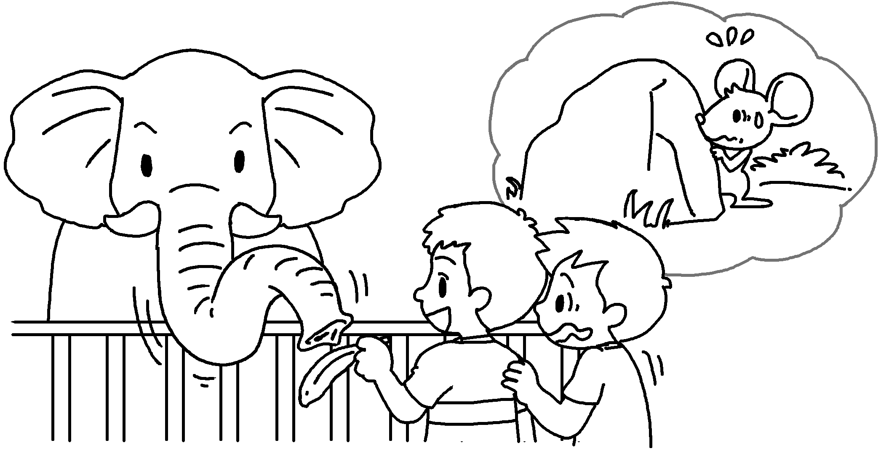 | Alan is  .
5 | 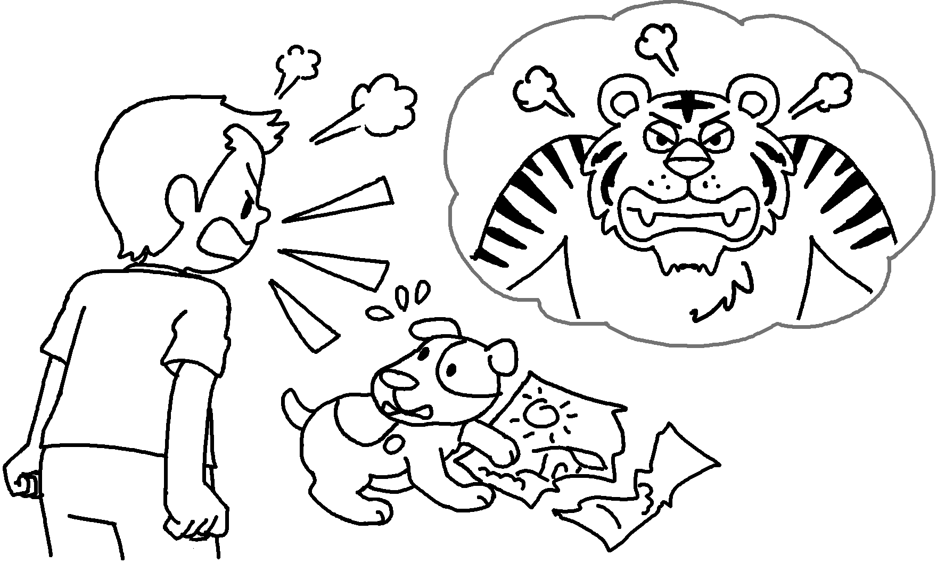 | Tommy is  .
6 | 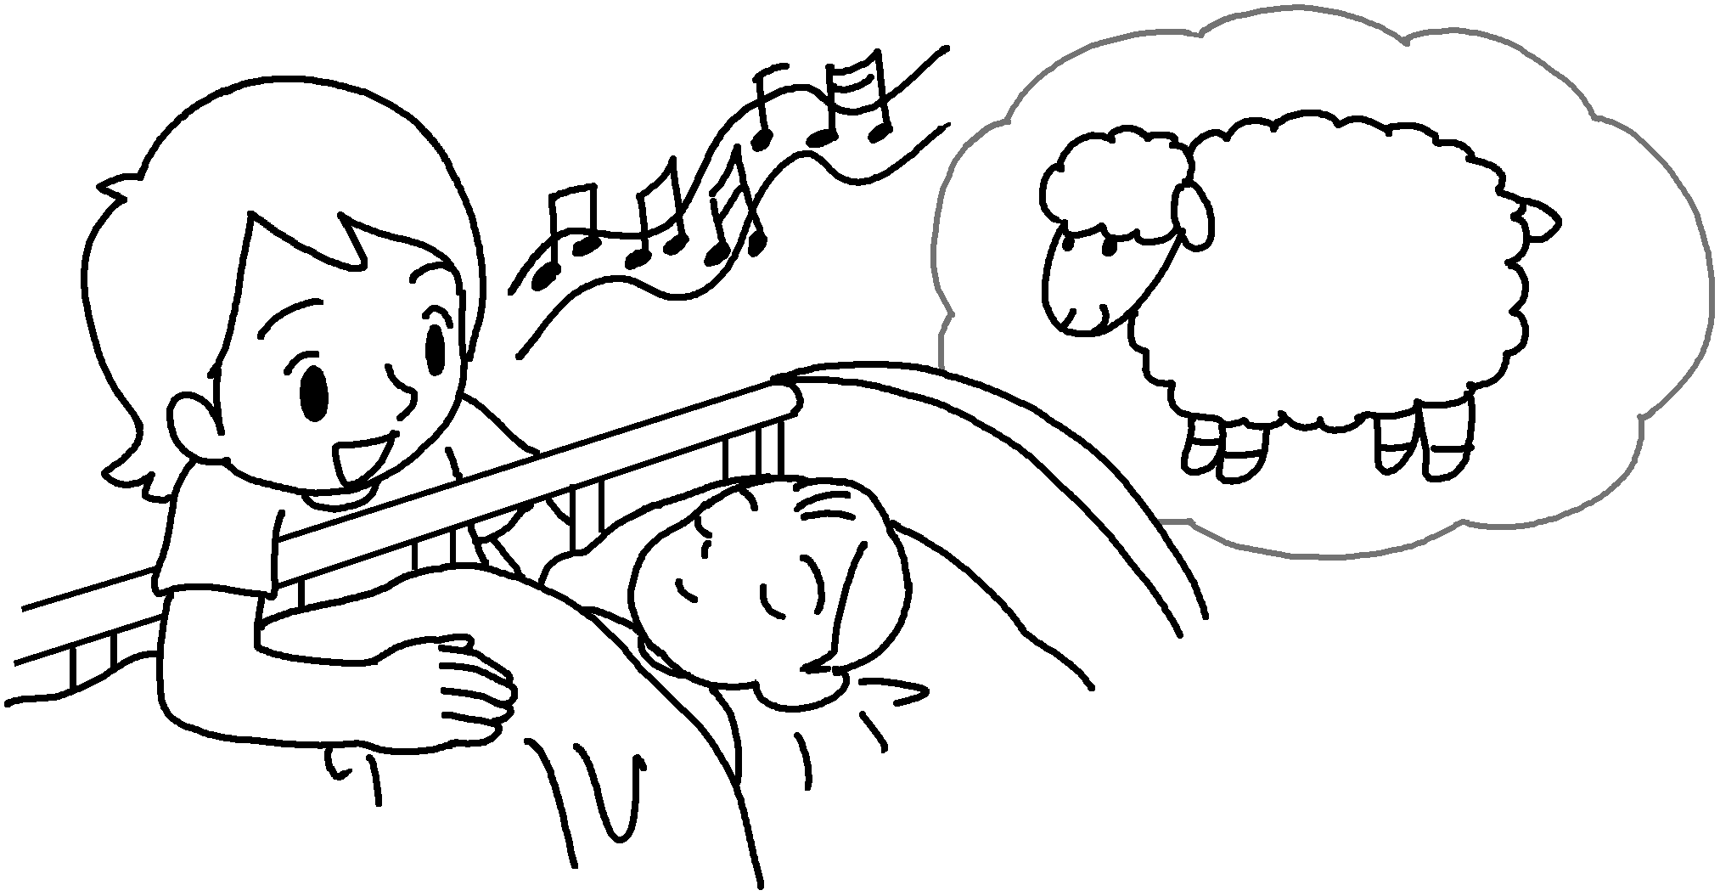 | Mary is  .


Book 6B Chapter 1 Graded Worksheets
Worksheet 2⬇⬇⬇
1 as as
2 as brave as lion
3 as slow as a snail
4 as timid as a mouse
5 as fierce as a tiger
6 as gentle as a lamb

