Choose and write.
whiteroughtallquickslowheavy
like

1 | 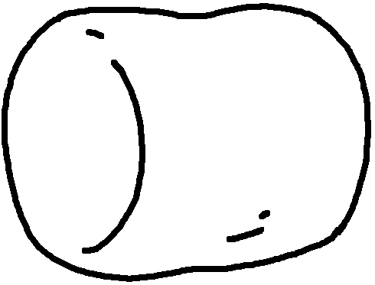 | A marshmallow is soft a pillow. | 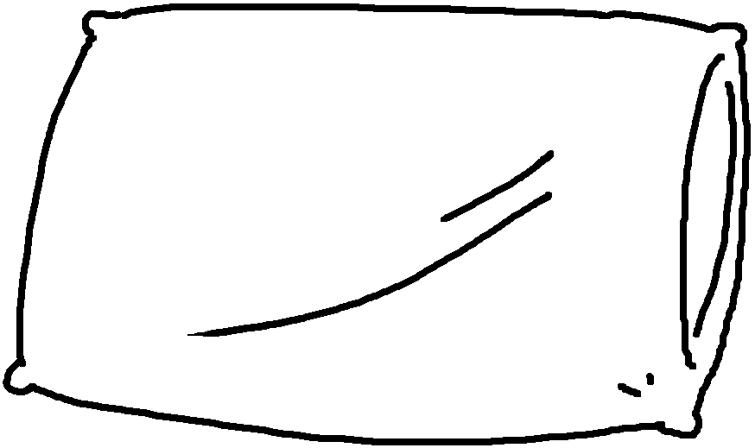
2 | 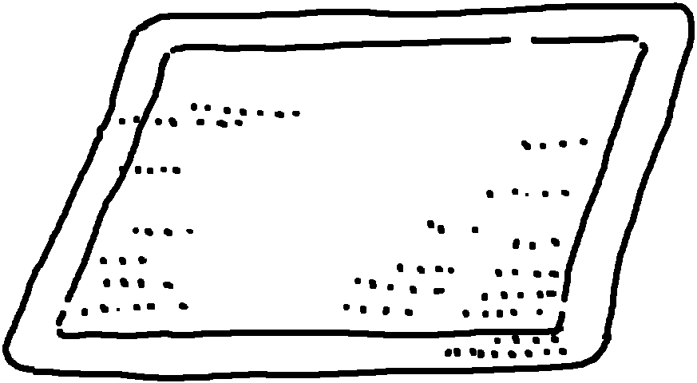 | This doormat is  sand. | 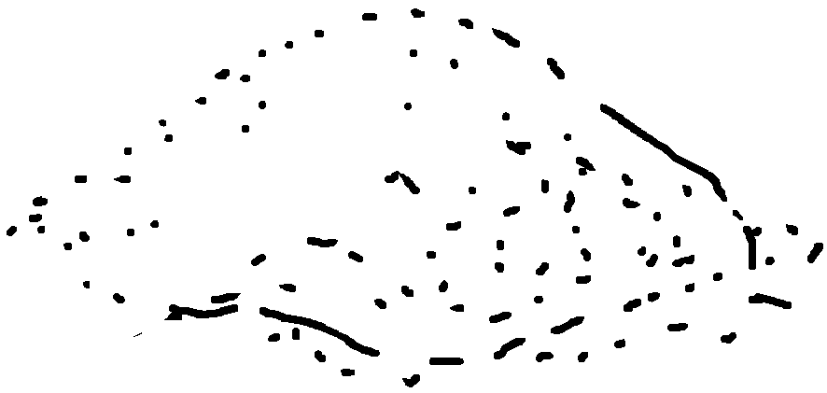
3 | 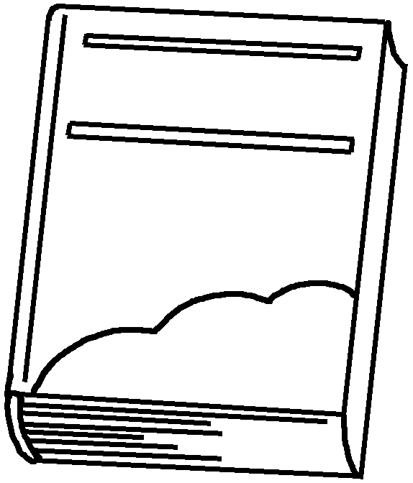 | This book is a rock. | 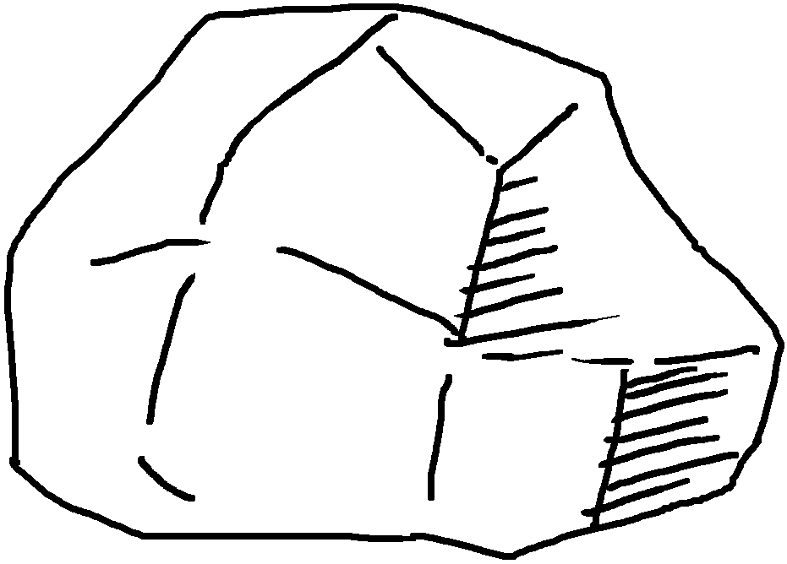
4  Peter  Sam | 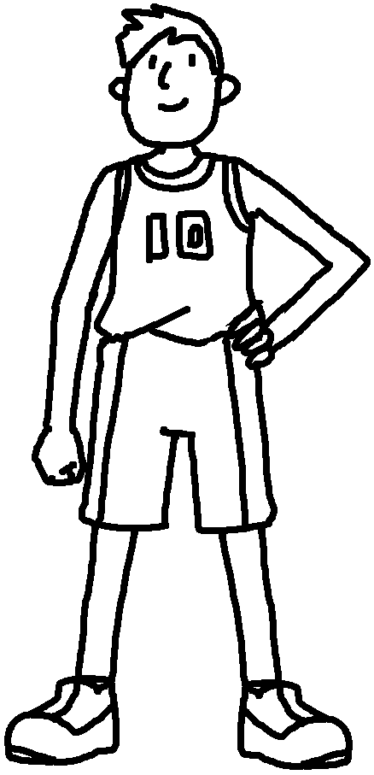 | John is  a mountain. | 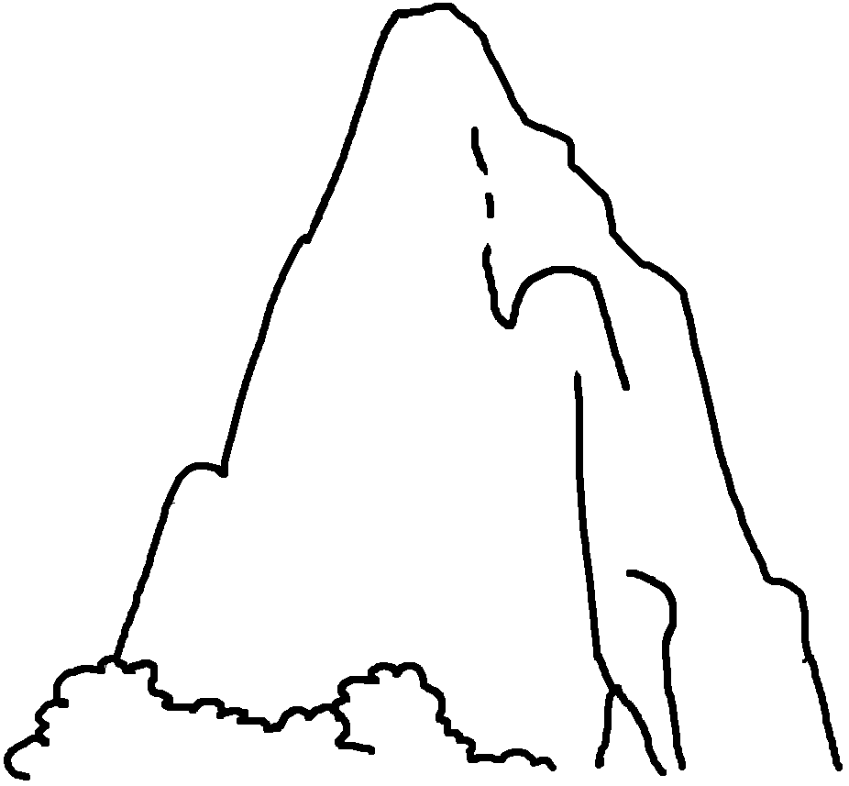
5 | 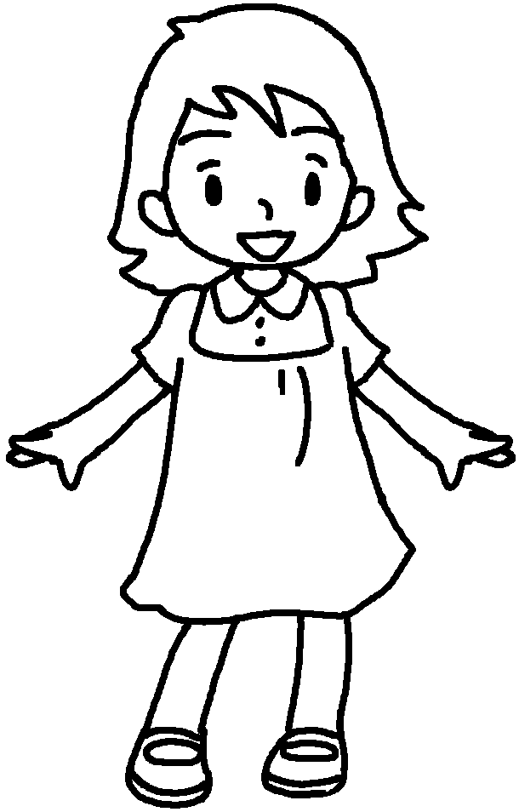 | Mary’s dress is  snow. | 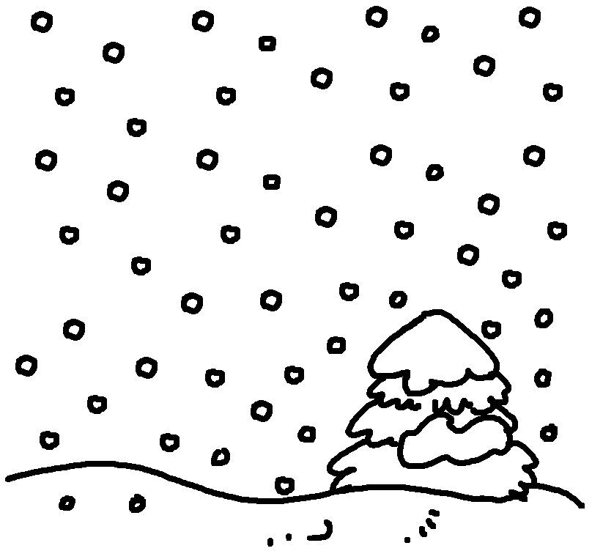
6 | 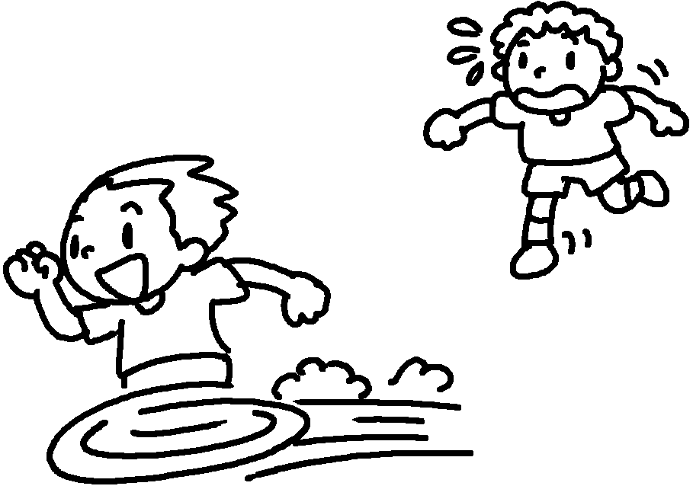 | Peter is  the wind. Sam is  a tortoise. | 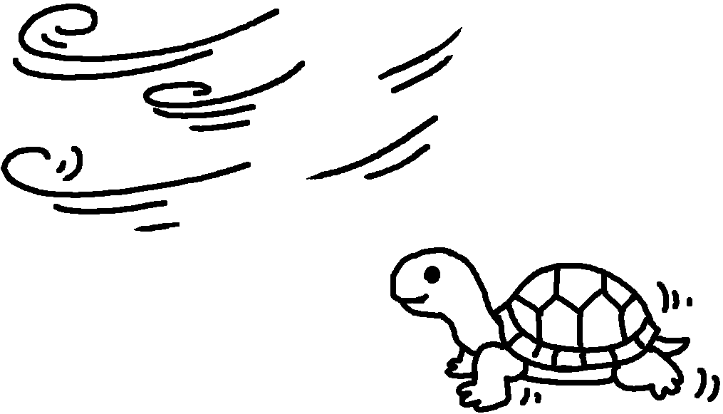


Book 6B Chapter 1 Graded Worksheets
Worksheet 3⬇
- like
- rough like
- heavy like
- tall like
- white like
- quick like
slow like

