Finish the sentences using ‘is … like …’.

white rough tall
quick slow heavy

1 | 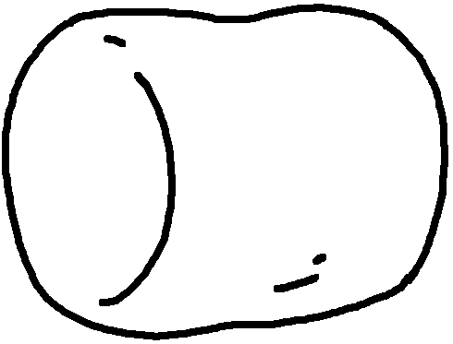 | A marshmallow is soft a pillow. | 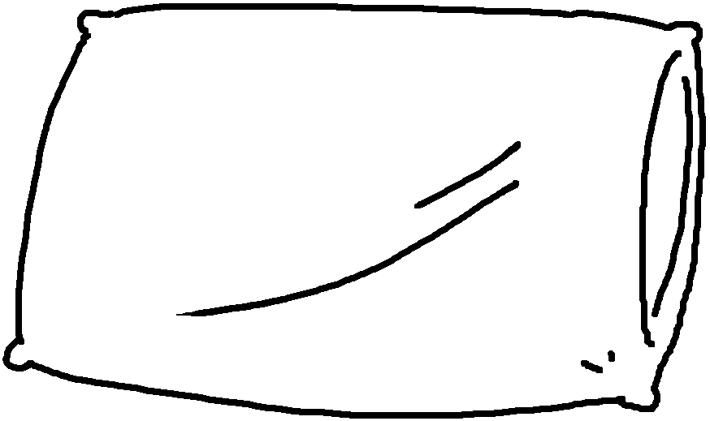
2 | 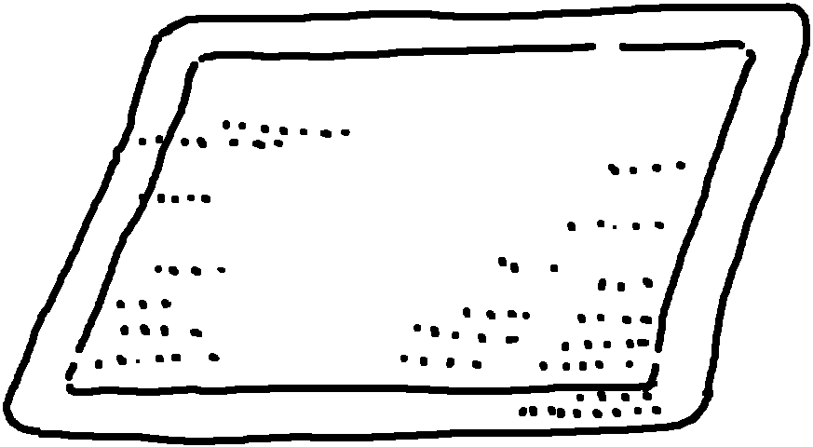 | This doormat is  like . | 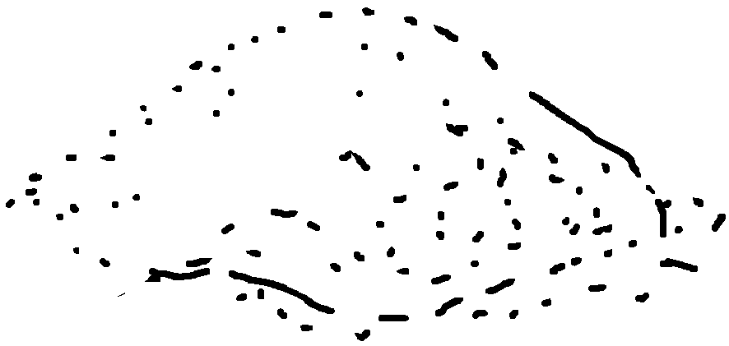
3 | 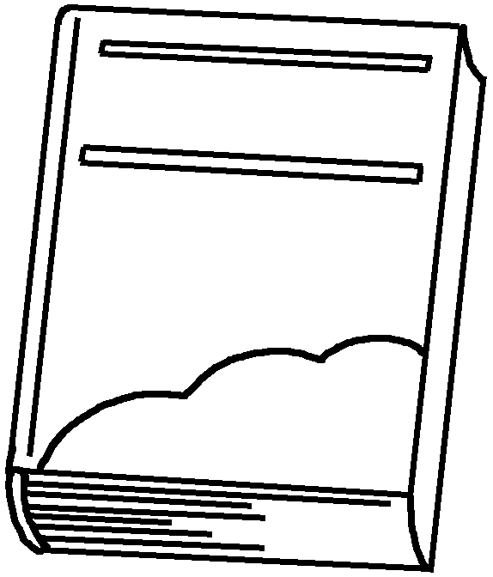 | This book is  a . | 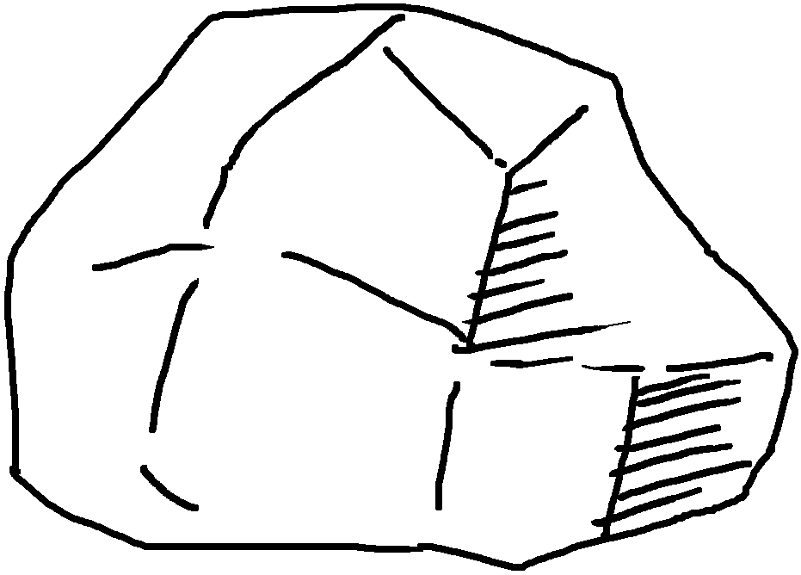
4  Peter  Sam | 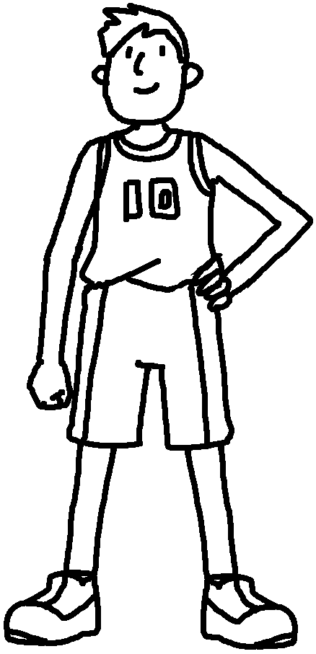 | John is  . | 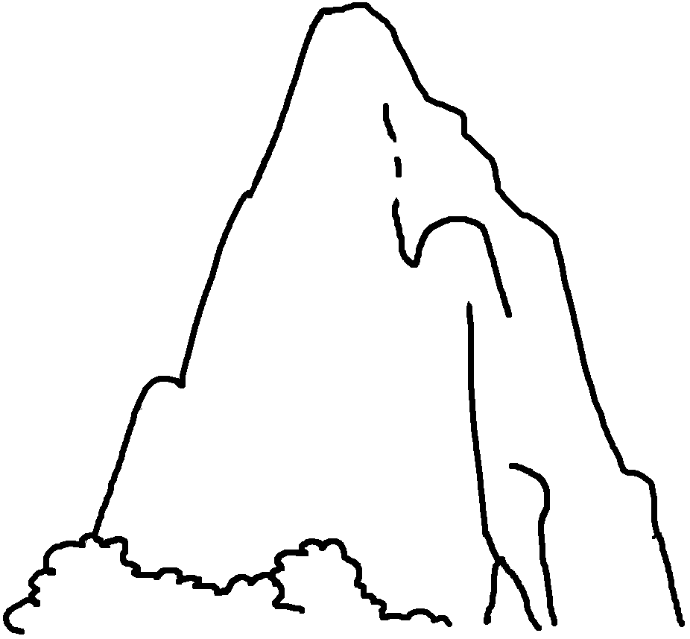
5 | 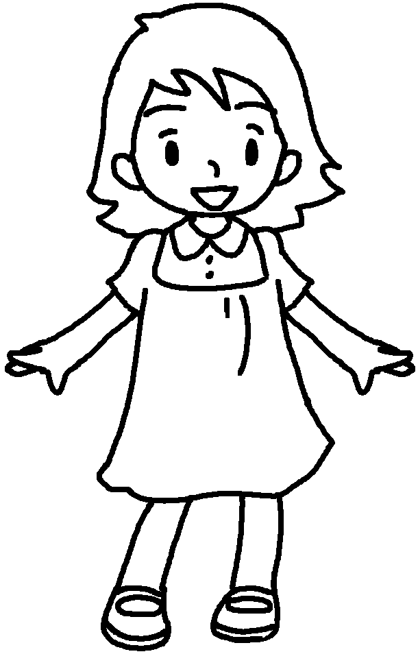 | Mary’s dress is  . | 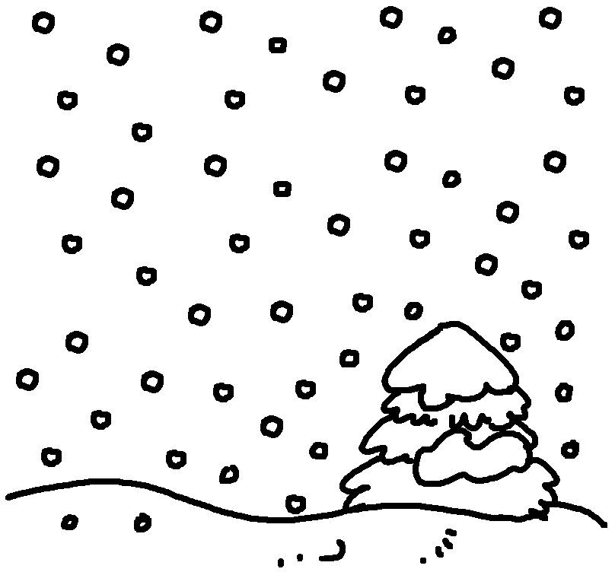
6 | 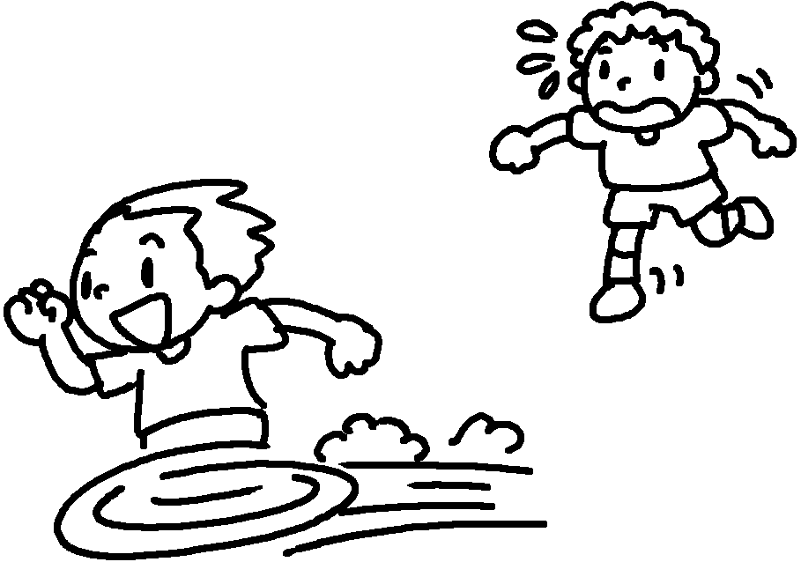 | Peter is  the . Sam is  a tortoise. | 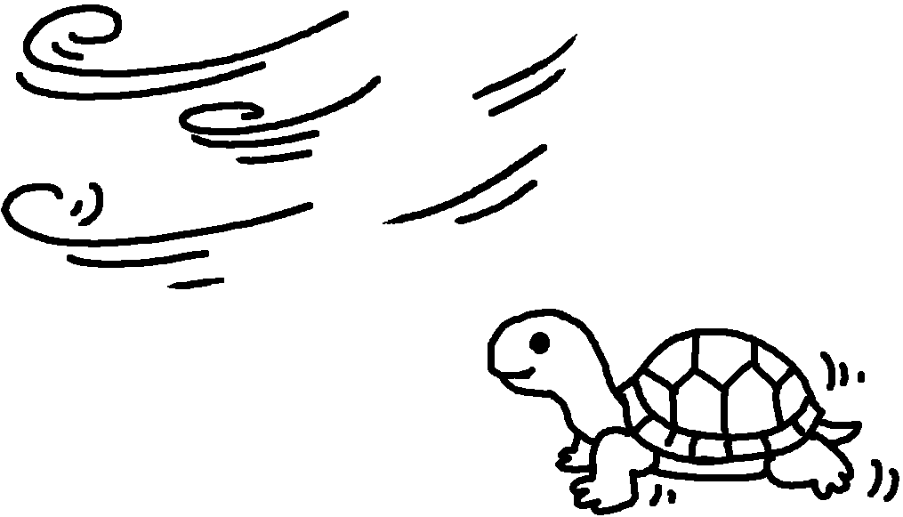


Book 6B Chapter 1 Graded Worksheets
Worksheet 3⬇⬇⬇
- like
- rough sand
- heavy like rock
- tall like a mountain
- white like snow
- quick like wind
slow like
(Accept any reasonable answers.)

