Riddles
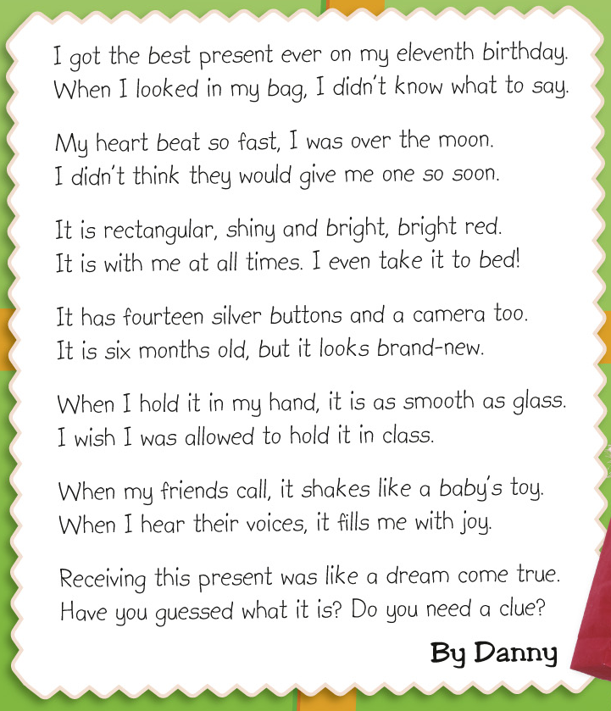
Write the answers and blacken  the circles.

1 Can Danny use the present at school? Which sentence tells you this?

2 How is the present like a baby’s toy?

3 Read Verse 2: …I was over the moon. Danny wants to tell us ____ .
 A. he loved watching the moon
 B. he was dreaming under the moon
 C. he was very happy
 D. he was very upset

4 Read Verse 6. How does Danny feel when he hears his friends’ voices?
 A. scared  B. happy
 C. surprised  D. worried

5 Read the last verse: Receiving this present was like a dream come true.
What does Danny mean?
 A. He does not believe the present is real.
 B. He has worked hard to get this present.
 C. He got this present in his dream.
 D. He has wanted this present for a long time.

6 Which of the following about the present is NOT true?
 A. It is a birthday present.
 B. It is with Danny when he sleeps.
 C. It is brand-new.
 D. It is useful for taking photos.
Answers: (Accept any reasonable answers.)
1 No. ‘I wish I was allowed to hold it in class.’ 2 It shakes.
3 C 4 B 5 D 6 C

