Choose and write.
reachappeardisappeardropfightfindleavelosesavewin

1 | 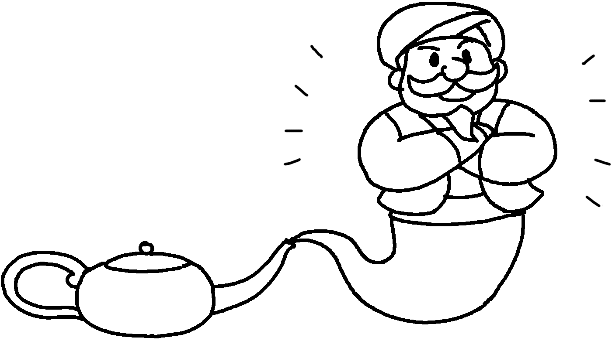 | 2 | 
3 | 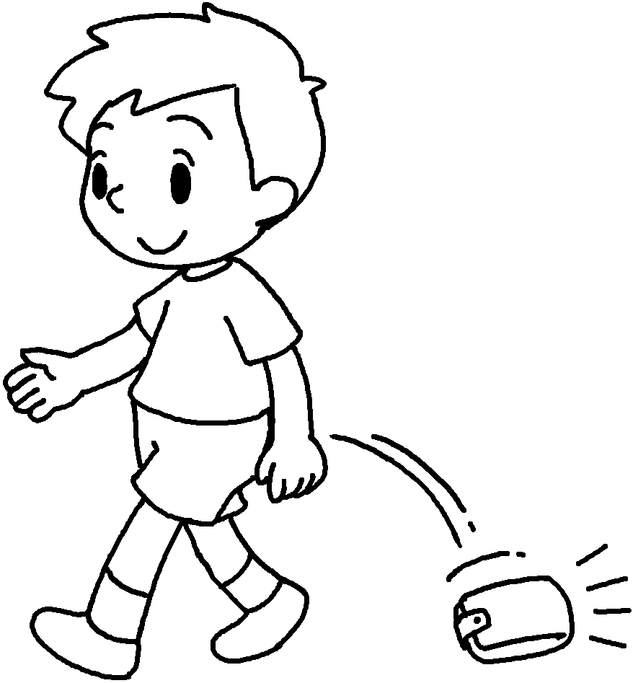 | 4 | 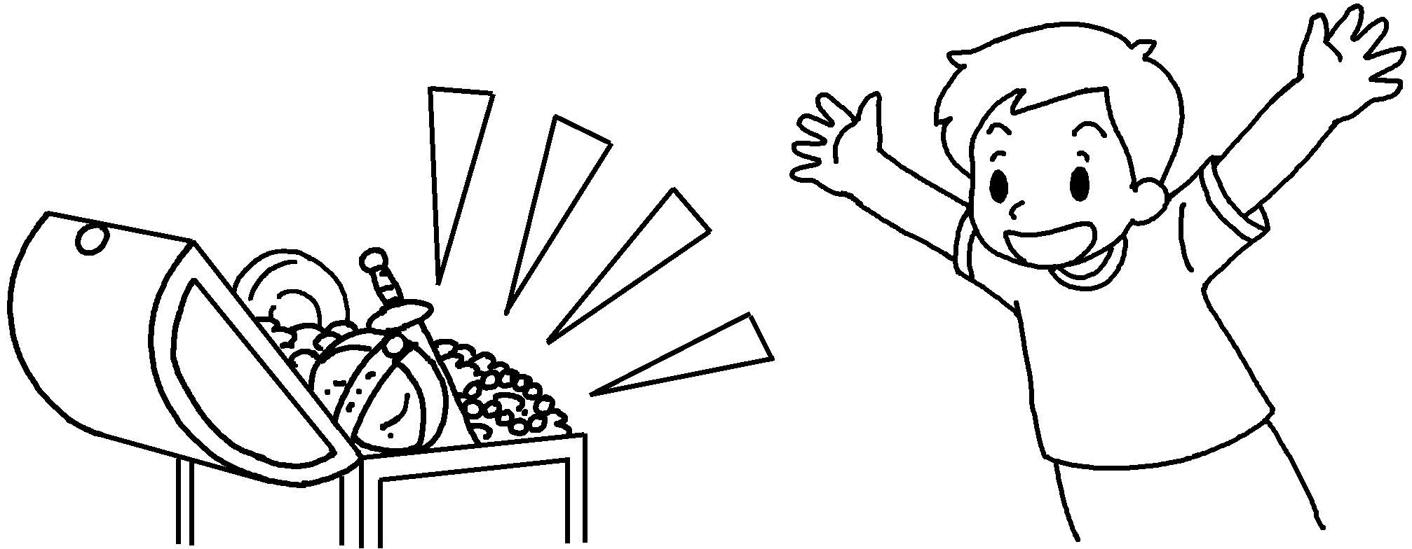
5 | 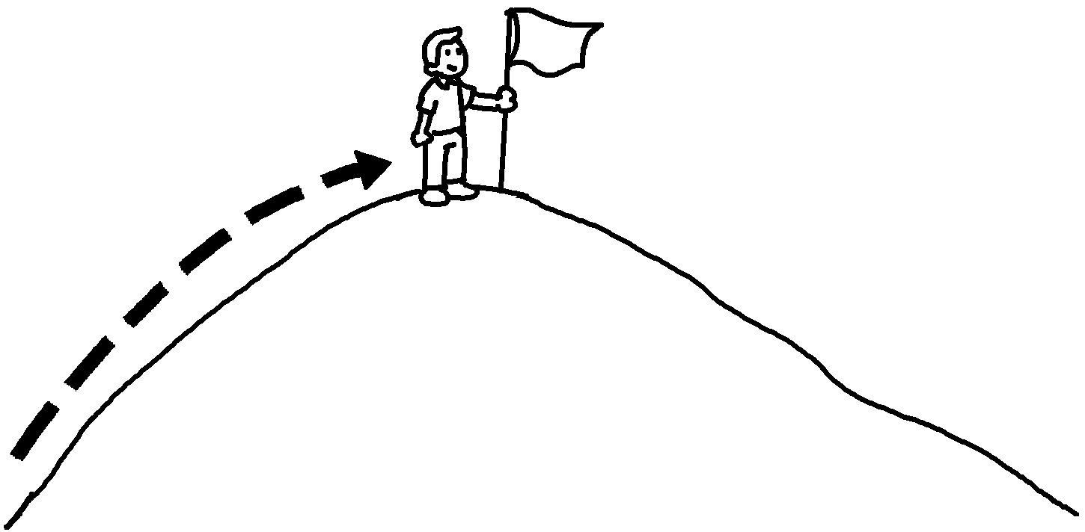 | 6 | 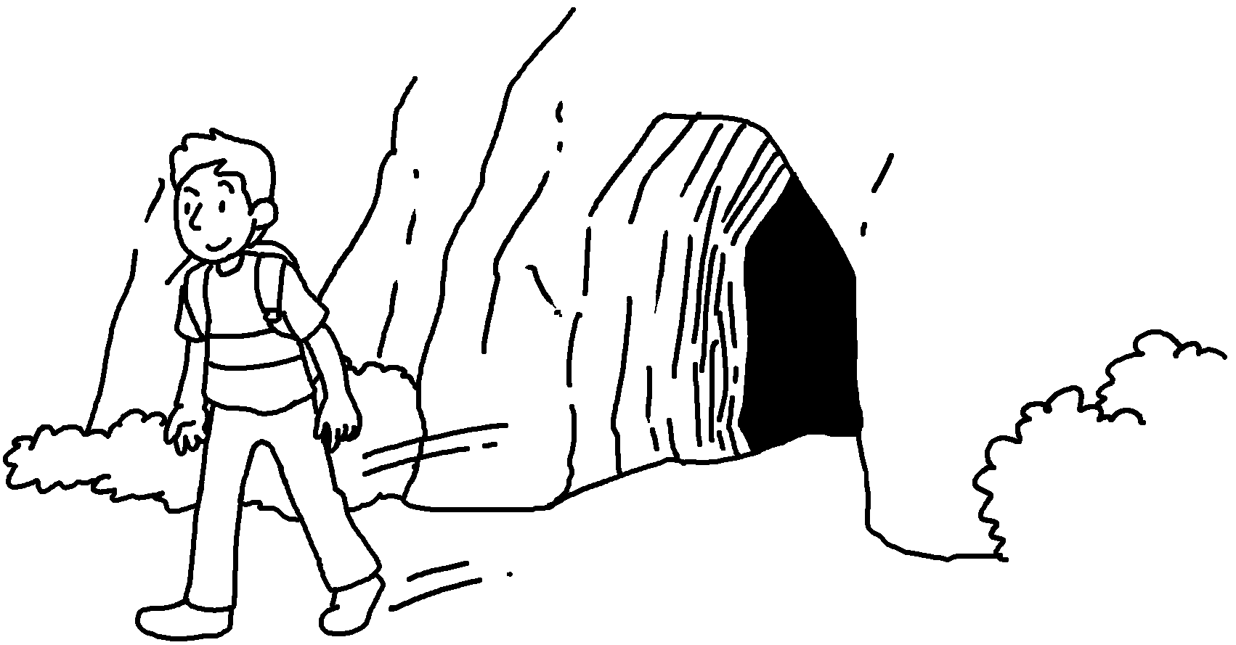
7 | 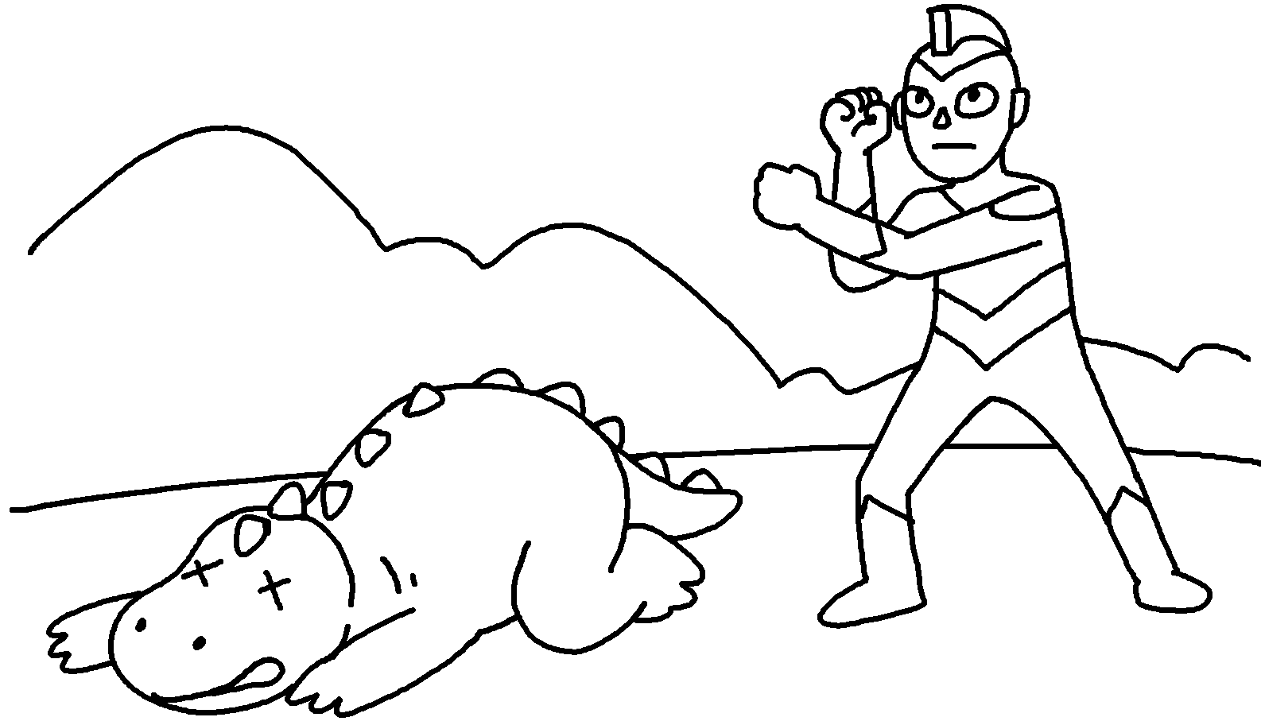 | 8 | 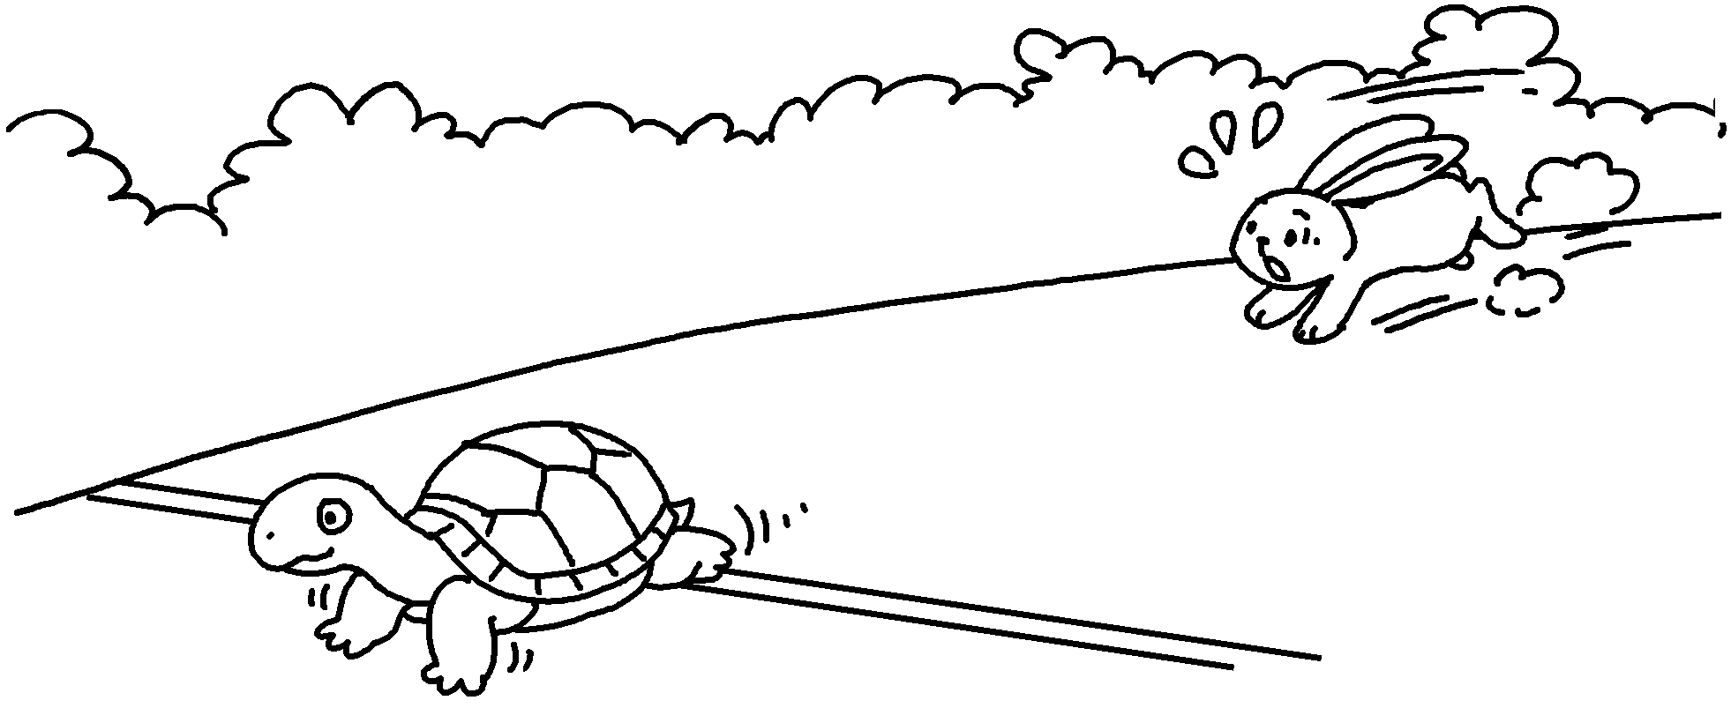
9 | 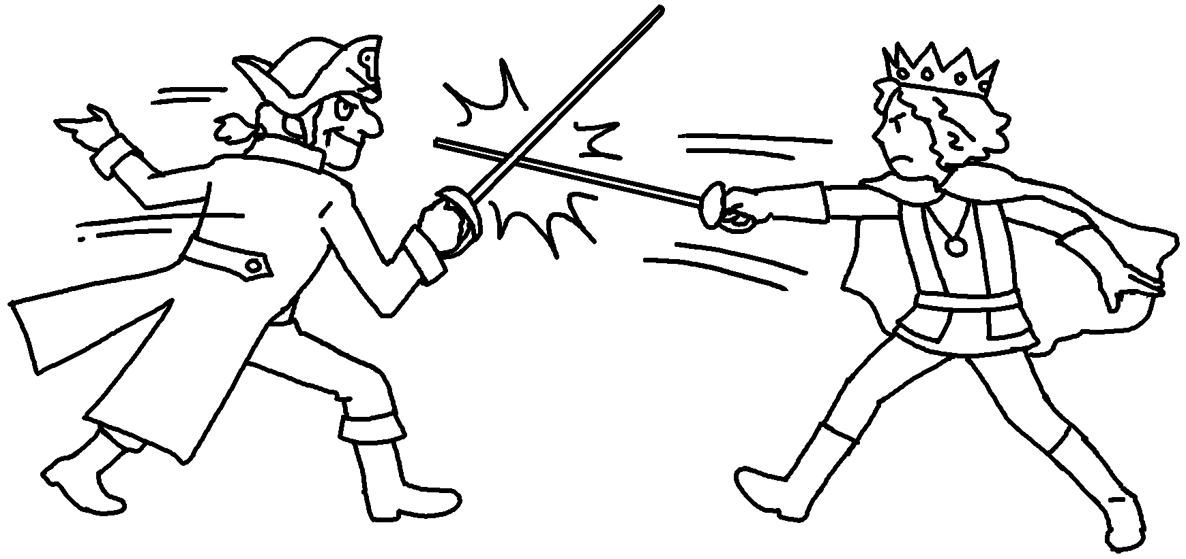 | 10 | 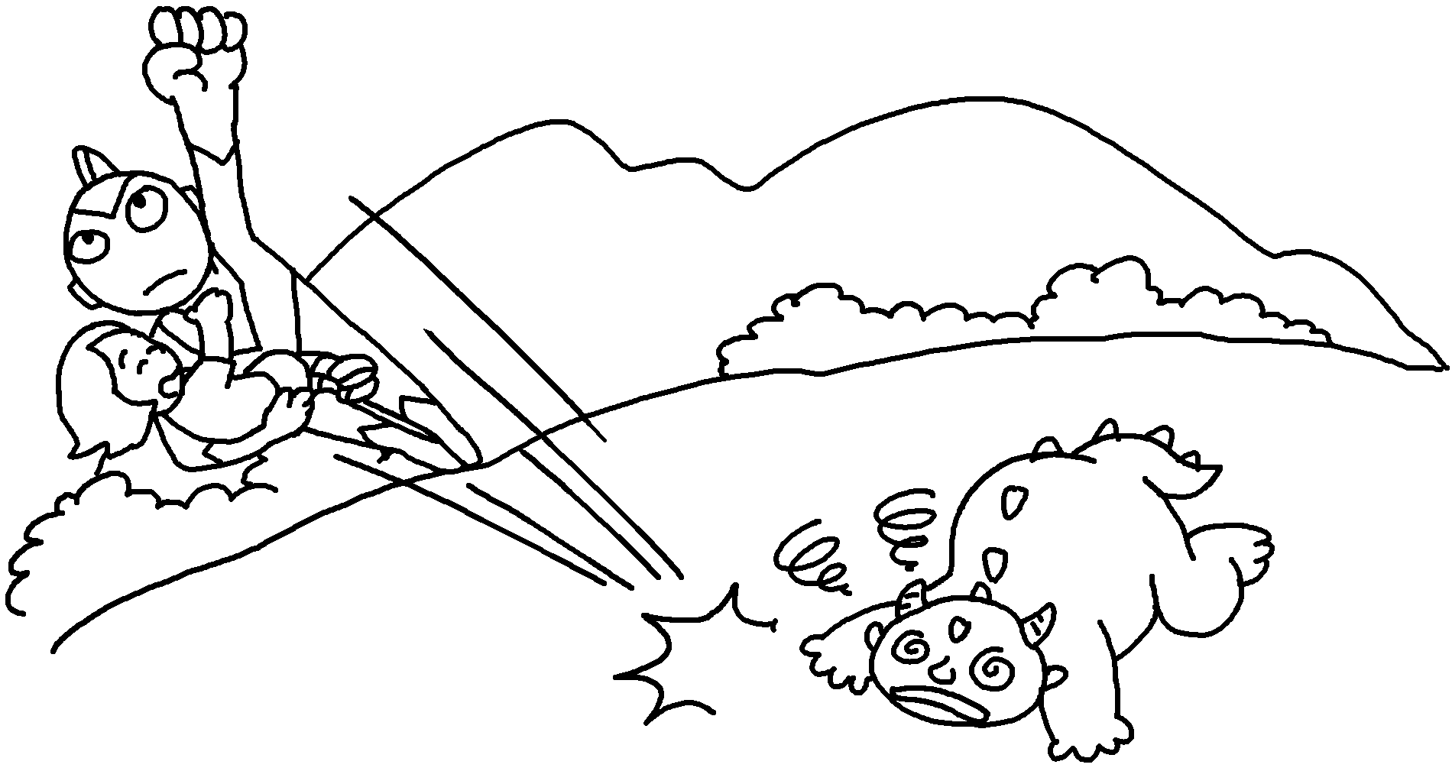


Book 6B Chapter 2 Graded Worksheets
Worksheet 1⬇
- appear 2 disappear
3 drop 4 find
5 reach 6 leave
7 win 8 lose
9 fight 10 save

