Look at the pictures and write the action verbs.

1 |   a | 2 |   d
3 | 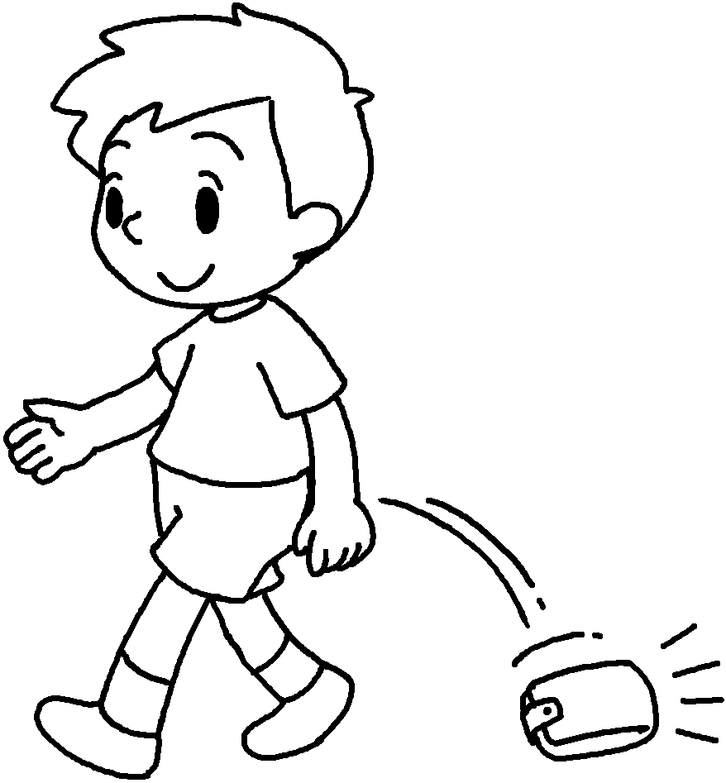  d | 4 | 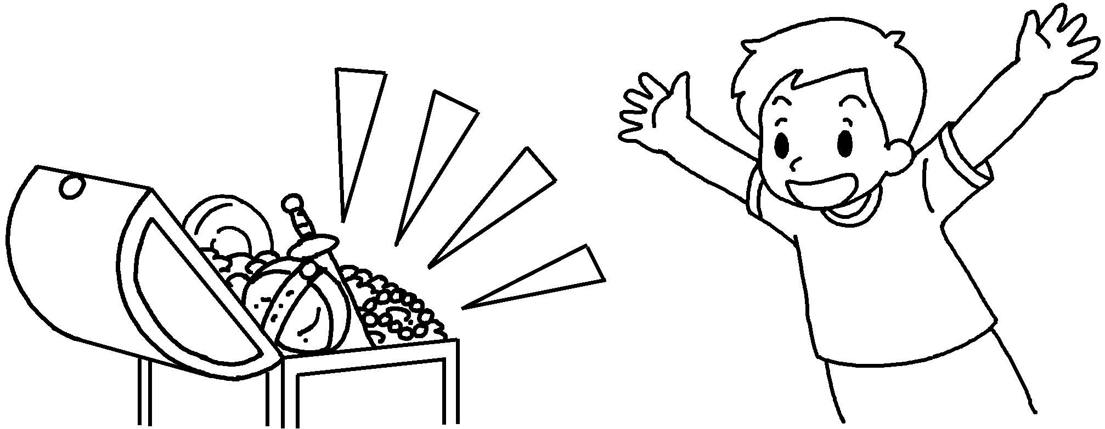  f
5 | 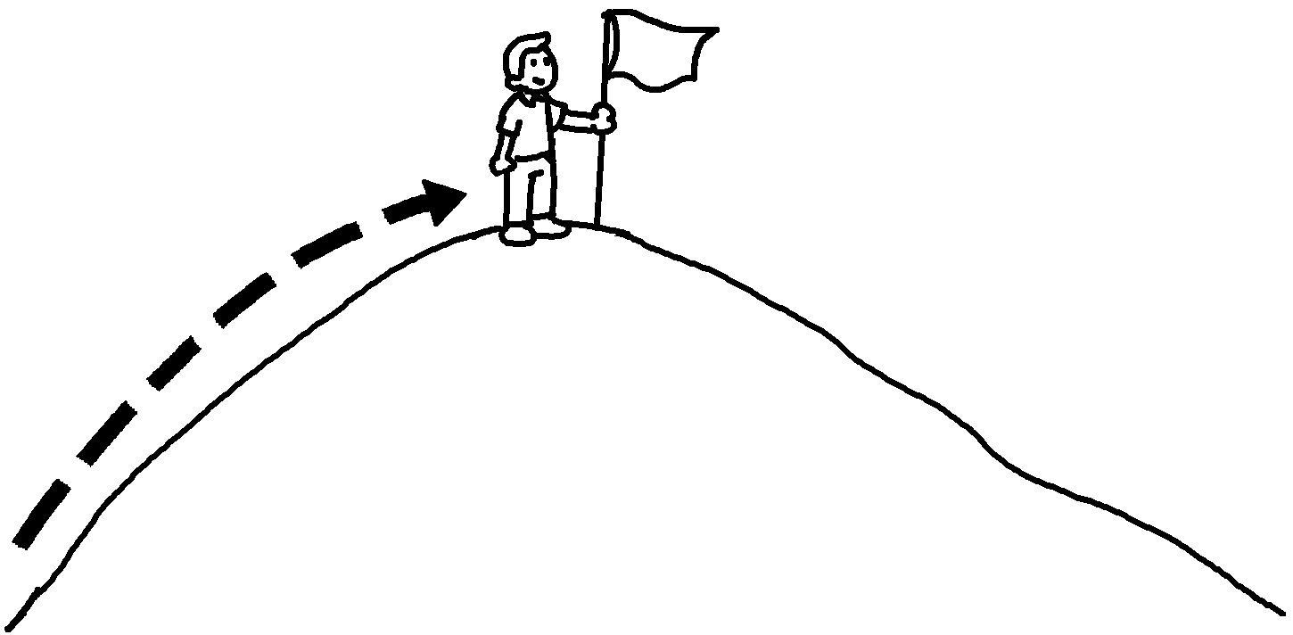  r | 6 | 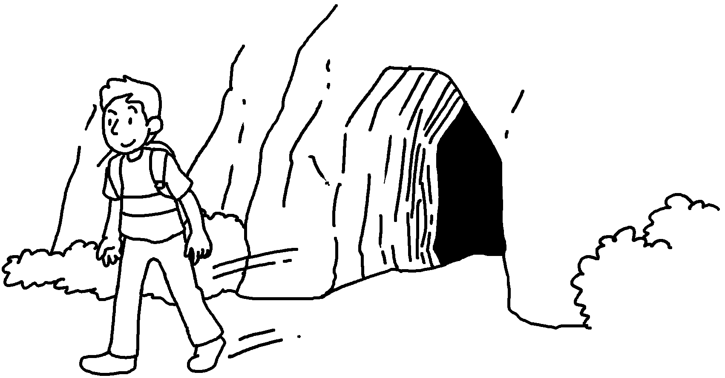  l
7 | 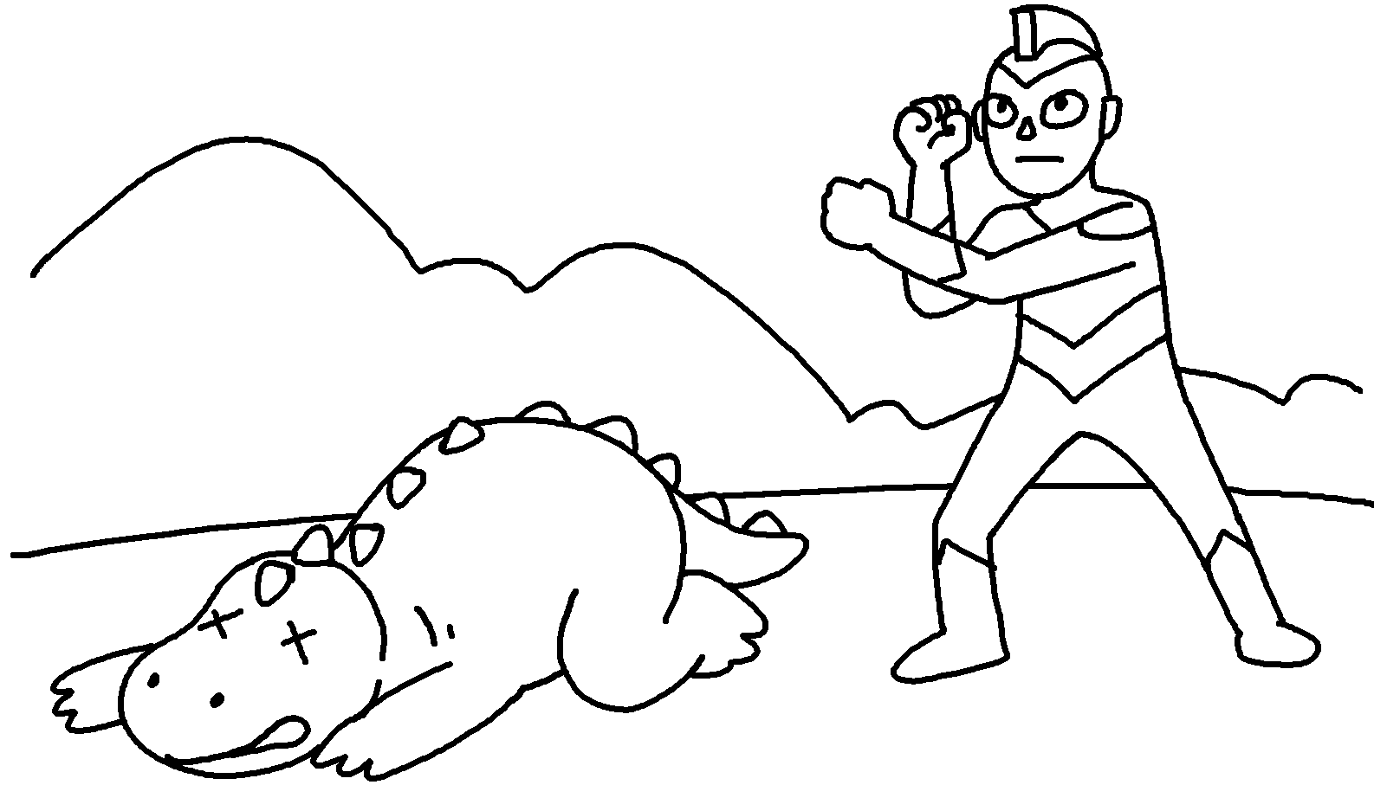  w | 8 | 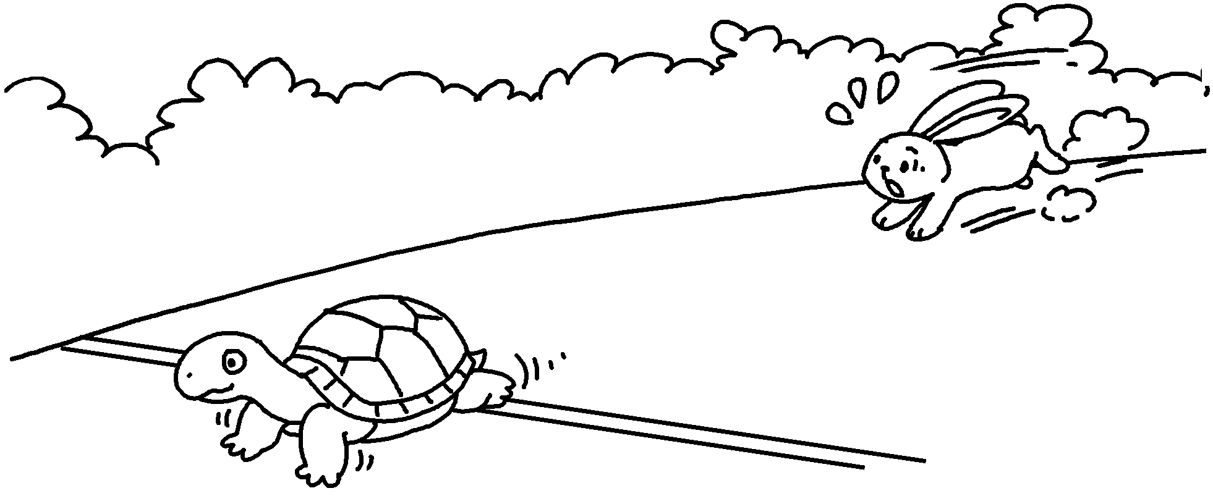  l
9 | 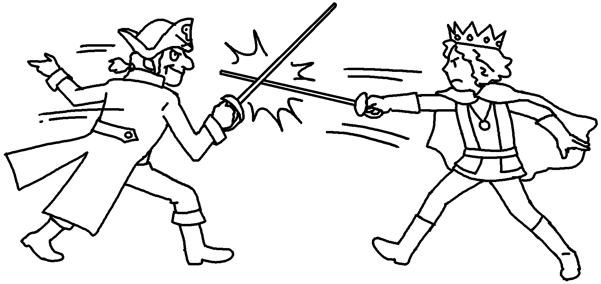  f | 10 | 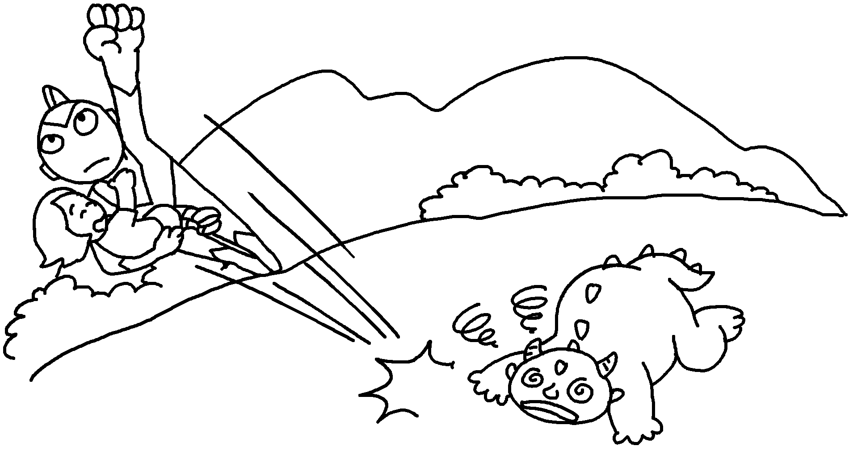  s


Book 6B Chapter 2 Graded Worksheets
Worksheet 1⬇⬇⬇
- appear 2 disappear
3 drop 4 find
5 reach 6 leave
7 win 8 lose
9 fight 10 save

