Circle and write the correct answers. Use the correct form of the verbs.

fight find save appear get

1 | 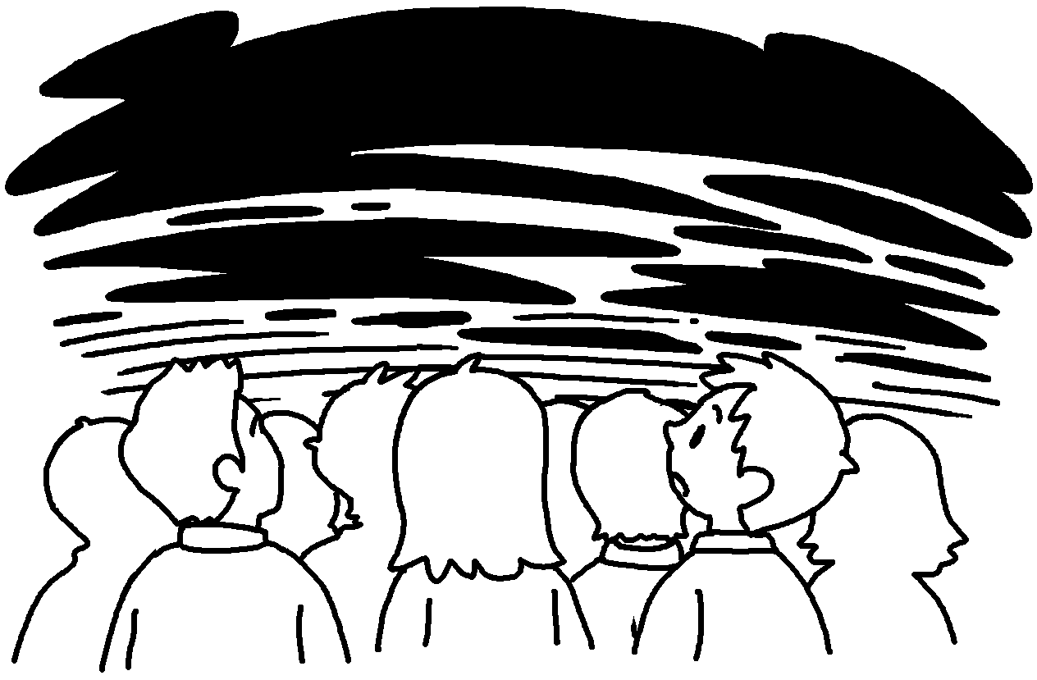 | 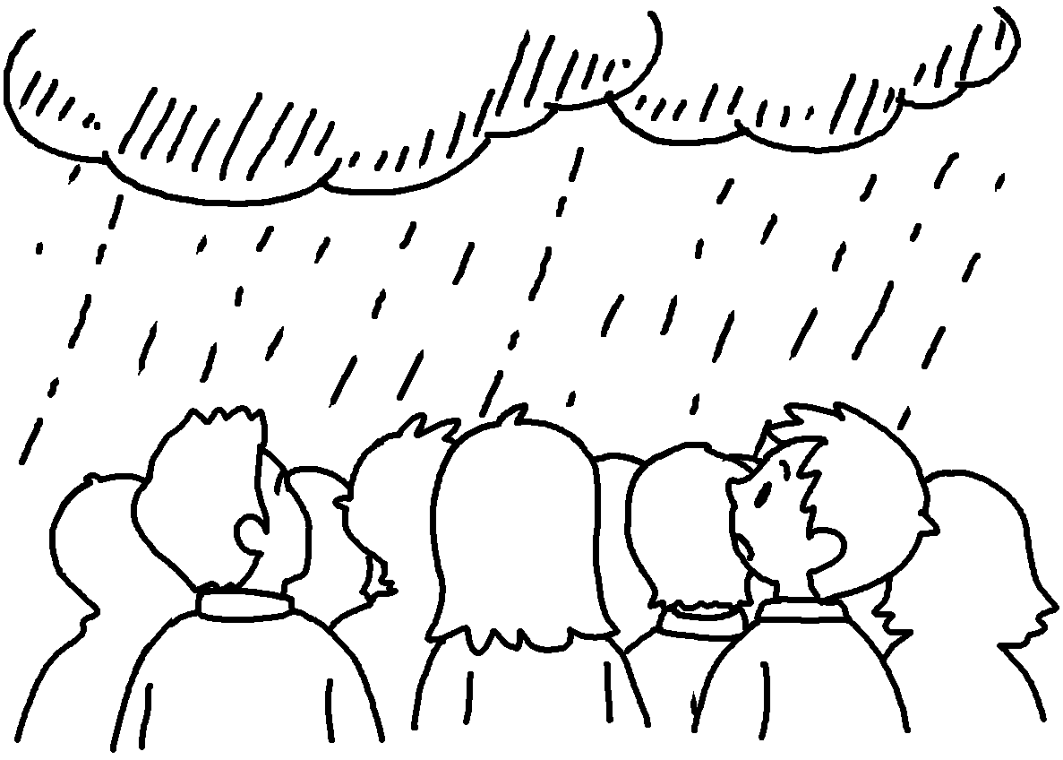 | 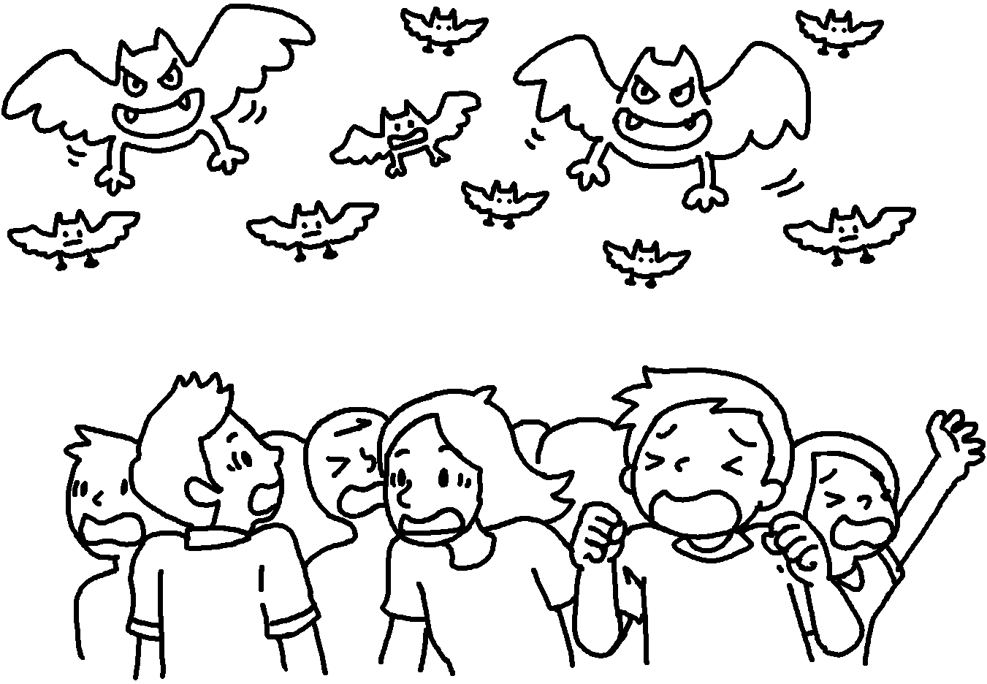
 | 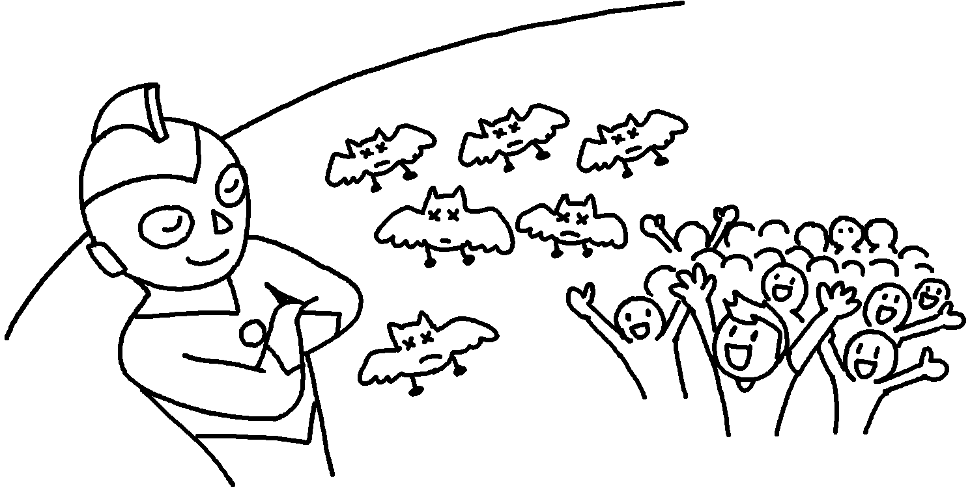 | 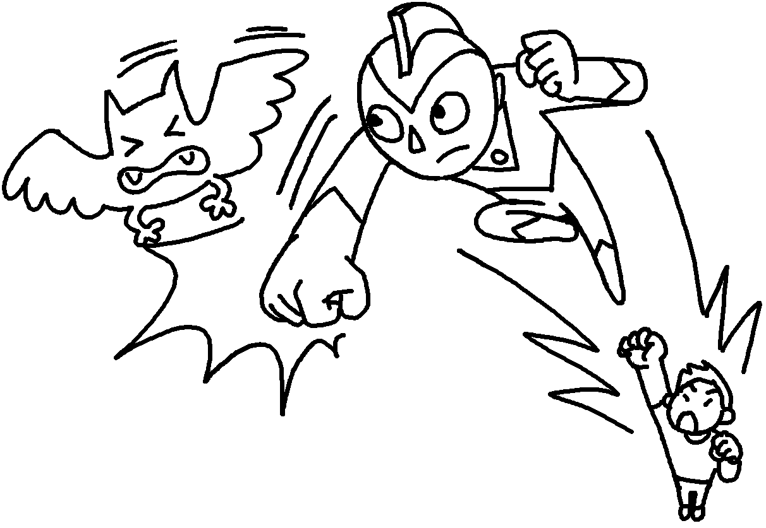
( After that / First ) the sky turned dark.
( Next / In the end ) it started to rain.
( First / Then ) a group of monsters ______________ .
( Finally / After that ) a man turned into a superhero and
_______________ the monsters.
( First / Finally ) the superhero won and ______________ the people.
2 | 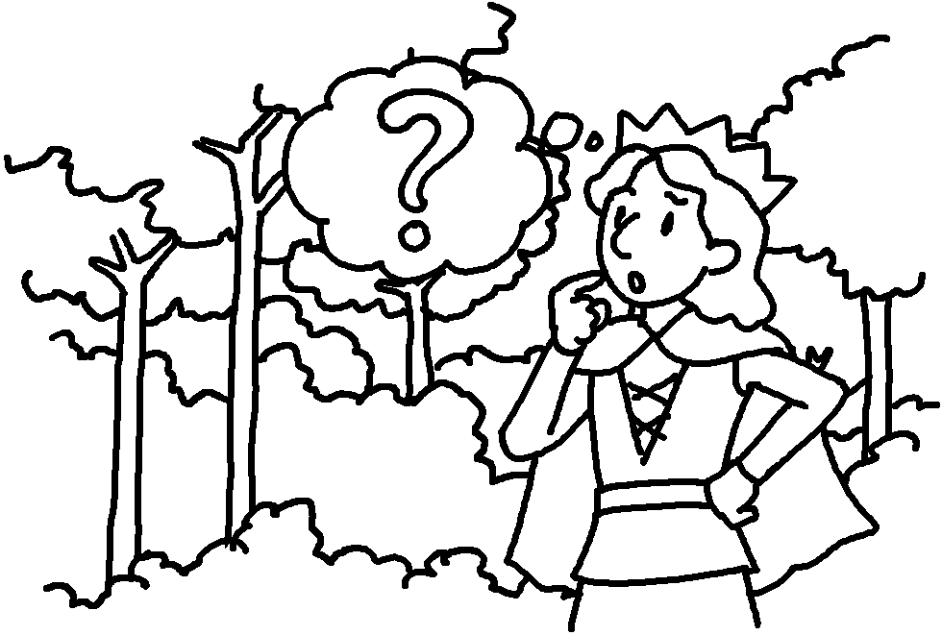 | 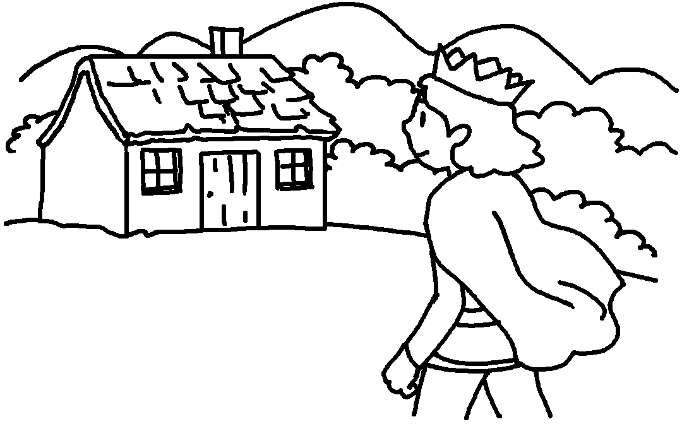 | 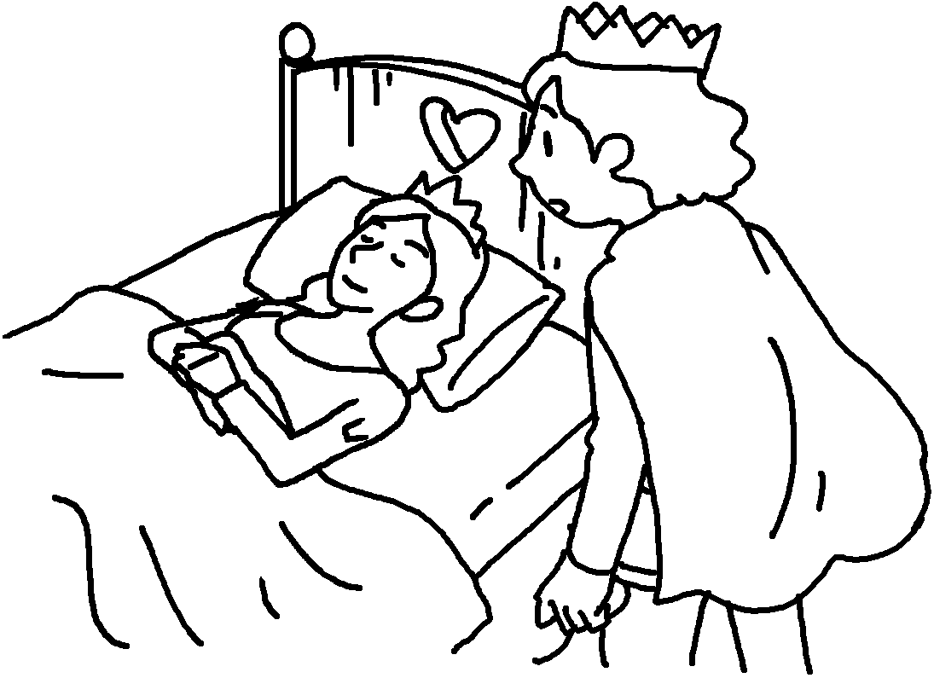
 | 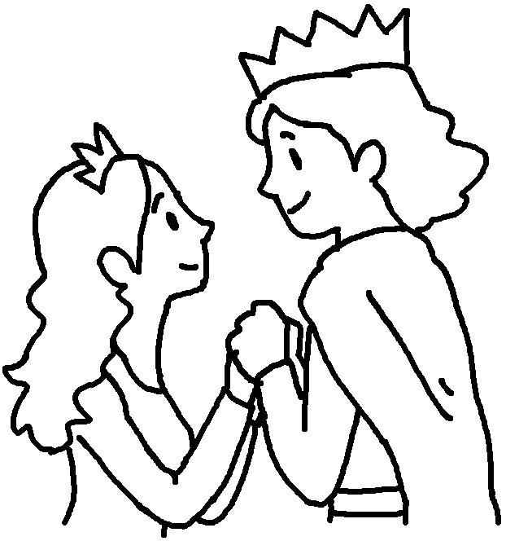 | 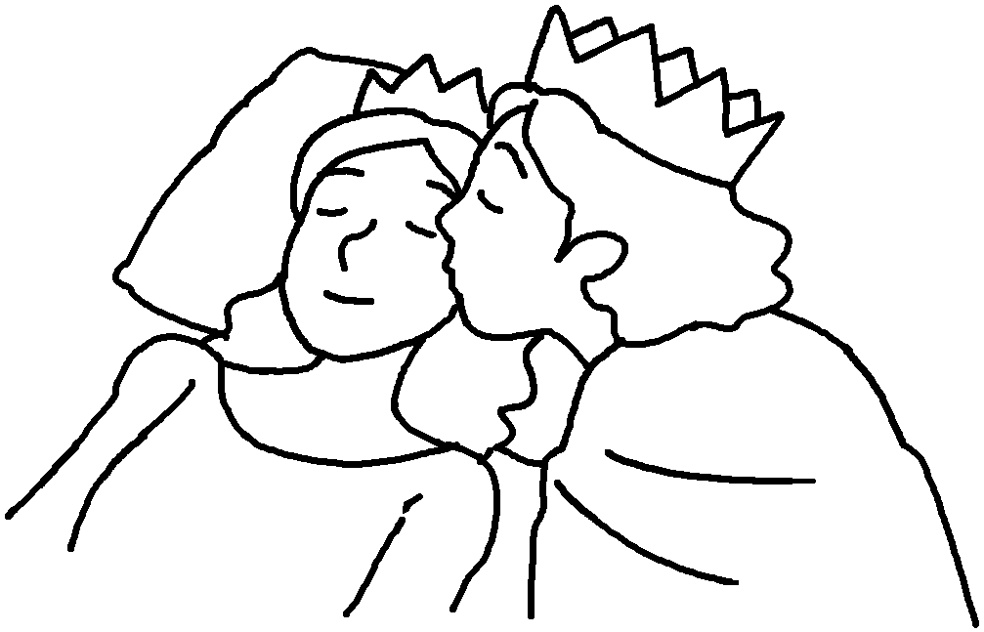
( Next / First ) a prince ______________ lost in a forest.
( First / After that ) he walked and walked and saw a house.
( Finally / Then ) he went inside the house and ______________
a princess sleeping in bed.
( After that / In the end ) he kissed the princess on her cheek.
( First / In the end ) the princess woke up and they lived happily ever after in the forest.


Book 6B Chapter 2 Graded Worksheets
Worksheet 2⬇⬇
- ( After that / First )
( Next / In the end )
( First / Then ) appeared
( Finally / After that ) fought
( First / Finally ) saved

- ( Next / First ) got
( First / After that )
( Finally / Then ) found
( After that / In the end )
( First / In the end )

