Circle the correct answers.
3
4
5
6
2
1
( Soon / Once upon a time ) there was a witch. She gave wishes to people who were kind. Peggy and Penny wanted to become princesses so they set out to find the witch. | 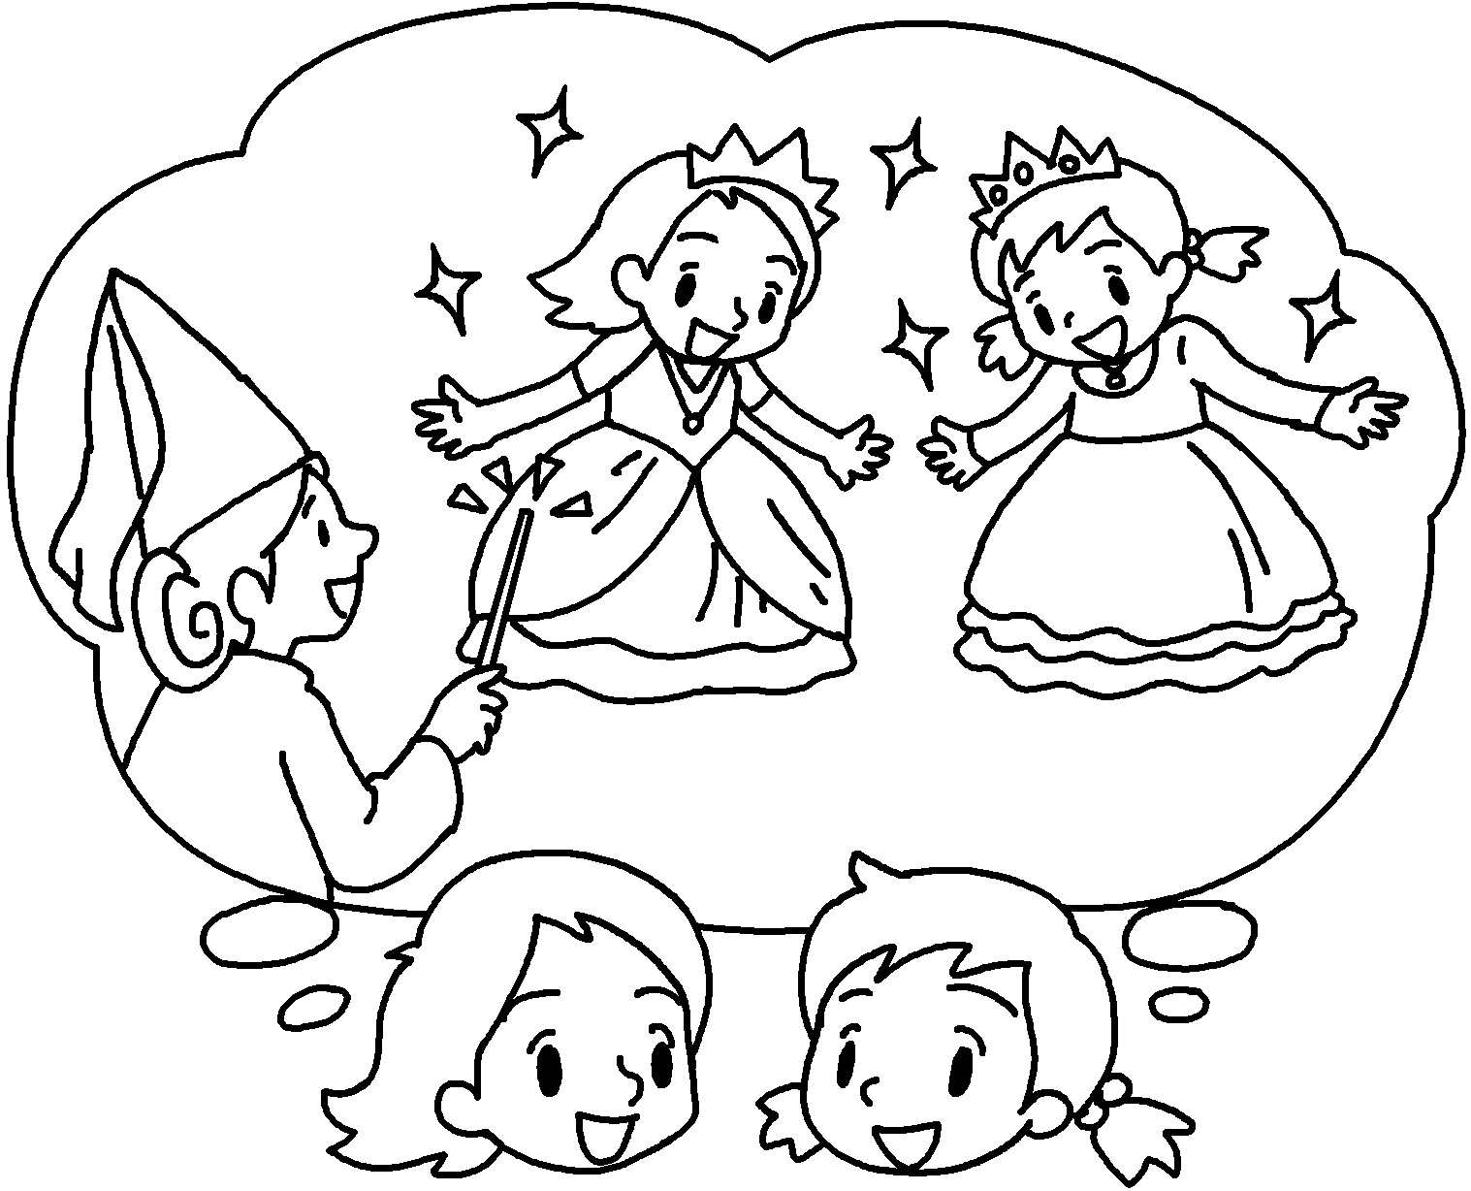
They walked and walked and ( at last /  suddenly ) reached the witch’s house. They knocked on the door. ( However / Soon ) there was no answer. They waited outside the house for  10 minutes. ( Once upon a time / After a while ) they decided to go inside the house. | 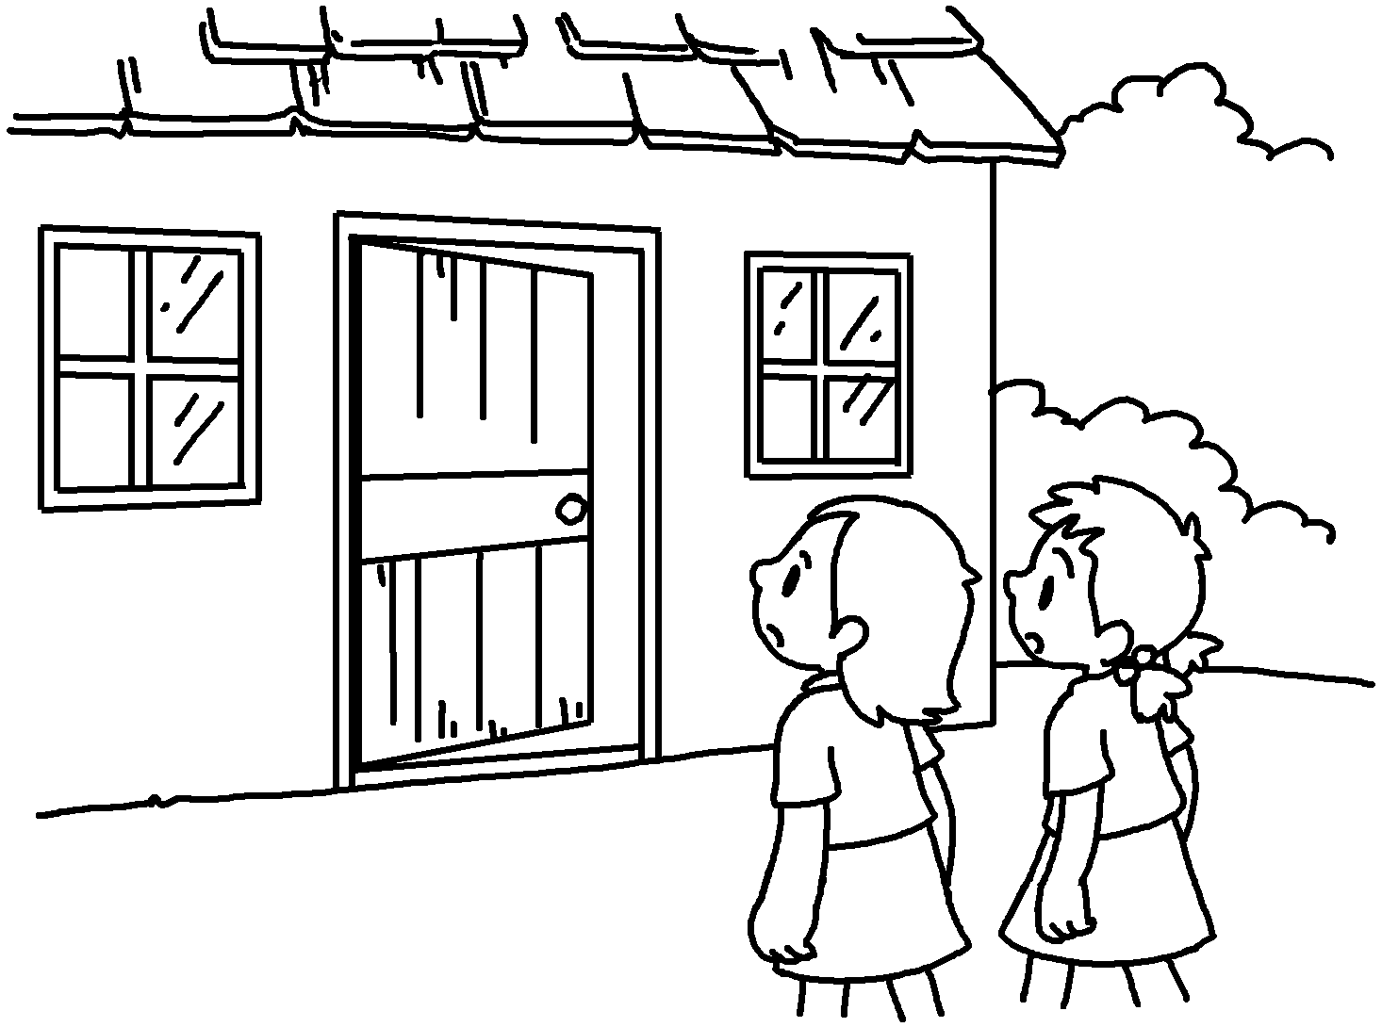
Peggy and Penny looked around for a few  minutes. ( At last / Soon ) they found a  cat sleeping in a room. There was a box of treasure next to it. ‘The witch isn’t here. Let’s take the treasure. No one will find out,’ said Peggy. Penny agreed. | 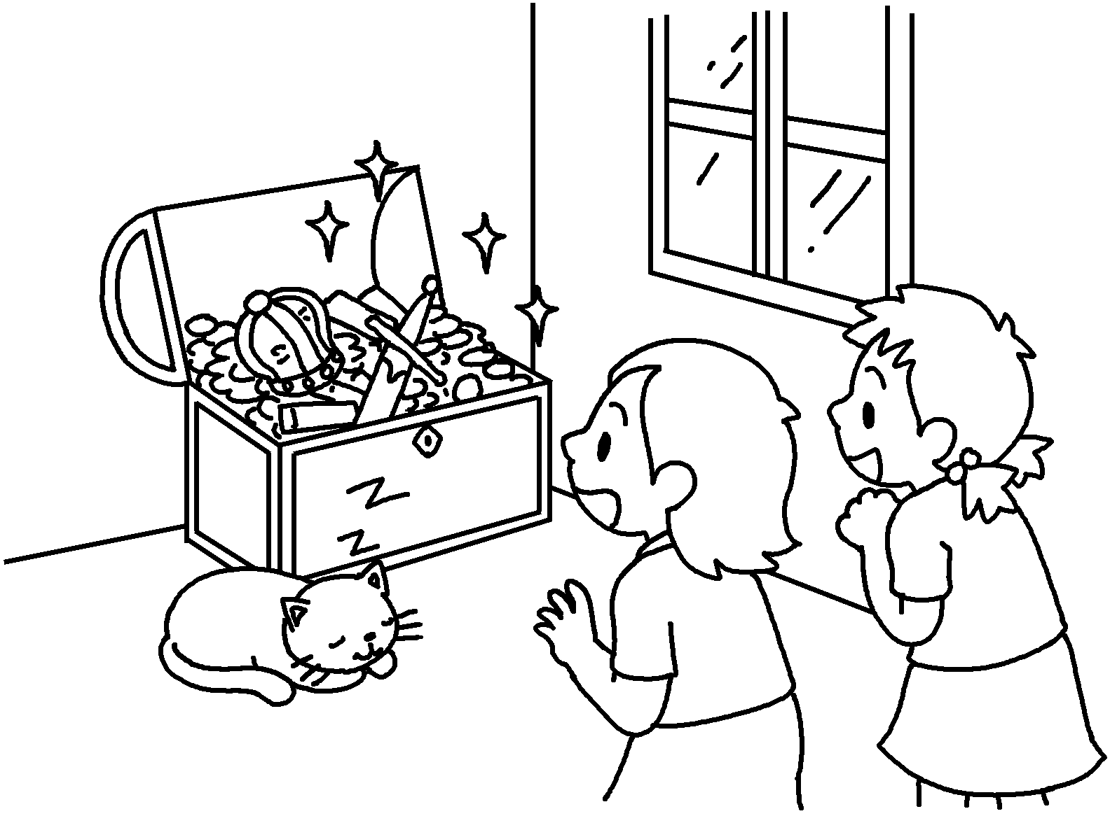
( Suddenly / However ) the witch appeared. ‘You two greedy girls! I must punish you!  Abracadabra!’ shouted the witch. Peggy and  Penny became shorter and shorter and turned into  two cats. | 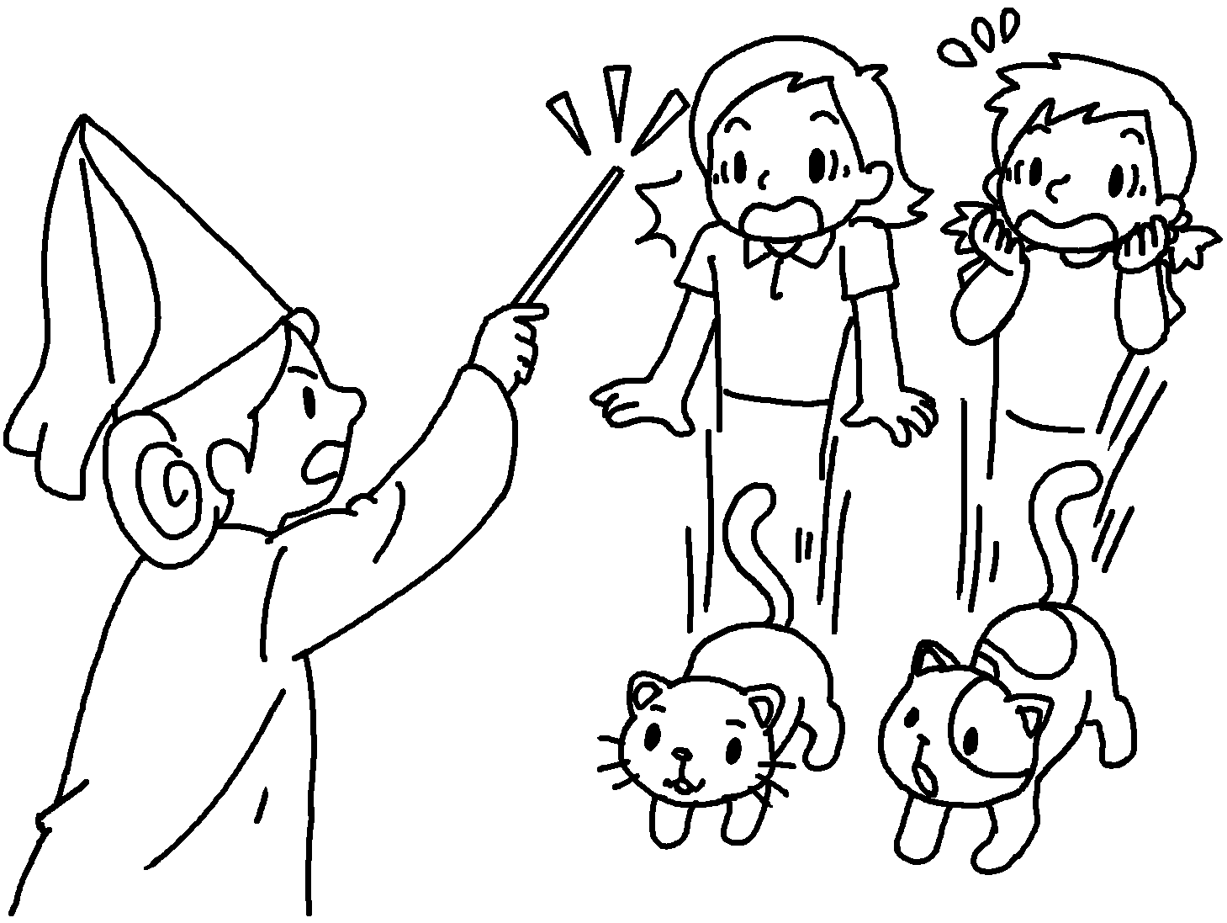


Book 6B Chapter 2 Graded Worksheets
Worksheet 3⬇
- ( Soon / Once upon a time )
- ( at last / suddenly )
- ( However / Soon )
- ( Once upon a time / After a while )
- ( At last / Soon )
- ( Suddenly / However )

