Choose and write. Use each word / phrase once only.
after a whileat lasthoweveronce upon a timesoonsuddenly
3
4
5
6
2

1
there was a witch. She gave wishes to people who were kind. Peggy and Penny wanted to become princesses so they set out to find the witch. | 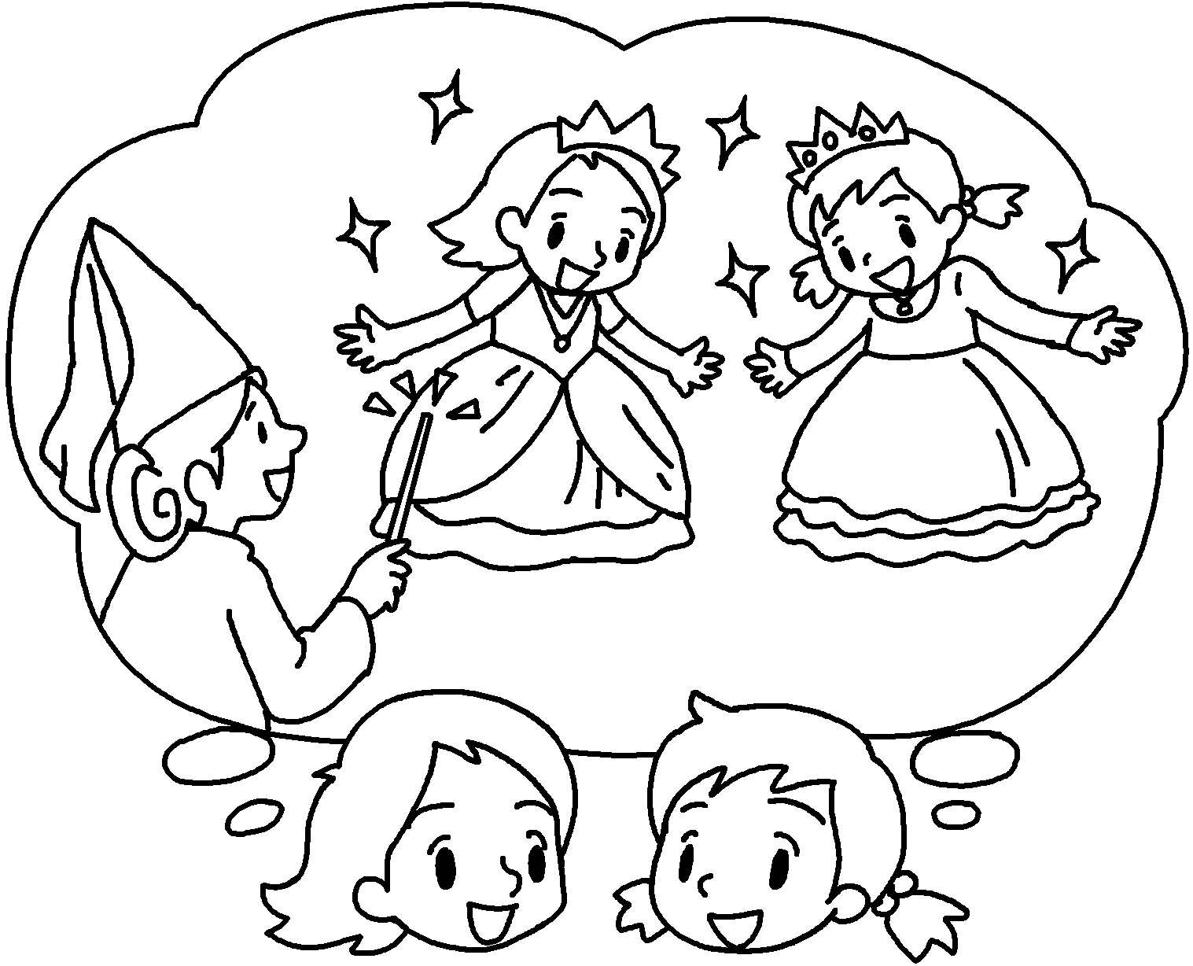
They walked and walked and  reached the witch’s house. They knocked on the  door. there was no  answer. They waited outside the house for  10 minutes. they decided to go inside the house. | 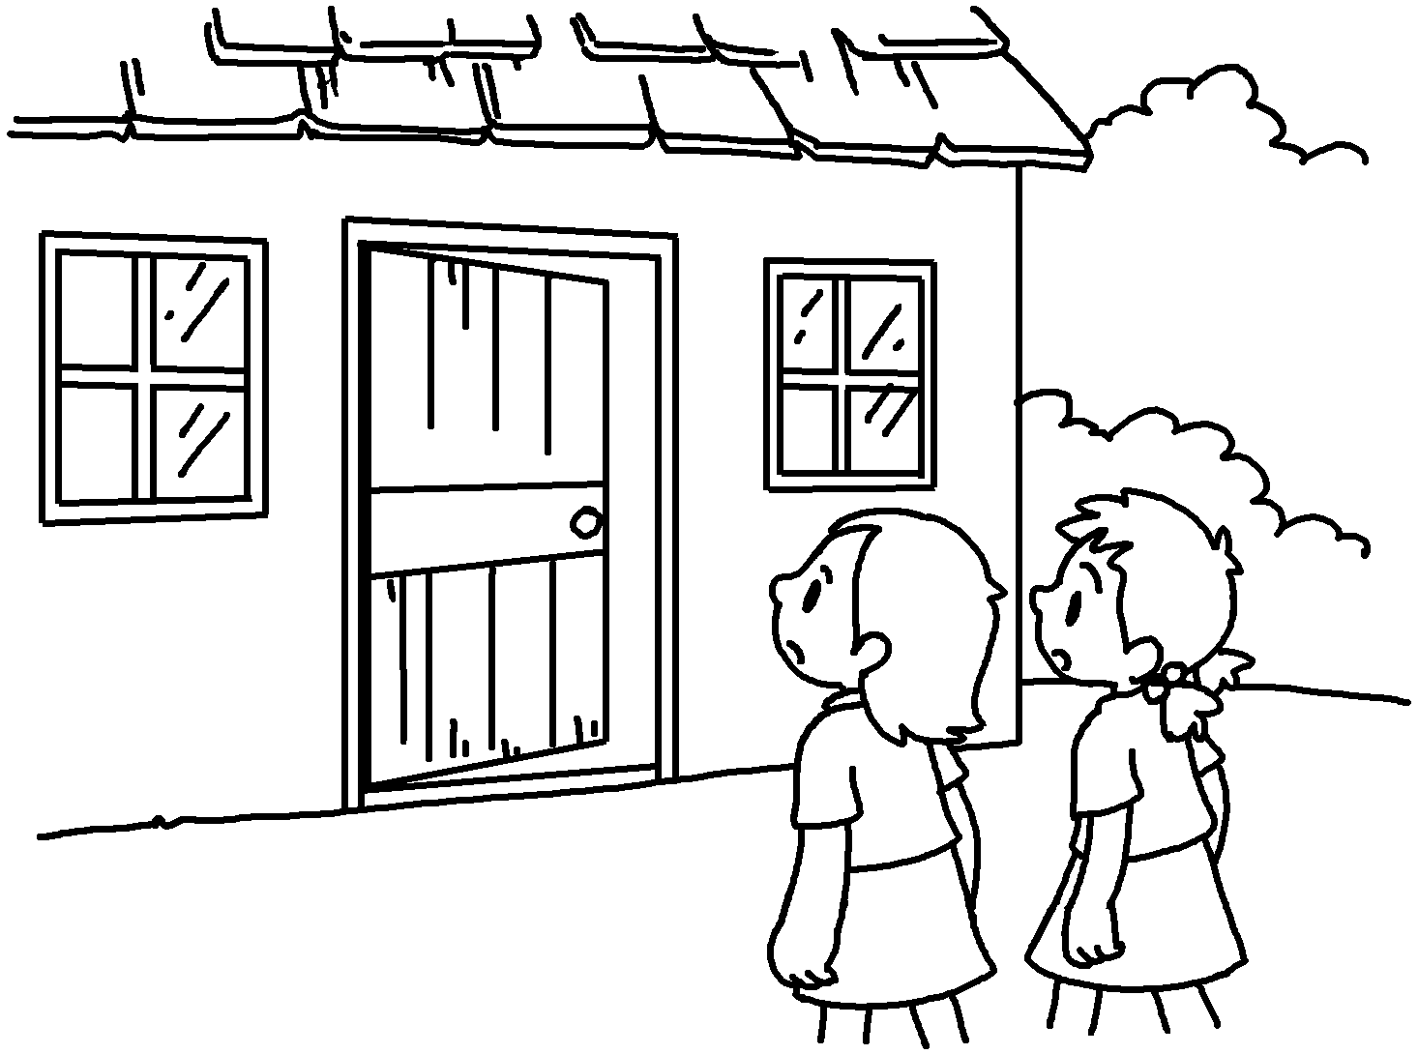
Peggy and Penny looked around for a few  minutes. they found a  cat sleeping in a room. There was a box of treasure next to it. ‘The witch isn’t here. Let’s take the treasure. No one will find out,’ said Peggy. Penny agreed. | 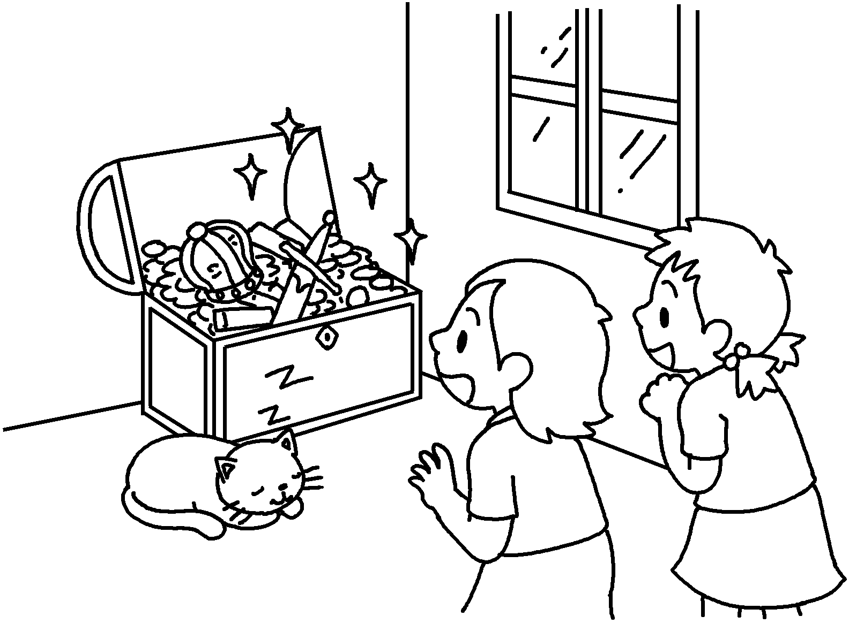
the witch  appeared. ‘You two greedy girls! I must punish you!  Abracadabra!’ shouted the witch. Peggy and  Penny became shorter and shorter and turned into  two cats. | 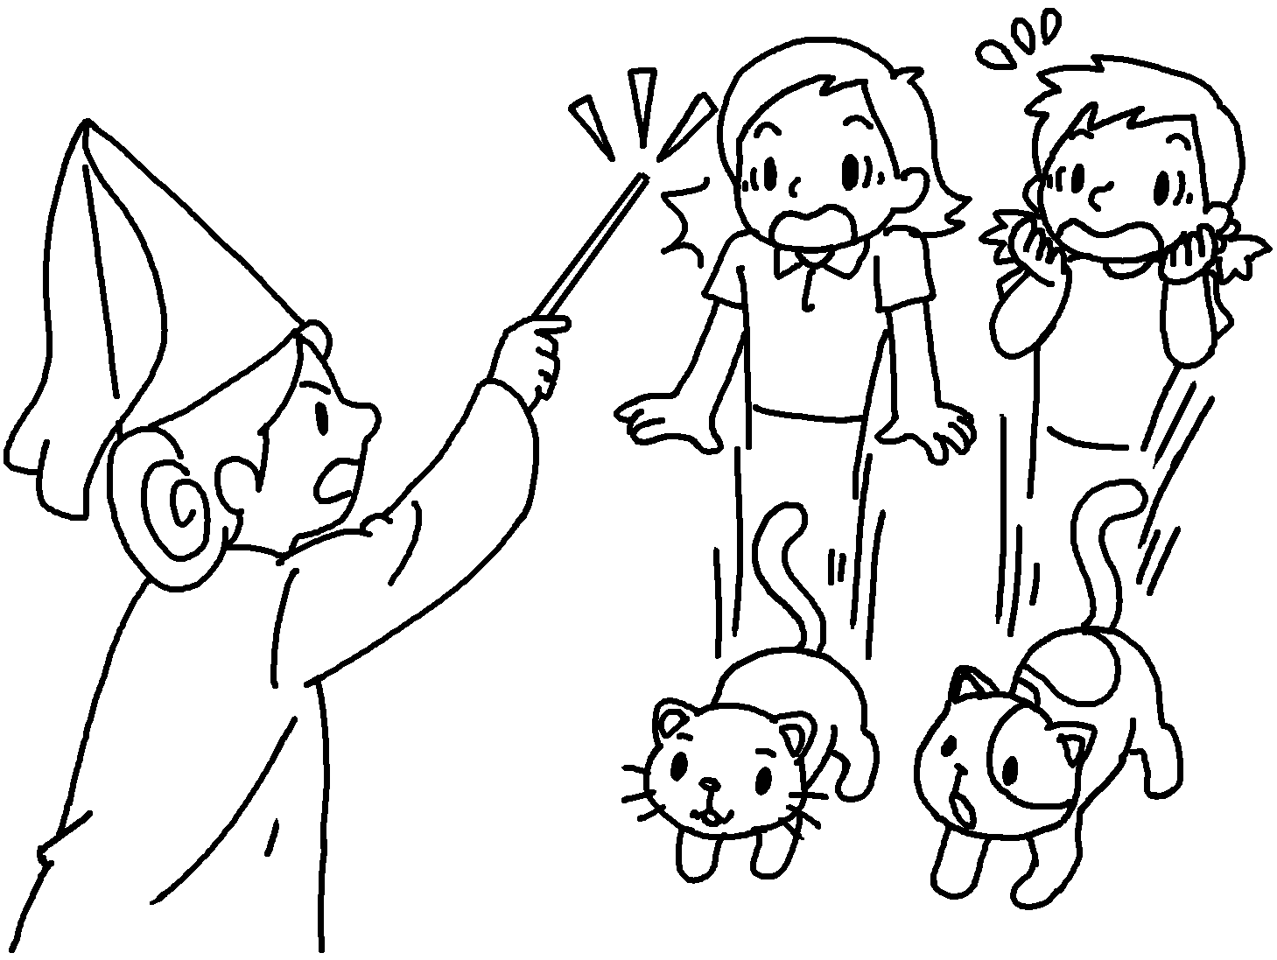


Book 6B Chapter 2 Graded Worksheets
Worksheet 3⬇⬇
- Once upon a time
- at last
- However
- After a while
- Soon
- Suddenly

