- The Young Writers’ Club
Mike and his friends love writing so they formed the Young Writers’ Club. Read and find out about their first story.
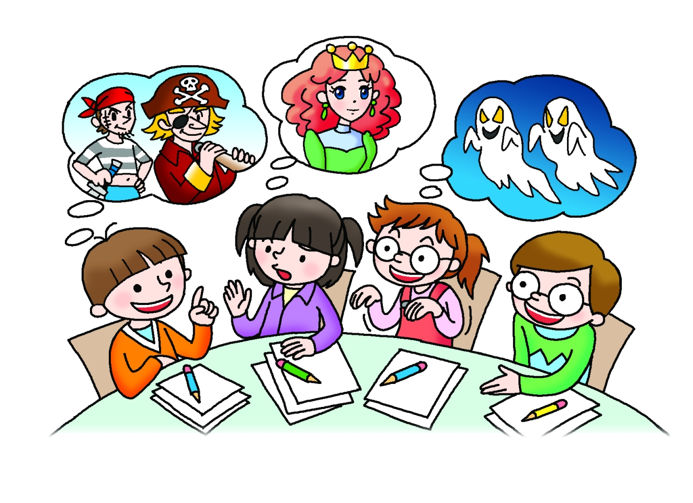

One day Mike and his friends were writing a story together.
‘Let’s write about pirates!’ said Mike.
Kelly pulled a face. ‘I want to write about a princess,’ she said.
‘Ghosts!’ said Ann.
‘We can write about them all,’ said Alan.
‘Once upon a time …’ said Kelly. She started to write.
‘… there was a pirate called Little Jim,’ continued Mike. ‘Jim was sailing his ship which was full of treasure. Suddenly there was a terrible storm …’
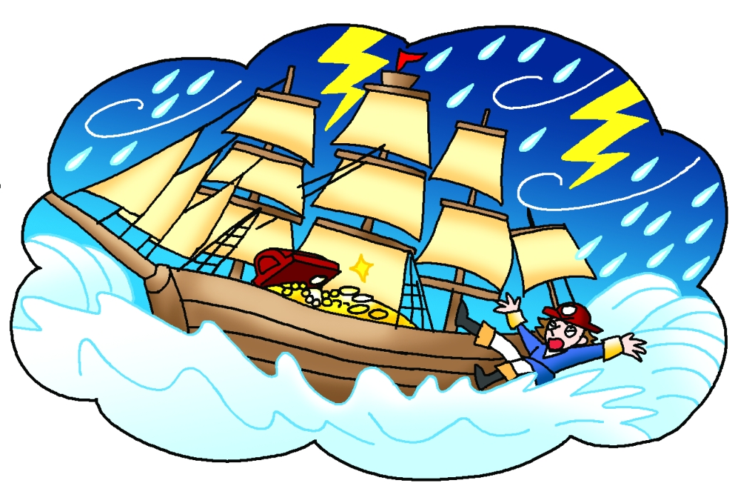
‘That’s a good start,’ said Ann. ‘Now we need a middle.’
‘During the storm, Jim fell overboard,’ said Alan. ‘He swam and swam and soon reached an island.’
‘I don’t understand,’ said Mike.
‘ “He swam and swam” means he swam for a long time, but “soon” means after a short time.’
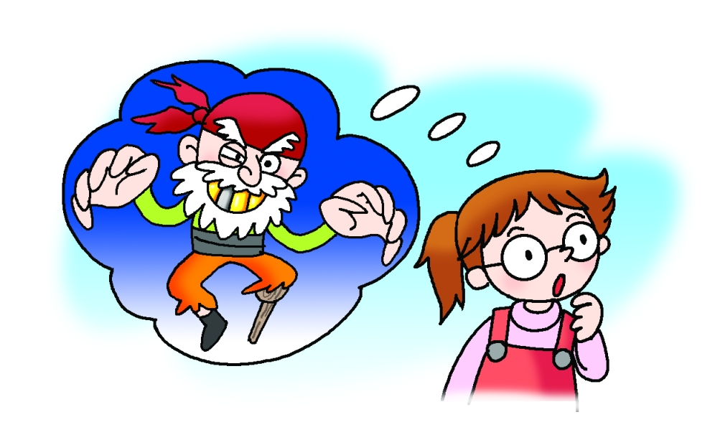
‘OK,’ said Alan, ‘I should say, “He swam and swam and at last reached an island.” ’
‘Then a ghost appeared,’ suggested Ann. ‘It was a pirate ghost with … erm … a white beard – as white as snow – and a wooden leg.’
‘This story needs a problem,’ said Kelly. ‘What if the pirate ghost had a prisoner? She was a sad, but lovely, princess.’
‘Now we need a solution,’ said Alan.
‘Jim fought with the ghost and won,’ said Ann.
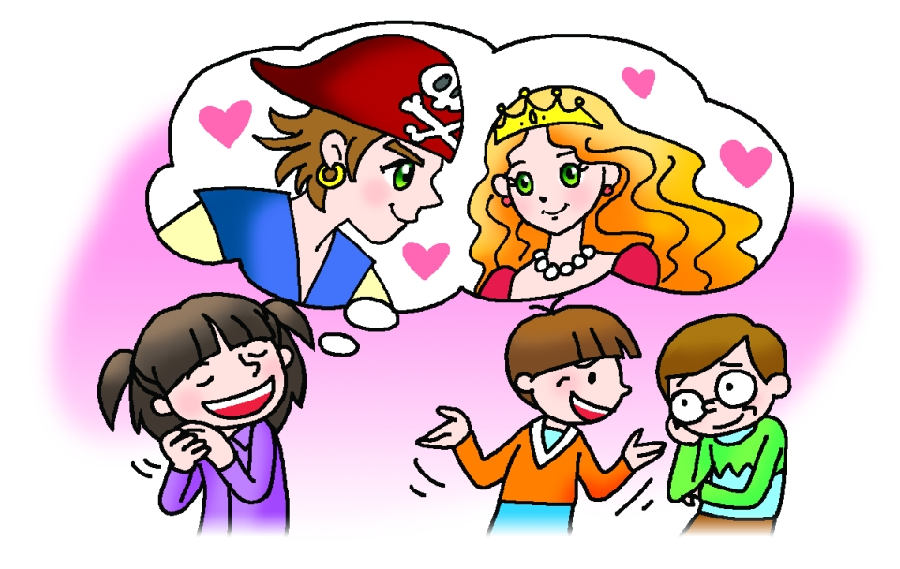
‘Now we just need an ending,’ said Alan.
‘Jim and the princess lived happily ever after on the island. The end,’ said Kelly.
‘Mmm … What if someone else was on the island …’ said Ann.
‘Yes!’ said Alan excitedly. ‘Aliens!’
‘Fairies!’ said Ann.
‘You’ve got enough ideas for another story,’ laughed Mike.
‘OK,’ Kelly said. ‘Let’s write a sequel then. How should we start?’

