RP no: Century Gothic 15pt
(所有圈號用15pt)
Choose and write.
1
2
3

bring have use throw away reuse turn off / down recycle

baths used paper lights facecloth plastic bags
showers air-con disposable products cans tap

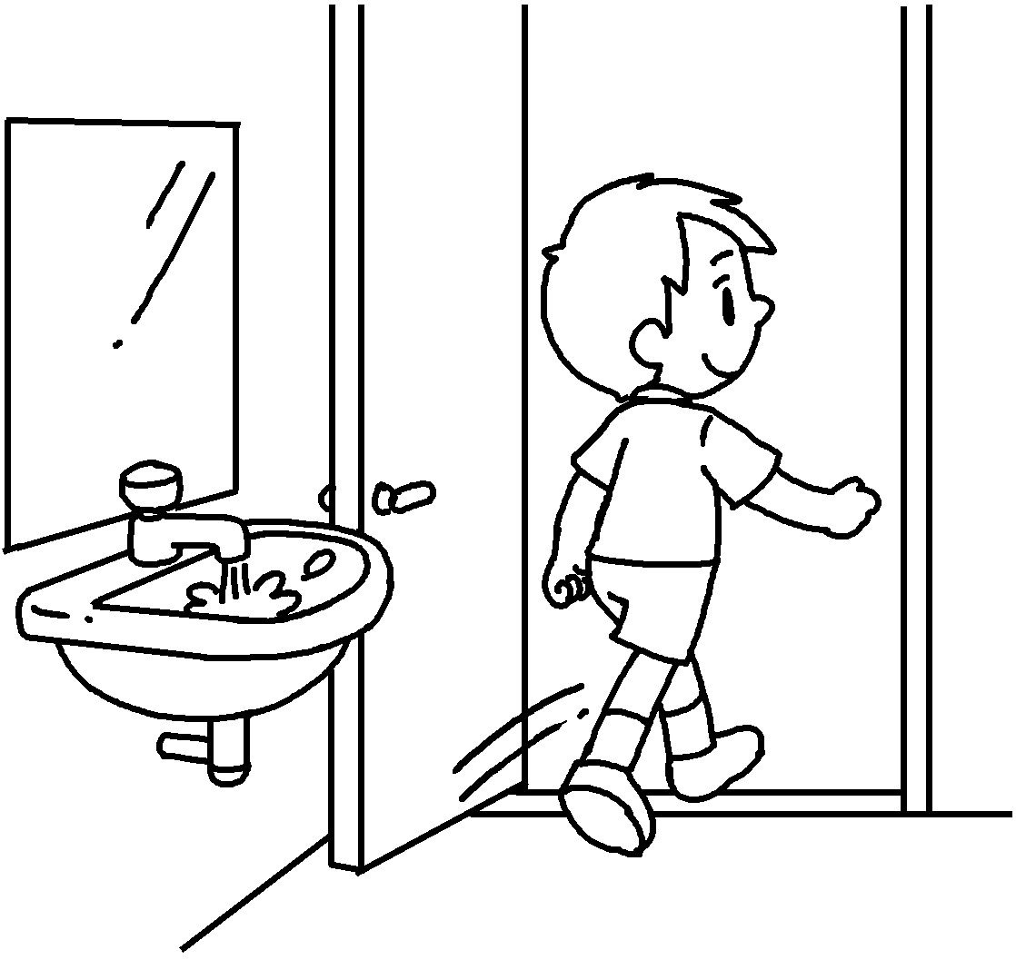 | 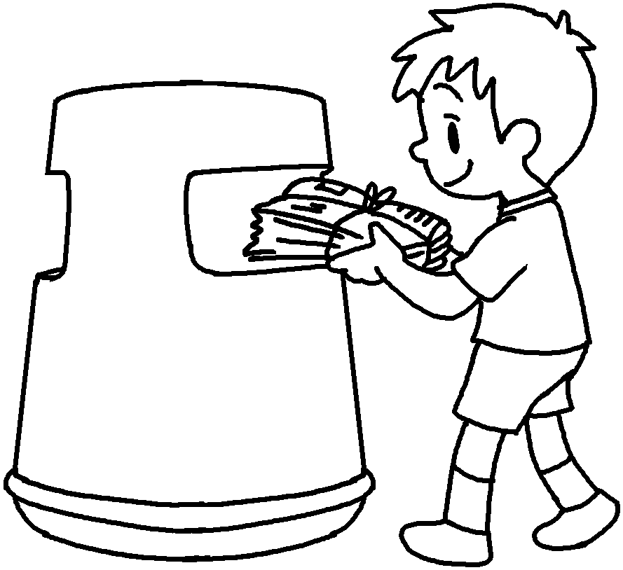 |  | 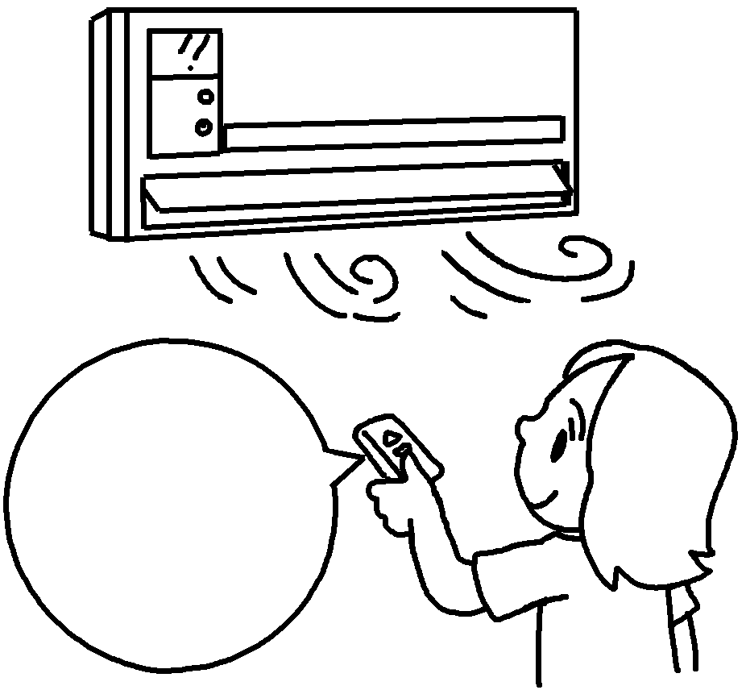  High  ↓  Low |  | 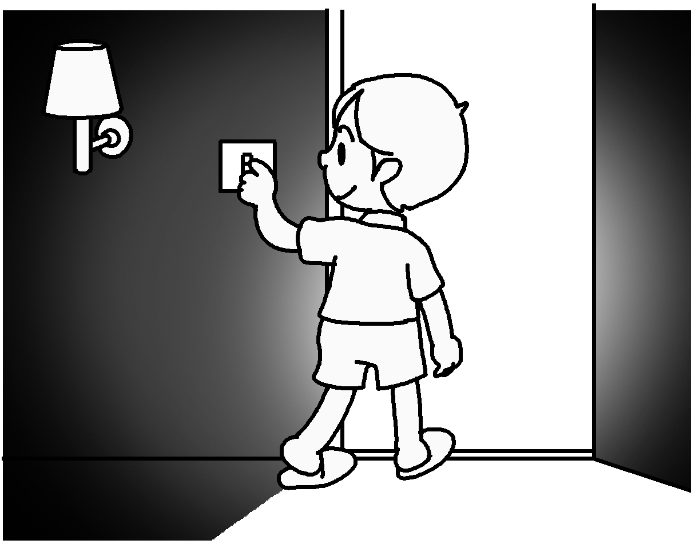  4
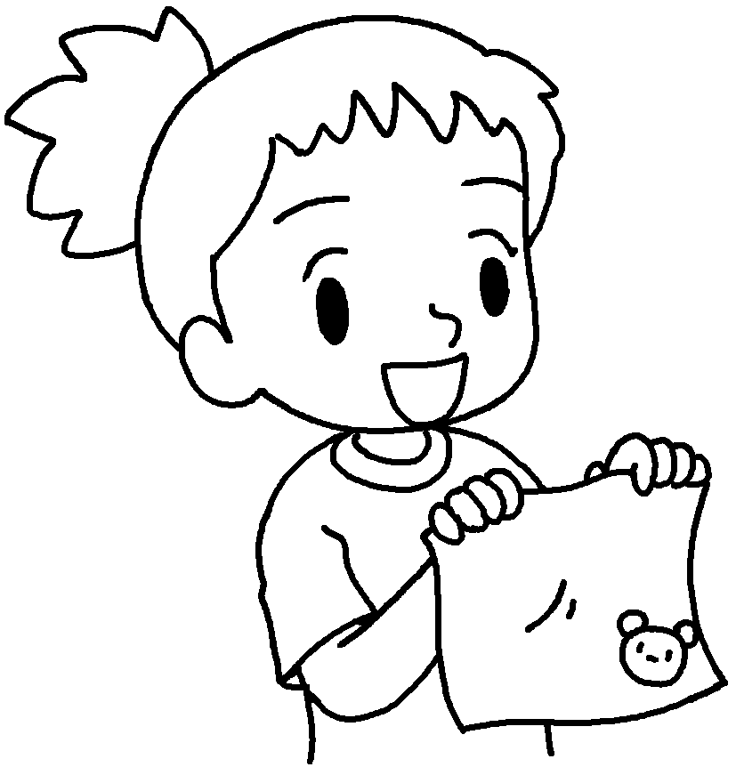  5 |  | 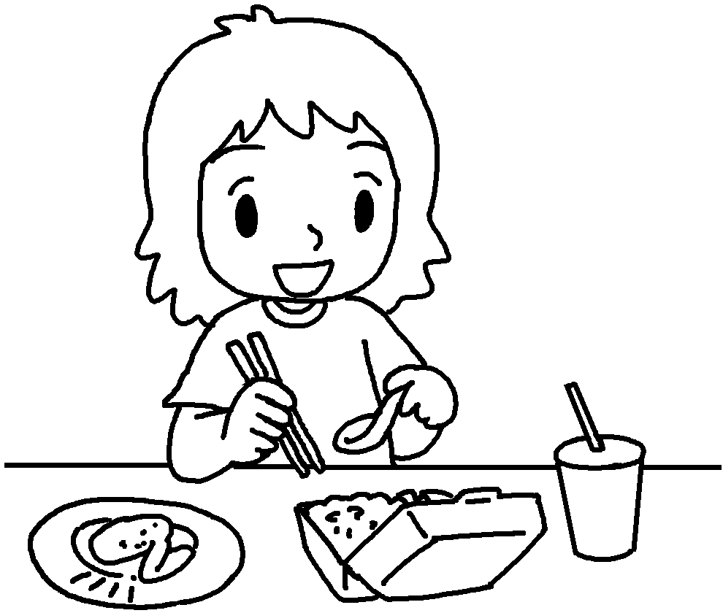  6 |  | 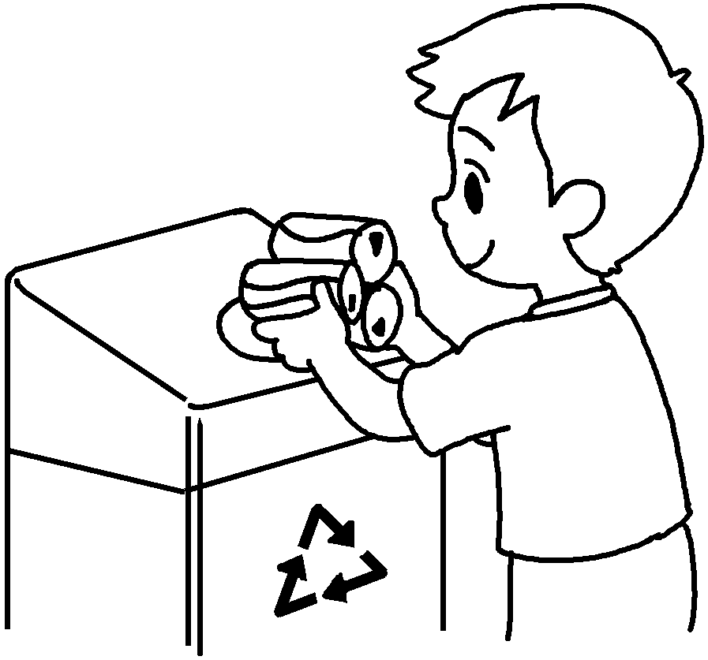  7
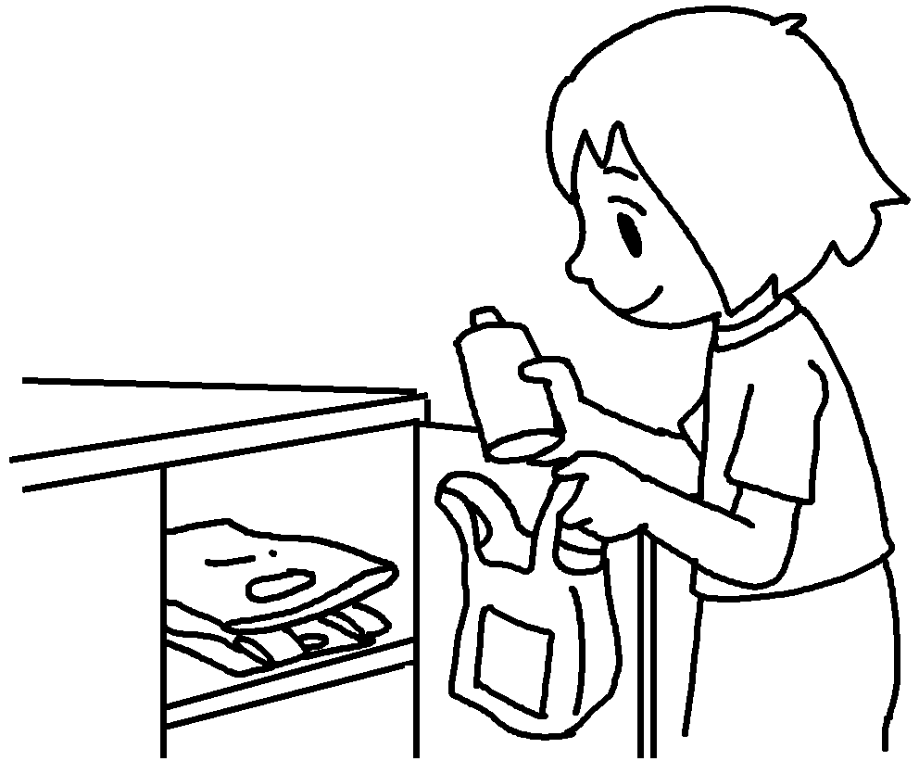  8 |  | 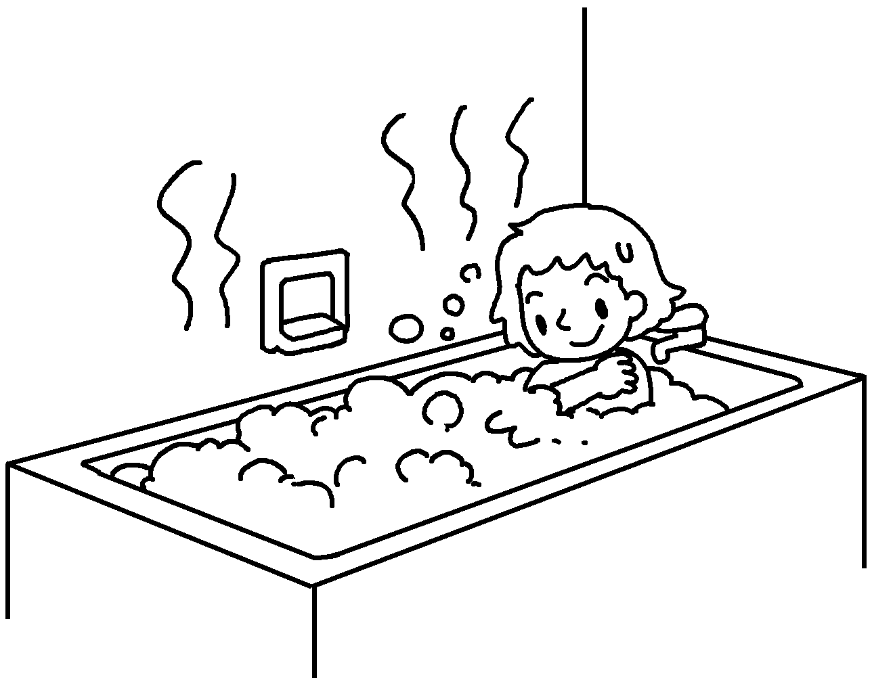  9 |  | 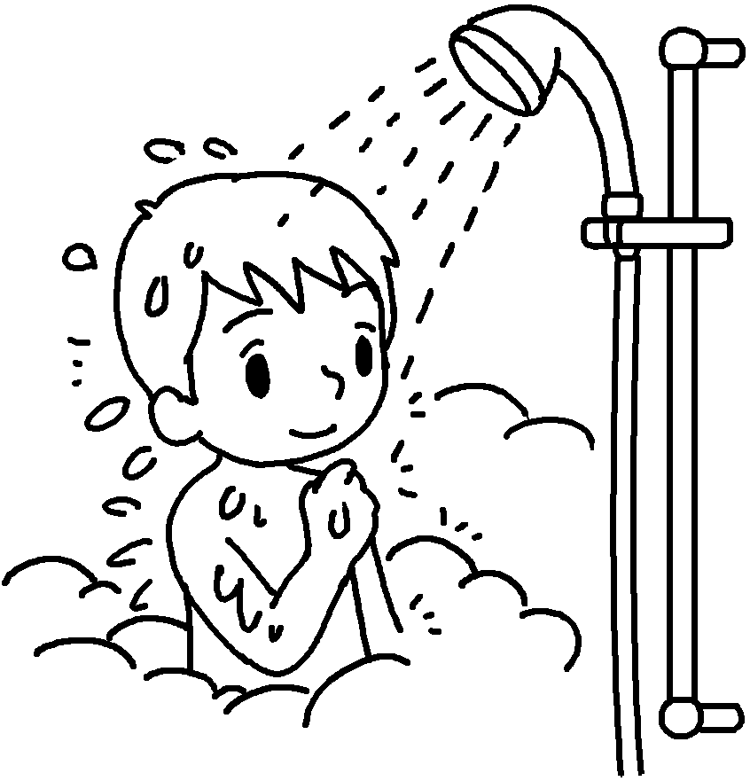  10

1 | leave the on |  | 2
3 | the |  | 4 | the
5 | my own |  | 6
7 |  |  | 8
9 |  |  | 10


Book 6B Chapter 3 Graded Worksheets
Worksheet 1⬇⬇
- tap 2 throw away used paper
3 turn down air-con 4 turn off lights
5 bring facecloth 6 use disposable products
7 recycle cans 8 reuse plastic bags
9 have baths 10 have showers

