RP no: Century Gothic 15pt
(所有圈號用15pt)
Look and write the habits.
1
2
3

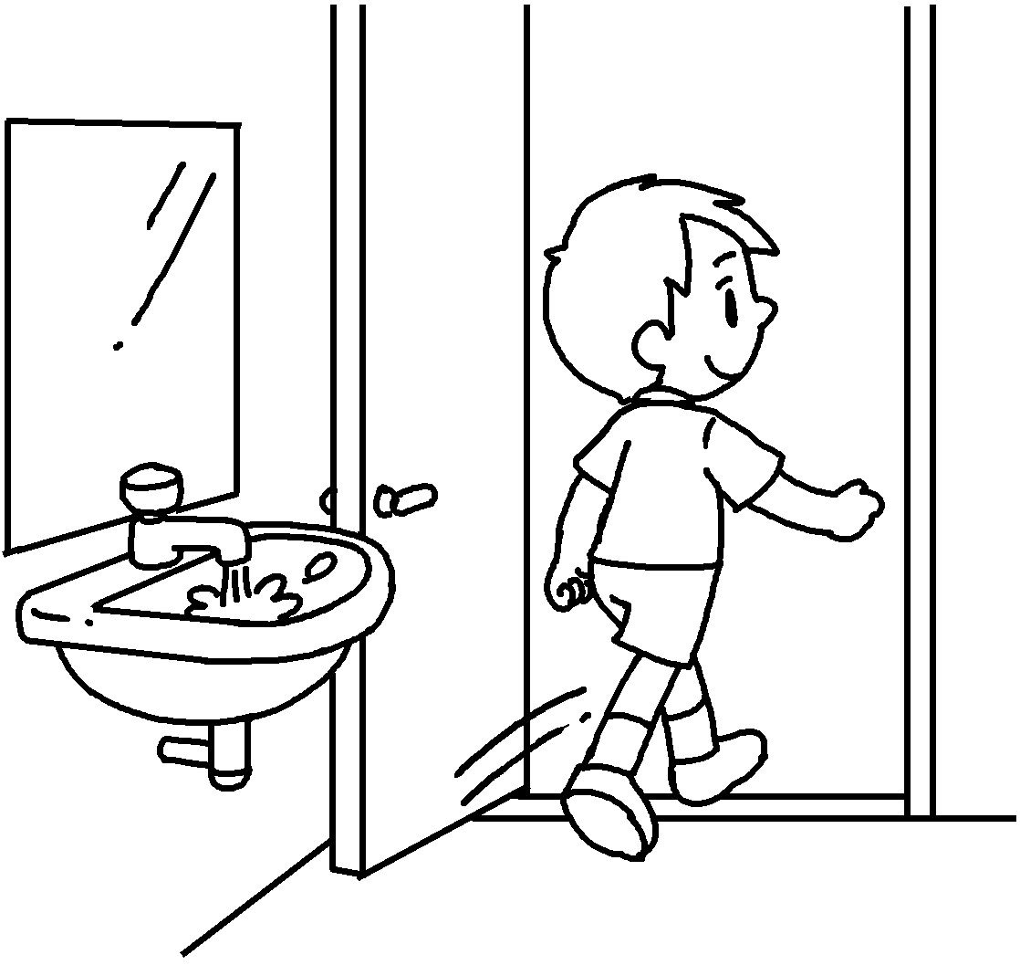 | 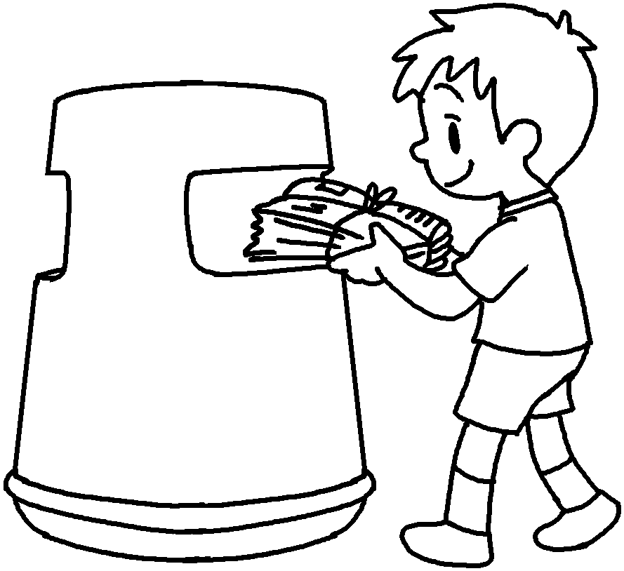 |  | 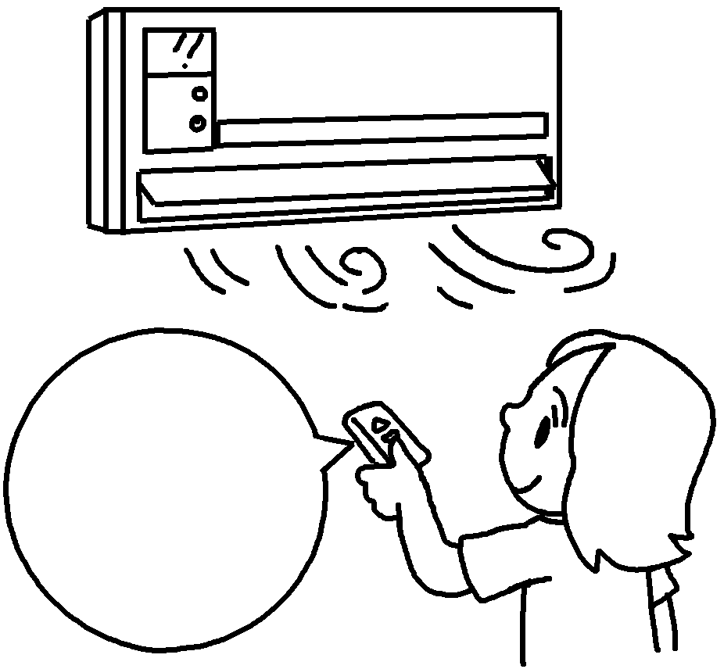  High  ↓  Low |  | 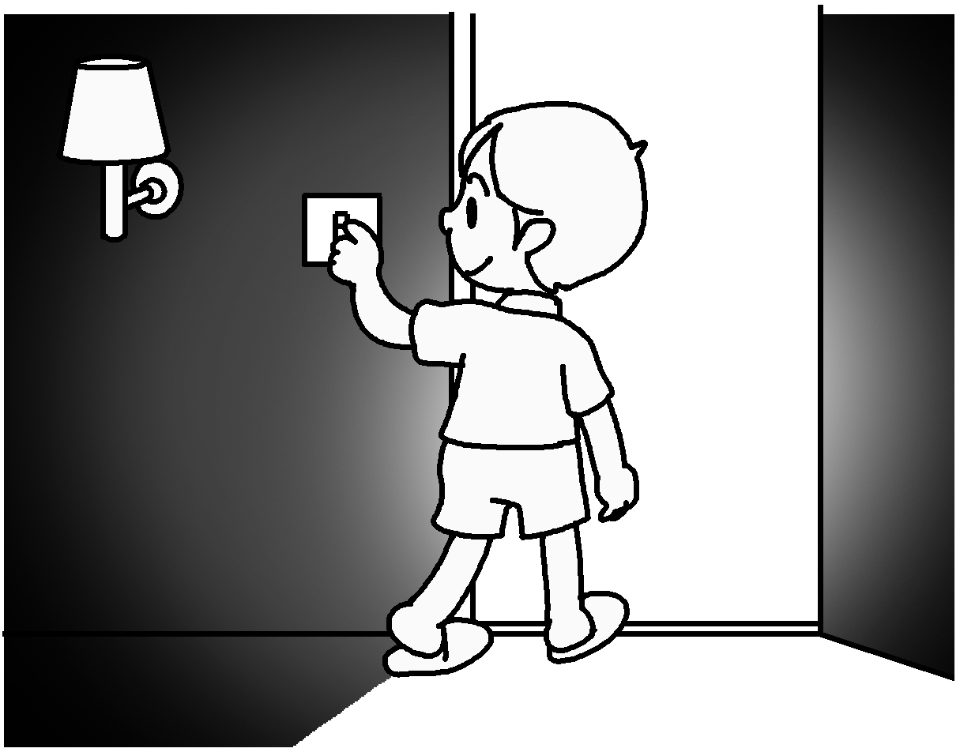  4
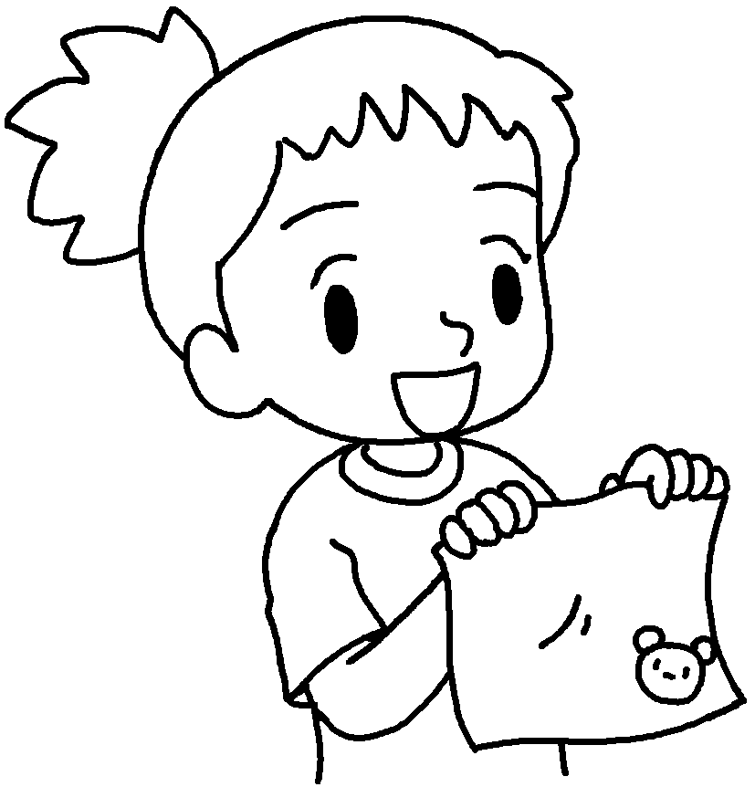  5 |  | 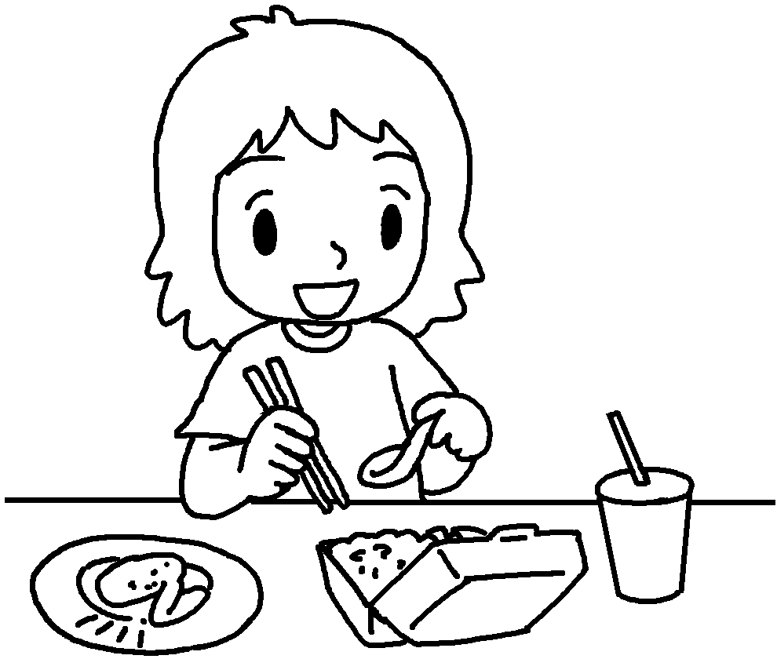  6 |  | 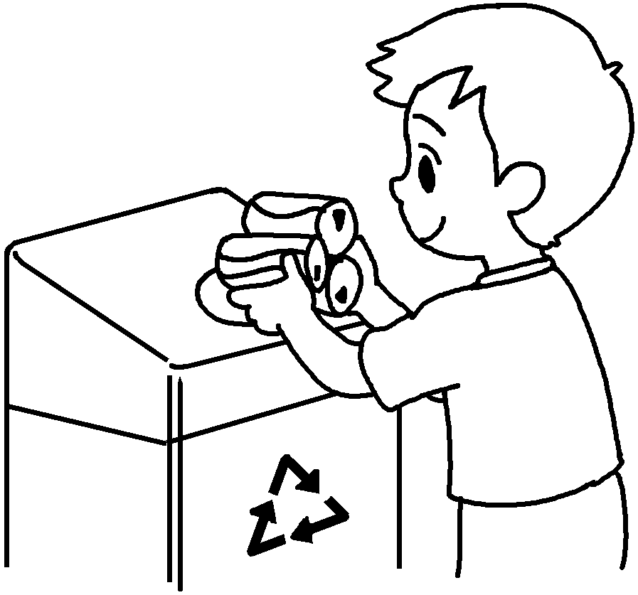  7
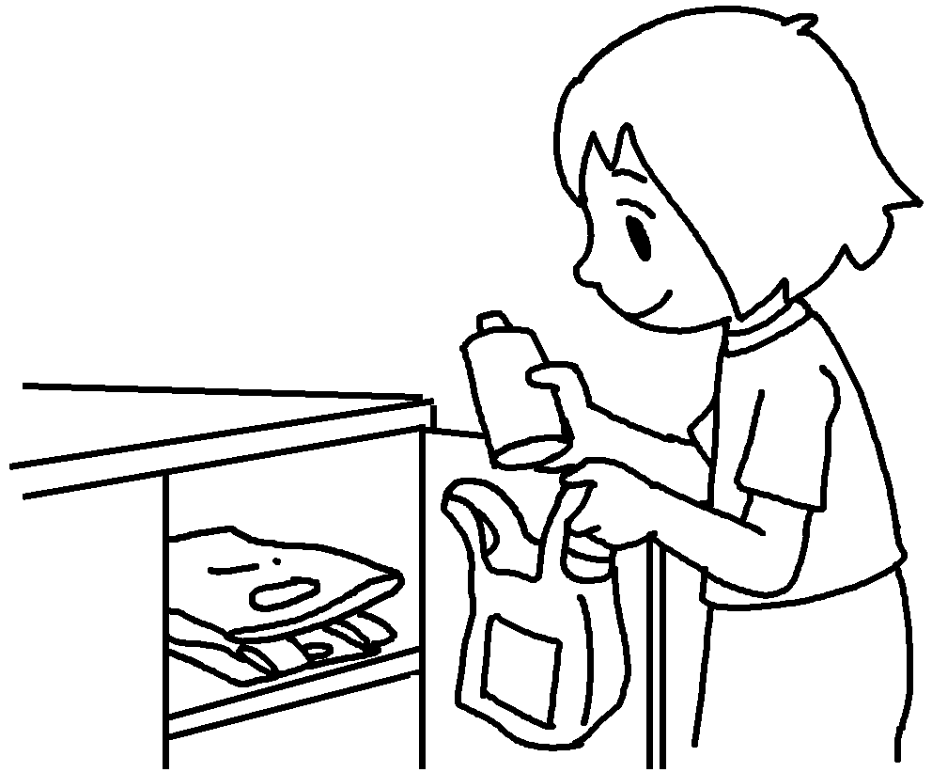  8 |  | 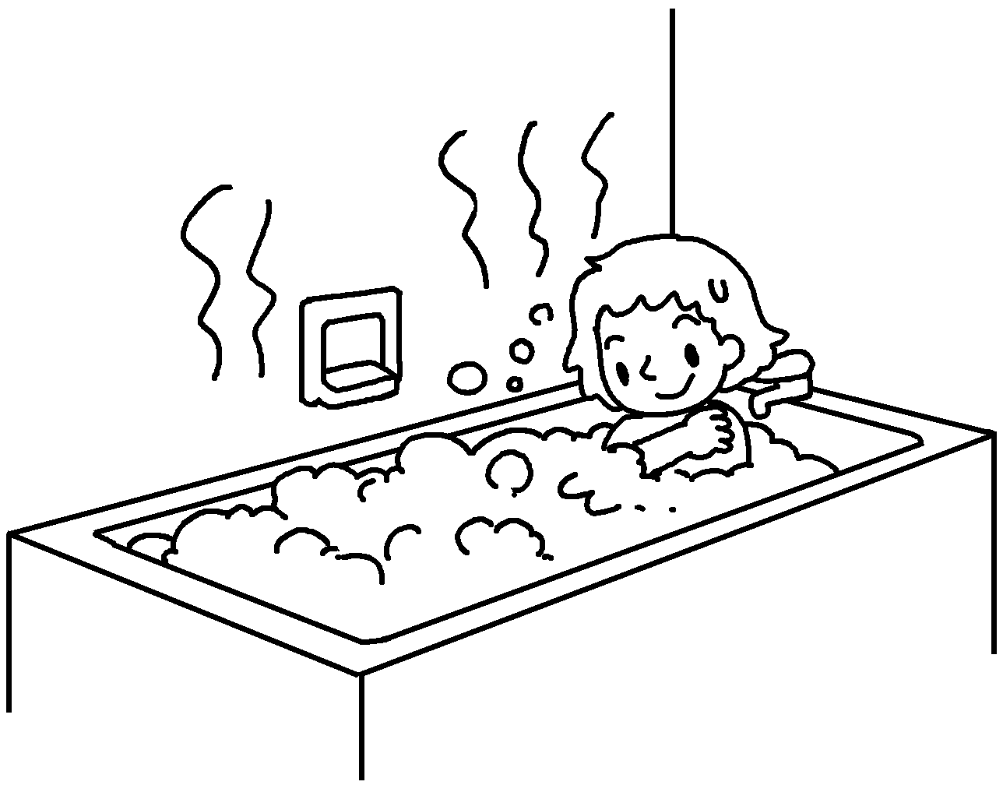  9 |  | 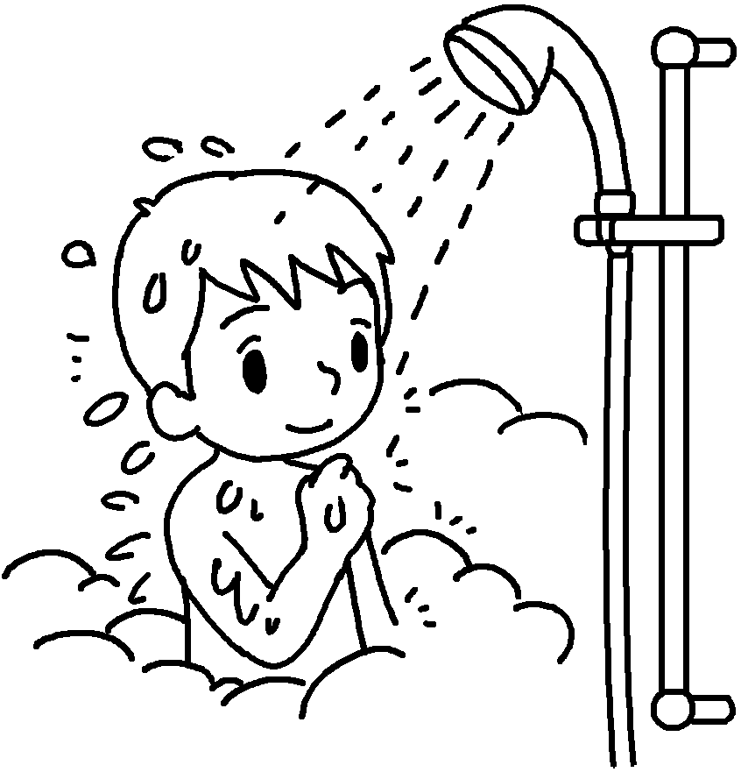  10

1 | l the tap |  | 2 | used paper
3 | the air-con |  | 4 | the lights
5 | b my own |  | 6 | u d products
7 | cans |  | 8 | plastic bags
9 | s |  | 10 | s


Book 6B Chapter 3 Graded Worksheets
Worksheet 1⬇⬇⬇
1 leave on 2 throw away
3 turn down 4 turn off
5 bring facecloth 6 use disposable
7 recycle 8 reuse
9 have baths 10 have showers
(Accept any reasonable answers.O

