Finish the sentences.
should
stop
…ing

1 | 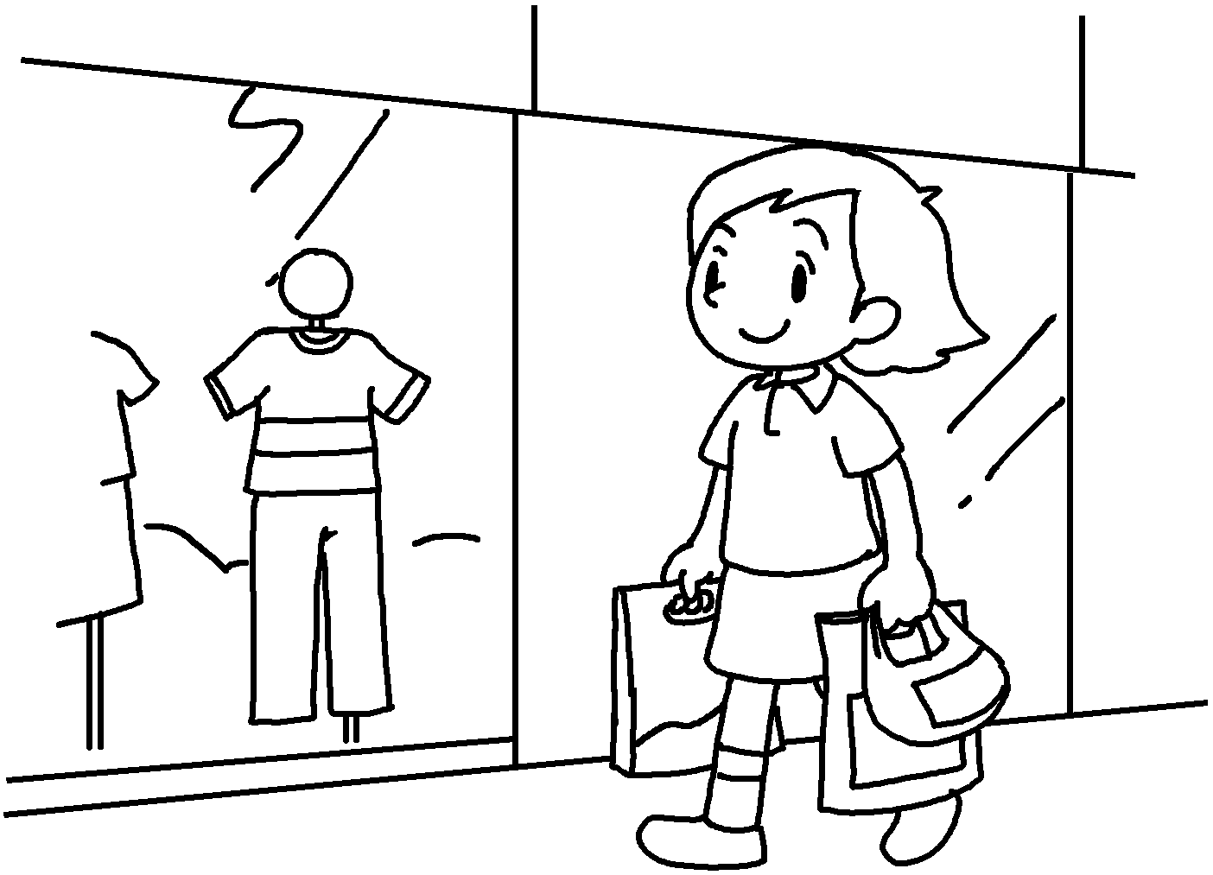 | Betty should stop ( use )  a lot of plastic bags.
2 | 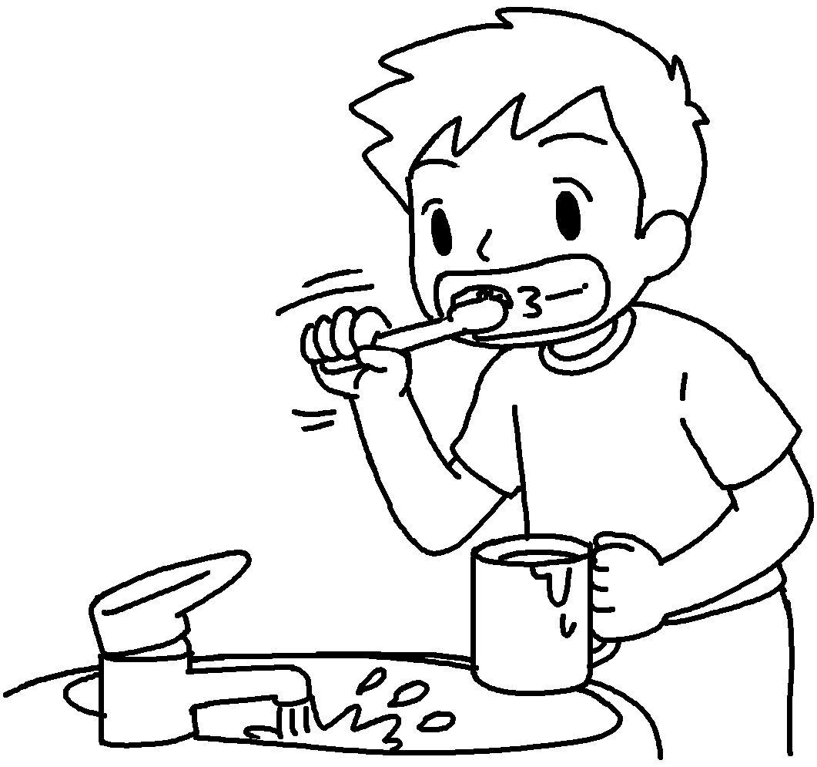 | Andy  leaving the tap on when he brushes his teeth.
3 | 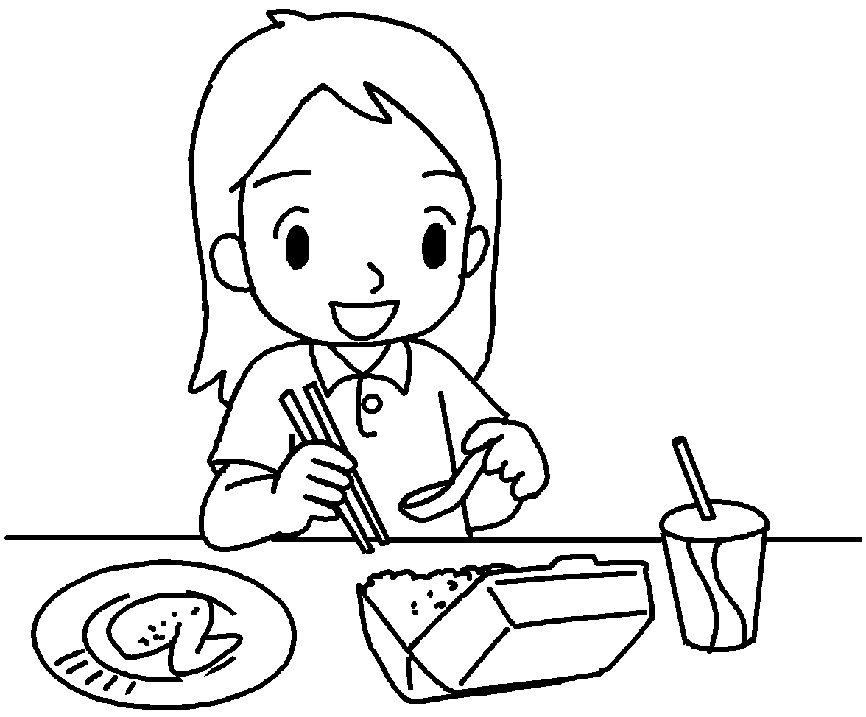 | Lily  ( use ) a lot of disposable products.
4 | 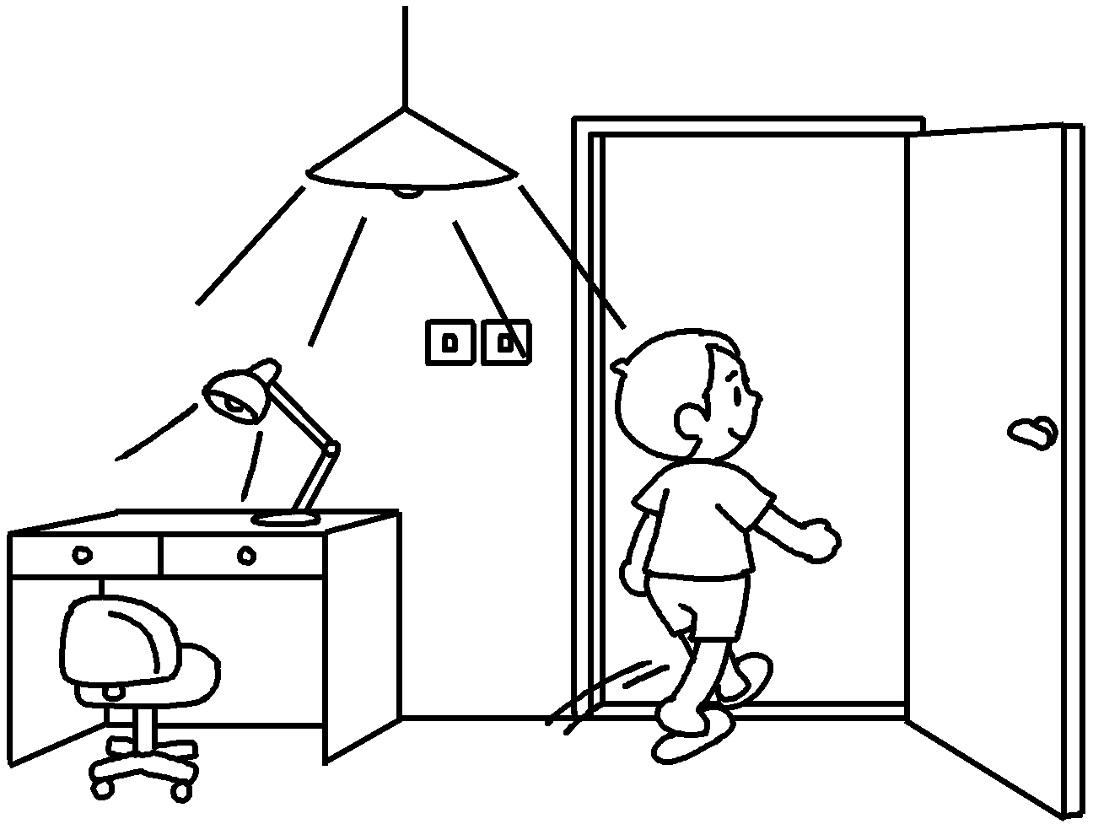 | Paul  ( leave ) the lights on when he leaves the room.
5 | 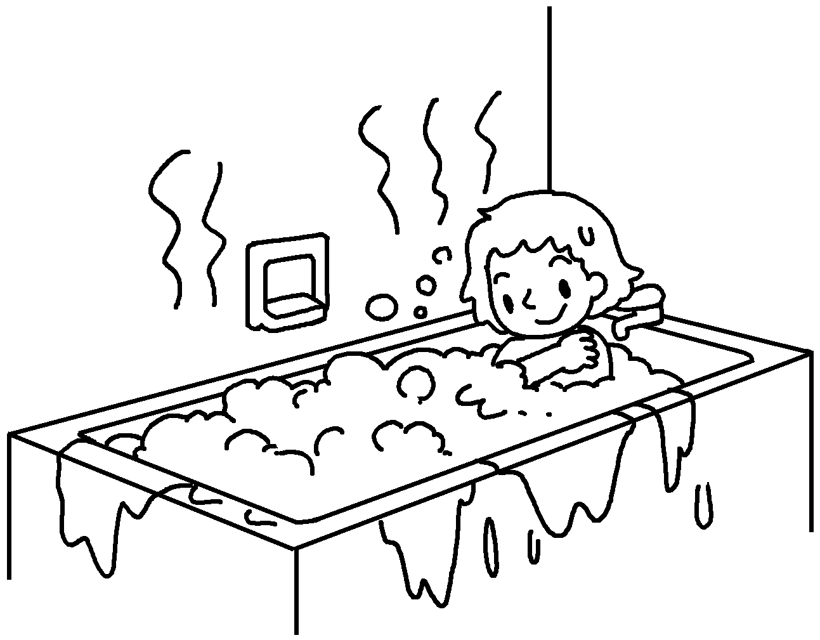 | Bonnie  ( have ) a bath every day.


Book 6B Chapter 3 Graded Worksheets
Worksheet 2⬇
- using
- should stop
- should stop using
- should stop leaving
- should stop having

