RP no: Century Gothic 15pt
(所有圈號用15pt)
Finish the sentences.
so much
so many

1 | 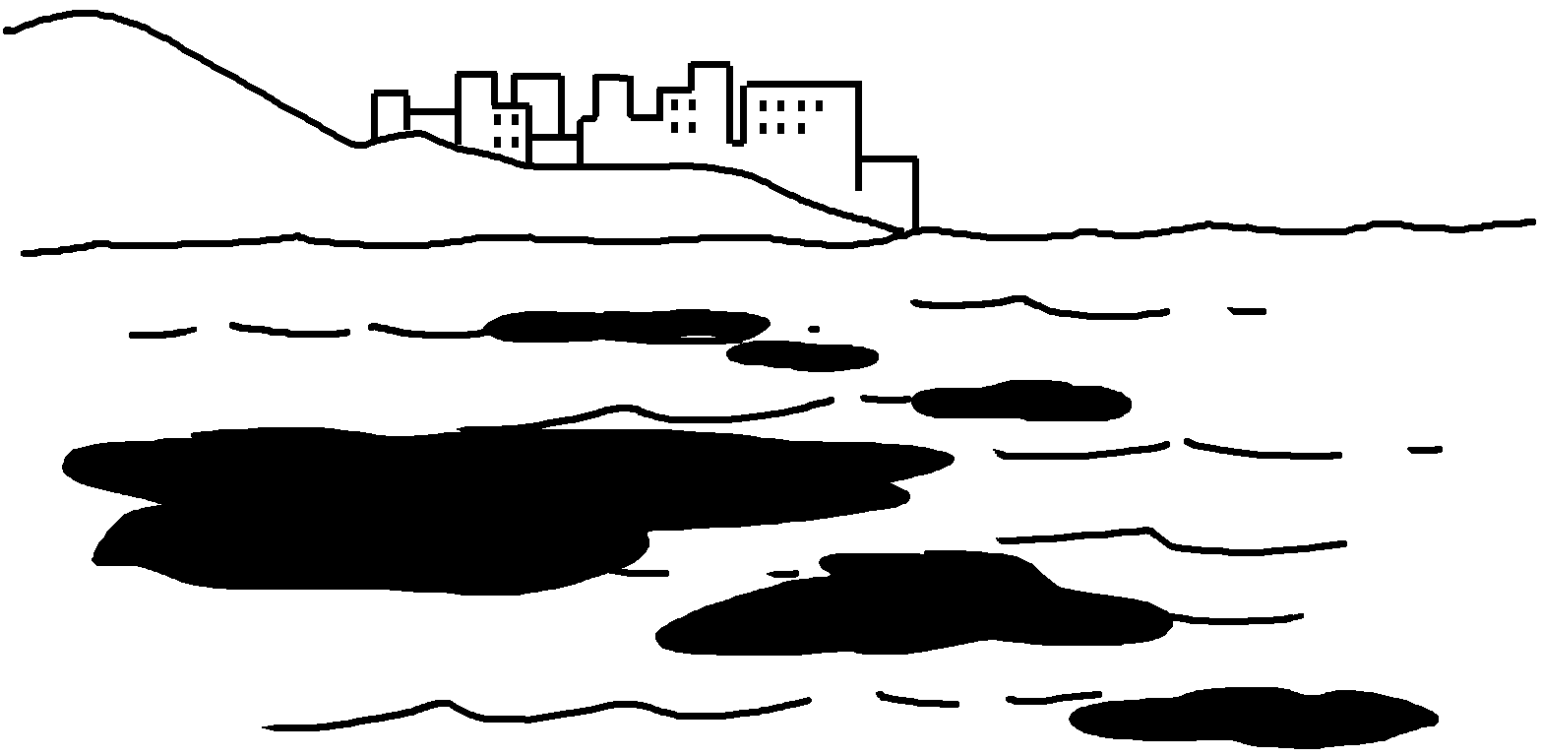 | People dump toxic  waste into the sea.
2 | 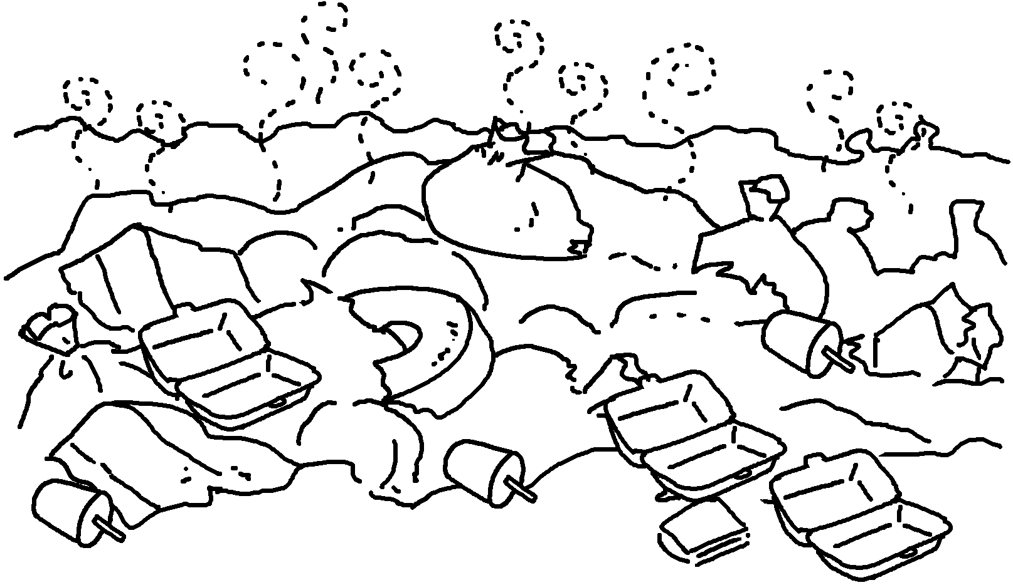 | People throw away  disposable products.
3  ( noise ) | 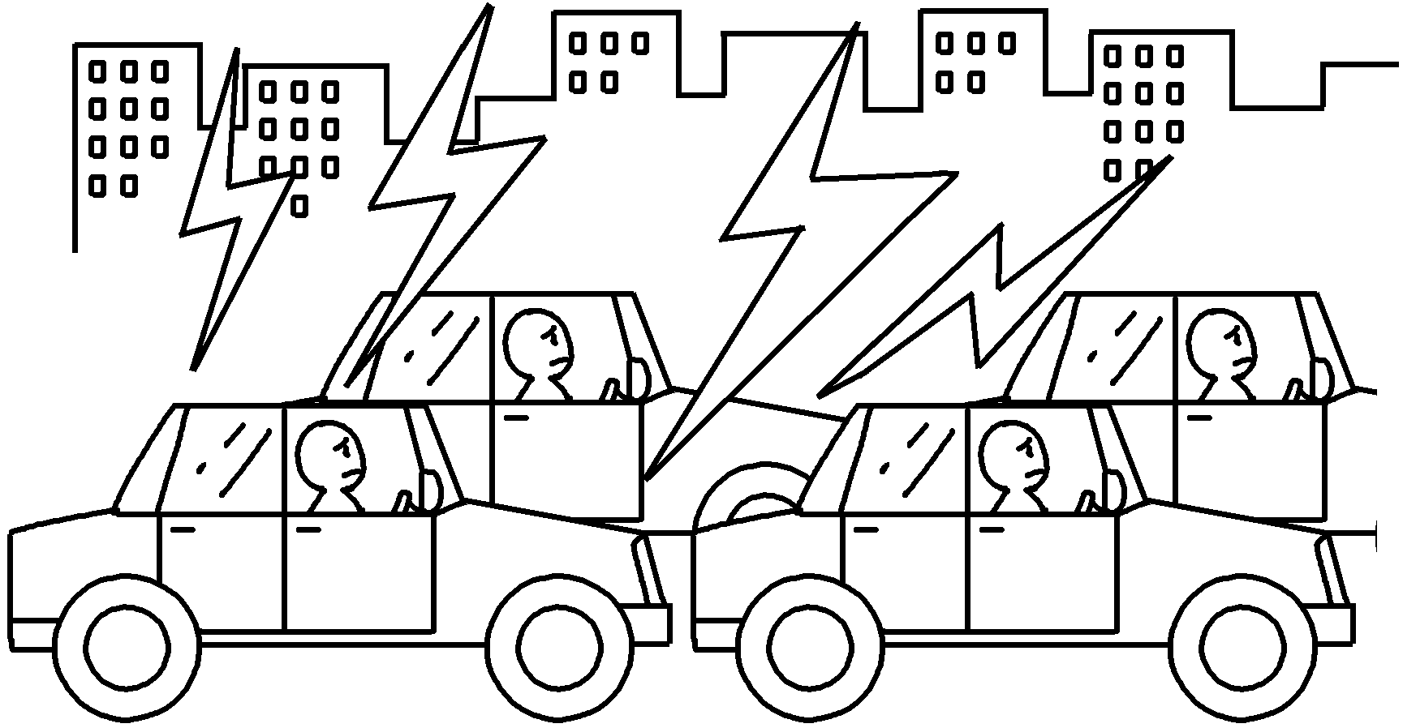 | The traffic makes  .
4  ( fumes ) | 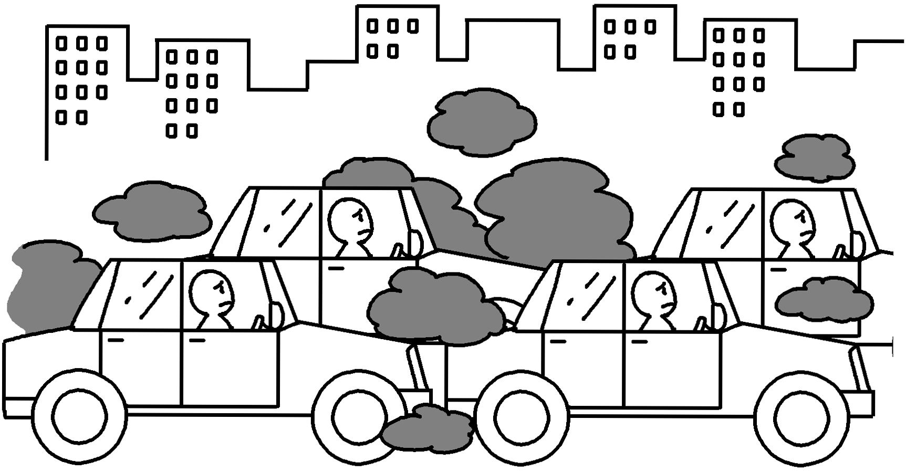 | Cars produce  .
5  ( smoke ) | 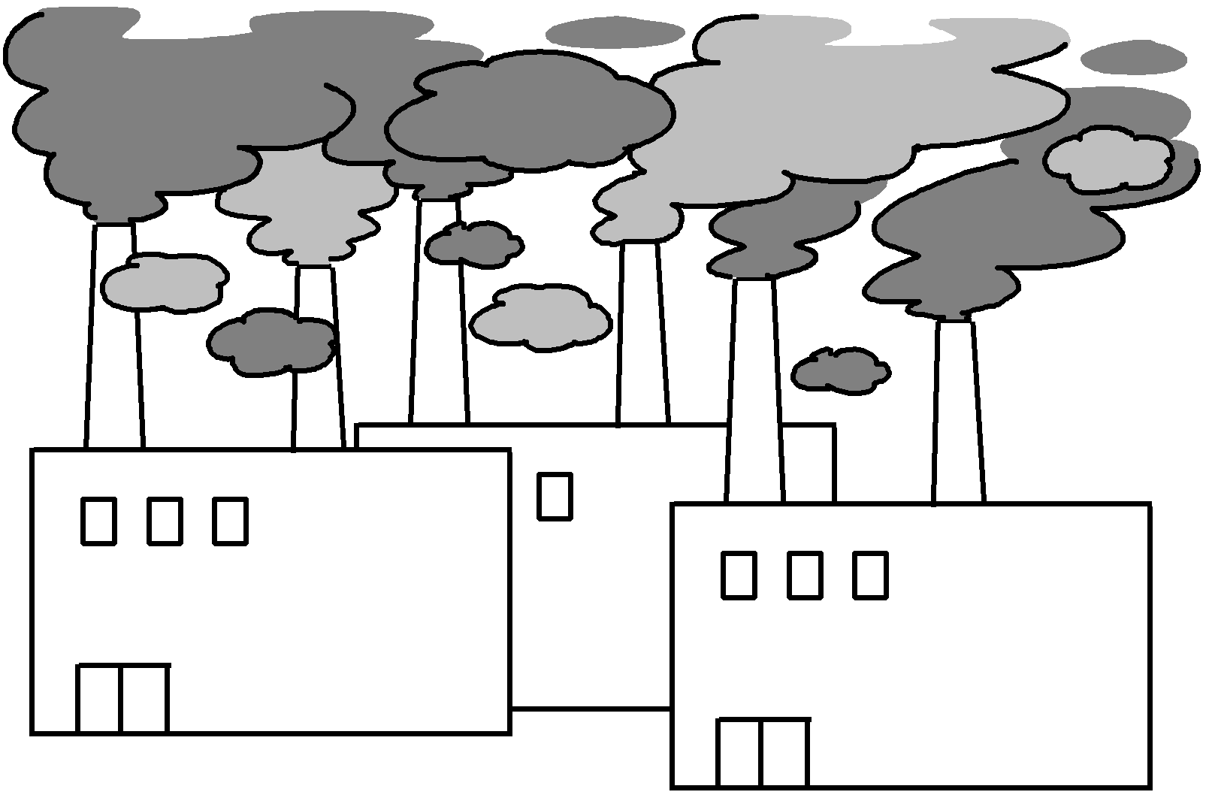 | Factories produce  .

RP no: Century Gothic 15pt
(所有圈號用15pt)


Book 6B Chapter 3 Graded Worksheets
Worksheet 3⬇
- so much
- so many
- so much noise
- so many fumes
- so much smoke

