RP no: Century Gothic 15pt
(所有圈號用15pt)
Finish the sentences using ‘so much’ and ‘so many’.
produce
make
throw away

smoke disposable products
fumes toxic waste noise

1 | 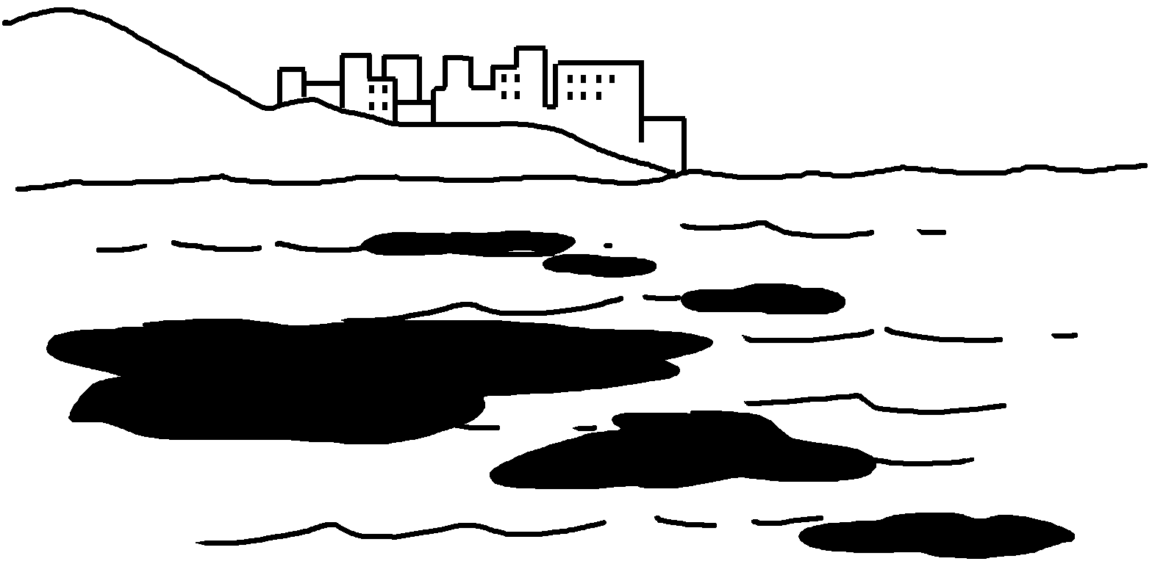 | People dump  _______________ into the sea.
2 | 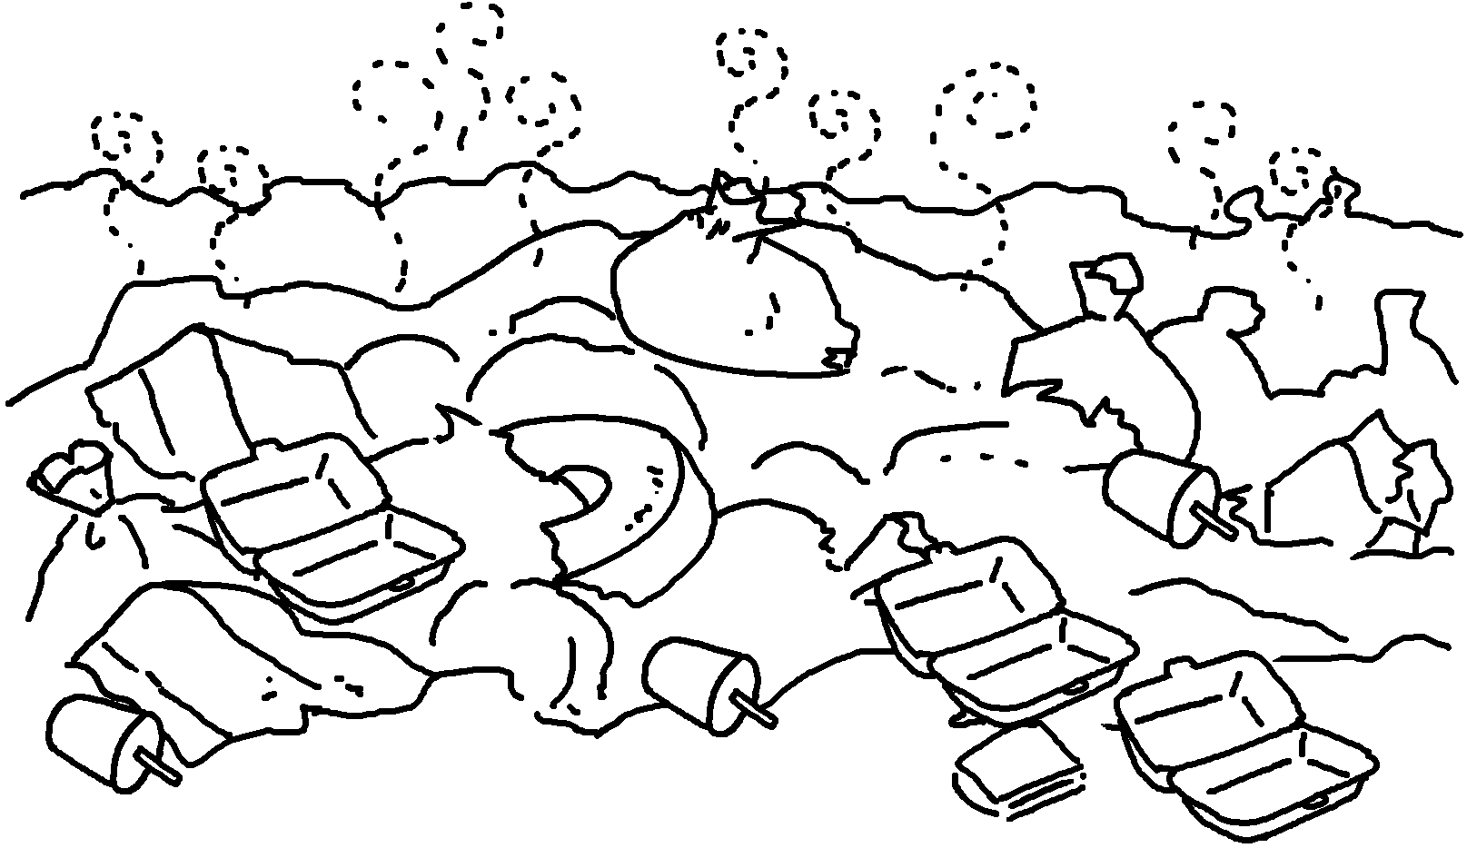 | People  ____________________________________ .
3 | 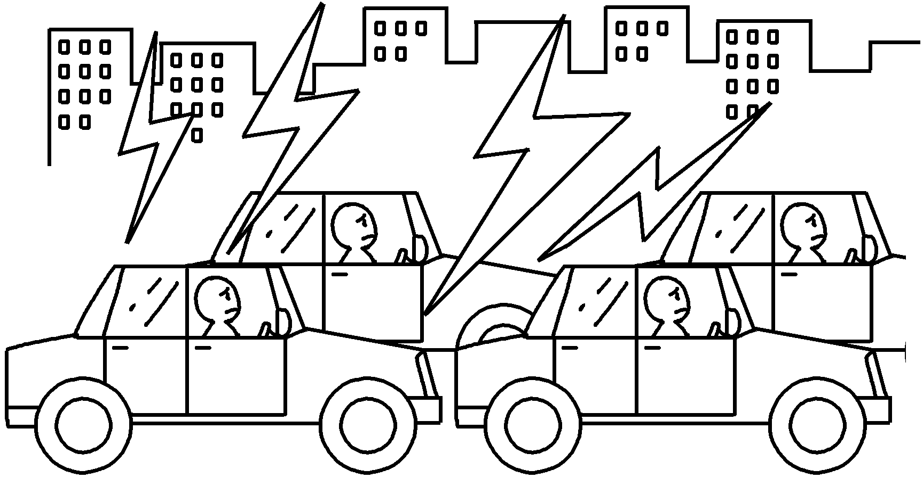 | The traffic  .
4 | 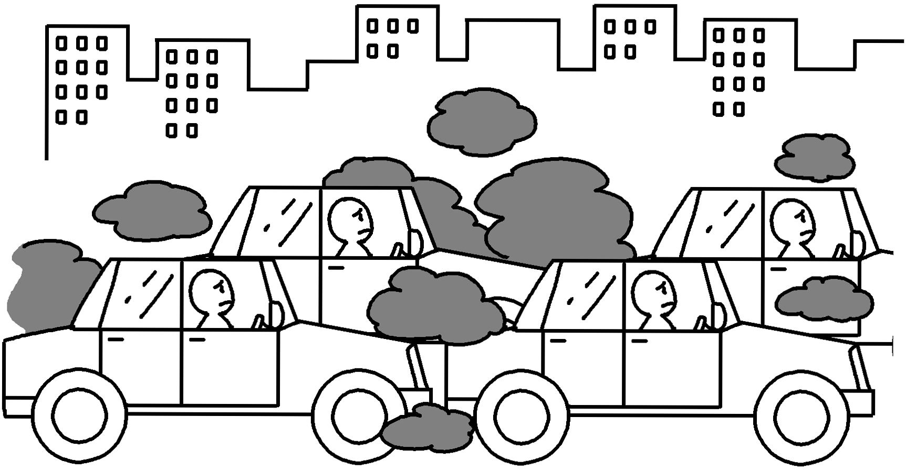 | Cars  .
5 | 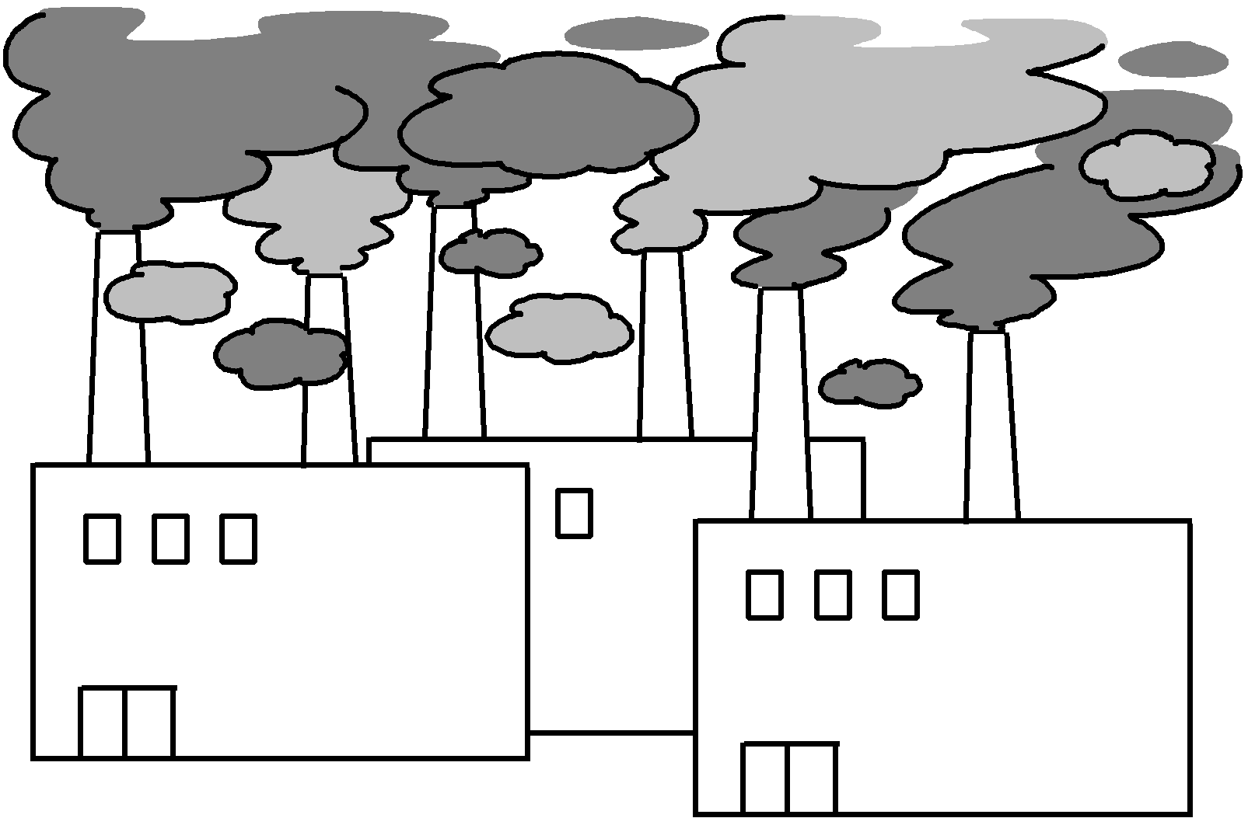 | Factories  .


Book 6B Chapter 3 Graded Worksheets
Worksheet 3⬇⬇
- so much toxic waste
- throw away so many disposable products
- makes so much noise
- produce so many fumes
- produce so much smoke

