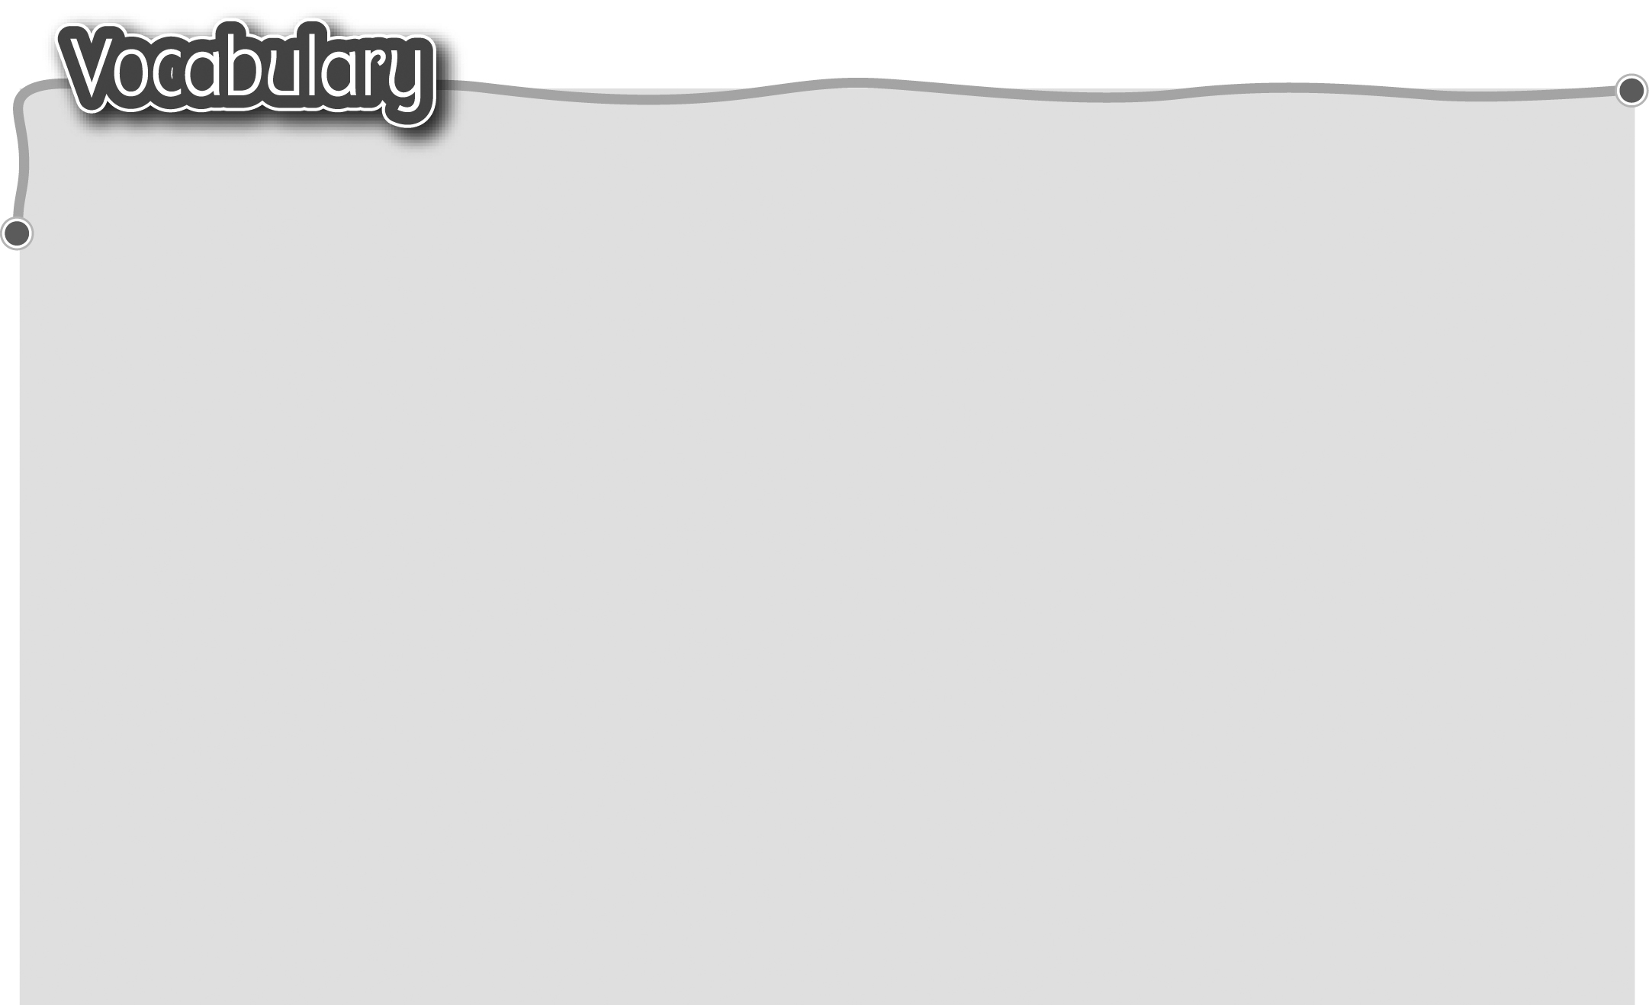
1 good for the environment 9 leave the lights on 讓燈開着
對環境有益 10 waste water 浪費食水
2 turn down the air-con 調低冷氣 11 leave the tap on
3 turn off the lights 關燈 讓水龍頭流着
4 have showers 淋浴 12 have baths浸浴
5 bring your own bag / water 13 waste plastic / paper
bottle / facecloth 自備購物袋、 浪費塑膠、紙張
水壼、小毛巾 14 use a lot of plastic bags /
6 recycle / reuse cans, paper, bottles / tissues / disposable
plastic bags / bottles products 使用大量膠袋、
循環再造 / 循環再用金屬罐、 膠樽、紙巾、即棄用品
紙張、膠袋、膠樽 15 throw away a lot of used
7 bad for the environment paper / plastic bags /
對環境有害 bottles 丟棄大量用過的
8 waste energy 浪費能源 紙張、膠袋、膠樽
The words marked with * have different meanings in other contexts. You can look up those meanings in a dictionary.

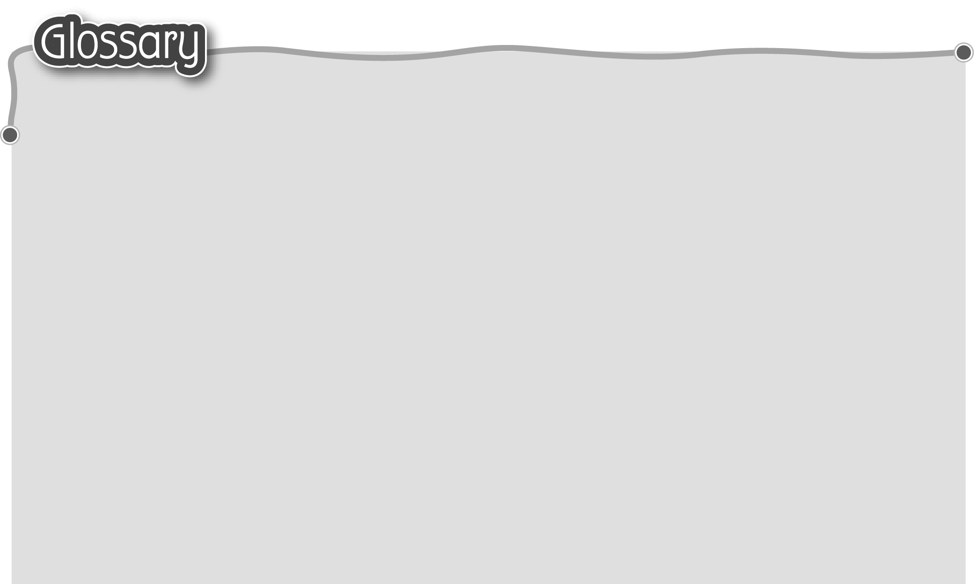
1 reduce (p.20) 減少 15 promise* (p.27) 承諾（名詞）
2 lose* (p.20) 失去 16 event programme (p.27) 節目表
3 so much / many (p.20) 這麽多 17 speech* (p.27) 演講
4 tin (p.20) 金屬罐 18 principal* (p.27) 校長
5 bin (p.20) 桶 19 Guest of Honour (p.27)
6 traffic (p.23) 交通 榮譽嘉賓
7 noise* (p.23) 噪音 20 Parent-Teacher Association (p.27)
8 produce* (p.23) 製造 家長教師會
9 fumes (p.23) 廢氣 21 responsible* (p.27) 負責
10 smoke* (p.25) 煙（名詞） 22 musical* (p.27) 音樂劇（名詞）
11 roadworks (p.25) 道路工程 23 conduct* (p.27) 指揮（動詞）
12 dump* (p.25) 傾倒 24 judge* (p.27) 評判（名詞）
13 toxic waste (p.25) 有毒廢料 25 presentation* (p.27) 頒發
14 air / land / water pollution (p.25) 26 monitor* (p.27) 糾察（名詞）
空氣/土地/水質污染

