Event programmes
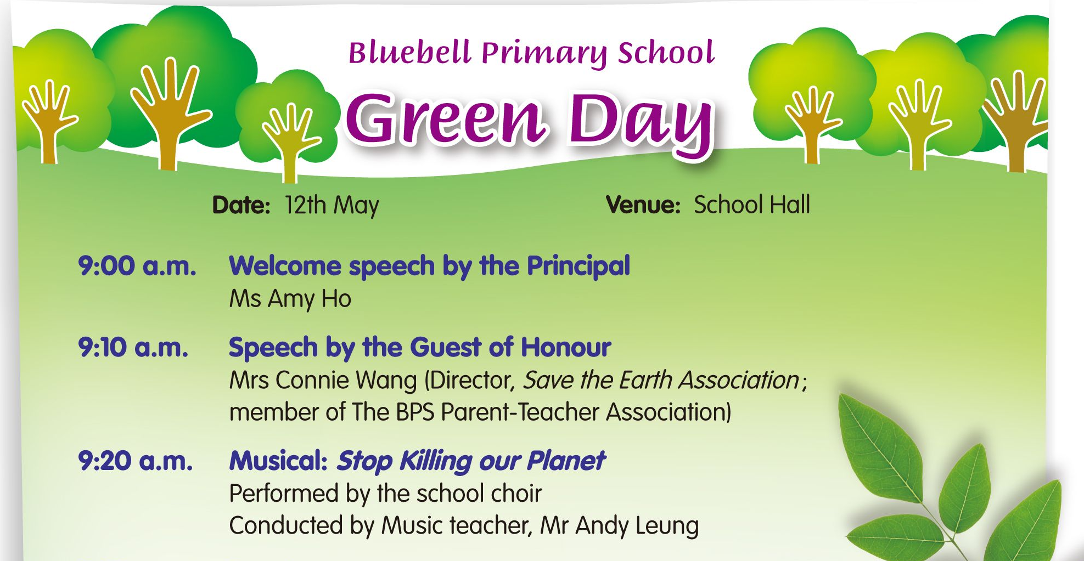
Write the answers and blacken  the circles.

1 Find the names of three people who work at Bluebell Primary School.

2 Who sings on Green Day?

3 How many speeches are given on Green Day?

4 Where can you watch the musical?

5 When does this event take place? It takes place ____ .
 A. at the start of the school year
 B. at the end of the first term
 C. in the middle of the second term
 D. at the end of the school year

6 Some prizes are given to students who _____ .
 A. gave speeches
 B. performed a musical
 C. are class monitors
 D. painted nice pictures

7 At what time can you have a snack?
 A. 9:05 a.m.  B. 9:30 a.m.
 C. 10:20 a.m.  D. 11:35 a.m.
Answers: (Accept any reasonable answers.)
1 Ms Amy Ho, Mr Andy Leung, Mr Donny Li. 2 The school choir sings on Green Day.
3 Three speeches are given on Green Day. 4 We can watch the musical in the school hall.
5 C 6 D 7 C

