Choose and write.
dolphin elephant shark whale

1
2
3
4
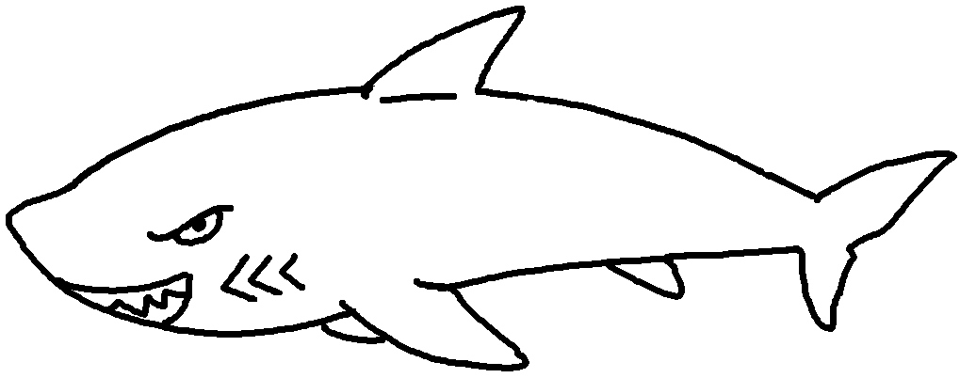 | 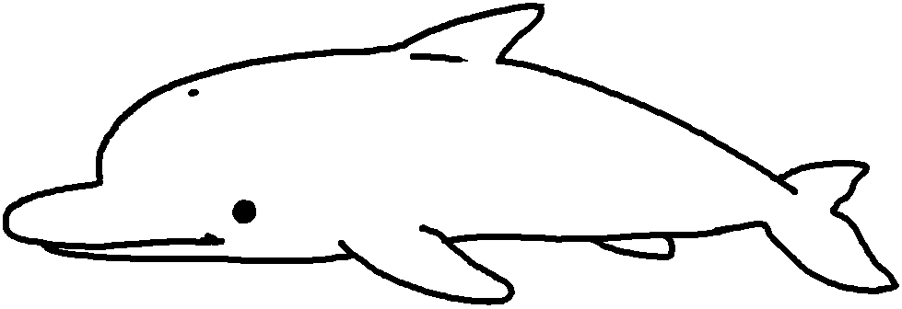 | 1 a  2 a  3 a  4 an
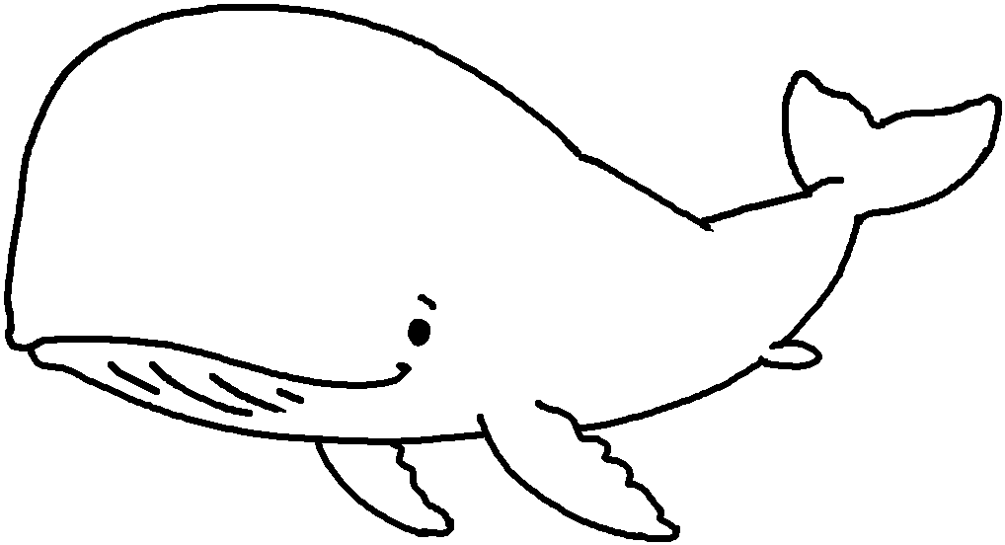 | 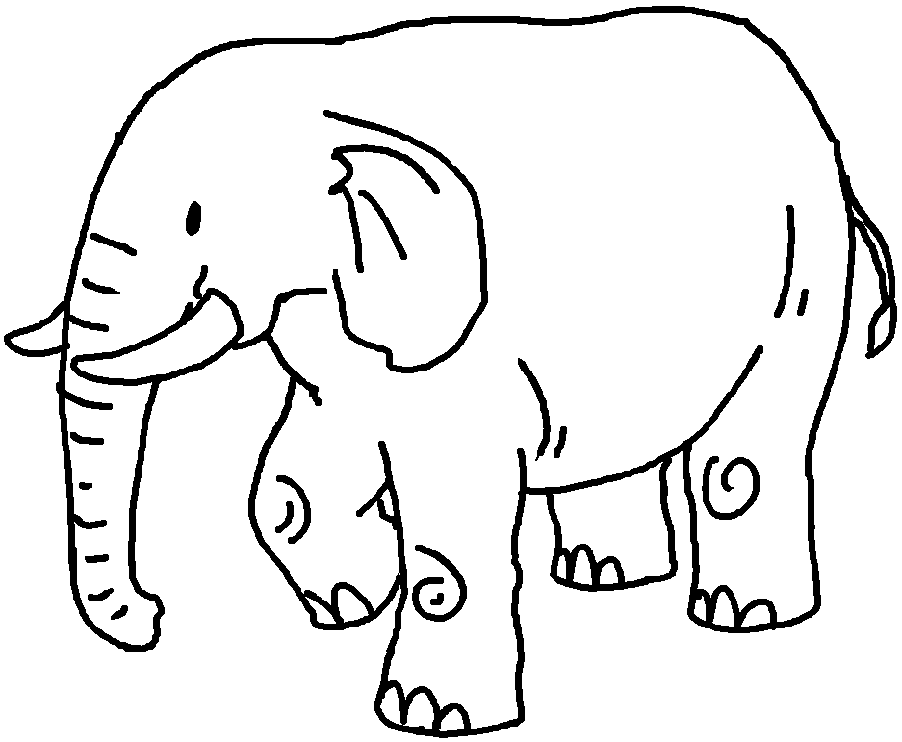 | 1 a  2 a  3 a  4 an
catch destroy hunt kill
5
6
7
8
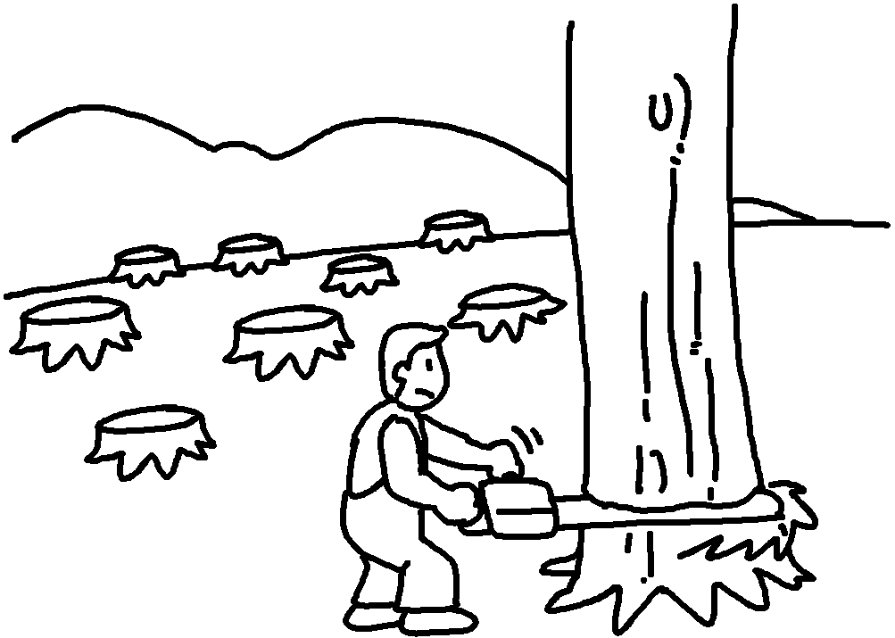 | 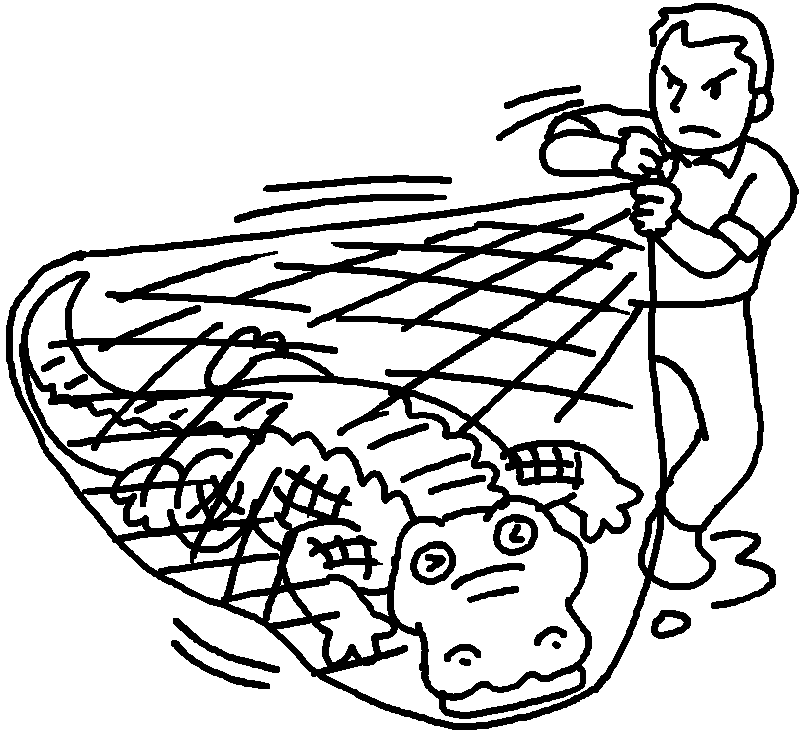 | 5  6  7  8
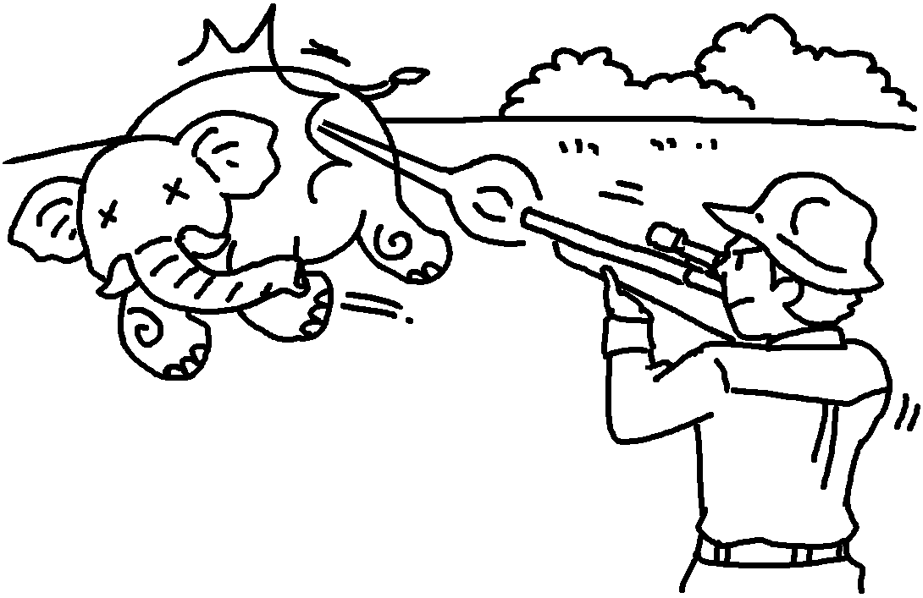 | 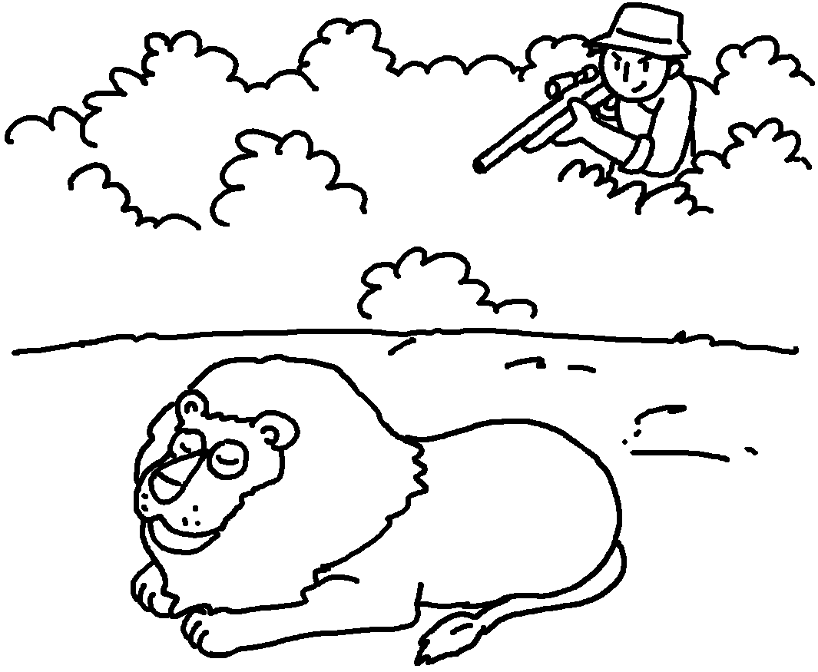 | 5  6  7  8
endangered extinct
9
10
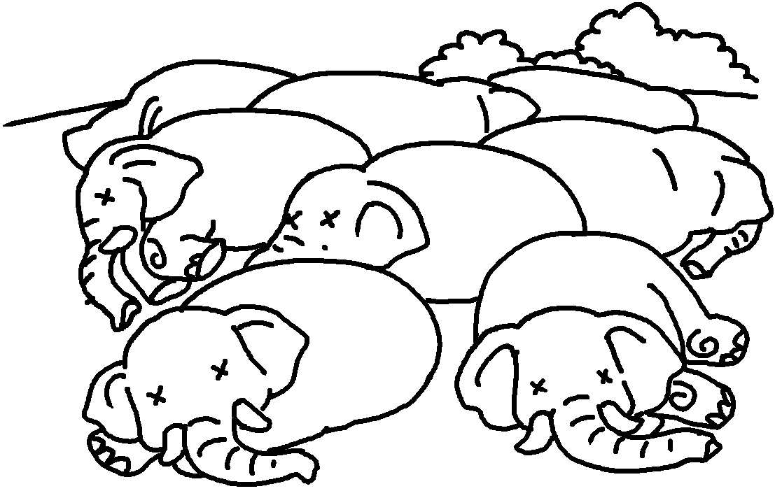 | 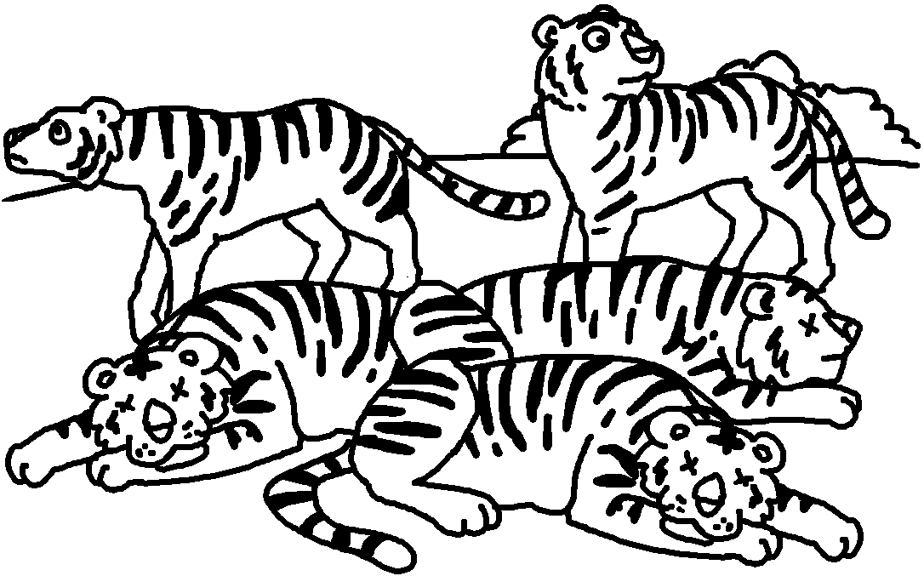 | 9 become  10 become

Book 6B Chapter 4 Graded Worksheets
Worksheet 1⬇
- shark
- dolphin
- whale
- elephant
- destroy
- catch
- kill
- hunt
- extinct
- endangered



