What are they? Fill in the missing letters.
1
2
3
4
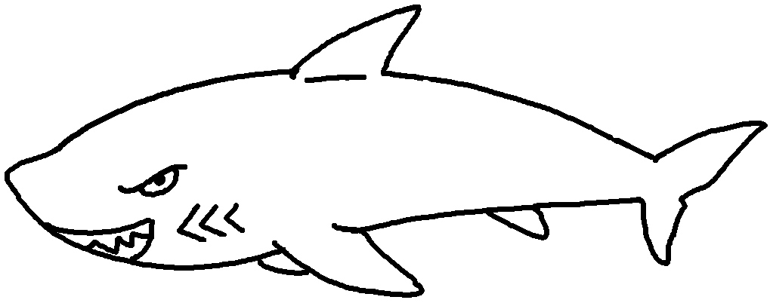 | 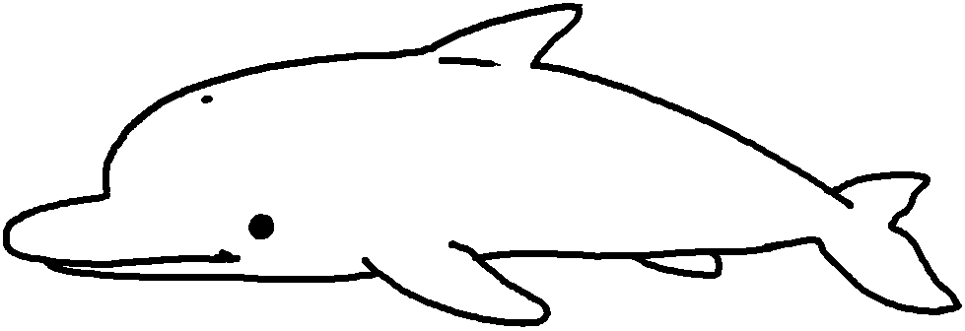 | 1 a s __ __ __ __  2 a d __ __ __ __ __ __  3 a w __ __ __ __  4 an e __ __ __ __ __ __ __
 | 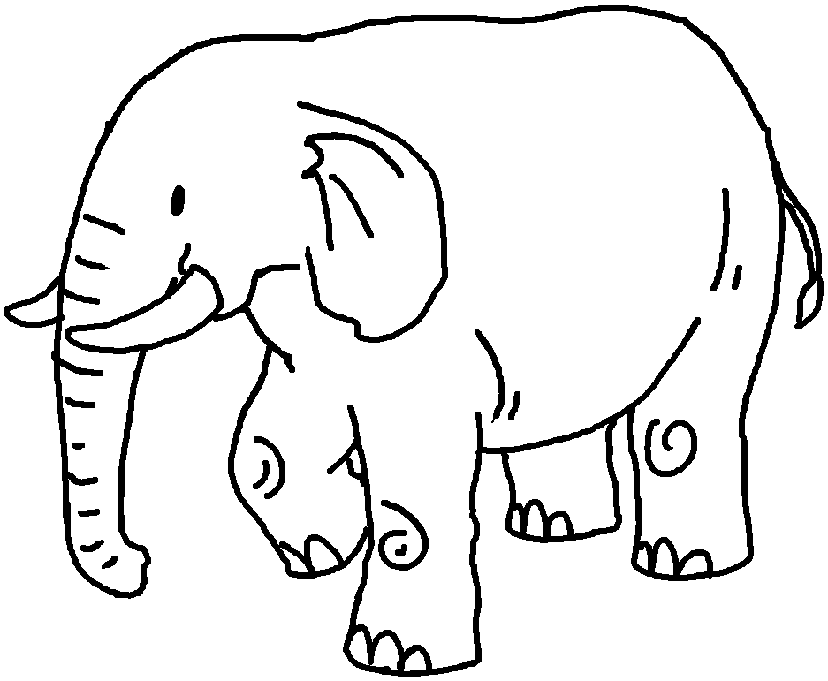

Write the action verbs or adjectives. Fill in the missing letters.
5
6
7
8
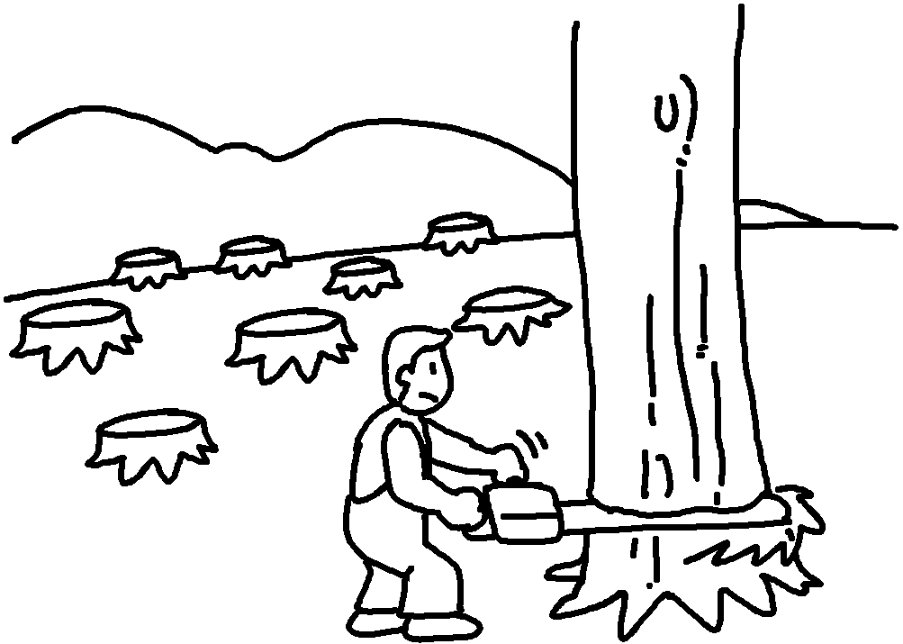 | 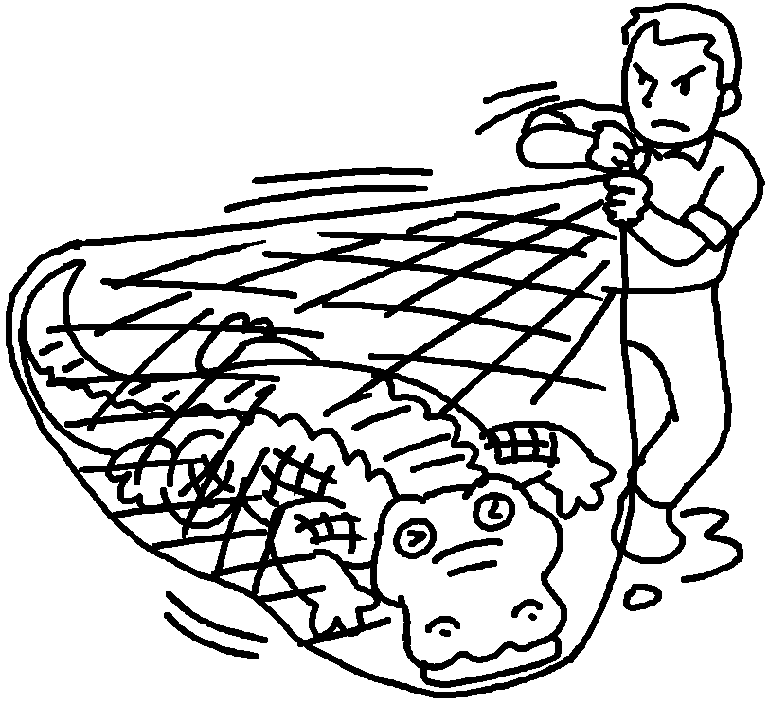 | 5 d __ __ __ __ __ __  6 c __ __ __ __  7 k __ __ __  8 h __ __ __  9 become  e __ __ __ __ __ __  10 become  e __ __ __ __ __ __ __ __ __
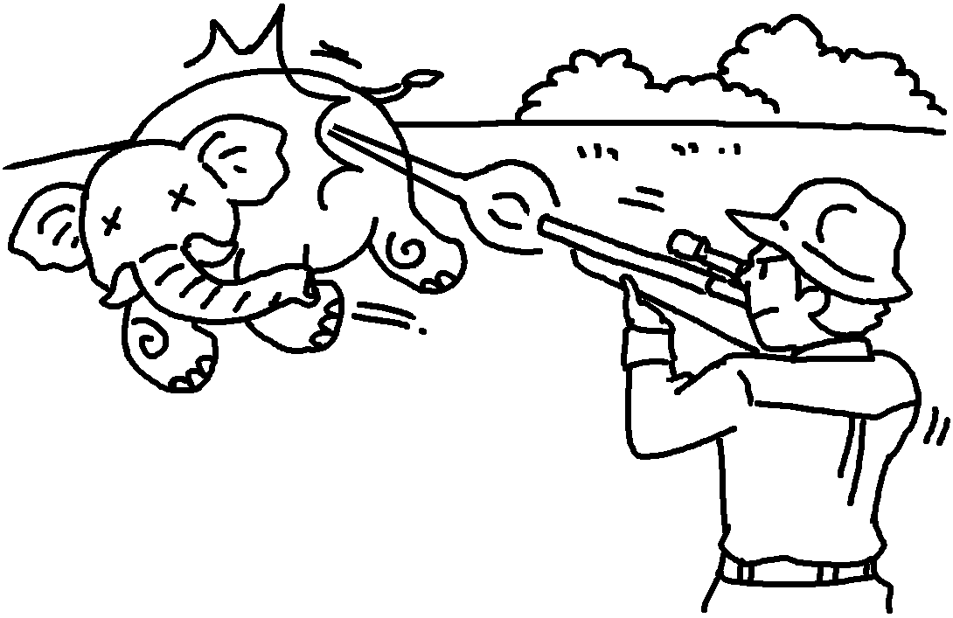  9  10 | 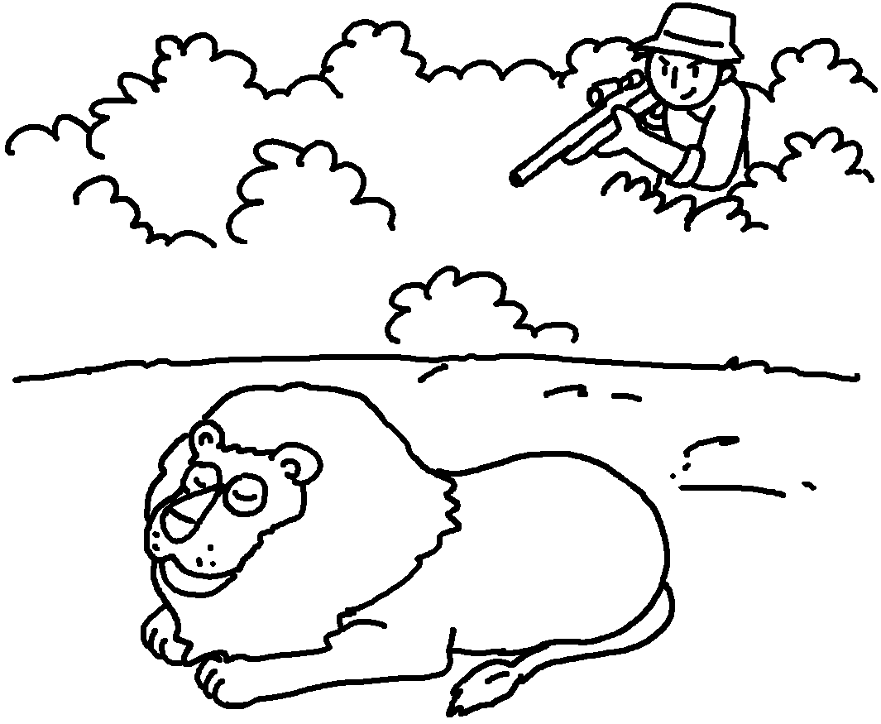
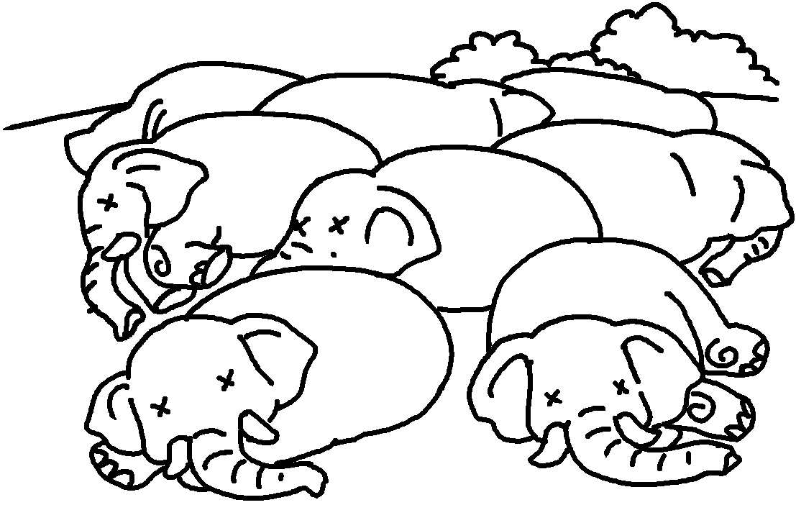 | 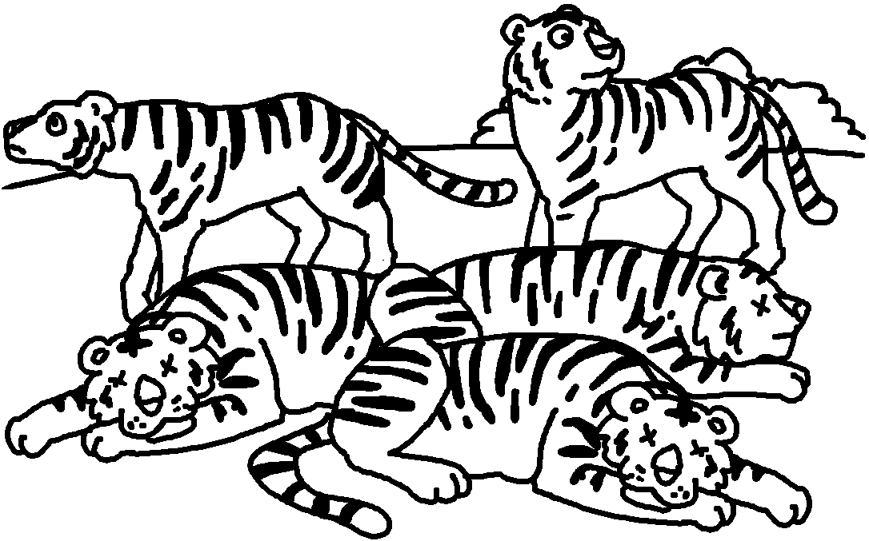


Book 6B Chapter 4 Graded Worksheets
Worksheet 1⬇⬇
- s h a r k
- d o l p h i n
- w h a l e
- e l e p h a n t
- d e s t r o y
- c a t c h
- k i l l
- h u n t
- e x t i n c t
- e n d a n g e r e d

