What are they? Write.
1
2
3
4
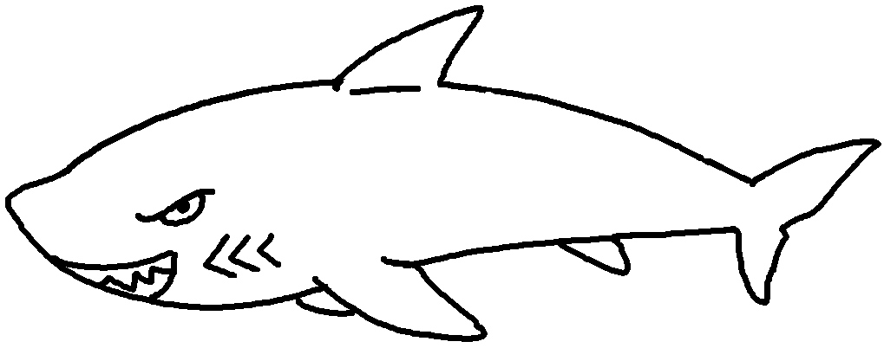 | 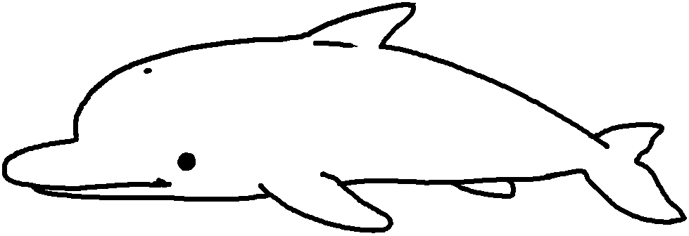 | 1 a  2  3  4
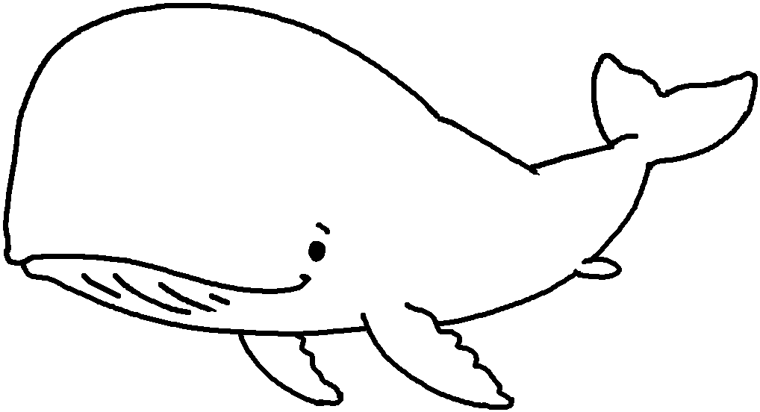 | 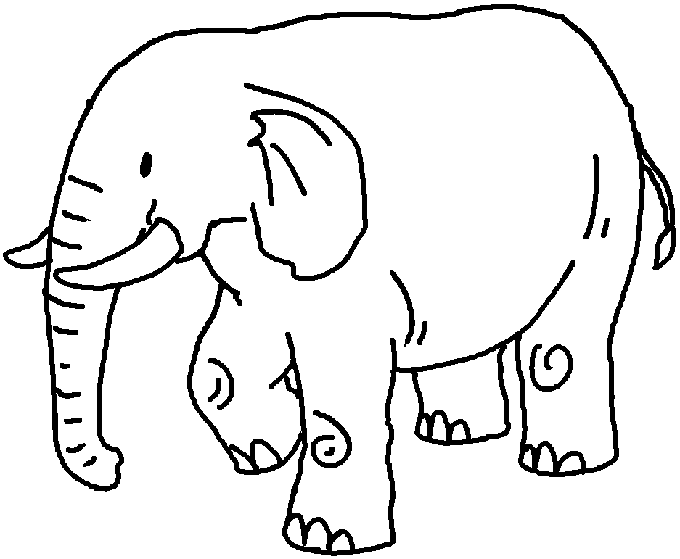 | 1 a  2  3  4

Look at the pictures. Write the action verbs or adjectives.
5
6
7
8
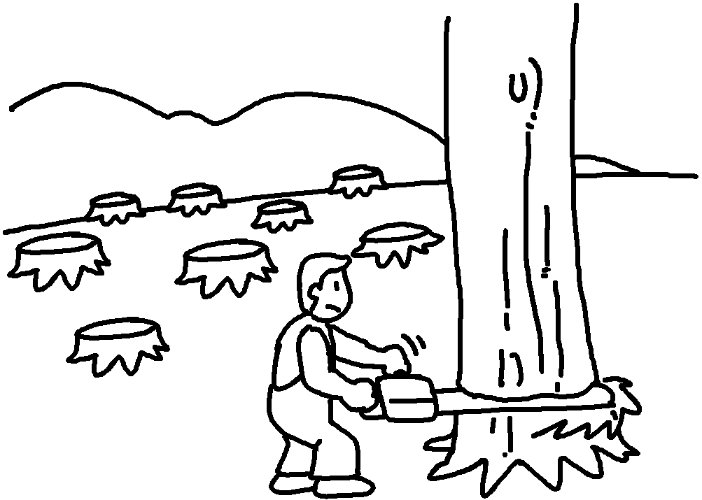 | 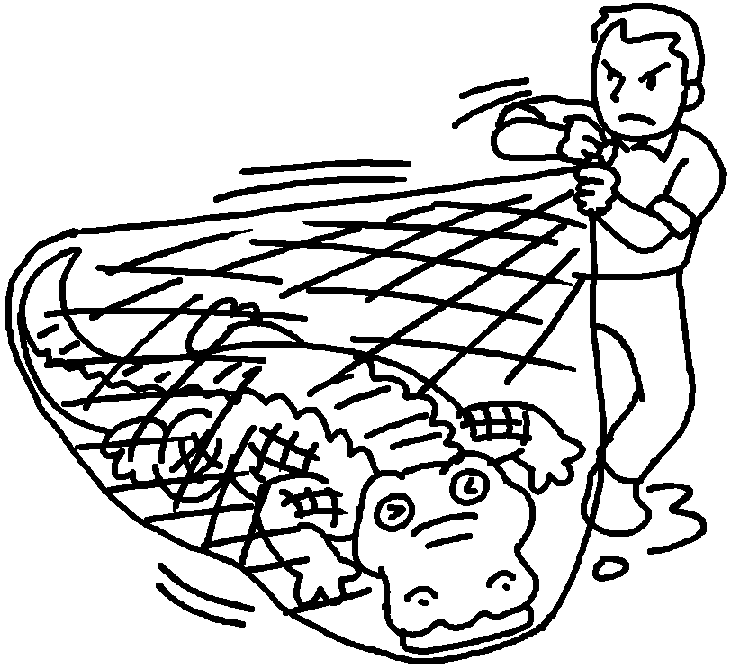 |  | 5 d  6 c  7 k  8 h  9 become e  10 become e
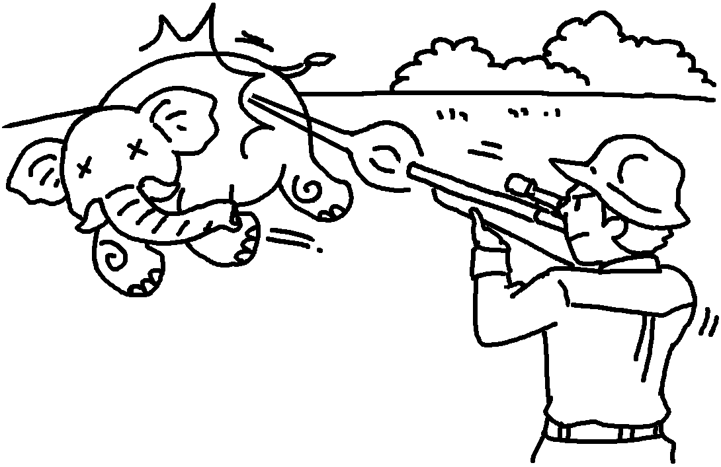  9  10 | 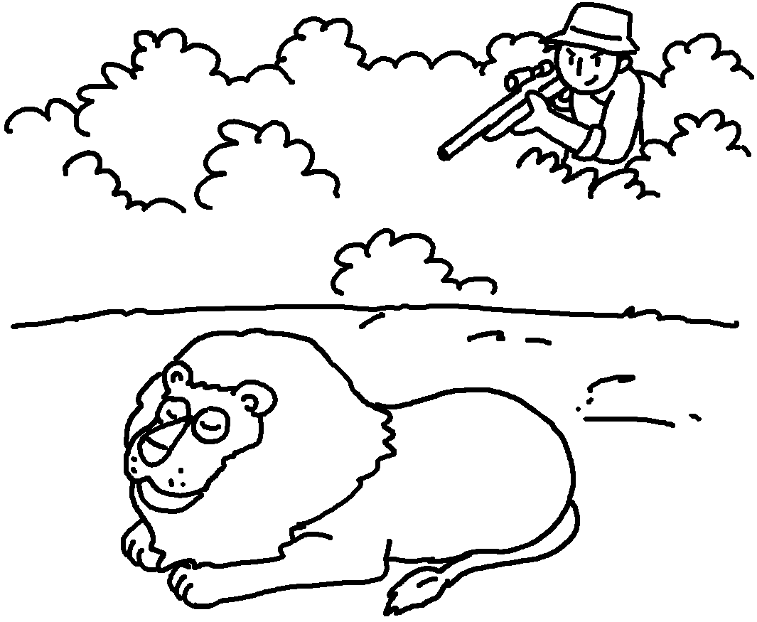 |  | 5 d  6 c  7 k  8 h  9 become e  10 become e
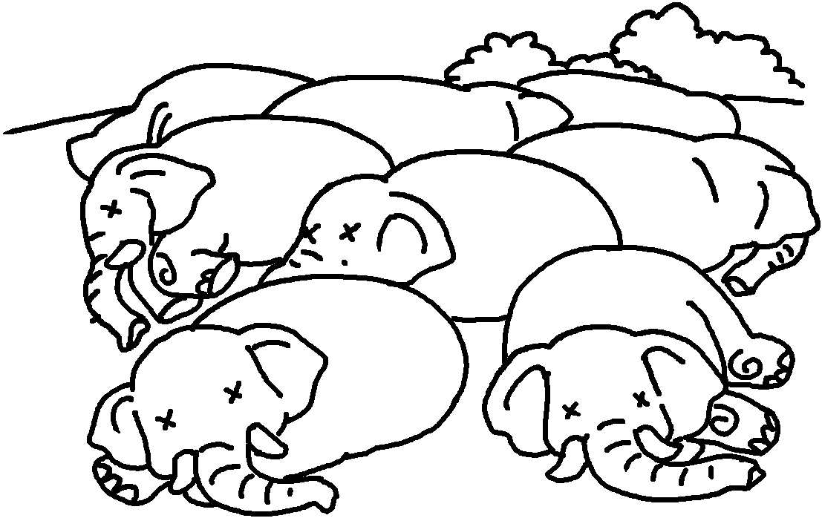 |  | 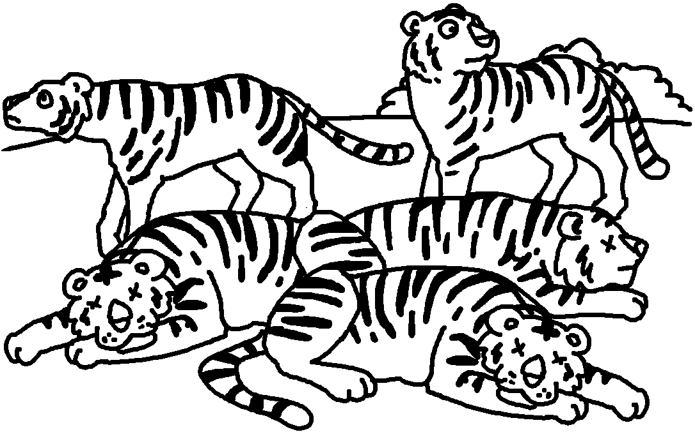 | 5 d  6 c  7 k  8 h  9 become e  10 become e


Book 6B Chapter 4 Graded Worksheets
Worksheet 1⬇⬇⬇
- shark
- a dolphin
- a whale
- an elephant
- destroy
- catch
- kill
- hunt
- extinct
- endangered

