Finish the sentences.
unless
stop ...ing

1 | 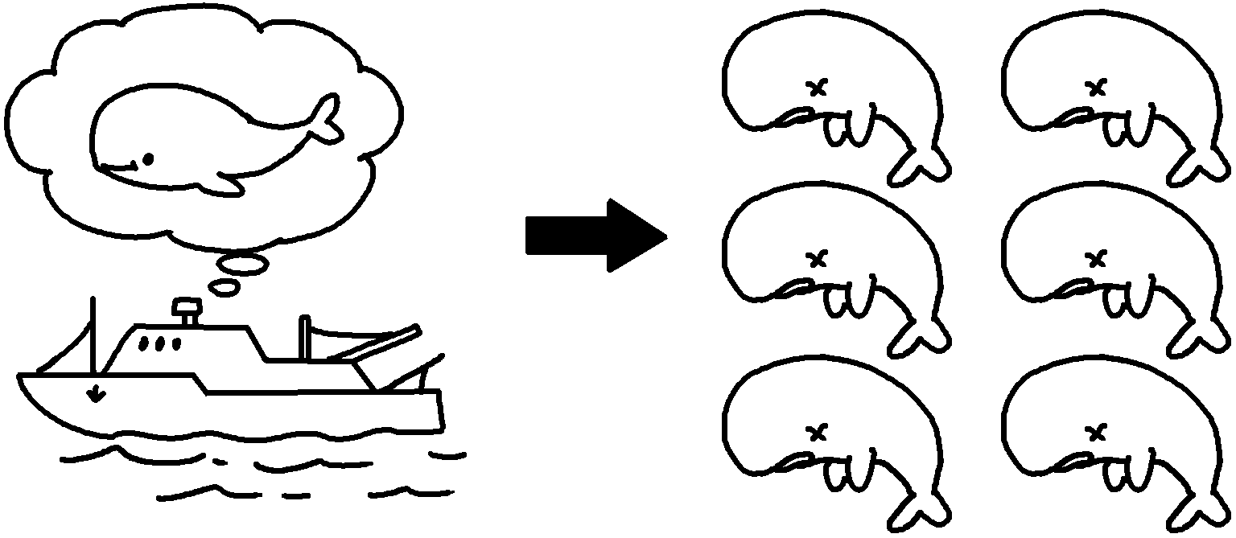 | Whales will become extinct people stop hunting them.
2 | 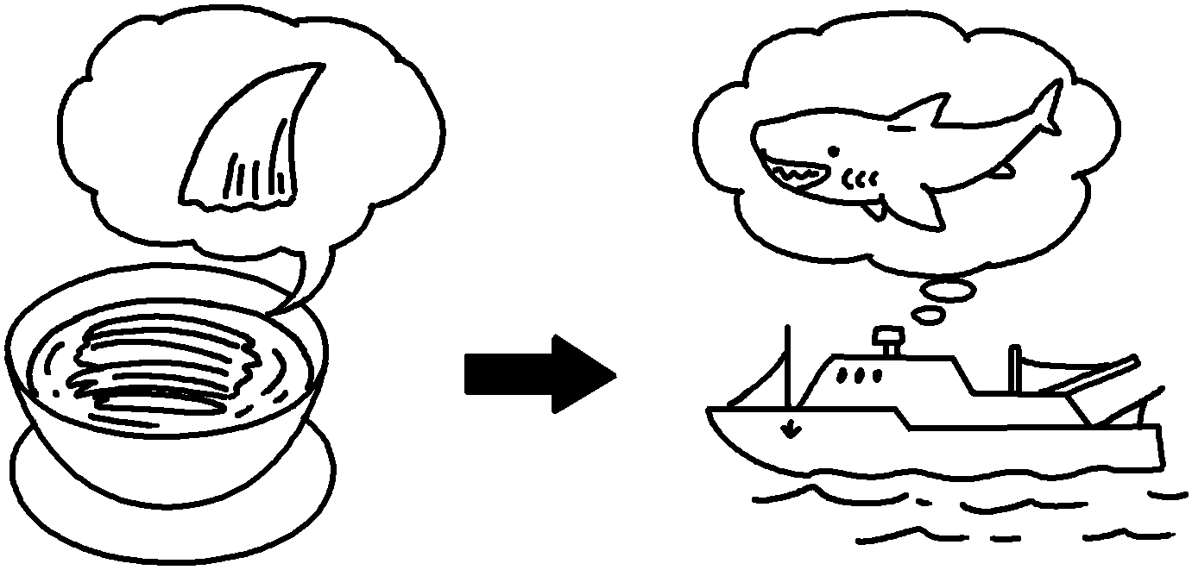 | Hunters will keep hunting sharks unless people  ______________________________ ( eat )  shark fin soup.
3 | 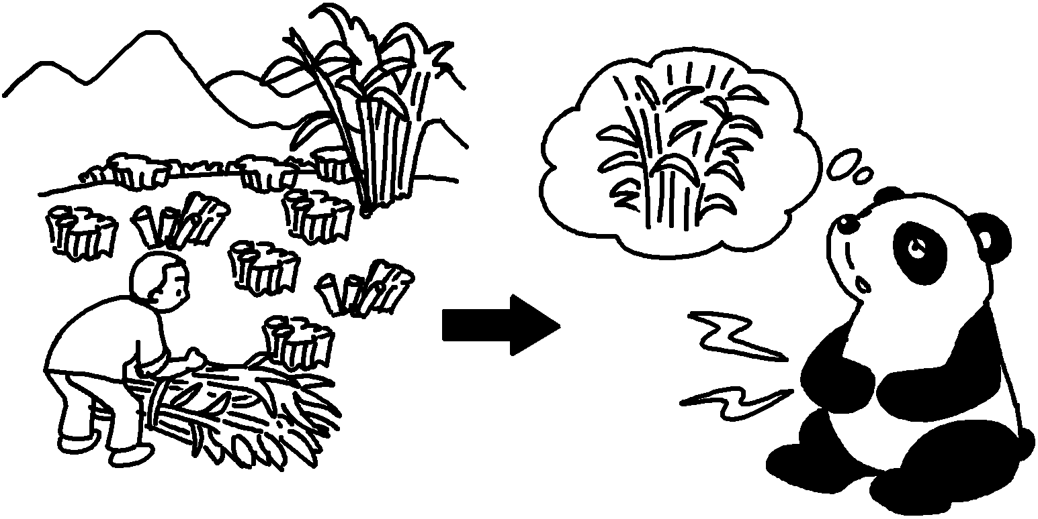 | Pandas will not have enough bamboo to eat unless people ( destroy ) bamboo forests.
4 | 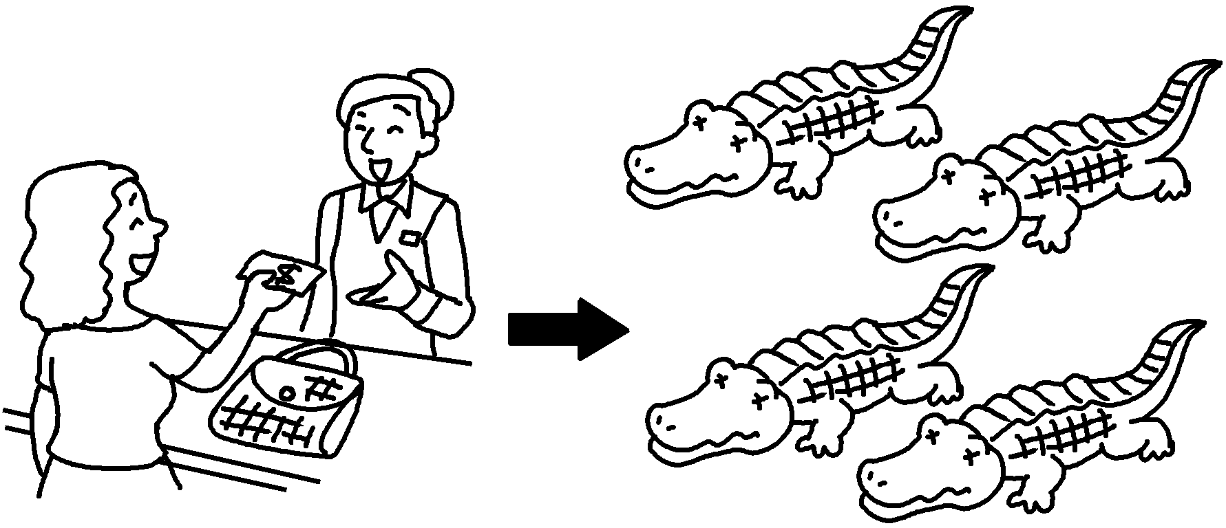 | Crocodiles will become extinct people ( buy ) leather handbags.
5 | 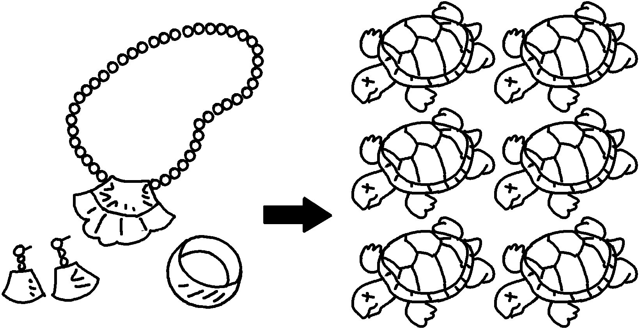 | Turtles will become extinct people ( use ) turtle shells for jewellery.


Book 6B Chapter 4 Graded Worksheets
Worksheet 2⬇
- unless
- stop eating
- stop destroying
- unless stop buying
- unless stop using

