Finish the sentences.
unless
buy leather handbags use turtle shells for jewellery
stop ...ing
destroy bamboo forests eat shark fin soup

1 | 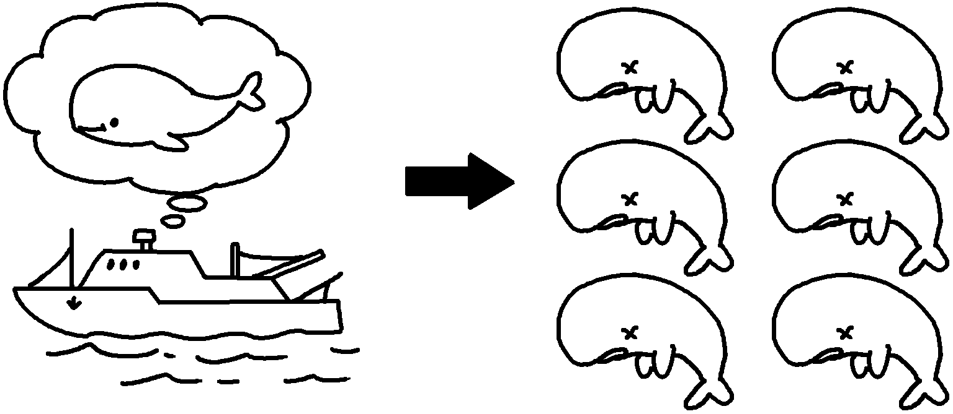 | Whales will become extinct people stop hunting them.
2 | 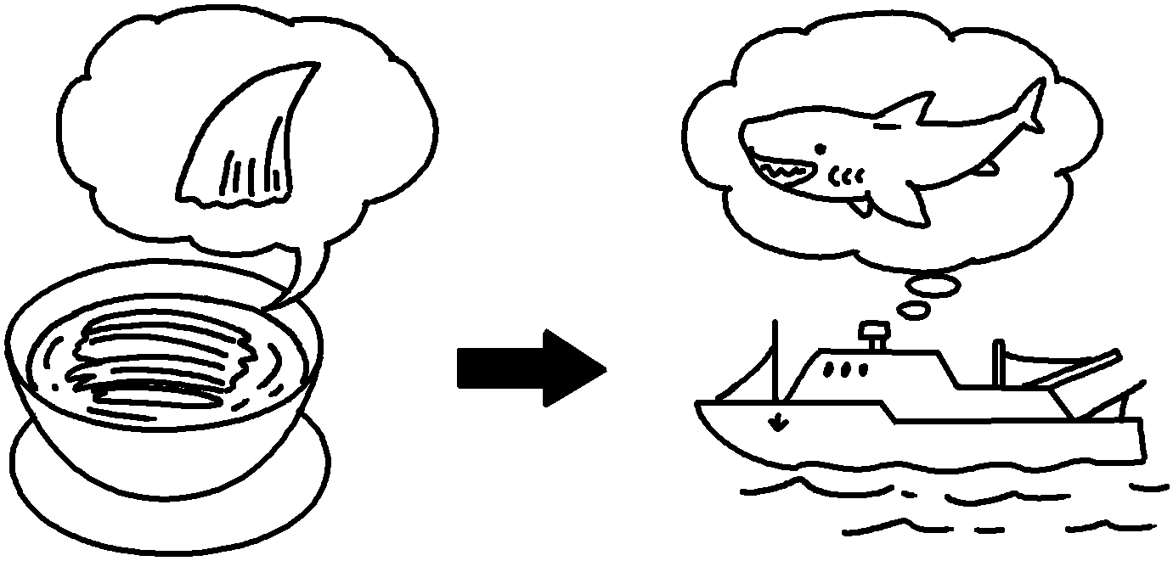 | Hunters will keep hunting sharks unless people  ___________________________________________  __________________________________________ .
3 | 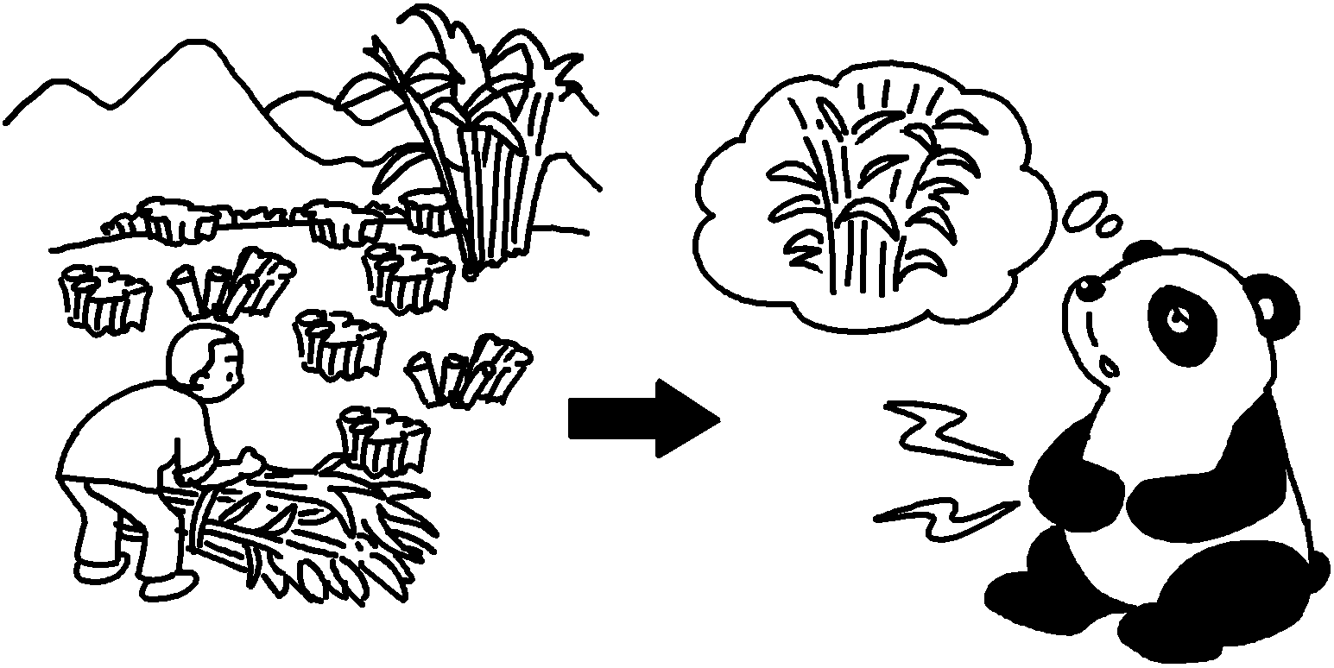 | Pandas will not have enough bamboo to eat ___________ people  _________________________________________ .
4 | 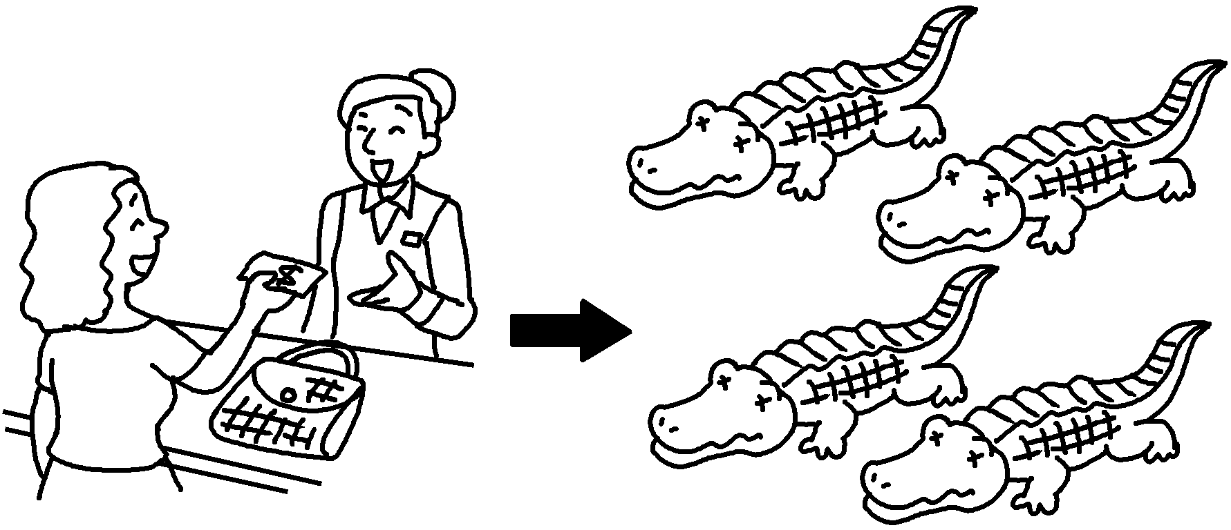 | Crocodiles will become extinct people  _________________________________________ .
5 | 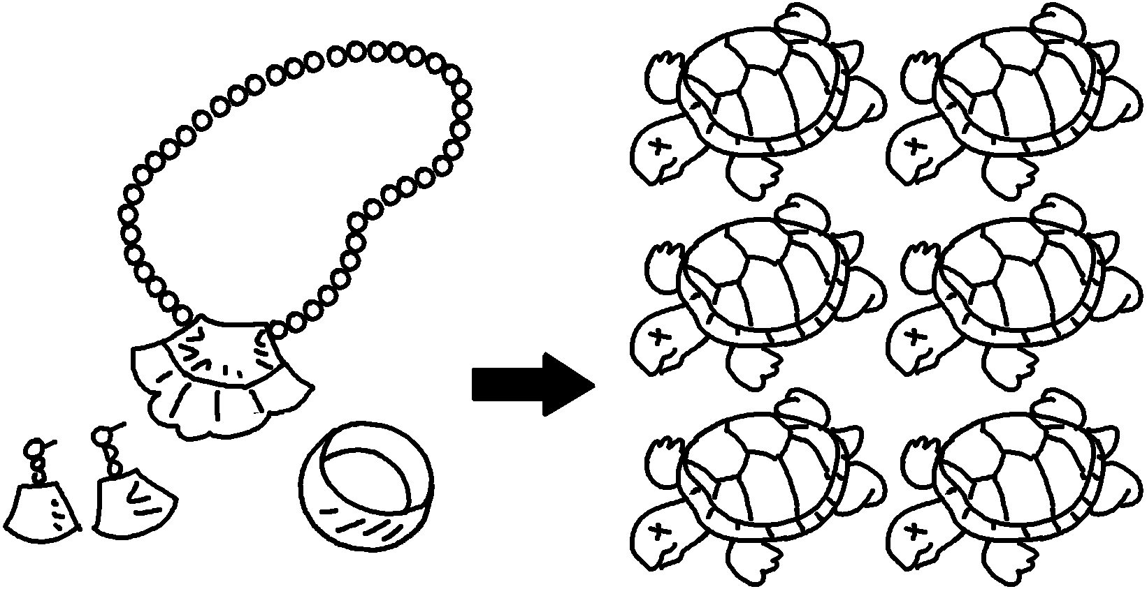 | Turtles will become extinct people  .


Book 6B Chapter 4 Graded Worksheets
Worksheet 2⬇⬇
- unless
- stop eating shark fin soup
- unless stop destroying bamboo forests
- unless stop buying leather handbags
- unless stop using turtle shells for jewellery

