Finish the sentences. Follow the example

not have buy leather handbags use turtle shells for jewellery
become extinct destroy bamboo forests eat shark fin soup

1 | 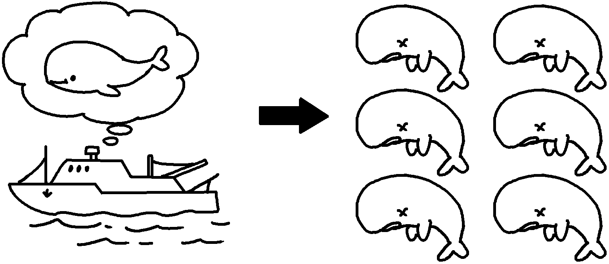  people stop hunting them | Whales _________________ extinct  will become  unless  .
2 | 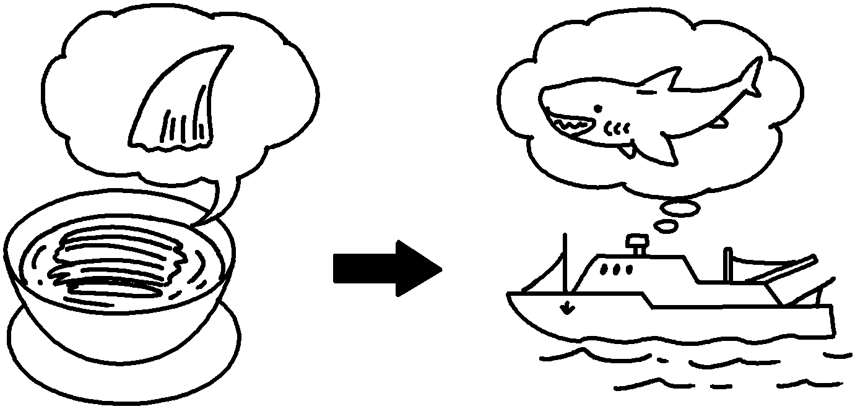 | Hunters will keep hunting sharks ____________  ___________________________________________  __________________________________________ .
3 | 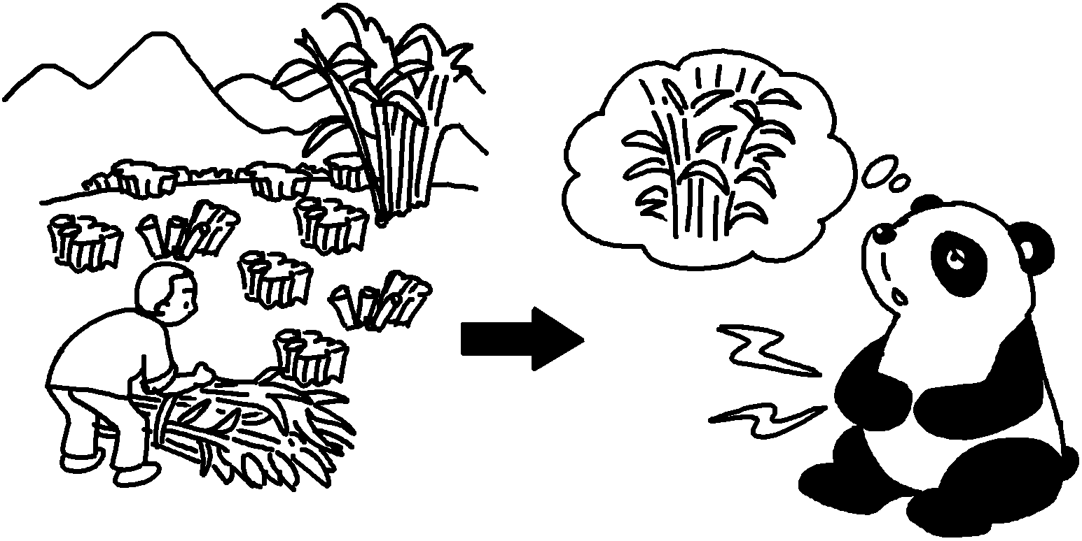 | Pandas ____________________________ enough bamboo to eat ____________________________  __________________________________________ .
4 | 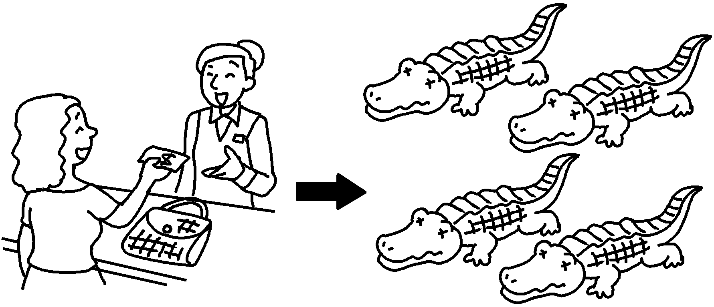 | Crocodiles  ___________________________________________  __________________________________________ .
5 | 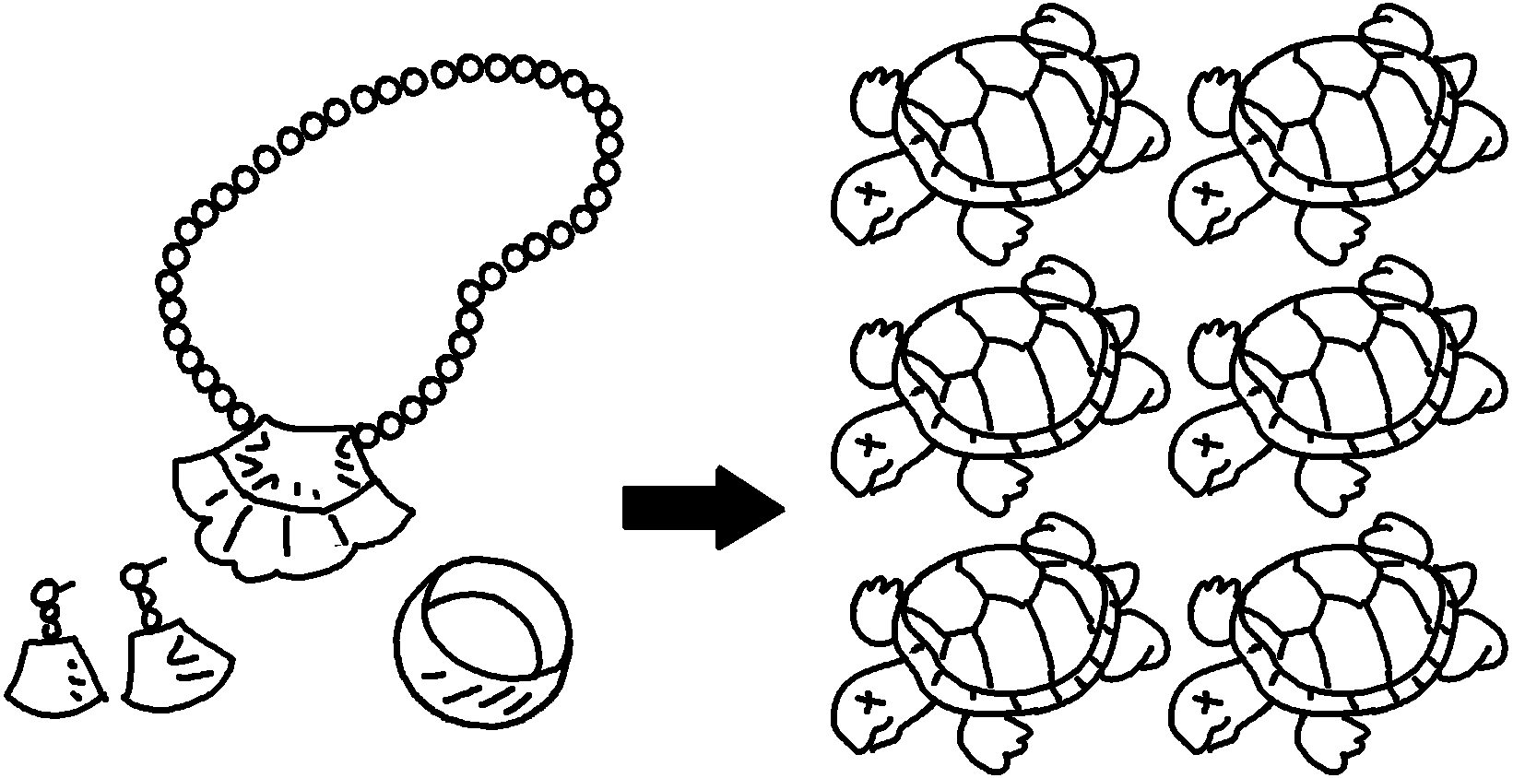 | Turtles  .


Book 6B Chapter 4 Graded Worksheets
Worksheet 2⬇⬇⬇
- unless people stop eating shark fin soup
- will not have unless people stop destroying bamboo forests
- will become extinct unless people stop buying leather handbags
- will become extinct unless people stop using turtle shells for jewellery

