Rewrite the sentences using ‘Therefore’.
1 | 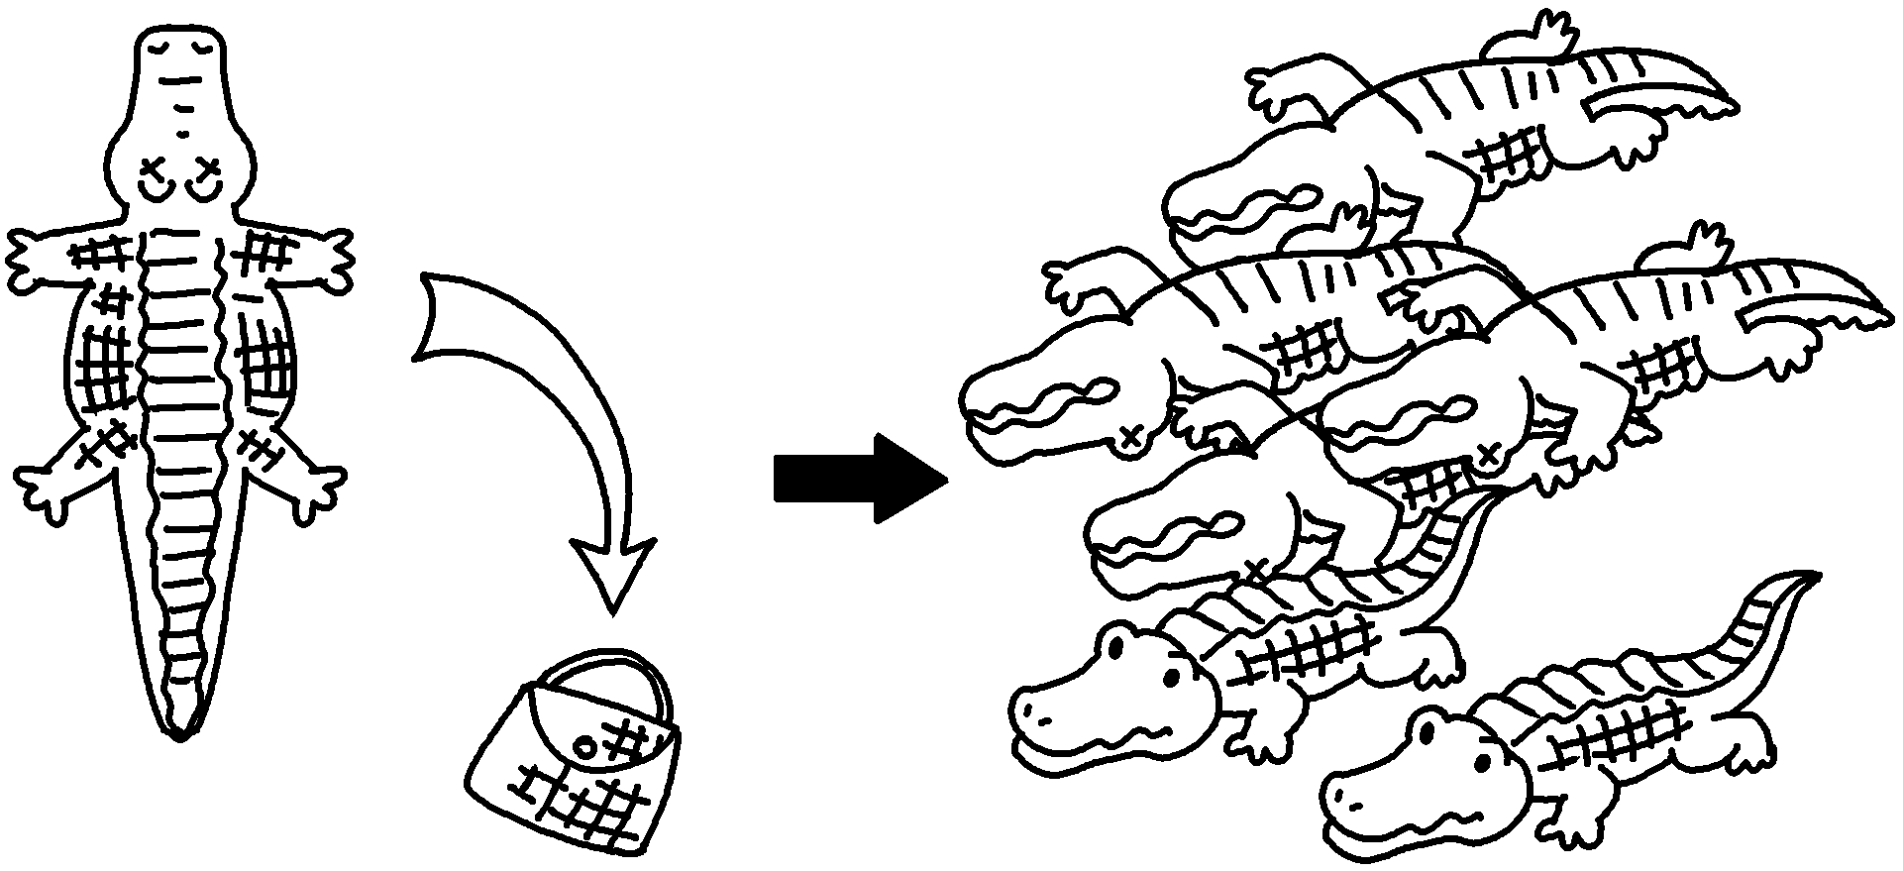 | People kill crocodiles for their skin.  There are very few left.  People kill crocodiles for their skin.  there are very few left.
2 | 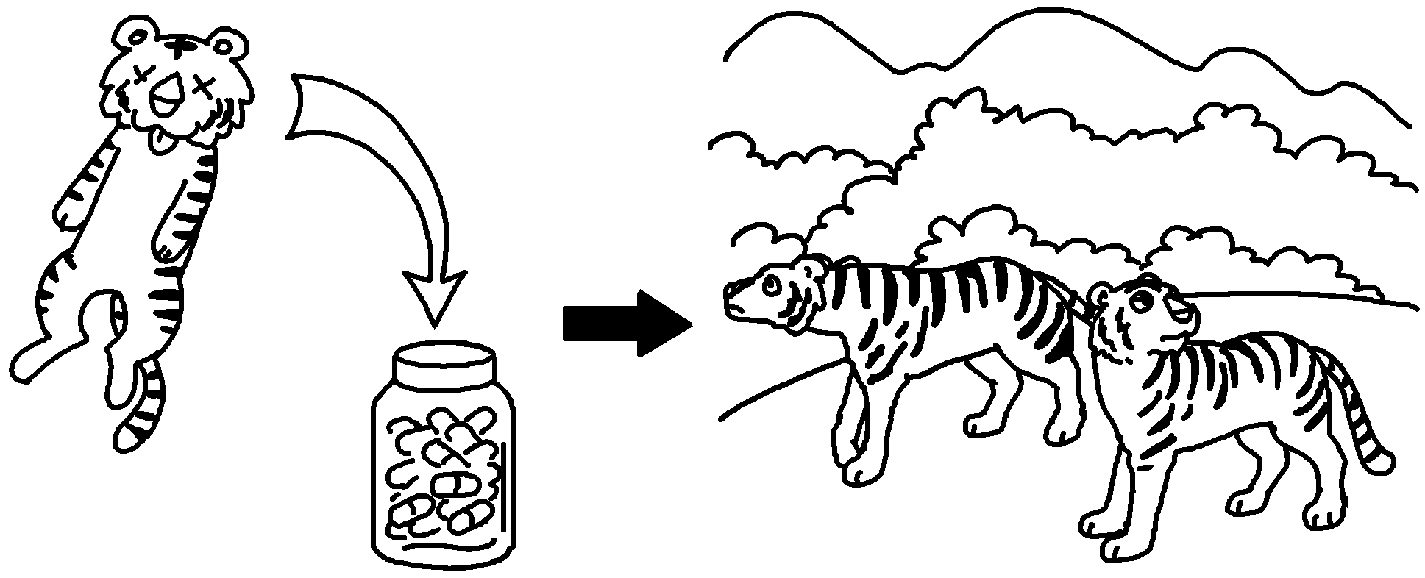 | People hunt tigers to make medicine.  There are very few tigers left.  People hunt tigers to make medicine.  .
3 | 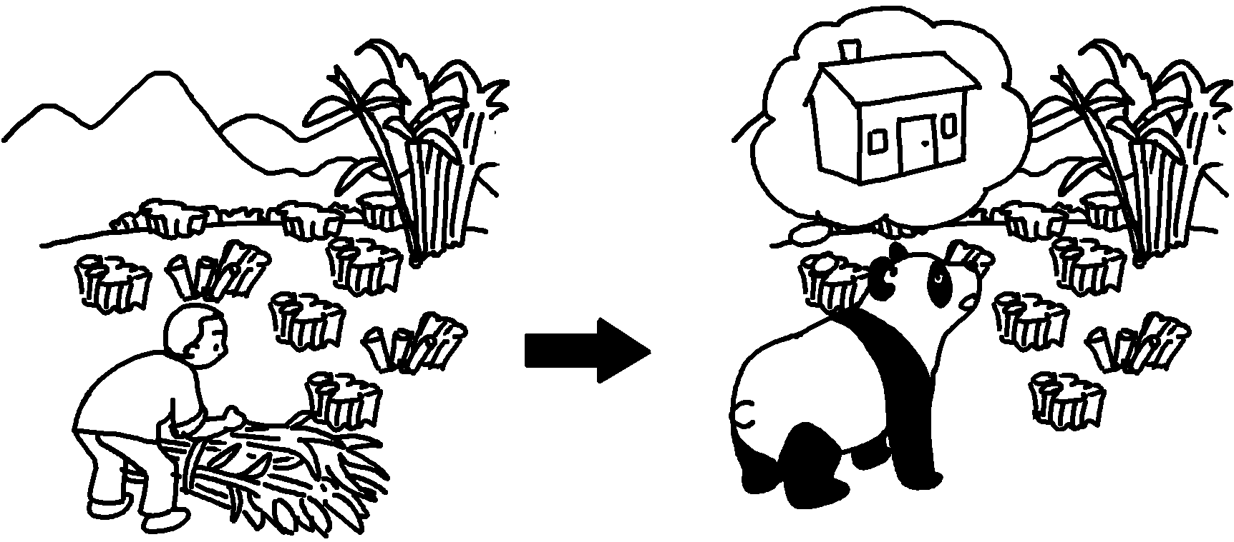 | People destroy bamboo forests.  Pandas have no place to live.
4 | 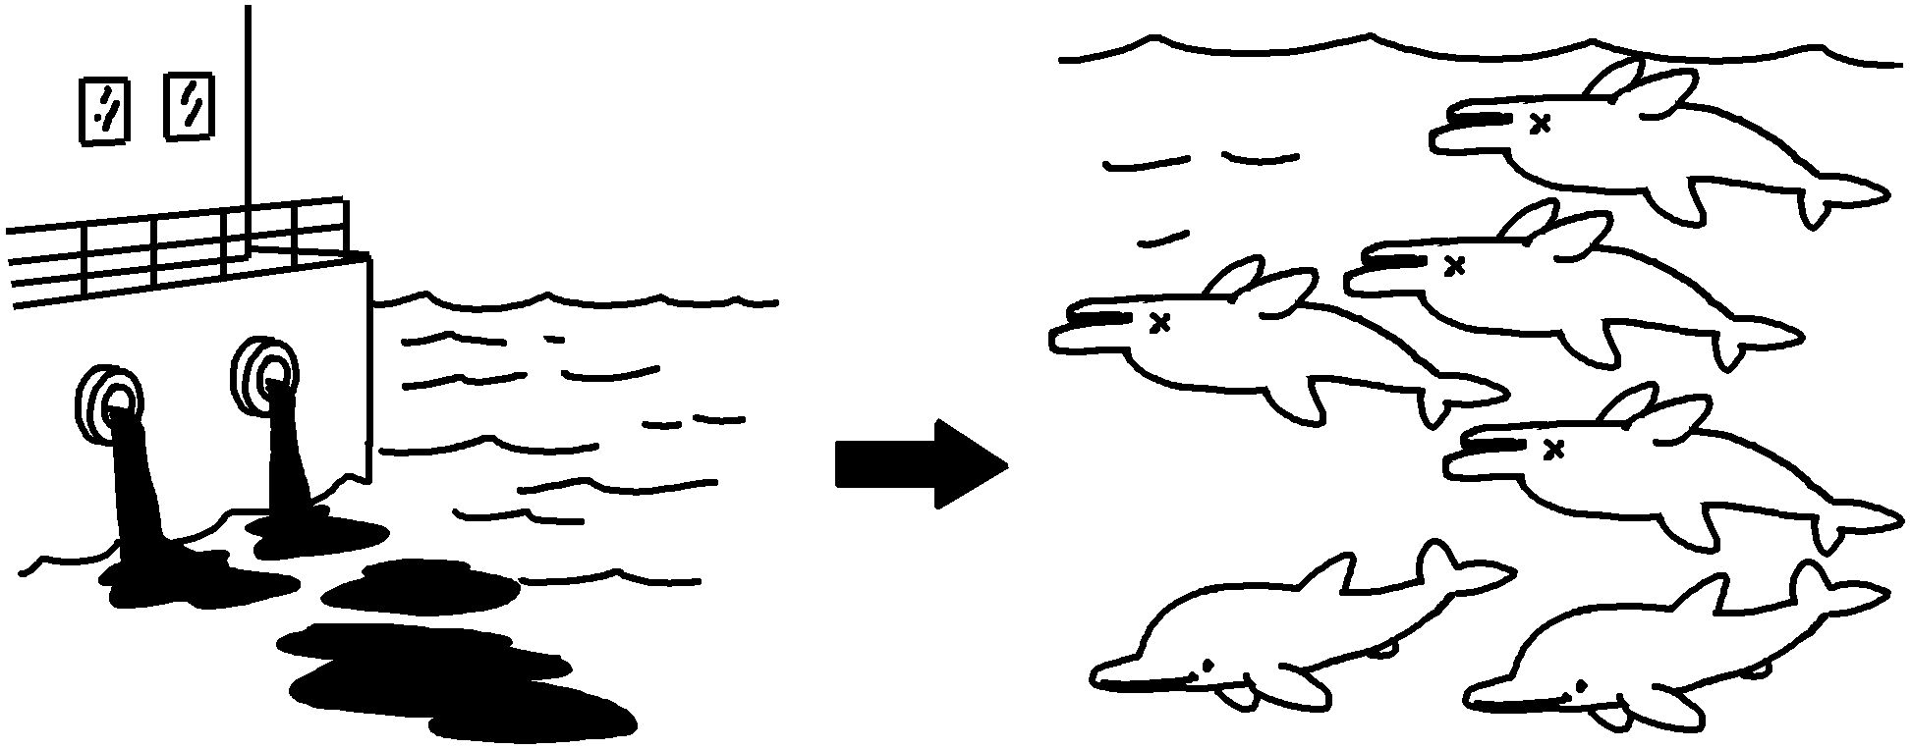 | People dump waste into the sea.  There are very few dolphins left in the sea.


Book 6B Chapter 4 Graded Worksheets
Worksheet 3⬇
- Therefore
- Therefore there are very few tigers left
- People destroy bamboo forests.
Therefore pandas have no place to live.
- People dump waste into the sea.
Therefore there are very few dolphins left in the sea.

