Look at the pictures and write sentences using ‘Therefore’.
1 | 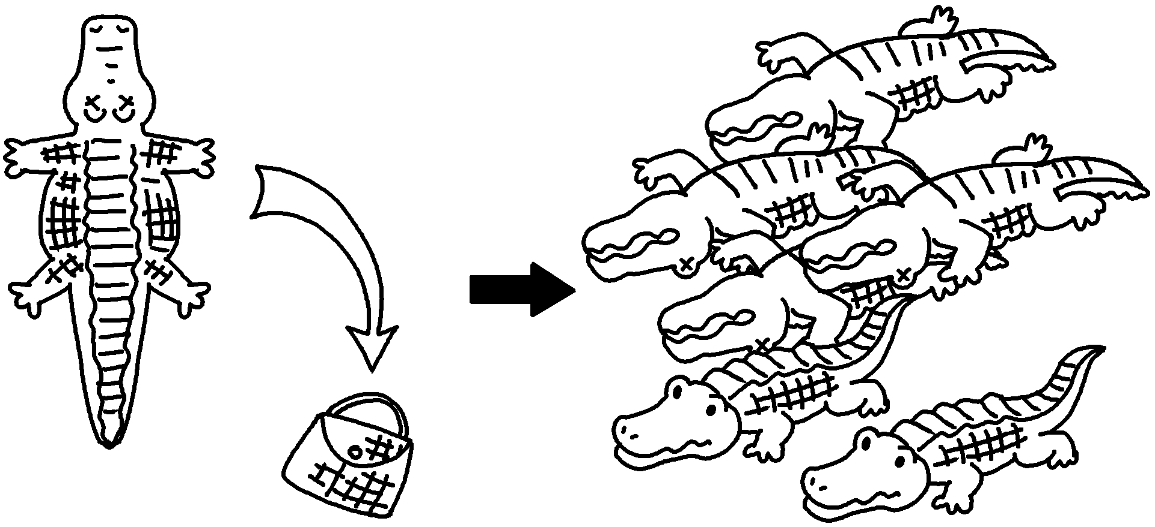 | People kill crocodiles for their skin.  there are very few left.
2 | 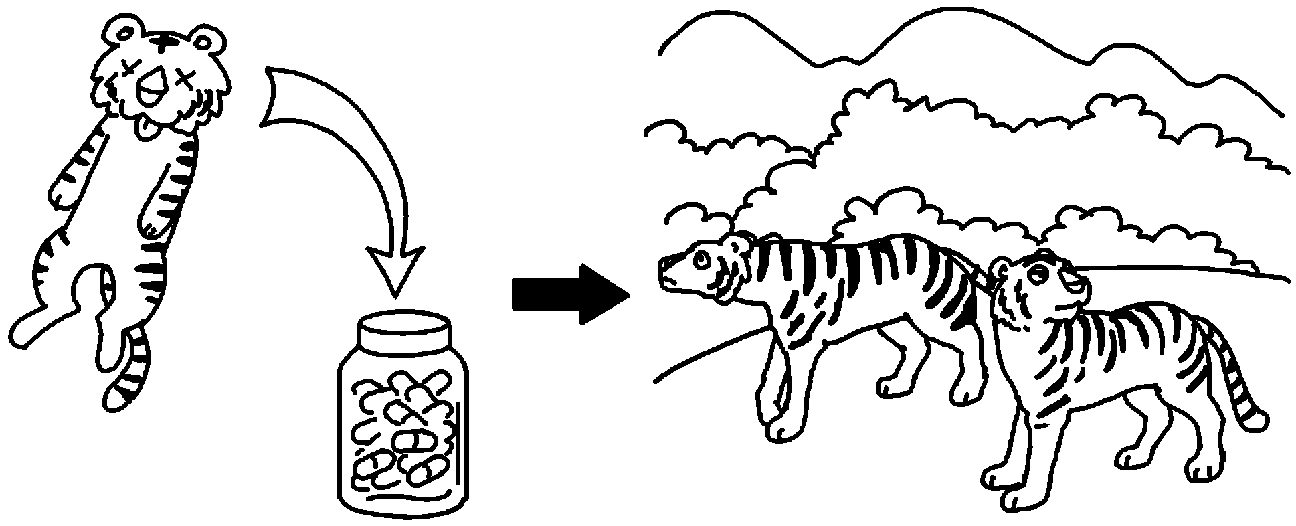  ( hunt tigers to make medicine /  very few tigers left ) | People _____________________________  .
3 | 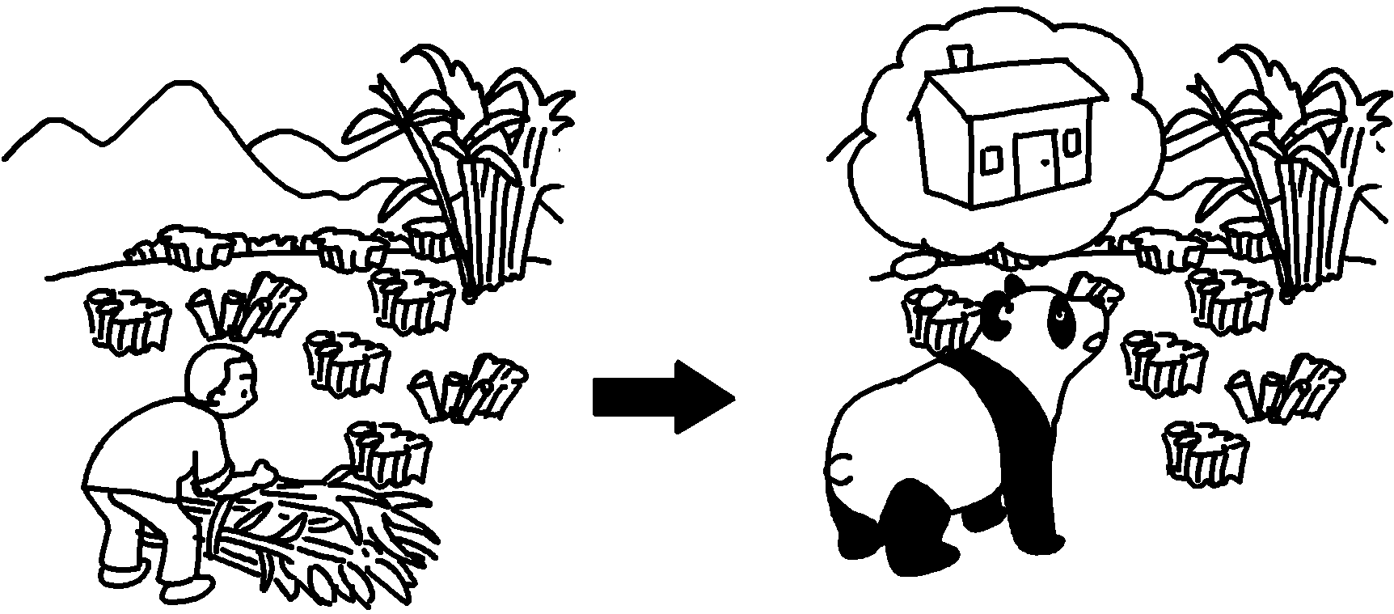  ( destroy bamboo forests /  pandas have no place to live )
4 | 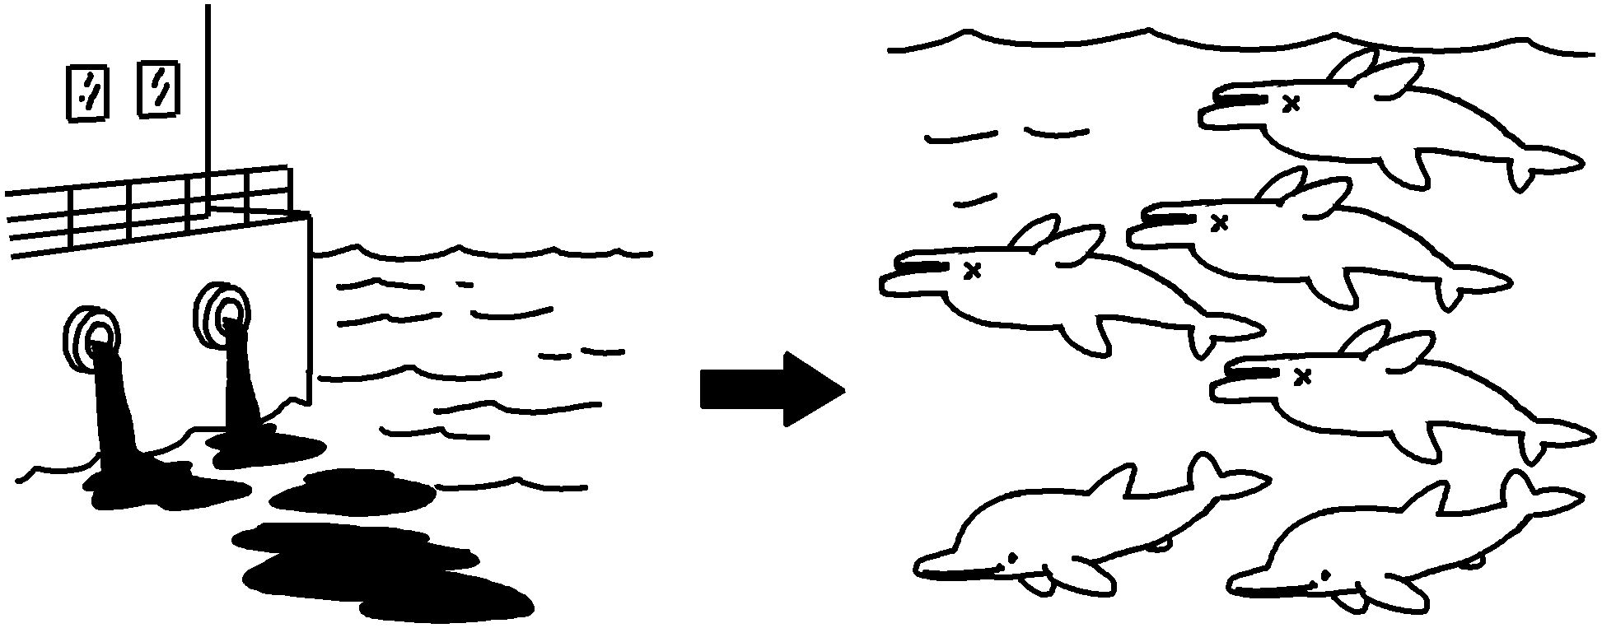  ( dump waste into the sea / very few dolphins left in the sea )


Book 6B Chapter 4 Graded Worksheets
Worksheet 3⬇⬇
- Therefore
- hunt tigers to make medicine
Therefore there are very few tigers left.
3 People destroy bamboo forests.
Therefore pandas have no place to live.
4 People dump waste into the sea.
Therefore there are very few dolphins left in the sea.

