Look at the pictures and write sentences using ‘Therefore’. Use the helping words and your own words to write the sentences.

destroy bamboo forests very few … left in the sea
hunt … to make medicine … have no place to live
dump waste into the sea very few … left

1 | 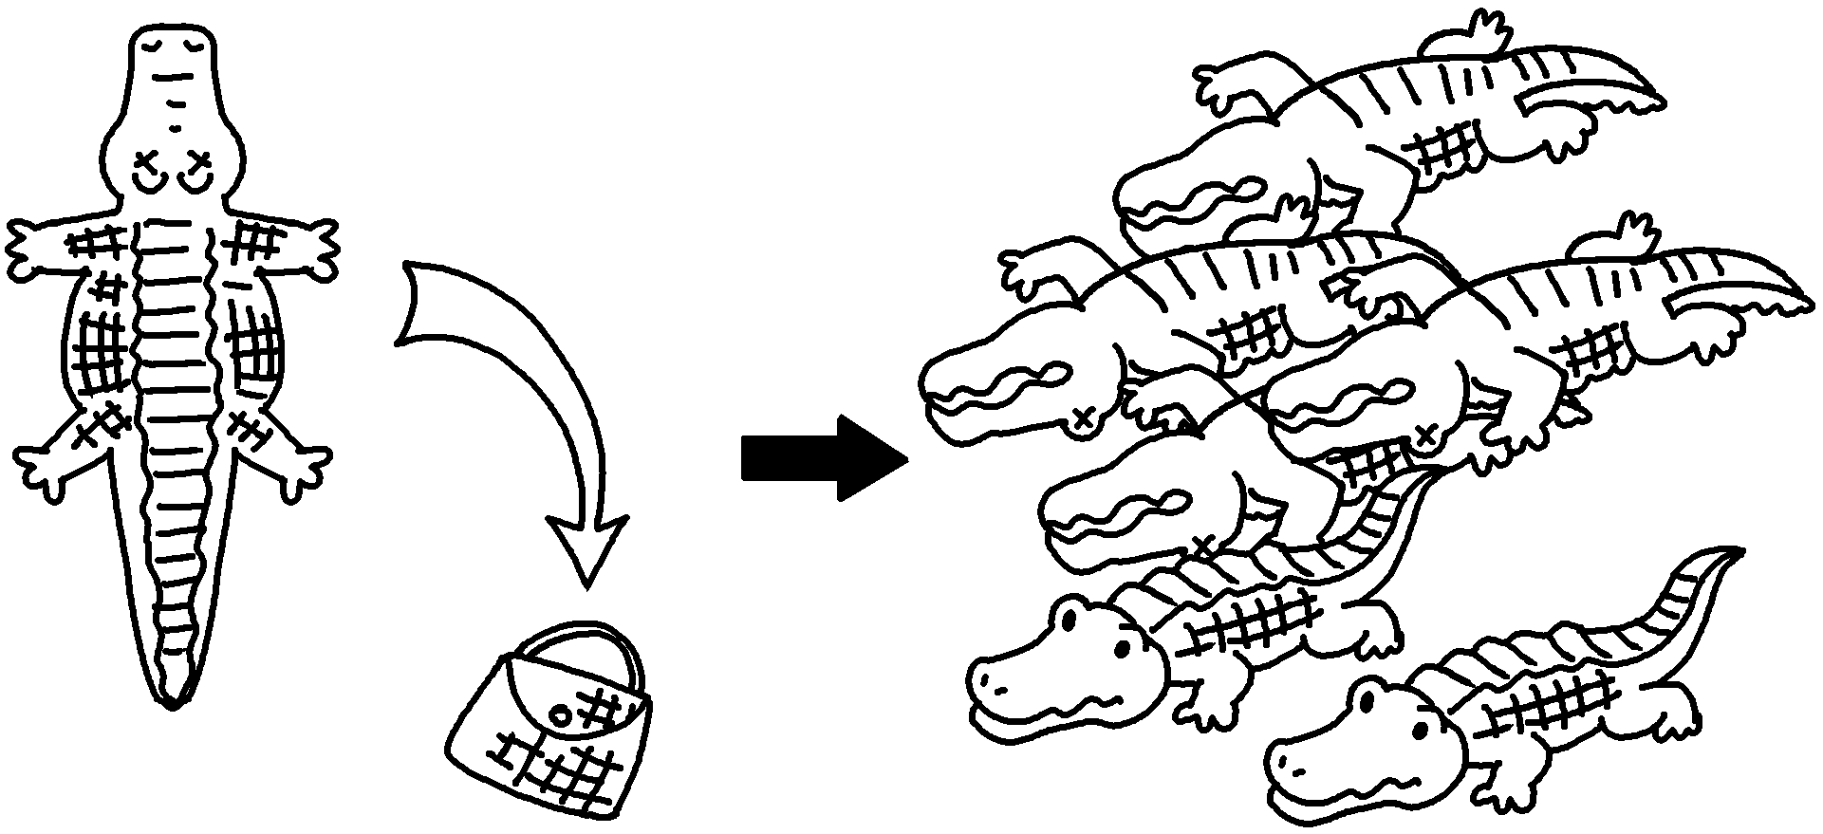 | People kill crocodiles for their skin.  there are very few left.
2 | 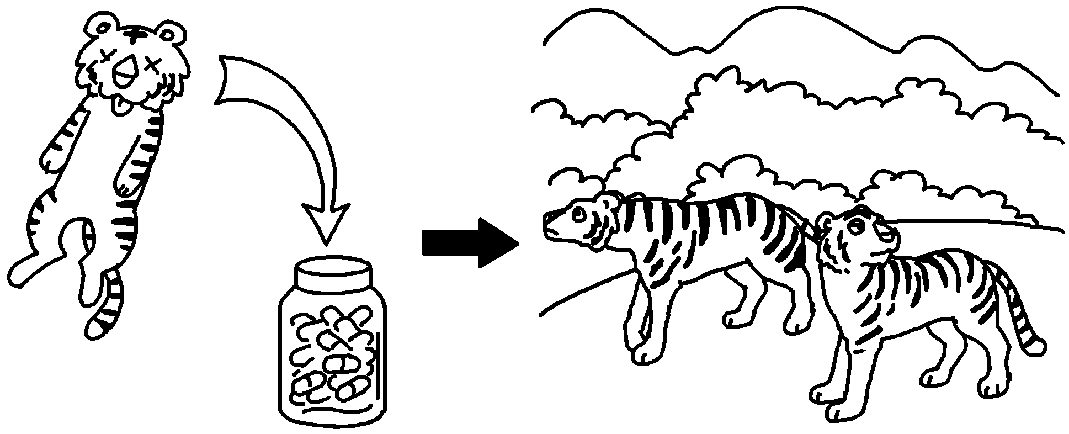 | People _____________________________  .
3 | 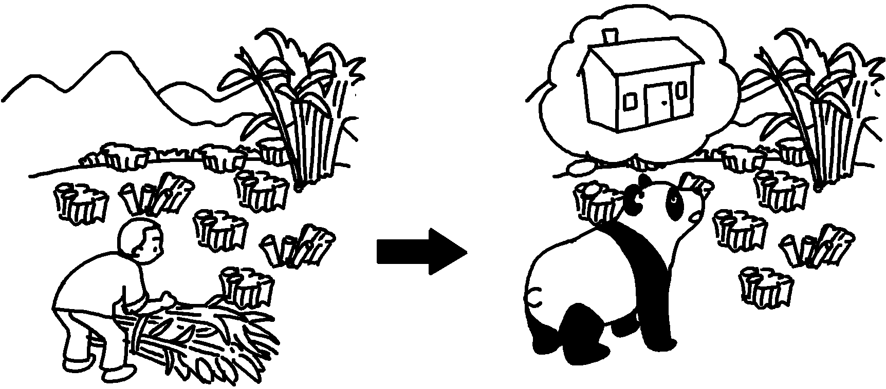
4 | 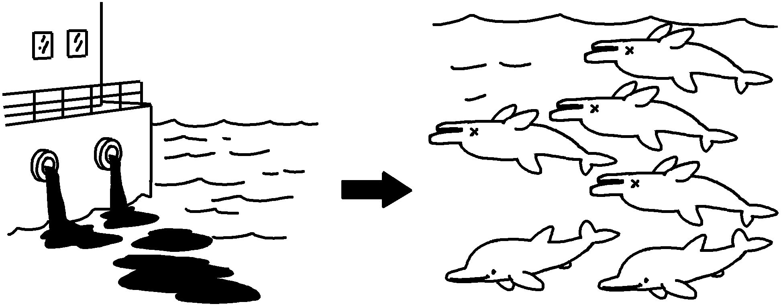


Book 6B Chapter 4 Graded Worksheets
Worksheet 3⬇⬇⬇
- Therefore
- hunt tigers to make medicine
Therefore there are very few tigers left.
3 People destroy bamboo forests.
Therefore pandas have no place to live.
4 People dump waste into the sea.
Therefore there are very few dolphins left in the sea.
(Accept any reasonable answers.)

