- Animals in danger
Do you know the story of Noah and his ark? Read about Noah of the future. Is the story the same or different?
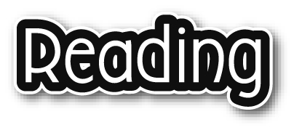
Noah’s Space Ark
Scene 1 In Noah’s garden
This is read as ‘twenty ninety-nine’.
Narrator : It is the year 2099. This planet has become a terrible place to live because people have polluted it. One man – Noah – has a plan.
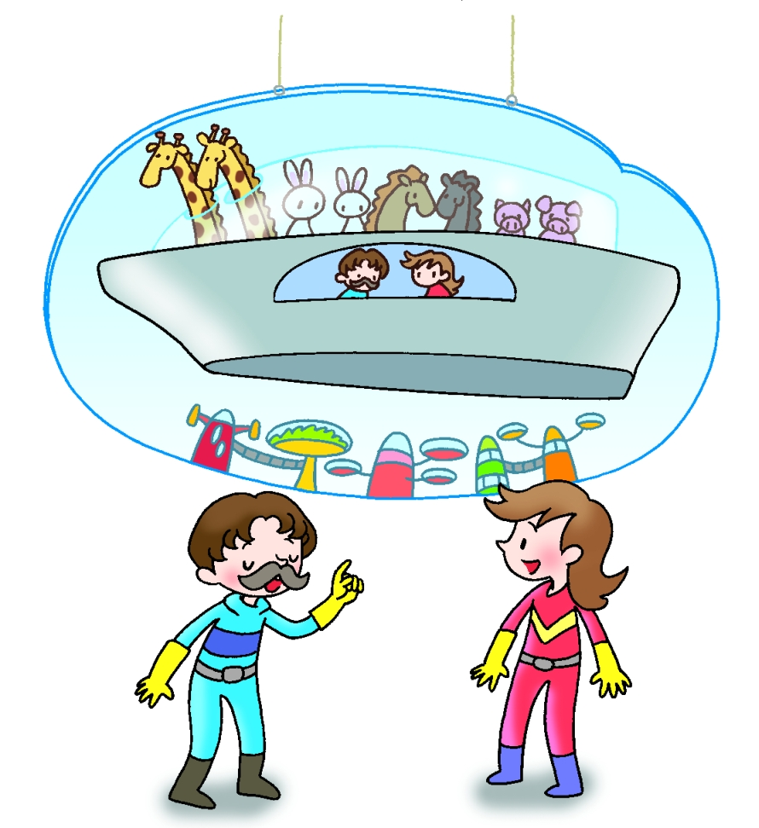
Enter Noah and his wife.
Noah : (patiently) All the people and animals will die unless we get away from the Earth. I’ve built this space ark. I’m going to take a pair of every type of animal to another planet.
Noah’s wife: But this space ark is not big enough.
Noah : That means some animals must stay here. I’ll go to the zoo and tell them.
Exit Noah.
Scene 2 At the zoo
Narrator : Noah has just told the animals.
Tiger : (angrily) I can’t survive here. I’m already endangered. I’ll become extinct unless I go in the space ark.
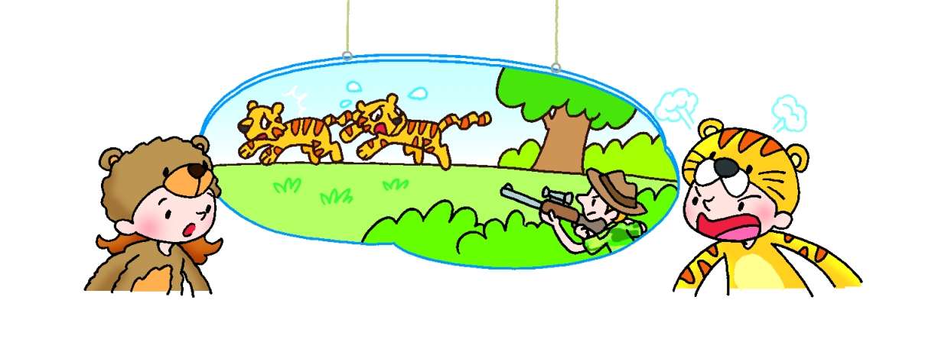
Bear : Why are you endangered?
Tiger : People hunt tigers. They wear our fur and use us in medicines.
Bear : People also use us in medicines. We’ll soon be extinct unless people stop hunting us.
Panda : (sadly) I’m endangered too. People destroy our bamboo forests. Therefore there isn’t enough food for us and we die.
Turtle : People use turtle shells to make jewellery and they eat our meat. There’ll be no turtles left unless people stop killing us.
Tiger : Are we all endangered?
Bear : Not all of us. (pointing slowly at Noah)
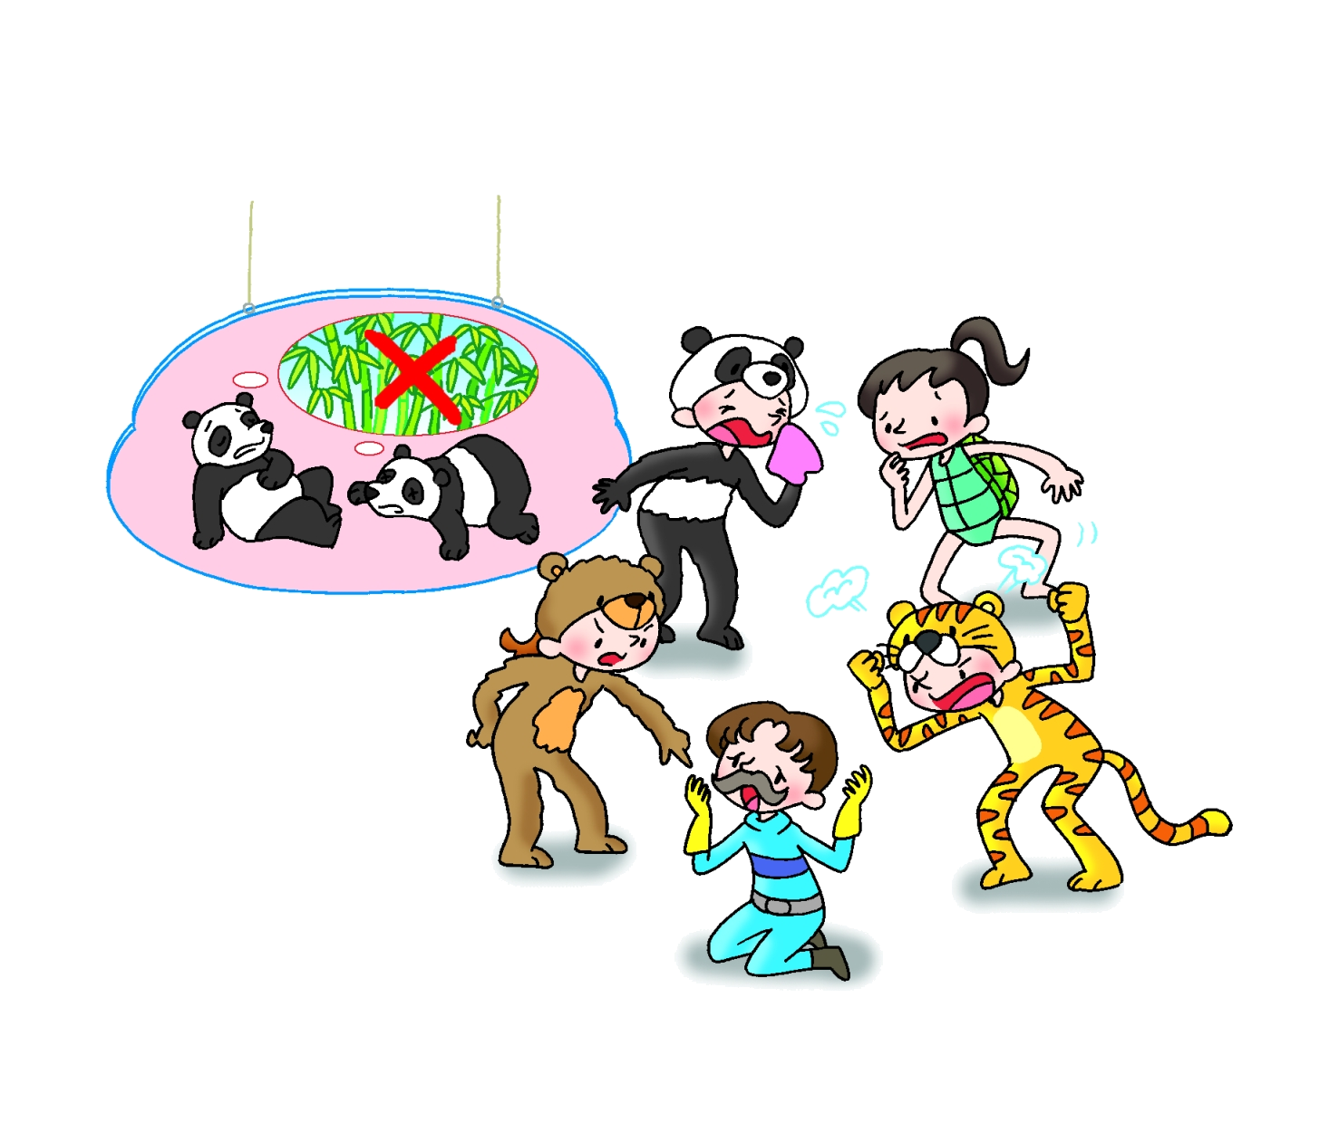
Noah : It’s my space ark. I made it!
Turtle : You made the Earth into a terrible place.
Tiger : People are destroying this planet. They’ll destroy our new planet unless we stop them.
Bear : Therefore we must leave the people here.
Noah : (loudly) No!
Narrator : What will happen next?

