Choose and write.

always | never

1 | 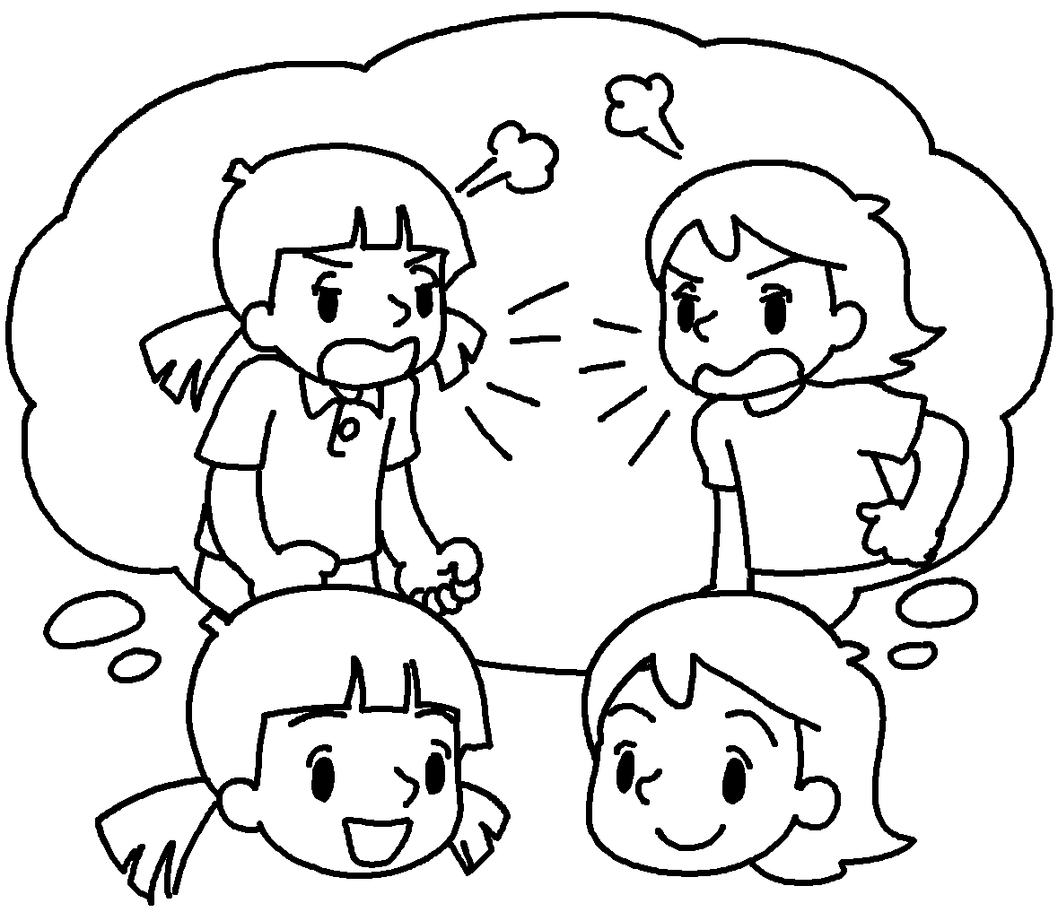 | Sue is my best friend.  We quarrel.
2 |  | My friend Pam is there for me. She is loyal.
3 |  | David is a diligent student.  He is lazy.
4 | 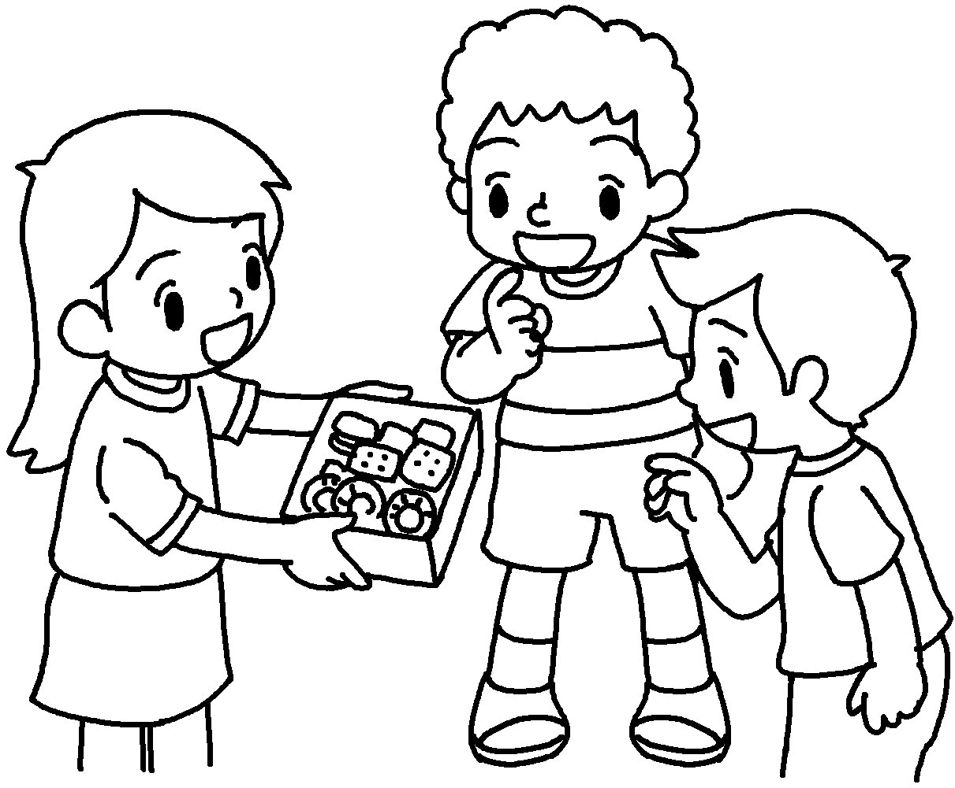 | Lucy is generous.  She shares her snacks with her friends.
5 | 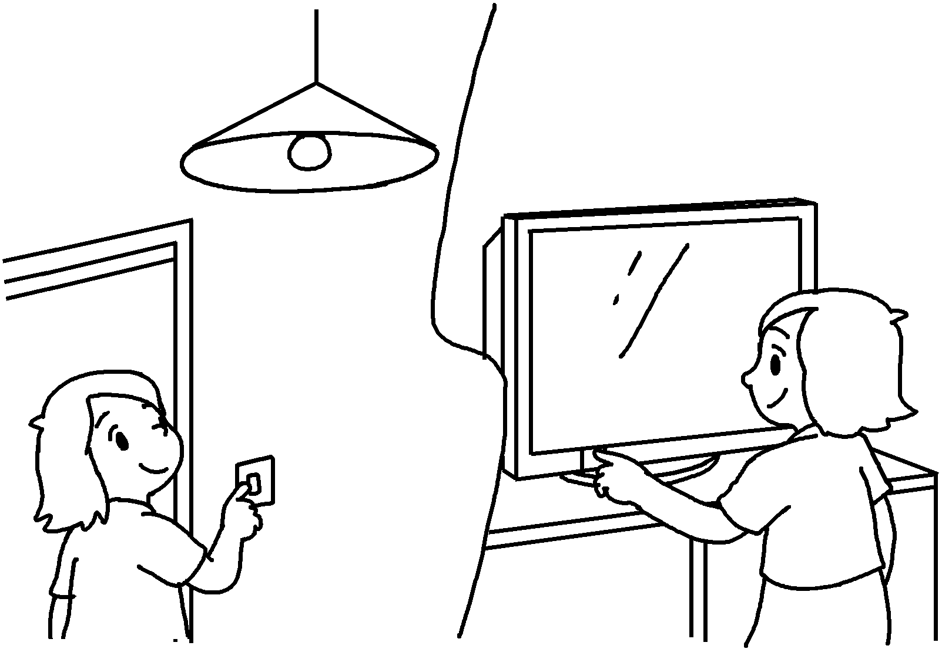 | Alice forgets things.  She is responsible.
6 | 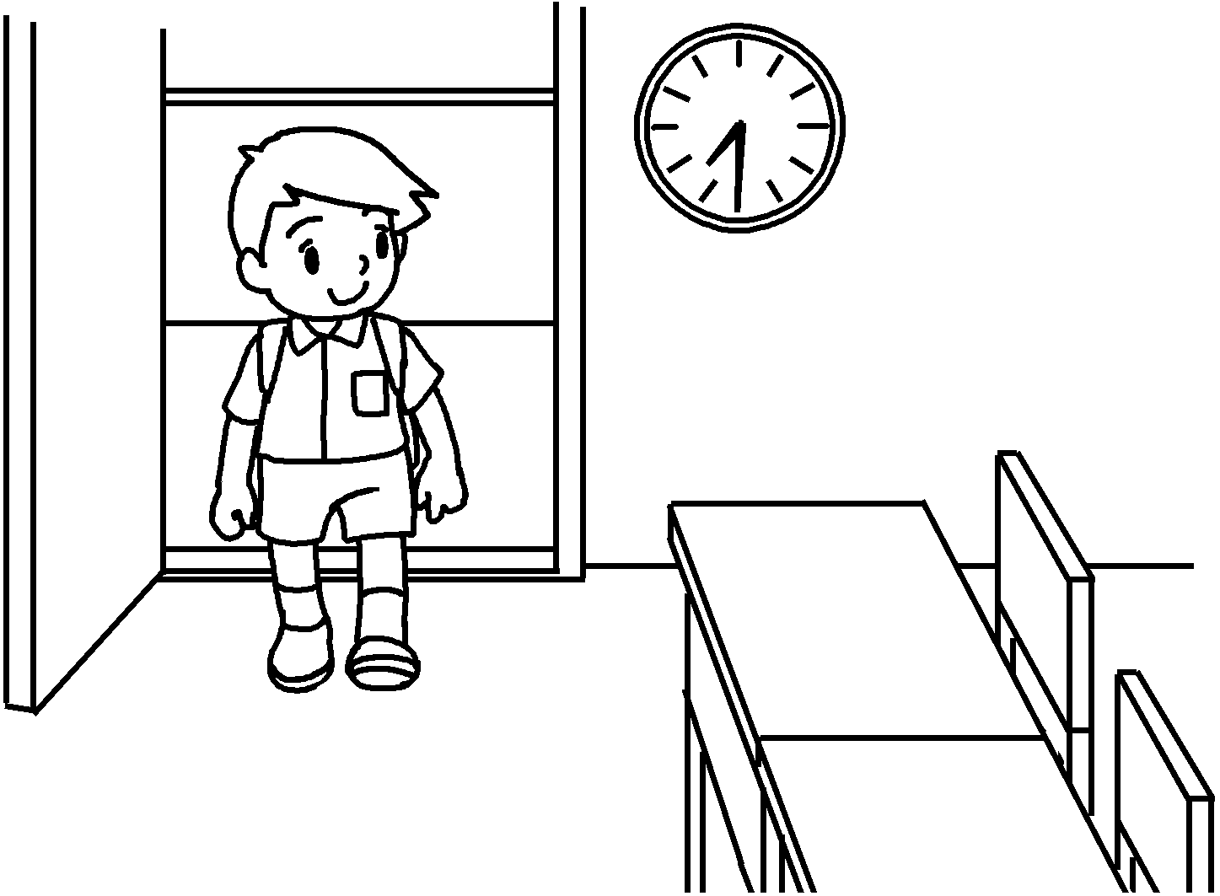 | Tim is punctual.  He goes to school late.


Book 6B Chapter 5 Graded Worksheets
Worksheet 2⬇
- never
- always
- never
- always
- never
always
- always
never

