Look at the pictures. Finish the sentences using ‘always’, ‘never’ and the suitable adjectives.

1 |  | Sue is my best friend.  We quarrel.
2 |  | My friend Pam is there for me. She is l .
3 |  | David is a d student.  He is lazy.
4 | 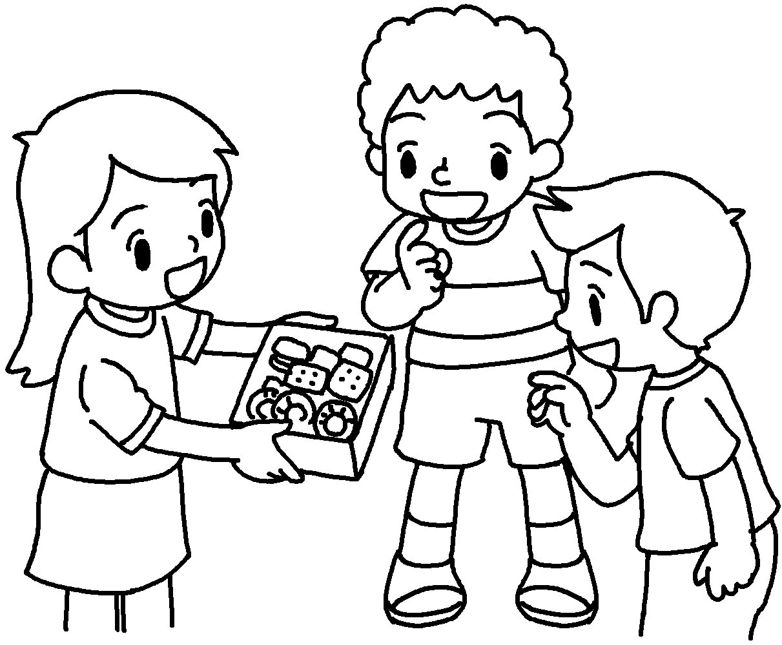 | Lucy is g .  She shares her snacks with her friends.
5 | 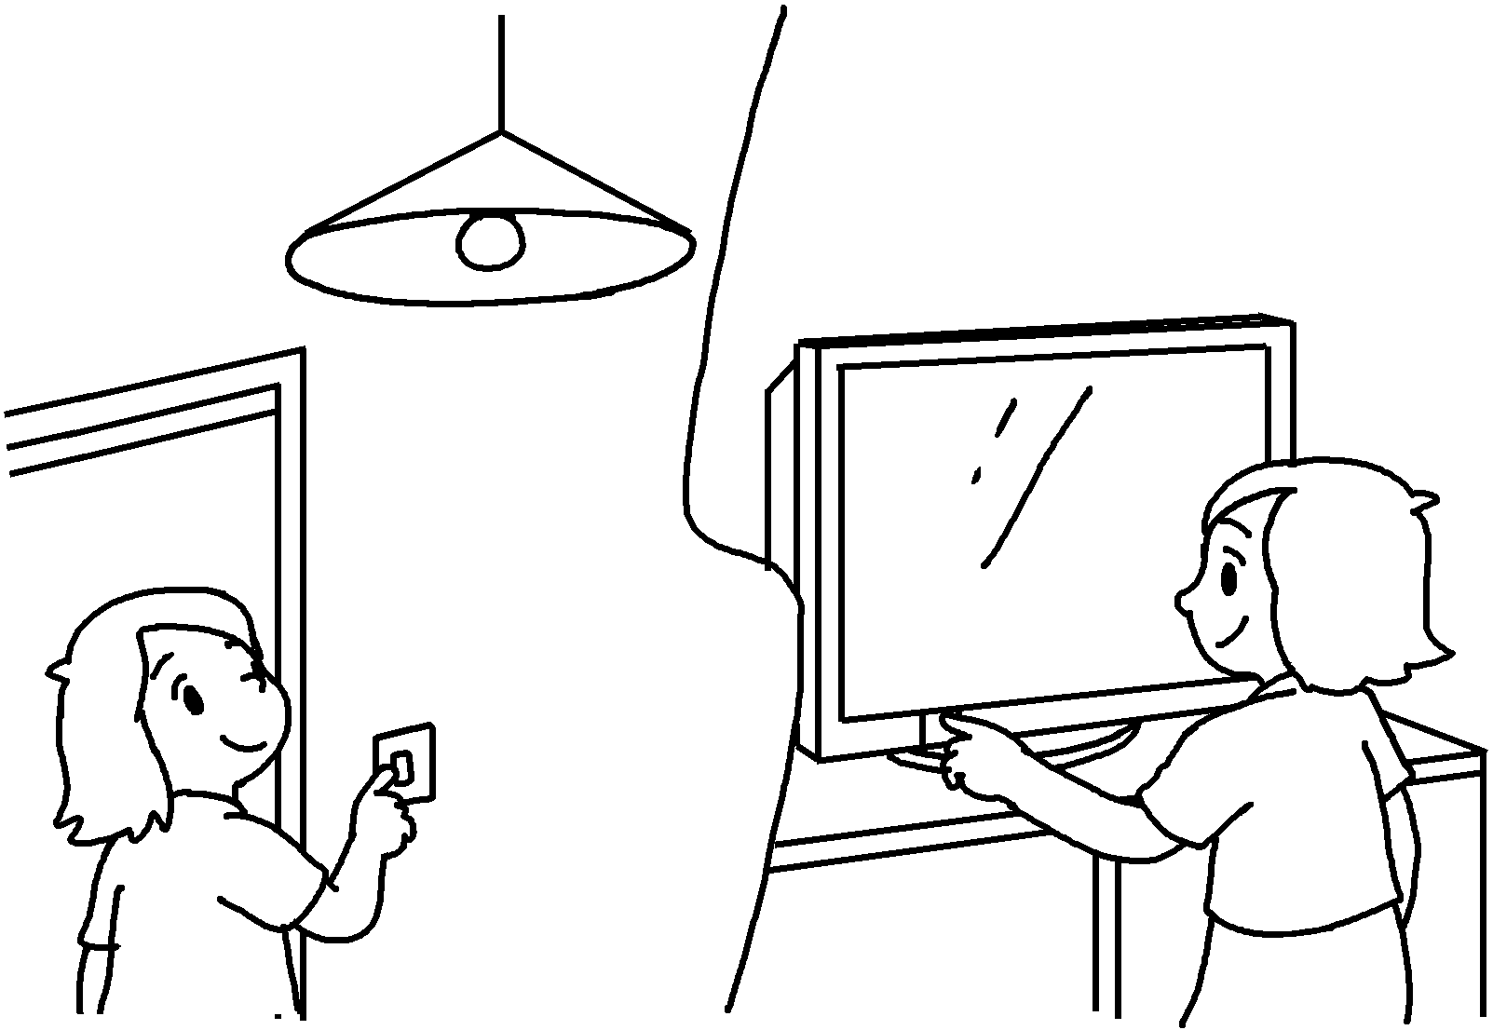 | Alice forgets things.  She is r .
6 | 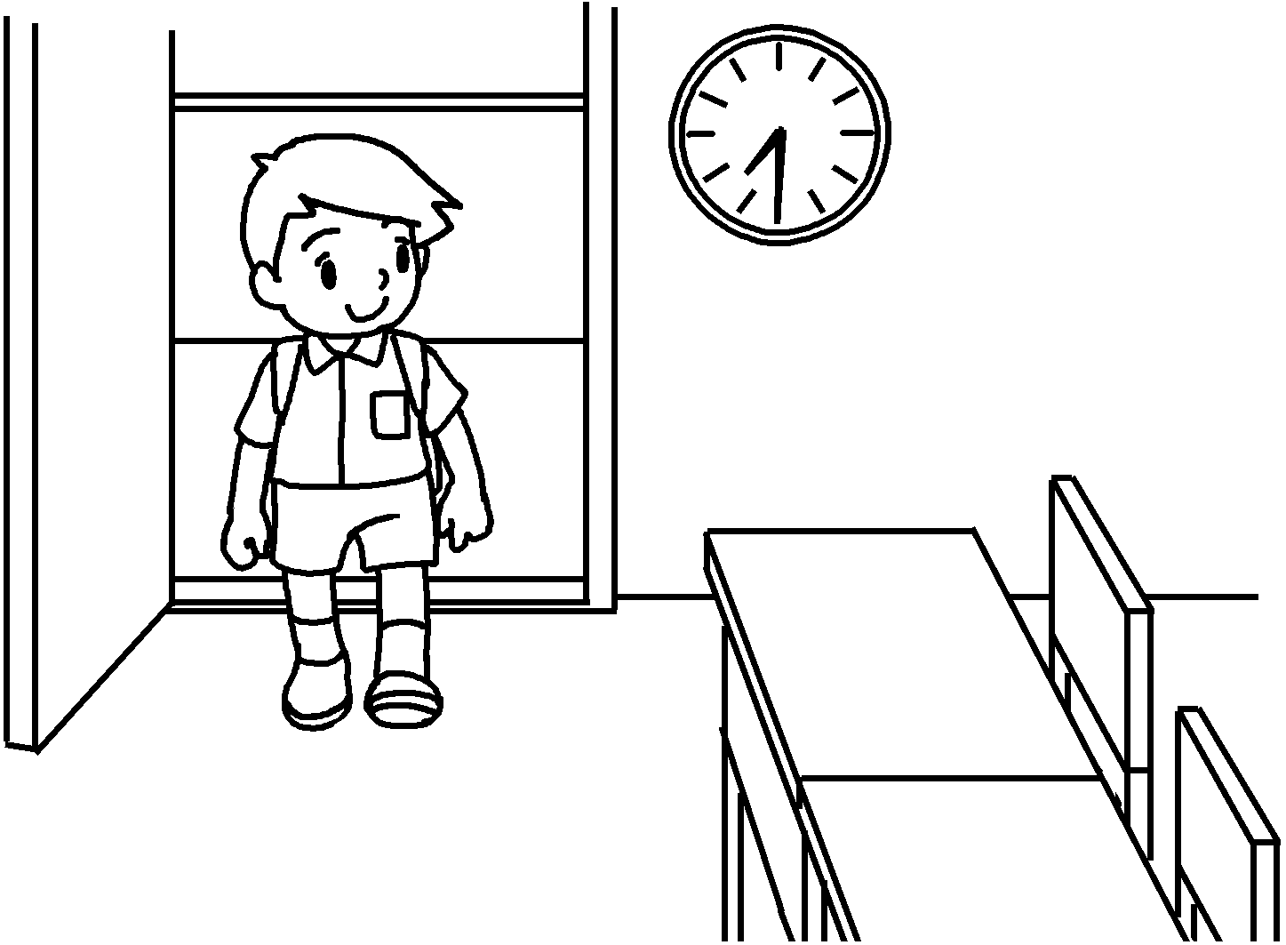 | Tim is p .  He goes to school late.


Book 6B Chapter 5 Graded Worksheets
Worksheet 2⬇⬇⬇
- never
- always
loyal
- diligent
never
- generous
always
- never
responsible
- punctual
never

