Fill in the blanks with the correct form of the words.
1 | 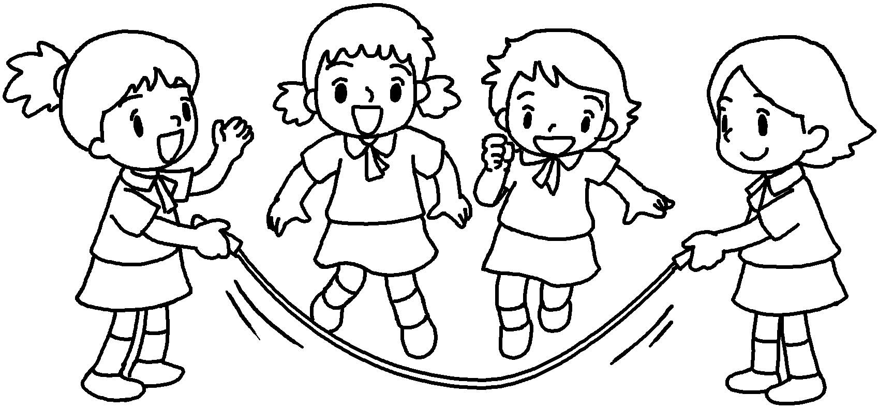 | The girls are skipping ( happy ) in the playground.
2 | 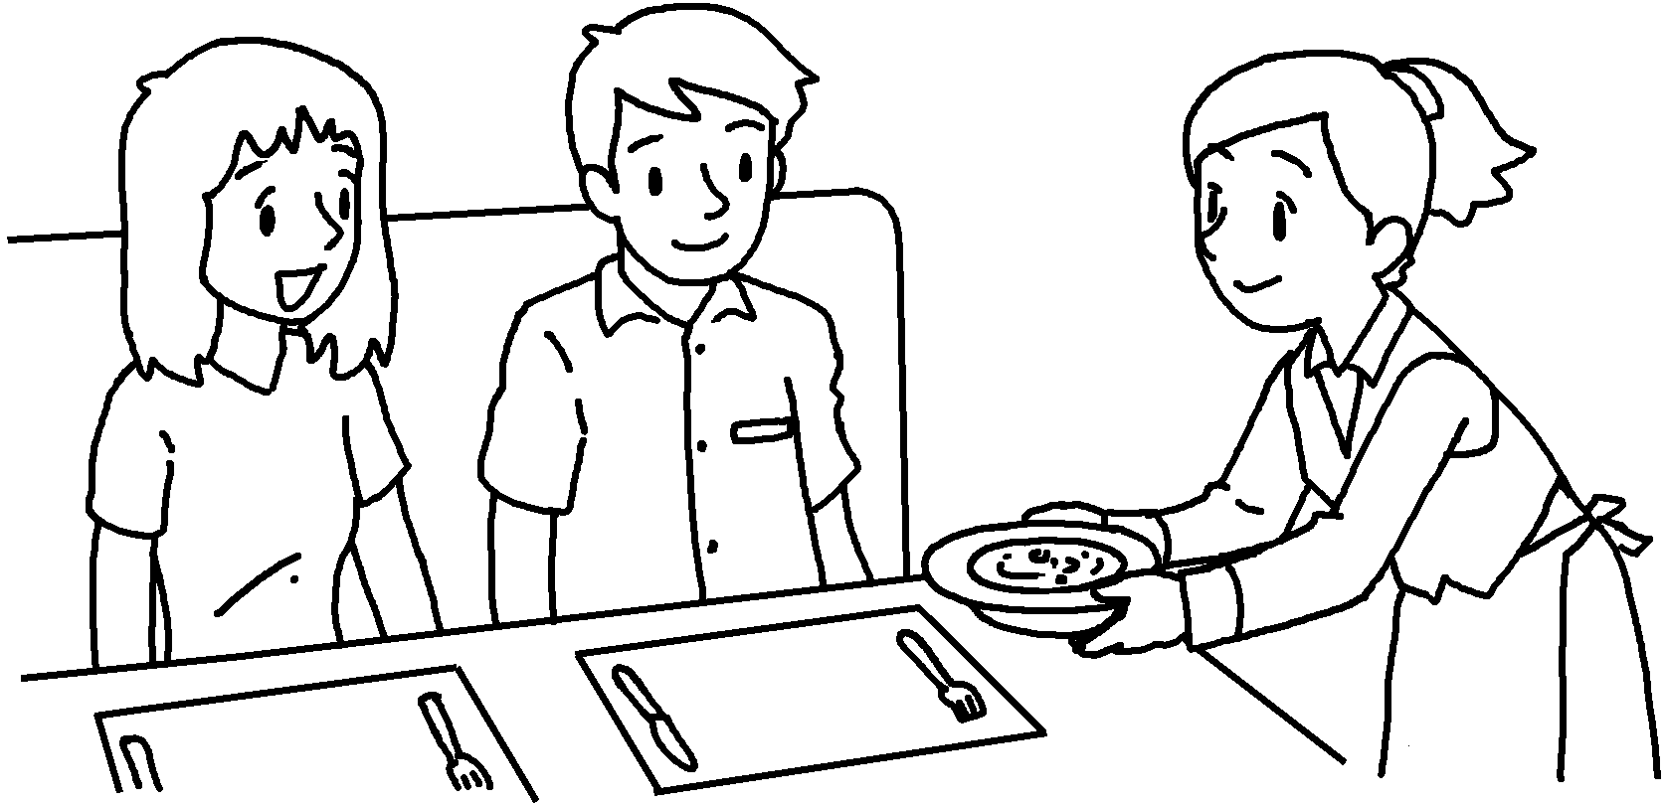 | The waitress served food to us  ( careful ).
3 | 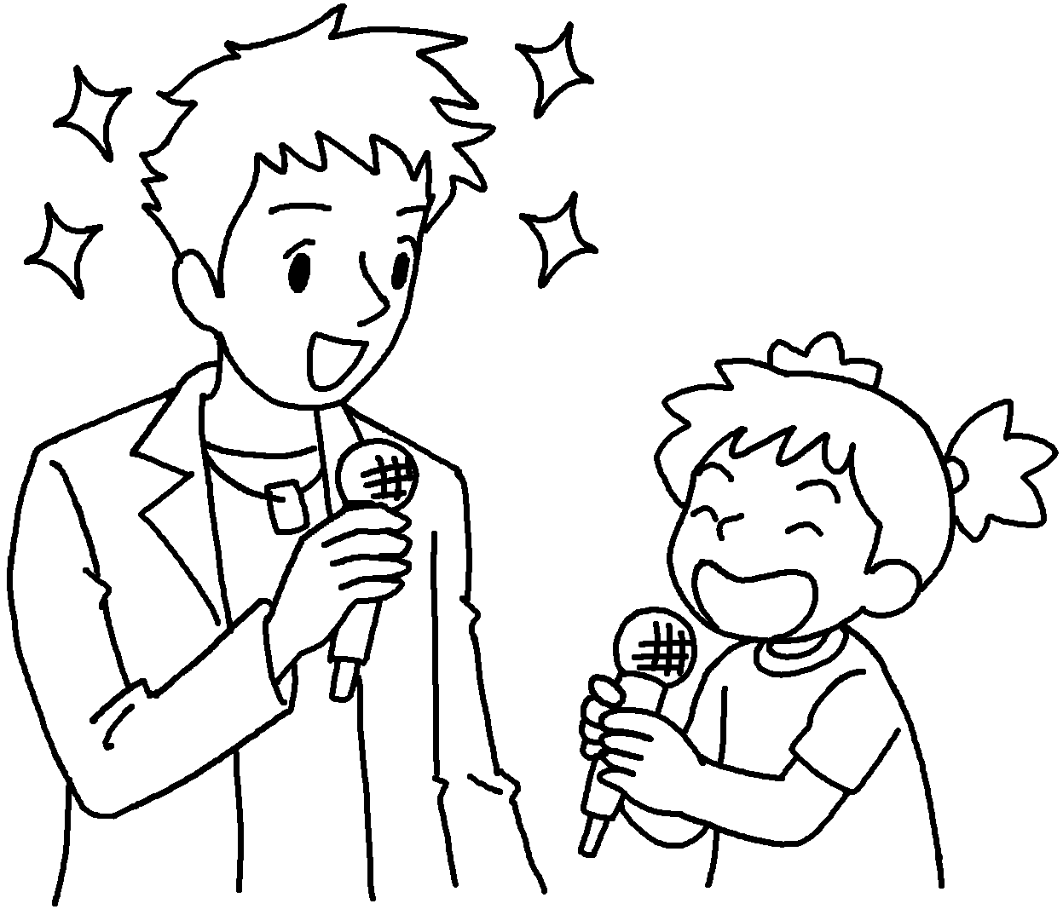 | Sarah sang with her favourite singer  ( excited ).
4  Exam week  Mimi | 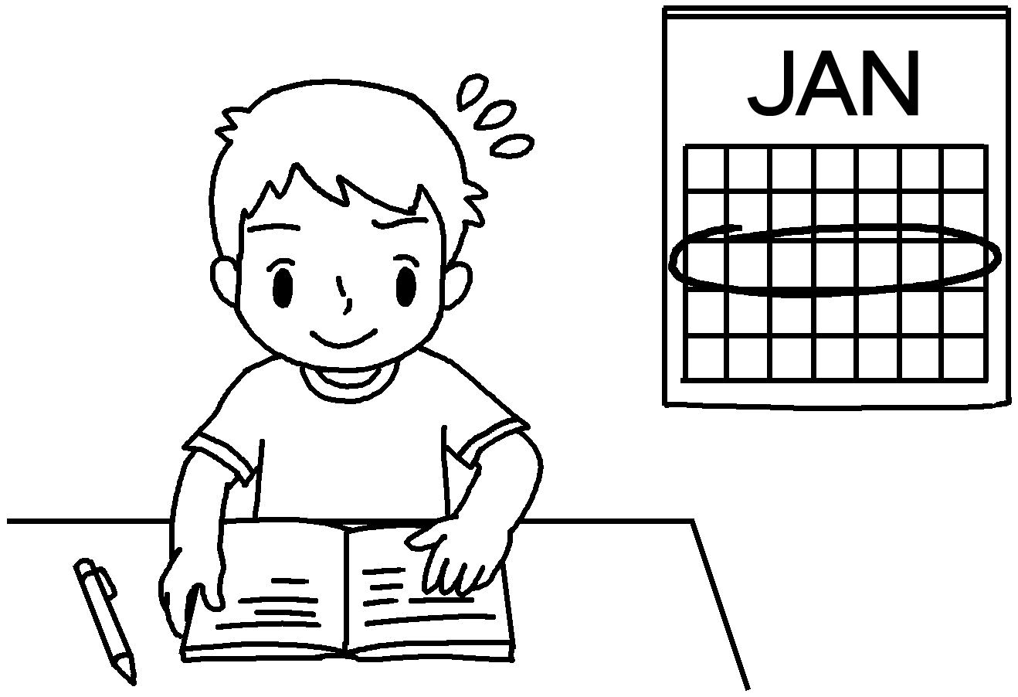 | Tommy is a diligent student.  He always works ( hard ) for the exams.
5 | 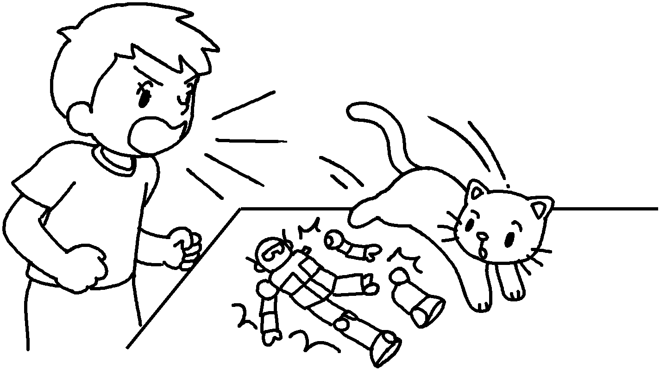 | Mimi broke Ben’s model.  Ben shouted at her ( angry ).
6 | 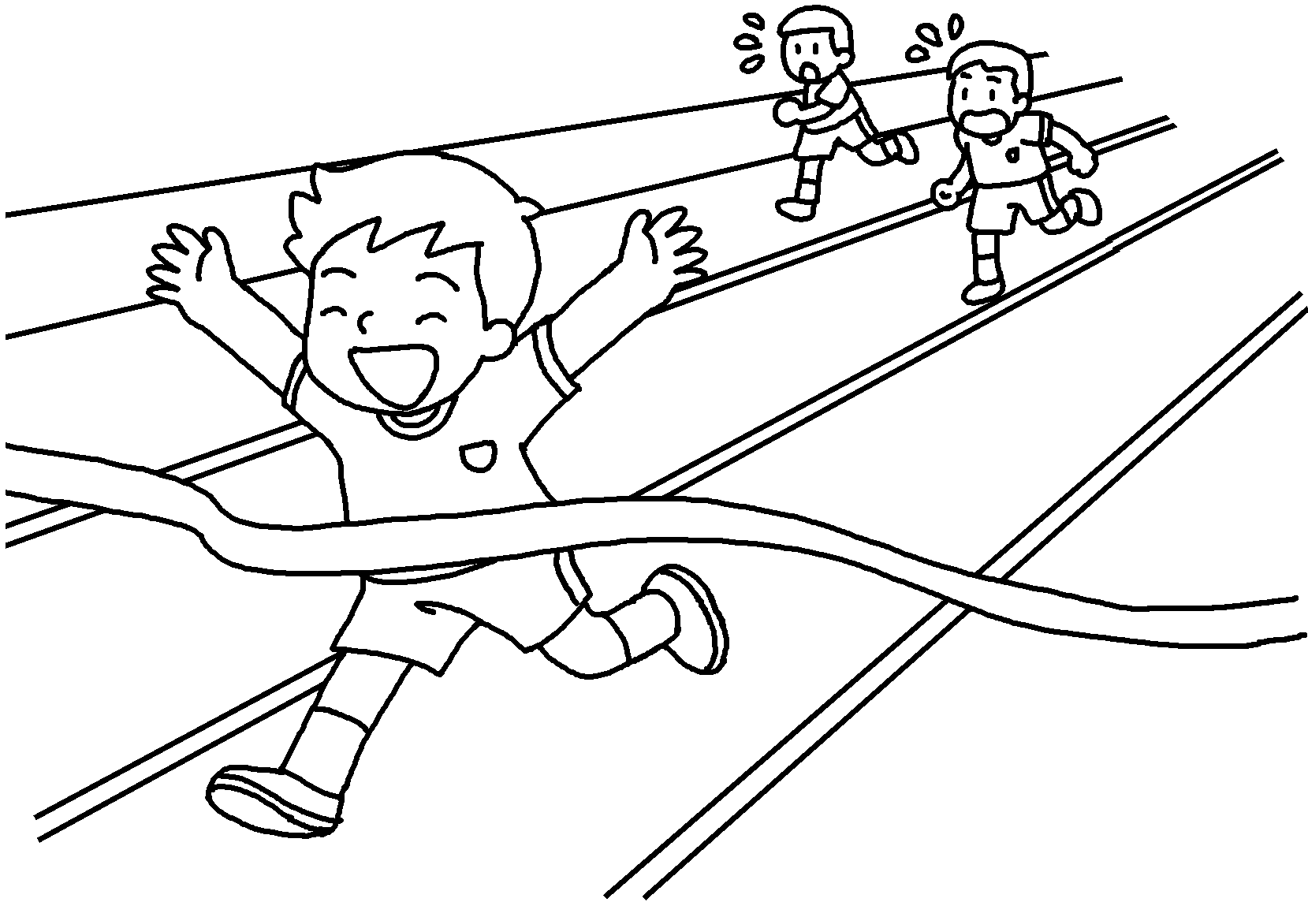 | John is good at sports.  He runs ( fast ).  He won first prize on Sports Day.


Book 6B Chapter 5 Graded Worksheets
Worksheet 3⬇
- happily
- carefully
- excitedly
- hard
- angrily
- fast

